Unit 5 Topic 5.6-5.7 Chpt. 17 INTEREST GROUPS, AMSCO pg. 554-586
LINKAGE INSTITUTIONS
- Linkage institutions are channels that allow individuals to communicate their preferences to policy-makers:
- What are the four linkage institutions?
  - Elections
  - Political Parties
  - Interest Groups - Organization of people whose members share policy views on specific issues and attempt to i______________ the g_____________ and p___________ p______________ to their benefit.
  - Mass Media
- How do you let the government know about your opinions and beliefs?

WHAT WERE INTEREST GROUPS ACCORDING TO JAMES MADISON?
- Madison called interest groups “f________________”
- Madison’s dilemma: allowing people the l____________ to form g__________ and express their views could d__________ the hope for an o_________ society.
- Madison expressed the view that f_____________ are u______________ but i_______________ in a free society>> need to c_______________ their effects.
- Madison addressed the problem of establishing a stable constitutional system that at the same time would respect liberty in The Federalist, No. ____ (freedom but limit factions)

Interest Groups in American Representative Democracy
- Exercising your right to form groups is, in essence, forming a faction
– James Madison, Federalist No. 10
- Factions are inevitable in a representative democracy and represent liberty
- Lesson the dangers of faction by allowing them to compete
- Interest groups compete over conflicting policy desires

WHAT ARE INTEREST GROUPS TODAY?
- Interest group (AKA Special interests – term used in a negative way)
– Organization of people whose members s___________ policy views on specific issues and attempt to i____________ p__________ p__________ to their b____________.
- Interest groups are protected under the _______ Amendment of the Constitution (which means they have the freedom of s___________ and a______________)

PURPOSE OF INTEREST GROUPS
- E__________ /i______________ voters and o__________ holders (to make sure the policymakers are s_______________ to your issues)
- D_________/ write legislation (after you have gained access to sympathetic policymakers)
- M_____________ membership to apply pressure on and work with legislators and government agencies (to get laws created/changed in your favor)
Interest groups may represent very specific or more general interests
HOW DO INTEREST GROUPS LINK CITIZENS TO GOVERNMENT?
- L_____________ institution (along with elections, political parties, and mass media) – link citizens to government
  - Express their members’ preferences to government policymakers
  - Convey government policy i_________________ to their members
  - Raise and spend m____________ to gain access to policymakers

WHAT IS THE DIFFERENCE BETWEEN INTEREST GROUPS AND POLITICAL PARTIES?
- Interest groups seek to s________________ public officials and i__________________ government policies.
  - In contrast, political parties n_____________ candidates, c_______________ elections and seek to gain c______________ over government.
- Interest groups focus only on s___________ issues that directly affect their m______________. As a result, interest groups are able to articulate s______________ policy positions.
  - In contrast, political parties have positions on a w__________ r___________ of public issues.
- Interest groups are p____________ organizations that are accountable to their m_____________.
  - In contrast, political parties are p_____________ organizations that are accountable to the v________________.

HOW DO INTEREST GROUPS EXERT INFLUENCE?
Interest groups exert influence through long-standing relationships with bureaucratic agencies, congressional committees, and other interest groups; such relationships are described as “iron triangles” and issue networks and they help interest groups exert influence across political party coalitions

IRON TRIANGLES
Definition: A__________ among b_____________, i_________ groups, and congressional sub___________ members and staff sometimes form to promote their common causes. Also known as s_______________.
Congressional subcommittees oversee the i_______________ of p___________ policy in the b__________________.

Example: An important issue that government has recently addressed is the effect of tobacco on health and the government's role in regulating it.
The tobacco farmers and industry have numerous interest groups, a "tobacco l__________" that provide i_______________ to the tobacco division of the Department of Agriculture and to s_______________ of the House and Senate Agricultural committees. They support the agency's budget requests and make c_________________ to the election campaigns of the subcommittee members. The subcommittees pass legislation affecting tobacco farmers and other members of the industry and approval higher budget requests from the agency. The agency gives the subcommittees i__________________, help with constituents' complaints, and develop r______________ on tobacco production and prices. They all have a common interest - the promotion of tobacco farming and industry, and they can help one another achieve their goals. As a result, the president and Congress beyond the subcommittee have little decision-making power.

ISSUE NETWORKS
Definition: Network that consists of people in interest groups, on congressional staffs, in bureaucratic agencies, in universities, and in the mass media who regularly debate an issue. They are not permanent.
The iron triangle may be criticized because interest groups today are so prolific that they are bound to create cross- demands on subcommittees and the bureaucracy. In the tobacco issue discussed above, interest groups have formed demanding that tobacco products be banned or heavily restricted by the federal government. With these counter-demands, the policymaking process would not run so smoothly and would broaden the number of people involved in the system. The issue is discussed on many levels, both inside and outside government. An agency, then, can be described as being embedded, not in an iron triangle, but in an i_________ n_____________. The networks are contentious, with arguments and disagreements occurring along p____________, ideological, and economic lines. When a president appoints a new agency head, he will often choose someone from the issue network who agrees with his views.

The Revolving Door
Revolving door—the movement from the job of legislator to a job within an industry affected by the laws or regulations. Many officials leave their jobs on Capitol Hill or in the executive branch to lobby the government they departed. Some members of Congress take these positions after losing an election. Others do so because they can make more m________ by leaving government and working in the private sector. These former lawmakers already have i_________ r____________ with members of C_____________.
Almost half the members of Congress who left in 2017 became lobbyists.
What are some of the problems that the “revolving door” could cause?
Fill in the flow chart of the Iron Triangle

ARE ALL INTEREST GROUPS CREATED EQUAL? NO!!
There are some factors that affect how influential an interest group can be:
- Inequality of political and economic resources.
- Unequal access to decision makers.
- “Free rider” problem- EXPLAIN

Free Rider
Free rider” policy: a problem of group behavior that occurs when an individual can receive a p________ b_________ without making a personal contribution of money or effort; for example, a person might listen to public radio but never contributes to the station, assuming that other donors will pay to keep it operating
There are many competing interest groups, and they can take a variety of forms, but all seek to influence public policy in favor of the needs of their constituents. Not all interest groups have an equal impact on policy, however, as some have more funds, greater access to decision makers, and more committed members.
WHAT FACTORS MAKE INTEREST GROUPS STRONG?
SIZE
- M_________ members = more money, more votes
- M_________ members also mean greater cross-pressure among members and possibly less focus
- As size increases, f_______ r_______ problem increases.
  - F________ riders (problem) are people who b____________ from the interest group without making any c____________.
  - i.e., an elderly person will benefit from the group’s lobbying efforts whether or not he joins AARP.
  - IG try to prevent this by giving incentives for people to join the group.
SPREAD
- The extent to which membership is concentrated or dispersed - is important

ORGANIZATIONAL STRUCTURE: CENTRALIZED OR
- An organization with separation of powers tends to be less cohesive than a centralized, disciplined group

LEADERSHIP
- Leaders may either bring the various elements of a group together or sharpen their disunity

RESOURCES
- Money
- Expertise
- Reputation
- Connections
- Volunteers

Mass m__________ (computerized and targeted)
L__________________ (USED BY NAACP, ACLU, NOW, ETC.)
- If an interest group fails in one arena, the c___________ may be able to provide a remedy.
- Interest groups can file a____________ c___________ briefs to influence a court’s decision.
- a___________ c_________: briefs submitted by a “friend of the court” to raise additional points of view and present information not contained in the briefs of the formal parties
- Class Action lawsuits permit a small number of people to sue on behalf of all other people similar situated.
USE OF MASS MEDIA
- Independent expenditures
- Issue advocacy-is a form of political advertisement not endorsing a candidate but an issue of interest to the public
BOYCOTTING
ELECTIONEERING
- Funneling volunteers to campaigns
- Encouraging members to vote
- Campaign contributions
- Endorsement of candidates
- “Targeting” of unfriendly candidates
- Issuing “r__________ cards” to rate candidates
INITIATIVE, REFERENDUM AND RECALL AT STATE AND LOCAL LEVELS
LOBBYING= i___________ with expert i__________ and or P____ $ for re-election campaigns.
INFLUENCES ON PUBLIC POLICY
Today it is commonplace for various p___________ actors, in the form of interest groups, professional organizations, social movements, the military, and bureaucratic agencies, to influence the p_________ m_________ process.
Does that make it right?

WHAT ARE EFFECTIVE TACTICS (TECHNIQUES) OF INTEREST GROUPS?
Outside lobbying, more accurately described as g_______-r________ lobbying, is an effort to mobilize public o__________ and put p______________ on public officials. It may involve organizing a l________-writing or e-_______ campaign or taking out a_______ in the print and electronic media in support of an issue.
Organized labor’s attack against the North American Free Trade Agreement (NAFTA) is a good example of grass-roots lobbying. Labor’s ads on billboards and in newspapers, as well as its television/radio spots, emphasized that NAFTA would export U.S. jobs to other countries.
How do Interest Groups Participate Directly in the Electoral Process?
- They openly e________ candidates who support their goals and e__________ their members to v____ for those candidates.
- This approach is somewhat risky because, if an interest group’s candidate loses, the interest group will likely not have the same access to the winner.
- The ratings that many public interest and ideological interest groups publish on members of Congress are either a form of endorsement or ammunition for a challenger in the race.
- Interest groups can help out a campaign by providing mailing lists, by mobilizing volunteers to get out the vote or distribute literature, and, most important, by contributing money largely through political action committees (PACs).

WHY DO INTEREST GROUPS KEEP GROWING?
- Economic developments.
- Government policies, whenever govt. creates an agency, it creates an entry point for interest groups – more groups needed to form in order to protect their stakes in these agency activities.
- Diversity of population – countless social, racial, economic and geographic c_____________- the division of voters into v____________ b__________.
- Diffusion of power in government. Political power shared by many –> plenty of places in which a group can argue its case. The more places there are to influence policy, the more organizations there will be to exercise that influence.
- W___________ of political p_____________.
- Reforms of the 1970's opened up the lobbying process (FECA and the explosion of PACs).
- Interest groups tend to beget interest groups ( when one is formed, another may be formed to c__________ it)
- T_________________, e.g., computerized mailing lists to solicit funds, use of communications media and Internet.

HOW DOES PUBLIC OPINION BECOME POLICY?
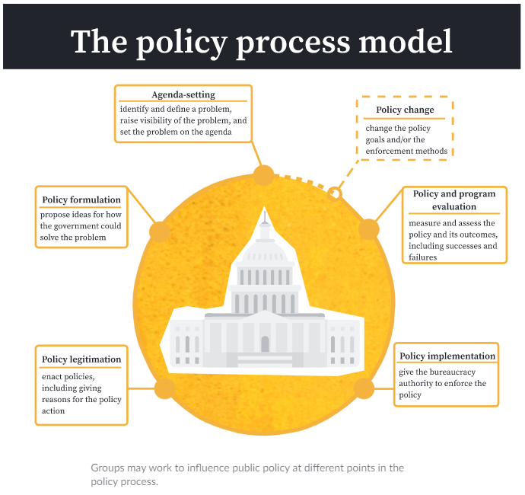

TYPES OF INTEREST GROUPS: BUSINESS
Interest groups can be classified according to the groups that they represent. How do they try to impact society and policy making?

Most interest groups are founded based on e___________ interests. Among those groups, are those representing business, labor, agriculture, and certain professions
Trade Associations- created to protect business interests.
- National Restaurant Association,
- American Trucking Association,
- National Cable Telecommunications Association,
- Business Roundtable and some of the biggest hitters out there are part of the group. CEOs from Amazon, Apple, and General Motors are members. This gives the group a lot of clout in addition to power.

TYPES OF INTEREST GROUPS: LABOR
Samuel Gompers- founder of the American Federation of Labor- to protect worker’s rights. Later merged with Congress of Industrial Organizations- The AFL-CIO. At one point in time, the largest labor union in USA.
UAW- United Auto Workers
International Brotherhood of Teamsters

What three things do labor unions want for their members?

TYPES OF INTEREST GROUPS: AGRICULTURAL GROUPS
Oliver Hudson Kelley- The Grange. Formed to address farmers concerns, especially against the railroads.
The Farm Bureau
National Farmers Union

Interest groups can be classified according to the groups that they represent.
How do they try to impact society and policy making?
What is a single-issue interest group?

- Groups that form to address a narrow area of concern or simply focus on o___ topic.
- Goal is to get government action on one overriding issue.

What is an ideological interest group or social movement?
Groups that form around a particular political ideology.
Goal is to bring about change in society, such as the C___________ R__________ Movement or the Environmental Movement; these groups support policies and elected officials that align with their beliefs.
Examples: NOW, NAACP, ACLU

What is a protest movement?
Groups that form out of p____________.
Goal is to b__________ a_____________ to a s___________ p__________ through public demonstrations or other forms of direct action. Examples: BLM, Occupy Wall Street.

TYPES OF INTEREST GROUPS: SOCIAL MOVEMENTS INTERESTS

Social Movements Interests from American History
The Progressive Era 1890-1920
Progressive Era Amendments:
16th Amendment- income tax
17th Amendment- direct election of senators
18th Amendment-_________________________________________________________
19th Amendment- granted women the right to vote

Civil Rights – NAACP – used litigation to end separate but equal
Martin Luther King- Southern Christian Leadership Conference- used civil disobedience to garner national attention to the plight of African Americans in the south
Environmental Movement
Congress passed the first Clean Water Act and Clean Air Act, respectively, in part through the efforts of the environmental groups.

Consumer Movement
Ralph Nader emerged as America’s chief consumer advocate. He published Unsafe at Any Speed, an exposé of the industry, especially General Motors’ (GM) sporty Corvair AMSCO pg. 571
INTEREST GROUP VS. SOCIAL MOVEMENT
Interest groups voluntarily association of people who come together with the goal of getting the p______ that they favor enacted
Social movements diffuse (spread out, not concentrated) groups that e________ the public and put pressure on policymakers an effort to bring about so s___________ change
TYPES OF INTEREST GROUPS: INSTITUTIONAL GROUPS
Intergovernmental lobby are g______________ institutions and their e______________—police, firefighters, EMTs, sanitation workers, and others—who have a keen interest in government rules and regulations that affect their jobs and funding that impacts their salaries.
Professional associations are concerned with business success and the laws and practices that guide their trade.
Think tanks are research institutions, often with specific ideological goals in mind to influence policy.

TYPES OF INTEREST GROUPS: PUBLIC INTERESTS GROUPS
Public Interests Groups- is an organization that works or the best interests of the o___________ community, rather than the n______________ interests of one segment. It seeks policies that benefit all or most people, whether or not they belong to or support the organization.
Common Cause- is an organization fighting for an a______________ government, equal rights/opportunities/representation and empowering voices to be heard.
League of Women Voters- We empower v_________ and defend democracy through advocacy, education, and litigation, at the local, state, and national levels.
Public Citizen, Inc.-is a nonprofit c_____________ advocacy organization that champions the public interest – your interests – in the halls of power. Ex. Safety in medical devices.
THE INFLUENCE OF LOBBYISTS
WHAT IS LOBBYING?
- Attempting to i_______________ the decisions of p______________________.
- Interest group lobbying is generally most e_______________ on n____________ technical issues that are not well publicized (nobody has expertise on the issue except for the lobbyist)
WHO ARE LOBBYISTS AND WHAT DO THEY DO?
- A person who is employed by and acts for an organized i____________ group or corporation to try to i_____________ policy decisions and positions in the e______________ branch (bureaucratic agency) and l____________ branch (congressional committee)
  - I______________ governmental decisions, especially legislation
  - Provide i_________________ to government (Lobbyist = policy specialist, congressman = policy generalist)
  - T______________ at hearings
  - Help w____________ legislation
- The r_______________ door is the employment cycle from government to interest group
  - Government employee to lobby the agency they came from is illegal –> conflict of interest
  - Congress to lobbyist is legal (with a “cooling off” period)

EXPLAIN WHY LOBBYISTS ARE GOOD FOR AMERICA? | EXPLAIN WHY LOBBYISTS ARE BAD FOR AMERICA?
- They provide useful i________________ to government  - They provide a means of p_____________ (l_______________) for people  - They provide a means of representation on the basis of i______________ rather than g______________. A “third house of Congress.”  - _______ Amendment protection  - Lobbyists have always s__________ money. It’s more out in the open.  - As Madison points out in Federalist #______, the “remedy” of curing the evils of faction by eliminating their causes is w________ than the disease. Potential loss of l________ is worse than the a__________ of lobbyists. | - Rich and powerful interests are o_________ represented.  - Average and poor people are u__________ represented.  - By safeguarding, l_____________, equality is sacrificed.  - Single-issue lobbies, especially, contribute to political polarization.  - Lobbies contribute even further to diffusion of power, making it even m_________ d_____________ for govt. to get things d____________.

LOBBYING BY INTEREST GROUPS
Interacting with government officials in order to advance a group’s public policy goals (done to all branches)
Legislative – influence legislation
- Congress is a target for lobbyists
- Strategies:
» Contact members or their staff
» Prepare research reports and briefs to bring more attention to issue
» D_________ bills and lobby to have them introduced
» Provide useful and timely i________________
Executive – how laws are implemented
  - When establishing rules and procedures, bureaucratic agencies generate data and hire experts
  - Aide in the creation of regulation, just like policy
Judicial – how laws are interpreted
- File lawsuits
» Brown v. Board of Education
» NAACP attempted to end legal segregation
- When n________ party to a case, can file a__________ c____________ briefs (attempt to p______________ the Court to agree with the arguments set forth in the brief- written arguments for a court case presented to the judges of the court)
- I_________________ judicial appointments
- Lobbyists provide useful k_________________ and access( linkage) to those in government
- Lobbyists have greater access to policymakers than average citizens

THEORIES OF INTEREST GROUP FORMATION
Three main theories explain the impact of groups on the political process, all seek to control the
policy agenda: _____________________________________________________________________________________
- Participatory democracy - theory that believe that citizens impact policymaking through their involvement in civil society
- groups outside the government that advocate for policy
- Pluralist theory- political power is distributed among many competing groups, which means that no one group can grow too powerful
- Elite theory a theory that the wealthy elite class has a disproportionate amount of economic and political power

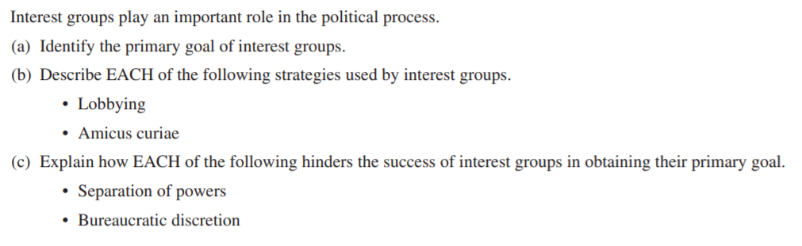
FRQ PRACTICE 172

