**Chpt. 11 The Great Depression**

* Economies historically pass through good and bad periods that regularly repeat themselves.
* 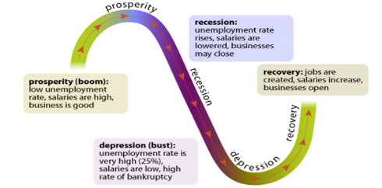These ups and downs are referred to as the **___________ ______________.**
* The bad times are called a **______________** – these usually include:
  + Business failures
  + High unemployment
  + Falling prices

The good times are called **economic boom- a period of general p_____________.**

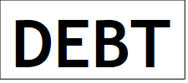The Great Depression was the worst in our nation’s history!

**Causes of the Great Depression**

1. **Overproduction/ Under consumption**

* The 1920s saw a rapid economic expansion as manufacturers made and sold new products like cars, radios, refrigerators and numerous other consumer items. **Economic Boom**
* By the end of the 1920s many consumers lacked the money to buy all these new products.
* Manufacturers were soon producing ________ goods than they could sell, no matter how low they priced their goods.

|  |  |
| --- | --- |
| **The __________ _________’s “Easy Money” Policies** | **Overconsumption** |
| During the 1920s, the ***F______ R_______*** kept \***i_______ rates** low, which encouraged borrowing.  *After the stock market crash, the Fed suddenly TIGHTENED the money supply.*  *\*the cost of borrowing money* | Consumers borrowed money to pay for new appliances and other consumer goods, purchasing these items on the installment plan.  *Buy on credit. Buy now pay later* |

By the late 1920s, consumers had so much debt that they could no longer pay for expensive consumer goods, which lowered demand. This resulted in **overproduction**, lower prices and resulted in decreased profits for companies.

1. **Tariffs on International Trade**

The government also passed **________** (a tax on goods imported; customs duties) making foreign imported goods more expensive. **Smoot-Hawley Tariff Act (1930)**

Foreign nations retaliated by passing tariffs on American made goods imported into their nations making US made goods more ____________. It became a ____________ war.

The effect was that it made it harder for U.S. businesses to sell their products to other nations. This shrinking of world trade contributed to the Great Depression.

**GDP=C+I+G+(X-N).** This formula calculates GDP- the total value of all goods & services produced by the economy in a year. **Gross Domestic Product= Consumption Spending + Investment Spending + Government spending+ (Exports-Imports)**. The overall size of the American economy, measured by gross domestic product, sharply declined following the crash on Wall Street—from **$103.6 billion** in 1929 to **$66 billion** in 1934. The economy lost nearly half of its value.

1. **Stock Market Speculation:** ***Buying on Margin***

In the 1920s, stocks could be purchased for a 10% down payment called buying on m__________- borrow money to buy stock. The rest of the price of the stock was financed by a **loan** from a **stock_______** or a **bank**.

1. **Shaky Banking Methods**

|  |
| --- |
| **Stock Market SPECULATION** |
| This speculation caused the price of stocks to rise higher and higher each day as more people invested in Wall Street.  By 1929 the price of stocks had tripled since 1920. This is known as a stock market b_________. And it was about to pop. |

Most banks in the 1920s were honest and followed good banking guidelines, however there were some who invested their depositor’s money in unsound investments such as ***speculating*** in the stock market.

|  |
| --- |
| **5. Stock Market SPECULATION** |
| **SPECULATION:**  **Buying on the ______________**  *(Borrowing $$$ to buy stocks)* |

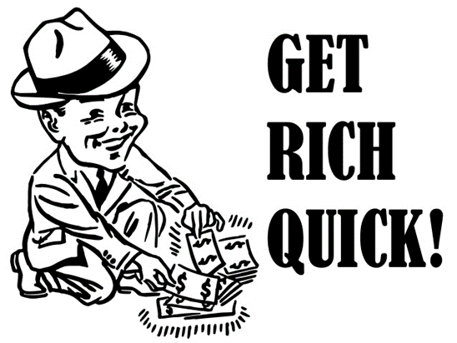

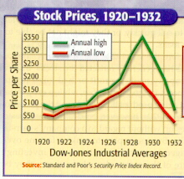

**Brace for Impact**

**The national economy goes up and down like a roller coaster over time**

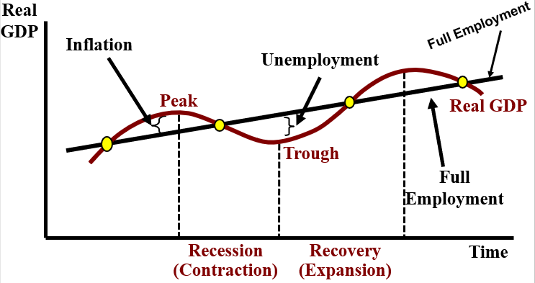

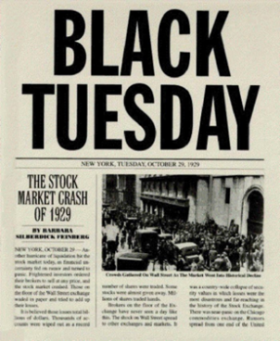6. **The Stock Market Crash-**On October ____, 19_____ aka **Black** __________, the stock market crashed. As stock prices dropped, people couldn’t pay back their loans and frantically tried to sell their stocks driving the price of stocks down

**Bull Market**- a stock market in which stock prices are steadily _______________.

******Bear Market**- a stock market in which stock prices are steadily ______________.

The stock market, as measured by the Dow Jones Industrial Average, had been increasing until that time but then decreased by 48 percent in less than 2.5 months. The value of the stock market is a measure of the value, in the minds of investors, of all the firms in the economy. As the economy (GDP) declined, so did the value of stocks.

**Effects of the Stock Market Crash**

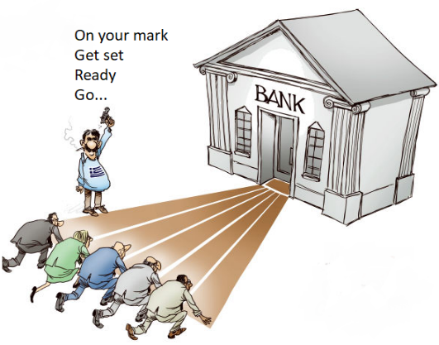**Bank Failures**

Banks that had made bad loans on risky stocks & were losing money.

People panicked and took their money out of the banks, this only made things worse for the banks.

These **__________ runs** forced many banks to close their doors as they ran out of depositor’s money.

**GNP-** Gross National Product- total value of all goods and services produced by the economy in one year. (This includes US investments income from abroad but not income earned by foreign investments in the USA)

**GDP-** Gross Domestic Product- the total value of all goods and services produced by the economy in one year.

**What happened to both GNP and GDP in the USA during the Great Depression? ____________________________________.**

During the early 1930s a severe **___________** (a long period without rain) hit the **Great Plains** region.



**Dust Bowl**

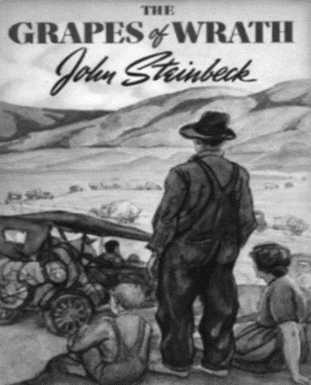**Farm Economy *COLLAPSES*** “O______” migrate to California looking (unsuccessfully) for work.

**Documenting the Dust Bowl**

Dorothea L_____“Migrant M______” famous photo during the Great Depression. Most used on EOC test

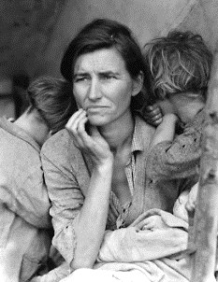

**John Steinbeck** wrote *“_____________________”* telling the story of Okies as they became migrant workers in California.

**Pres. Hoover Fails to Halt the Depression: Too Little, Too Late**

During the early years of the Great Depression the government did not give **direct __________**. **(cash or food directly to the poor). No welfare.** It should be left up to the states and charities.

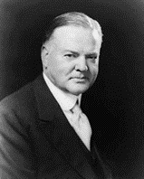

**INEFFECTIVE**

Despite rising unemployment, **Pres. Herbert Hoover** refused to get the government involved.

Hoover remained true to the idea of a **__________-faire** economy or limited government involvement in the economy. He believed that charities, states gov and local gov should help the individua but the federal gov should not.

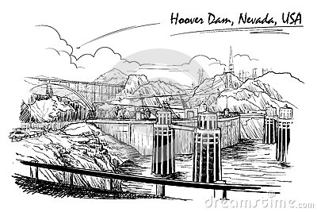Hoover feared government intervention would reduce the incentive to work and undermine **‘r__________ individualism’** that he believed had made America great.

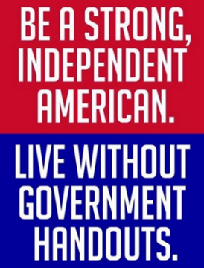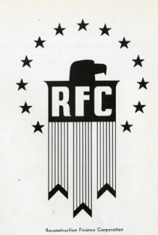

RFC-provided loans to banks & businesses but **NOT** to individuals

**Hoover’s Early Steps**

Hoover cut ____________, created a federal agency to buy excess farm crops, and increased federal spending on public projects like ____________ ***Dam***.

(1932) Hoover also established the ‘**Reconstruction ___________ Corp**.’ (**RFC**) that gave emergency loans to banks and businesses hoping to increase business (but not to the public).

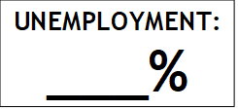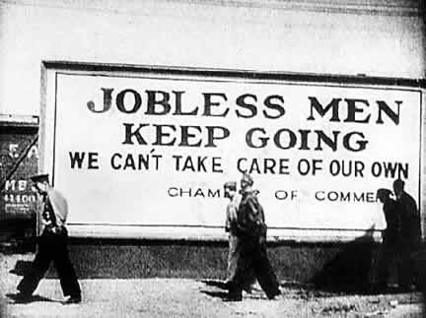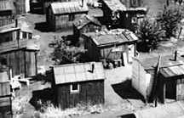**Public Frustration Grows**

“_________________” became a symbol of most Americans’ lack of confidence in Hoover’s leadership.

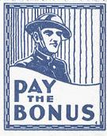

In 1932, a group of World War I veterans known as the   
  
“B___________ Army” marched on Washington to demand an early payment of their “Bonus,” or veterans pensions that were due to be paid in 1945.

The U.S. Army attacked the Bonus Army with cavalry, tanks, and gas, furthering the impression that Hoover was callous toward those who were suffering during the Depression.

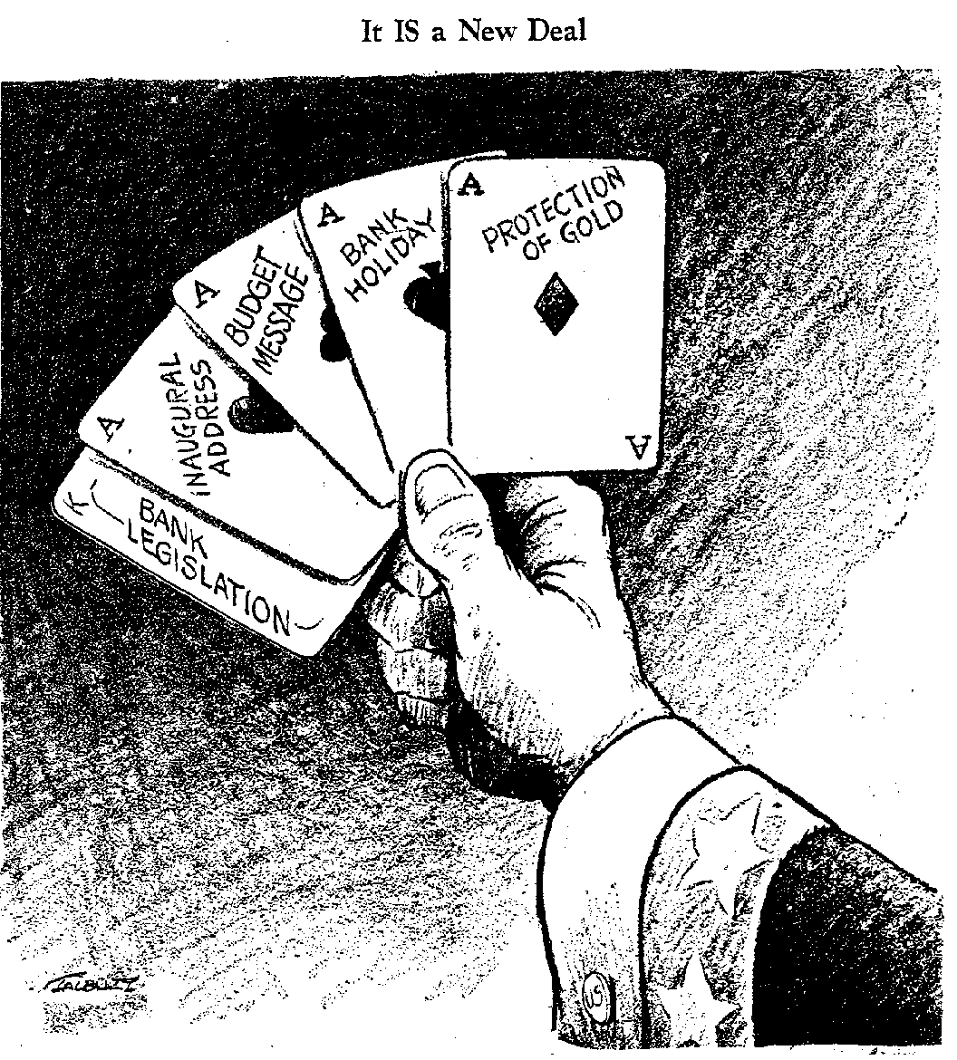**Franklin Delano Roosevelt “FDR” 19____- 19_____**

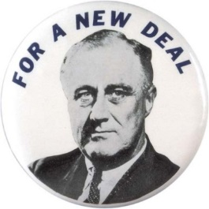FDR and his “**Brain Trust**” (his advisors) had a plan to end the depression and put the American people back to work, FDR called it the N________ D_______.

FDR was President from 1933-_______

In FDR’s 1933 inaugural address he reassured the American public with his famous quote: “we have nothing to f______ but f_______ i_______”

In the f_____ h_________ d______ of office FDR was able to get Congress to pass many new l_______ he proposed. It’s the h______________ period.

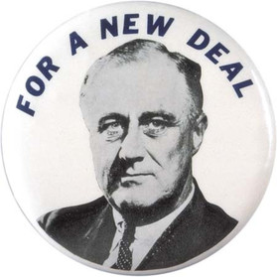FDR explained his New Deal in terms of the Three R’s

**New Deal Legislation: Relief, Recovery, Reform The Three R’s**

**R_______________**

**R_______________**

**R_______________**

The New Deal marked a change away from the **laissez-_______** attitude the government had previously taken with the economy.

It established the idea that the g__________ was r__________ to make sure the e____________ ran smoothly.

***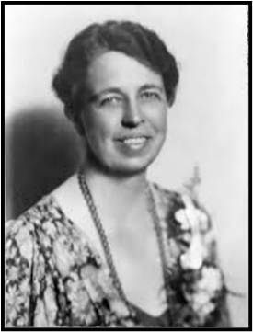*The New Deal permanently increased the size and p___________ of the federal government!**

**FDR a New Style of Leadership**

FDR used the **r_________** to speak directly to the American people in his ‘f_________ chats’.

***When FDR was 39, he was struck by p________, and he was unable to walk by himself.***

FDR’s wife **E____________**, served as his eyes and ears by traveling the U.S. in his place.

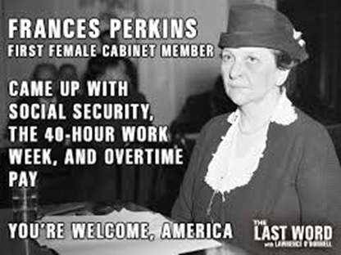F________ P_________ the 1st female member of the US cabinet served as Secretary of L__________.

*Eleanor Roosevelt*

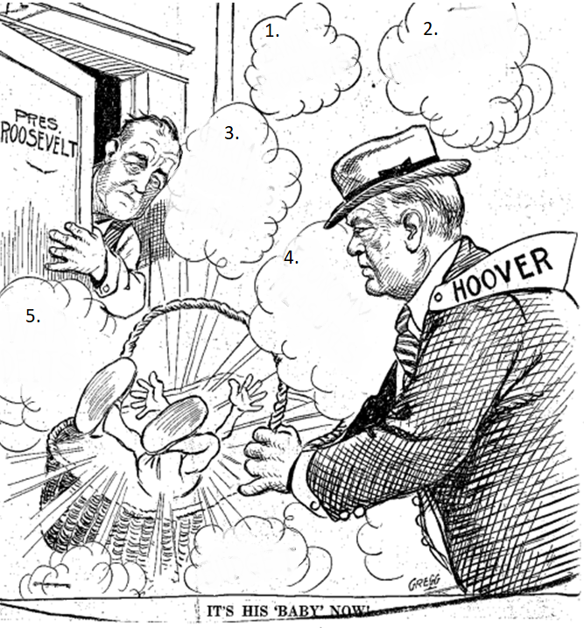**Problems Facing the Nation in 1933 (Gateway book pg. 231-32)**

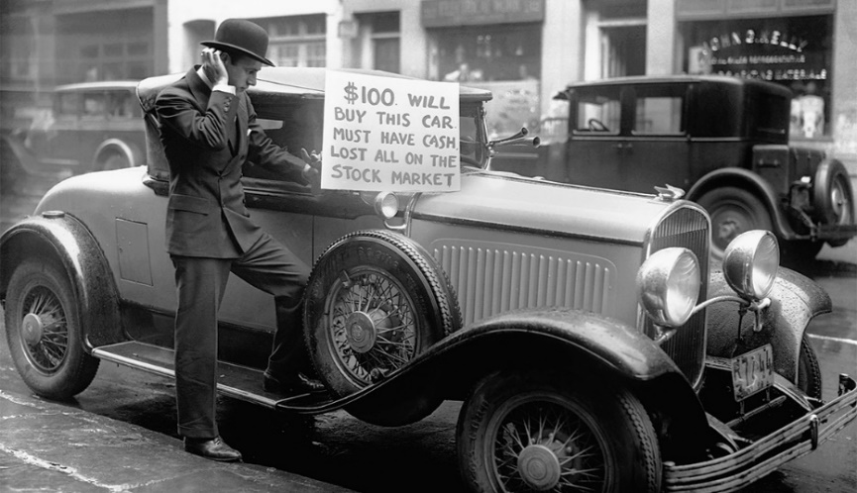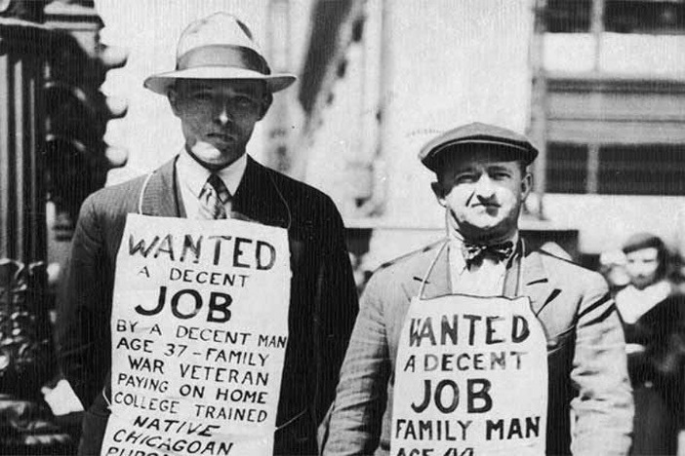

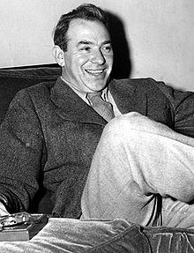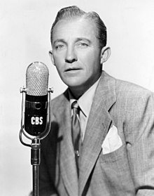**Brother Can You Spare a Dime?** Lyrics byYip Harburg, Performed by Bing Crosby 1932

They used to tell me I was building a dream   
And so I followed the mob  
When there was earth to plow or guns to bear  
I was always there right on the job

They used to tell me I was building a dream  
With peace and glory ahead  
Why should I be standing in line  
Just waiting for bread?

Once I built a railroad, I made it run  
Made it race against time  
Once I built a railroad, now it's done  
Brother, can you spare a dime?

Once I built a tower up to the sun  
Brick and rivet and lime  
Once I built a tower, now it's done  
Brother, can you spare a dime?

Once in khaki suits, gee we looked swell  
Full of that yankee doodly dum  
Half a million boots went sloggin' through hell  
And I was the kid with the drum

Say, don't you remember, they called me Al  
It was Al all the time  
Why don't you remember, I'm your pal  
Say buddy, can you spare a dime?

Bing Crosby

Yip Harburg

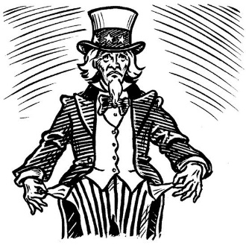

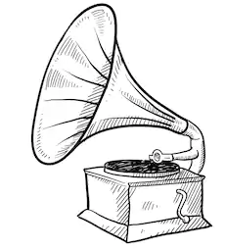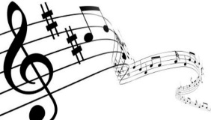

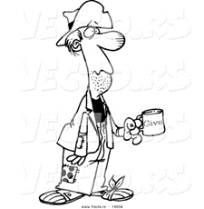

**Relief: #1 The Banking Crisis**

* FDR addressed financial panic- the bank runs- by ordering the closure of all banks & puts them on a b________ **h__________** for 3 days. During which time bank inspectors would certify banks health and would re-open those with solid financial standing.
* Bank closings soon decreased. As confidence was slowly restored.

Starting with the bank holiday, FDR used “_____________ chats,” radio addresses that he used to explain his plans to the people in plain language.

**Relief: The Unemployed**

* + **Federal Emergency Relief –**_________________________________________________
  + **Civilian Conservation Corp.** – _______________________________________________
  + **Public Works Admin.** – ____________________________________________________
  + **The 2nd New Deal- Works Progress Admin.** ____________________________________

**Programs like the CCC, PWA, WPA, were called the *______________ Soup Laws***

**Agriculture Adjustment Act- meant to help the f______________**

**Work Progress Administration (WPA)- created j______** for artists, writers, musicians, photographers, etc.

**Recovery: Priming the Pump- Get the Economy Working Again**

FDR felt the way to recovery was to stimulate demand for goods by putting money in the hands of the people in need by increasing government spending through public works projects-roads, bridges, etc.

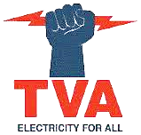**T__________ V________ A_________-** Government owned dams to generate electricity. Controlled flooding and produce fertilizer.

To generate electricity at a low cost to encourage business investments in a very poor area.

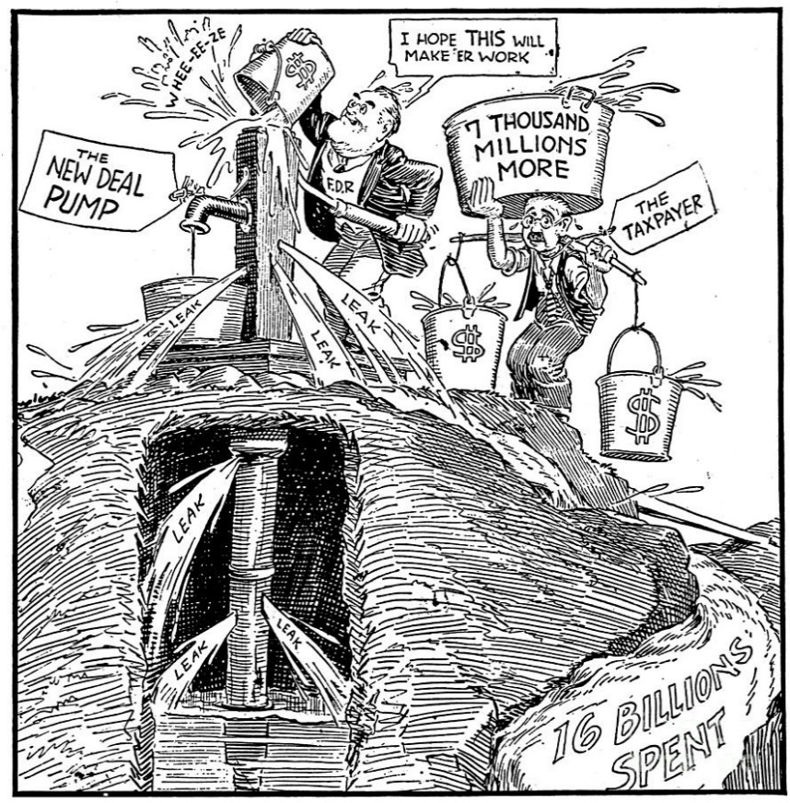**What criticism does this cartoon make of the New Deal?**

**Primming the Pump**



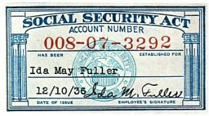



**Reform:**

**Glass-Steagall Act- _______________________________________________________________________**

**Federal Deposit Insurance Corp. – _________________________________________________________  
______________________________________________________________________________________**

**(1935) Social Security Act - ________________________________________________________________**

**_______________________________________________________________________________________**

**Security & Exchange Commission- __________________________________________________________**

**National Labor Relations Act (Wagner Act)- ___________________________________________________**

**Indian Reorganization Act 1934 (**Indian [New Deal](https://en.wikipedia.org/wiki/New_Deal)**)-** fostered the preservation of I________ culture. The major goal was to r___________ the traditional goal of a___________ of Indians into American society

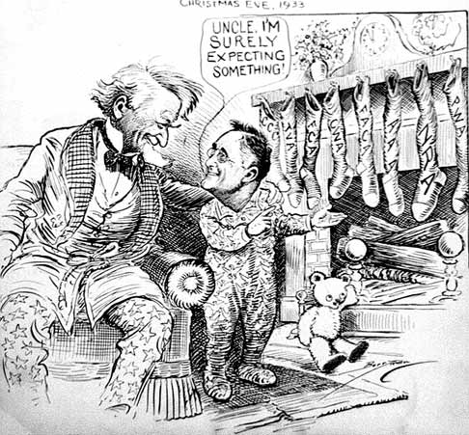

**The artist was trying to convey the message that FDR wanted to get many different things done in a short period of time. He also leans toward the idea that it isn’t possible to get such a massive amount of relief and legislation passed that quickly. In order for it to be done you would need “magic” or some other worldly force. This is shown by the iconic image of a child putting out a stocking over the fireplace at Christmas in the hopes for some treat to be delivered by Santa overnight. On the stockings themselves, are many different agencies that FDR created to provide jobs, such as the: CCC, TVA, FCA, TWA etc. It can be interpreted that these programs were the primary ideas to get America back on its feet. The “gifts” that would be received would hopefully make everything return to normal, and get America back to its former glory. FDR is the child and he seems to be reassuring “Uncle Sam” that everything will be okay in the end because his New Deal will work.**

|  |  |
| --- | --- |
| **From the “Left”** | **From the “Right”** |
|  |  |

**Criticisms of the New Deal** (Gateway book pg. 236)

__________________ – ‘The Kingfisher’ ran for president promising each American family $5,000 a year paid by taxing the rich, he was later assassinated before he ran.

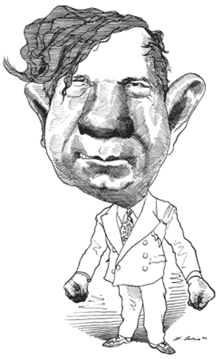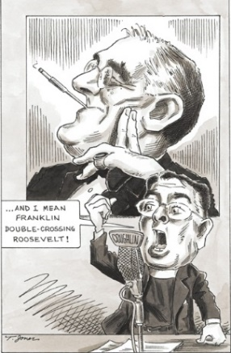Father ________________ – Catholic priest who gave radio speeches that were popular with nativists who distrusted Wall St., were anti-Jewish, and wanted the government to take over the banks and utilities company.

**Father Coughlin**

**Huey Long**

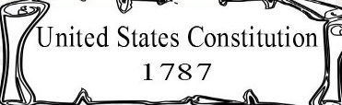**The Supreme Court and the New Deal**

****C:\Users\Tom\AppData\Local\Microsoft\Windows\Temporary Internet Files\Content.IE5\G001CGDR\MC900383446[1].wmfSupreme Court decision **“Schechter v. U.S.”** said Congress could not give the President more p____________ than those granted in the C___________.

In response to the Supreme Court’s ruling, FDR presented a plan to Congress to p______________ the Supreme Court, which would have allowed the president to appoint more justices to the Court. This plan undermined the system of c________________ and b_______________ that are enshrined in the U.S. Constitution. Congress rejected the “court packing” plan, handing FDR his first major legislative defeat.

**Pack(ing)**

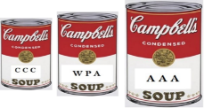

**FDR’s Alphabet Soup** (New Deal Agencies created by the FDR administration)

|  |  |  |  |  |
| --- | --- | --- | --- | --- |
| **http://www.fairloanrate.com/wp-content/uploads/2010/12/fdic-insured-banks-300x141.png** | **Name:** ____________________________________________ **(FDIC)**  **Purpose:** | | | |
| **AAA** | **Name:** Agricultural Adjustment Administration **(AAA)**  **Purpose:** | | | |
| **http://upload.wikimedia.org/wikipedia/commons/3/3b/NewDealNRA.jpg** | **Name:** National Recovery Administration **(NRA)**  **Purpose:** | | | |
| **SEC** | **Name:** ____________________________________________ **(SEC)**  **Purpose:** | | | |
| **http://1.bp.blogspot.com/_aP2GN0yCuO8/SEmngIUR8LI/AAAAAAAAAk0/6Djyv48Qhpg/s400/tva+power+fist.gif** | **Name:** ____________________________________________ **(TVA)**  **Purpose:** | | | |
| **CCC** | **Name:** Civilian Conservation Corps **(CCC)**  **Purpose:** | | | |
| **SSA** | | **Social Security Administration** | **NLRB** | **National Labor Relations Board** |
|  | | |  | |

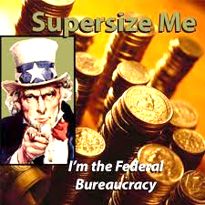**The Impact of the New Deal Reforms**

Under FDR’s New Deal the **p_______** of the **f__________ government** increased dramatically.

The federal government went from a **r____________** role to one of taking **r_______________** to make sure the economy ran smoothly & efficiently.

**US and Latin America in the 1930s**

It would finally take the massive spending of our involvement in what would become W______ W___ II to finally end the Great D______________.

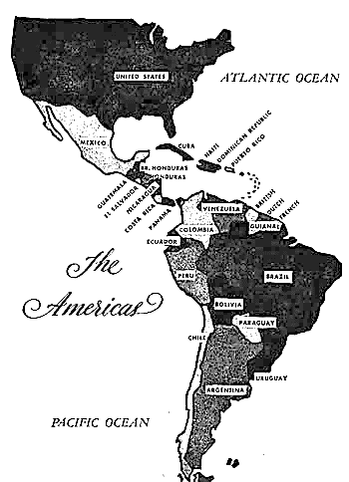**1930s US Foreign Policy Towards Latin America**

|  |
| --- |
| **The “Good __________________ Policy** |
| In the 1930s, the U.S. attempted to cultivate a better relationship with **Latin America** and get rid of the legacy of resentment from the days of U.S. imperialism. |

**Compare and Contrast; Continuity and Change**

**TR’s Foreign Policy in Latin America**

**William H. Taft**

**Woodrow Wilson**

**EOC Practice**

1. Breadlines, Hoovervilles, and the Bonus Army were all direct results of

(1) housing shortages in the 1920s

(2) relief efforts of the New Deal

(3) mechanization of agriculture

(4) unemployment during the Great Depression

2. Which economic factor contributed most directly to the start of the Great Depression?

(1) low worker productivity

(2) high income taxes

(3) decreasing tariff rates

(4) buying stocks on margin

3. What was a guiding principle of the New Deal economic policies?

(1) Pro-business tax breaks would solve the problems associated with urban poverty.

(2) Antitrust legislation would destroy the free market economy of the United States.

(3) Rugged individualism must be allowed to solve social inequality.

(4) Government must assume more responsibility for helping the poor.

4. The Civilian Conservation Corps (CCC) and the Works Progress Administration (WPA) were both New Deal programs developed to address the problem of

(1) excessive stock market speculation (3) increased use of credit

(2) high unemployment (4) limited income of senior citizens

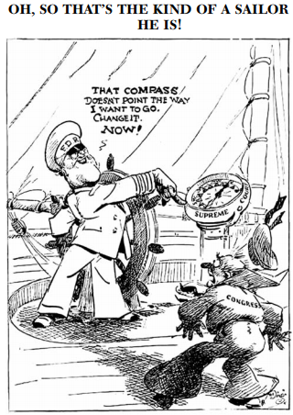

5. The cartoon illustrates President Franklin D. Roosevelt’s dissatisfaction with

(1) Congress leading the nation into World War II

(2) Congress resisting proposals to strengthen the navy

(3) New Deal programs being declared unconstitutional

(4) being unable to appoint minorities to the Supreme Court

. . . The ever-growing complexity of modern life, with its train of evermore

perplexing and difficult problems, is a challenge to our individual characters and

to our devotion to our ideals. The resourcefulness of America when challenged

has never failed. Success is not gained by leaning upon government to solve all the

problems before us. That way leads to enervation [lessening] of will and destruction

of character. Victory over this depression and over our other difficulties will be won

by the resolution of our people to fight their own battles in their own communities,

by stimulating their ingenuity to solve their own problems, by taking new courage

to be masters of their own destiny in the struggle of life. . . .

— President Herbert Hoover, February 12, 1931

. . . I am prepared under my constitutional duty to recommend the measures that

a stricken Nation in the midst of a stricken world may require. These measures, or

such other measures as the Congress may build out of its experience and wisdom,

I shall seek, within my constitutional authority, to bring to speedy adoption. . . .

— President Franklin D. Roosevelt, March 4, 1933

6. Which idea would best be supported by President Hoover’s statement?

(1) rugged individualism (3) deficit spending

(2) unemployment insurance (4) collective bargaining

7. These statements illustrate a difference in opinion between the two presidents over

(1) granting subsidies to big business

(2) promoting free-trade policies in the Western Hemisphere

(3) regulating supply and demand

(4) expanding the federal government’s role in the economy