Unit 3 Chpt. 10 Topic 3.7-3.9 Due Process AMSCO pg. 312-34
3.7 Selective Incorporation
Protections of the Bill of Rights have been selectively incorporated by way of the 14th amendment’s d_____ process clause to prevent state i____________ of b_______ liberties.
Explain the implications of the doctrine of selective incorporation.
The doctrine of selective incorporation has imposed l_________ on s________ regulation of civil r______ and l________ as represented by McDonald v. Chicago (2010), which ruled the Second Amendment’s right to keep and bear arms for self-defense in one’s home is applicable to the s_________ through the ________ amendment.

BILL OF RIGHTS AND THE STATES
BILL OF RIGHTS
- Added to the original Constitution to a____________ states. Demanded by the Anti-F______________
- Rights of the i________________ and states listed to protect them from the f______________ government
- Bill of Rights o________ applied to the f___________ government and did not include protections against s_________ governments (Barron v. Baltimore, 1833)
– Belief was that people could protect themselves against the state governments that were in their own backyards, but they needed additional protection against a new, powerful, and distant national gov’t. Each state had its own state constitution and state bill of rights to protect their citizenry from the state government.
SELECTIVE INCORPORATION OF THE BILL OF RIGHTS
- The B ____of R_______ only apply to n_________ (f_________) government… NOT the states –Barron v. Baltimore (1833)
- 14th Amendment: created the possibility that the B of R would apply to the s_________
14th Amendment: All persons b_______ or n____________ in the United States, and subject to the jurisdiction thereof, are c___________ of the United States and of the state wherein they reside. No s__________ shall make or enforce any law which shall a__________ the privileges or i_____________ of citizens of the United States; nor shall any s_________ d__________ any person of l______, l__________, or p____________, without d_______ p_________ of l_______; nor deny to any person within its jurisdiction the e_________ p____________ of the l_________.
SELECTIVE INCORPORATION OF THE BILL OF RIGHTS
DOCTRINE OF INCORPORATION constitutional doctrine through which the first t______ a___________ of the United States Constitution (known as the B_____ of R________) are made applicable to the states through the D_______ Process clause of the Fourteenth Amendment. I________________ applies both s________________ and p_______________.
SELECTIVE INCORPORATION: A constitutional doctrine through which the Bill of Rights are made applicable to the states through the Due Process clause of the Fourteenth Amendment and so applied to state and local governments.
Utilizing the language of the Fourteenth Amendment, specifically that “no state…shall a________…d________ p________ of law,” the n___________ government now serves as p___________ of our inalienable right to “life, liberty and property.” Most of the time this has resulted in the n___________ government i__________ its w_________ on s_________ and l_______ laws to the contrary.
The Fourteenth Amendment has weakened the states and strengthened the national government in our federal system of government.
Explain how has the 14th amendment impacted federalism? _______________________________________________
__________________________________________________________________________________________________
Modifying Effect of the 14th Amendment
- The d_____ p___________ clause has been used to apply some of the provisions of the B______ of Rights to the s______.
- This clause bans s_______ from denying l______, l_________, or p___________ without d_____ process of law.
- The “total i_____________” view would apply a_____ of the provisions of the B________ of Rights to the s______. It argues for n_____________ (or f_____________) of the Bill of R___________.
- The “s_____________ incorporation” view would apply only s_________ of these provisions and would do so on a c_________- by-c________ basis.
Utilizing the language of the Fourteenth Amendment, specifically that “no state…shall abridge…due process of law,” the n____________ government now serves as p____________ of our inalienable right to “life, liberty and property.” Most of the time this has resulted in the n___________ government imposing its w_______ on state and local laws to the contrary.
The F____________ Amendment has w___________ the states and strengthened the national government in our f____________ system of government.
Modifying Effect of the 14th Amendment
- Subsequent cases federalized parts of the Bill of Rights:
  - 1st – Freedom of Speech, Assembly, Petition, Religion
  - 2nd – Right to Bear Arms
  - 4th – Search and Seizure protections
  - 5th – Self-Incrimination, Double Jeopardy
  - 6th – Right to Counsel, Right to Bring Witnesses, Right to Confront Witnesses
  - 8th – Protection against Cruel and Unusual Punishment, Excessive Fines

The 14th amendment was created to p_________ the rights of the newly freed people from the states. It bestowed upon them US citizenship and full guarantees of the Bill of Rights. It was done to stop the J_______ Crow/ black c_______ of the post-civil war period. 14th am planted the seeds of the Civil Rights Movement

McDonald v. Chicago (2010)-SUPREME COURT YOU MUST KNOW
Issue: Does the Second Amendment right to keep and bear arms apply to state and local governments through the 14th Amendment and thus limit Chicago’s ability to regulate guns?
Majority: 2nd Amendment right to keep and bear arms for the purpose of self-defense is fully applicable to the s________ under the ____th Amendment. The Court considered whether the right to keep guns “is fundamental to our scheme of ordered liberty and system of justice.” The Court determined that both the Framers of and those who ratified the 14th Amendment considered the right to keep and bear arms among the f________________ rights “necessary to our system of ordered liberty.” S_______-defense is a basic right, and that, under Heller, individual self-defense is the central component of the S____________ Amendment right to bear arms.

The debate over the Second Amendment involves concerns about public safety and whether or not the government regulation of firearms promotes or interferes with public safety and individual rights.
Supreme Court: “Undoubtedly some think that the Second Amendment is outmoded in a society where our standing army is the pride of our Nation, where well-trained police forces provide personal security, and where gun violence is a serious problem.
That is perhaps debatable, but what is not debatable is that it is not the role of this Court to pronounce the Second
Amendment extinct.” -Justice Alito
- What was the significance of the ruling in McDonald v. Chicago?

- Have recent Supreme Court decisions on the Second Amendment leaned more toward individual liberty or public safety?

3.8 Amendments: Due Process and the Rights of the Accused
FOURTH AMENDMENT RIGHTS
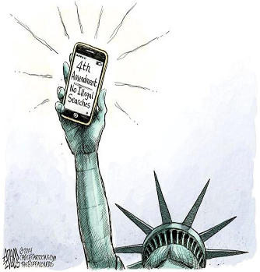
“The right of the people to be secure in their persons, houses, papers, and effects, a_________ u__________ s___________ and s____________, shall not be violated, and no Warrants shall issue, but upon p__________ cause, supported by oath or affirmation, and particularly d________ the place to be s________, and the p________ or things to be s_______.” -4th amendment US Constitution
Probable cause- sufficient reason based upon known facts to believe a crime has been committed or that certain property is connected with a crime. Probable cause m________ exist for a law enforcement officer to make an a________ without a warrant, search without a warrant, or seize property in the belief the items were evidence of a crime. https://www.law.cornell.edu/wex/probable_cause

The Constitution forbids only "unreasonable” searches and seizures
A police search without consent is constitutionally unreasonable unless it has been authorized by a valid search warrant. There are exemptions as in exigent circumstances.
– Ex: police use of sobriety checkpoints in enforcing drunk driving laws is ALLOWED.

Mapp v. Ohio (1961) - The Supreme Court ruled that evidence obtained unconstitutionally cannot be used in court against person from whom it was seized. EXCLUSIONARY RULE
Adopted mainly to p_____________ p___________ misconduct
- Not used if:
  - There would be“inevitable discovery” of the evidence (Nix v. Williams)
  - Police operate “in good faith” that the warrant was valid (U.S. v. Leon)
  - In plain view

What is reasonable suspicion compared to probable cause?

The Incorporation of the FOURTH AMENDMENT
Which case(s) really brought this amendment into public debate?
Weeks v. United States, 1914
Police officers in Kansas City, Missouri went to the house of Mr. Fremont Weeks and used his hidden key to enter and search his home. While there, they took papers, letters, books, and other items. They did not have a search warrant. These items were used in court to find Mr. Weeks guilty of sending lottery tickets through the U.S. mail.
Supreme Court Decision
The judgment of the district court was reversed. The evidence collected during the illegal search was in violation of the 4th Amendment and was thus inadmissible at the trial. In a criminal investigation, in order for a search to be legal, there must be probable cause. The p___________ cause must be used to gain a search warrant. If not, the search will be illegal, and evidence collected as a result of the search can’t be used in court. The Weeks decision was the birth of a new legal doctrine – The e____________ rule. https://judiciallearningcenter.org/your-4th-amendment-rights/

Rochin v. California, 1952
Rochin was a suspected narcotics dealer. Acting on a tip 3 Los Angeles County deputy sheriffs went to his rooming house. They forced their way into Rochin’s room. There the deputies found him sitting on a bed and spotted two capsules on a nightstand. When one of the deputies asked, “who’s stuff is this?” Roachin popped the capsules to his mouth. Although all three officers jumped him, Roachin managed to have swallowed them.
Deputies took Roach to a hospital, where his stomach was pumped. The capsules were recovered and found to contain morphine. The state then prosecuted and convicted Rochin for violating the state’s narcotics laws.
Did the police procedure forcing Rochin to vomit violate the Fifth Amendment privilege against self-incrimination and the Due Process Clause of the 14th Amendment? Explain
Did the police procedure forcing Rochin to vomit violate the Fifth Amendment privilege against self-incrimination and the Due Process Clause of the 14th Amendment? Explain

The Incorporation of the FOURTH AMENDMENT
Mapp v. Ohio, 1961
Cleveland Police had gone to Dollree Mapp’s home to search for a fugitive. They entered her home forcibly, and without a warrant. Mapp and police got into a scuffle. Their very extensive search failed to turn up any fugitive evidence, but they did find some obscene books . Mapp was convicted of possession of obscene materials and sentenced to jail.
4th Amendment The Fruit Of The Poisonous Tree Doctrine- The Exclusionary Rule
A doctrine that extends the e_________ rule to make evidence i_____________ in court if it was derived from evidence that was i__________ obtained. As the metaphor suggests, if the evidential "tree" is tainted, so is its "fruit."
The Exclusionary rule applies not only to evidence obtain indirectly as a result of improper police conduct but also to evidence obtained indirectly from the improper conduct.
Evidence derived initial improper conduct is usually called F_______ Of The P________ Tree

14th Amendment: All persons b_______ or n____________ in the United States, and subject to the jurisdiction thereof, are c___________ of the United States and of the state wherein they reside. No s__________ shall make or enforce any law which shall a__________ the privileges or i_____________ of citizens of the United States; nor shall any s_________ d__________ any person of l______, l__________, or p____________, without d_______ p_________ of l_______; nor deny to any person within its jurisdiction the e_________ p____________ of the l_________.
14th amendment was meant to protect citizens from the states. Passed in 1868 to protect the newly freed citizens of the Republic, the former slaves.
USA PATRIOT ACT (Uniting and Strengthening America by Providing Appropriate Tools Required to Intercept and Obstruct Terrorism) 2001
The law covered intelligence gathering and sharing by executive branch agencies, points of criminal procedure, and border protection. It also widened authority on tapping suspects’ phones.
- Soon, people began to question the law's constitutionality and its threat to c_________ l_____________.
- Some of the most controversial parts of the Patriot Act surround issues of privacy and government surveillance. The Fourth Amendment to the U.S. Constitution protects the "right of the people to be secure in their persons, houses, papers, and effects, against unreasonable searches and seizures . . . ." It requires law-enforcement officers to obtain w____________ before making most searches.
- Does the government have the right to collect phone and internet data from individuals?
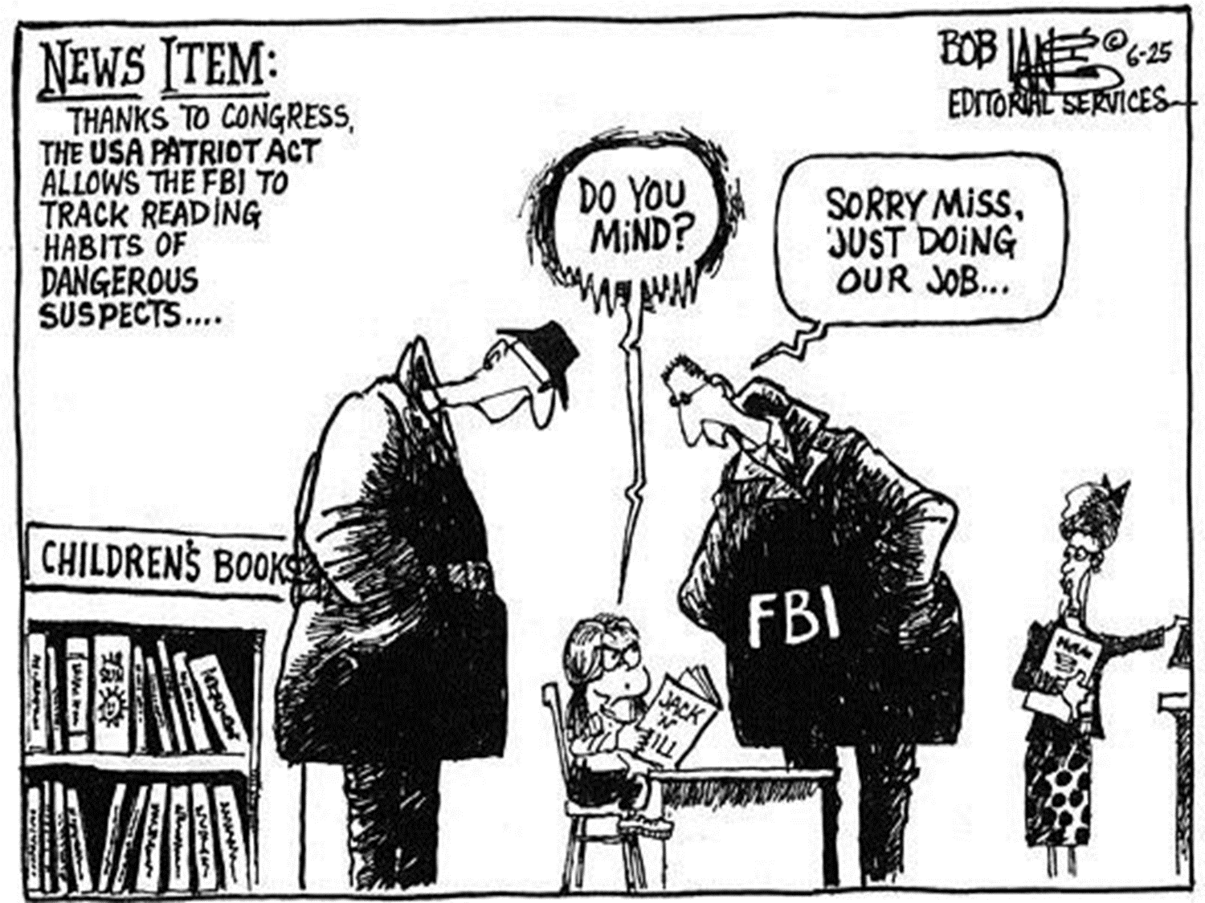
Is metadata collection on the part of the gov allowed without a search warrant? Explain. AMSCO pg. 305

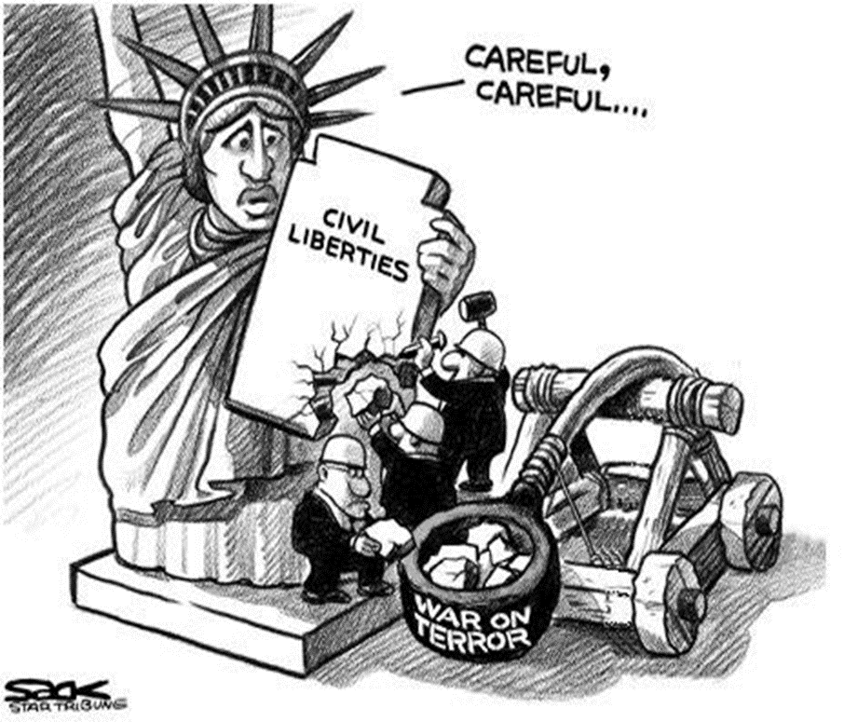
Did the government violate the 4th Amendment with the Patriot Act?

5th Amendment to the US Constitution-Protects us from the federal government.
"No person shall be held to answer for a capital, or otherwise infamous crime, unless on a presentment or i___________ of a g__________ j__________ except in cases arising in the land or naval forces, or in the militia, when in actual service in time of war or public danger; nor shall any person be s________ for the same offense to be t_________ put in j___________ of life or limb; nor shall be compelled in any criminal case to be a w_________ a___________ himself, nor be deprived of l_______, l_______, or property, without d_______ process of law; nor shall private property be taken for public use, without just compensation.“—eminent domain
eminent domain- ________________________________________________________________________________________
_______________________________________________________________________________________________________
FIFTH AMENDMENT RIGHTS – DUE PROCESS RIGHTS
When govt. denies life, liberty or property, it must use f______ procedures:
  - Observe Bill of R_________
  - Provide reasonable n__________
  - Provide chance to be h________
Procedural due process refers to the m__________ (process, the h_______ by which a law is e______________; pertains not to the law itself, but to the w________ in which the law is a___________.
  - Examples of violations of procedural due process:
    - Illegal Searches.
    - Unfair Court Procedures.
- Substantive due process p________ l_________ on what a government may do; pertains to the content (substance, the policies, the what) of the law
  - Examples of violations of substantive due process:
    - Ban on all abortions within a state.
    - County ordinance banning all firearms.
- Example of distinction between procedural and substantive: a law prohibits possession of narcotics (s___________) and police must generally obtain a warrant before conducting a search for narcotics in one’s home (p___________).

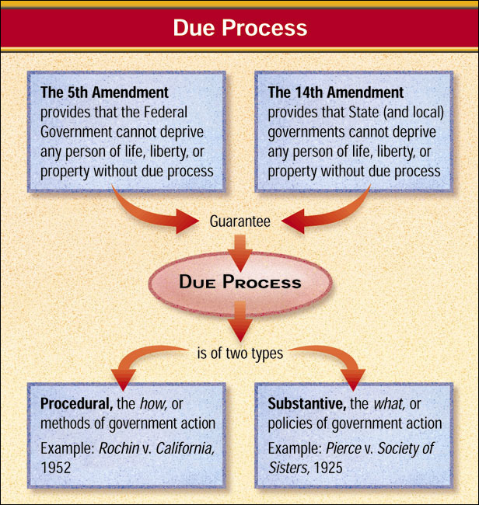
…nor shall be compelled in any criminal case to be a witness against himself…

FIFTH AMENDMENT RIGHTS AND THE MIRANDA WARNING
- Miranda v. Arizona (1966) - Supreme Court announced that no conviction could stand if evidence introduced at the trial had been obtained by the police during "custodial interrogation" unless suspects have been:
  - Notified that they are free to r__________ s_________
  - Warned that what they say may be used a__________ them in court
  - Told that they have a right to have a__________ present during questioning
  - Informed that if they cannot afford to hire their own lawyer, attorneys will be provided for them
  - Permitted to t____________ any stage of the police interrogation

6th Amendment
In all criminal prosecutions, the accused shall enjoy the right to a s______ and p______ trial, by an i________ jury of the S______ and d__________ wherein the crime shall have been committed, which district shall have been previously ascertained by law, and to be i___________ of the nature and cause of the a___________; to be confronted with the w___________ against him; to have c_____________ process for obtaining witnesses in his f_______, and to have the Assistance of C________ for his defense.
SIXTH AMENDMENT RIGHTS – “FAIR TRIAL”
- Right to an a________/counsel/lawyer- all are different terms for lawyers
- Government is obligated to give the defendant a s________ trial
- Government is obligated to give the defendant a p________ trial
- An i__________ jury consists of persons who represent a fair cross-section of the community= jury of your peers
- Defendant has the constitutional right to obtain w_________ in his/her favor
– Constitution gives accused persons the right to be c______________ with the witnesses against them

SIXTH AMENDMENT RIGHTS – “FAIR TRIAL” P_________ Due Process
- The Right to counsel
  - Judges have an obligation to ensure that all persons subject to any kind of custodial interrogation are represented by l____________.
  - Right to counsel extends to all hearings for all offenses for which an accused could be deprived of l__________
  - In G__________ v. Wainwright (1963), the United States Supreme Court ruled that the S______ Amendment right-to-counsel provision applies to those accused of major crimes under state laws and applies to the i____________.
VIDEO: Gideon v. Wainwright (1963)
FACTS:
Decision: | Constitutional Principle:
Why it matters?

Balancing Individual Freedoms with Public Order
What are your rights according to those amendments?
Fourth-
Fifth-
Sixth-
Eighth-
TOPIC 3.9 Amendments: Due Process and the Right to Privacy
Is There a Right to Privacy in the Constitution?
Definition: The right to a private personal life free from the intrusion of government
- N______ explicitly s________ in the Constitution, but implied through the penumbras (implied rights) of the Bill of Rights
- Supreme Court agrees that a right to privacy exist
  - Griswold v. Connecticut (1965)
    - Overturned an 1879 Connecticut law that made the contraceptives illegal to married couples
    - Even though “privacy” doesn’t appear in the Constitution, specific guarantees in the 1st, 3rd, 4th, and 5th Amendments create a zone of privacy that is protected by the 9th Amendment
The right to privacy or to be left alone is not mentioned in the constitution, it can be e can be inferred from the following amendments:
1st amendment: Freedom of s_________ or the p________ of your own t_________ or a_____________ (a______________)
3rd amendment: protects your home from the once used government practice of housing s_______ during peacetime in your house.
4th amendment: protects against i__________ searches, keeping your home or other areas p__________.
5th amendment: gives the accused the right to r_________ s_________ and thus keeping information p_________.
9th amendment: states that the p________ have r________ not s__________ l__________, i.e. p___________.

Video Roe v. Wade (1973)
FACTS:
Decision: | Constitutional Principle:
Why it matters?
A Woman’s right to privacy encompasses a woman’s decision whether or not to terminate her pregnancy
- In the first trimester of pregnancy (about three months), a State must recognize a woman's right to an abortion; it cannot interfere with medical judgments in that matter during that period.
2. In the second trimester, a State, acting in the interest o women who undergo abortions, can make reasonable regulations about how, when, and where abortions can be performed but cannot prohibit the procedure.
3. In the final trimester, a State, acting to protect the unborn child, can choose to prohibit all abortions except those necessary to preserve the li e or health o the mother. 2009 Magruder’s pg. 581
Roe Revisited: Planned Parenthood v. Casey (1992)
The issue: Was the Pennsylvania Abortion Control Act of 1982 constitutional?
- Law required that a woman seeking an abortion meet several conditions
- Would Roe be overturned?
  - No… Justice O’Connor argued that stare decisis (precedent of the Court) required the Court to not overturn Roe.
  - “A generation of women had come to depend on the right to an abortion.”
  - The Court held that states cannot prohibit abortion prior to viability (before the fetus could live independently outside of the mother’s womb).
  - HOWEVER, the Court allowed certain restrictions on abortions
    - States can regulate abortions before viability as long as the regulation does not place an “undue burden” (substantial obstacle) on the access to abortion.
    - After fetal viability, however, states have increased power to restrict the availability of abortions to
protect the health of the woman and the potential life of the fetus.
    - Thus, states can pass some laws that regulate abortion, but these laws cannot place a “substantial obstacle in the path of a woman seeking an abortion.”

Dobbs v. Jackson Women's Health Organization (2021)
Concepts of American Government
Judicial Activism or Judicial Restraint, (stare-decisis)
Federalism
Checks and Balances

