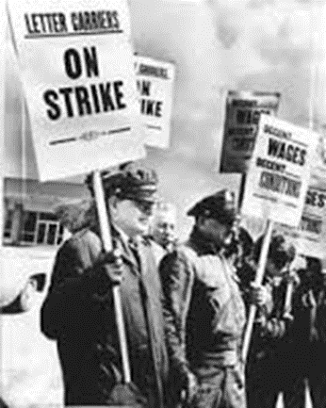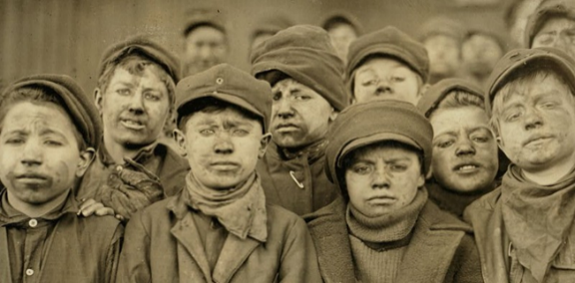**Chpt. 5 Labor Movement**

**Workers Face New Problems**

**List the hardships face by workers.**

**1. ________________________________________**

**2. ________________________________________**

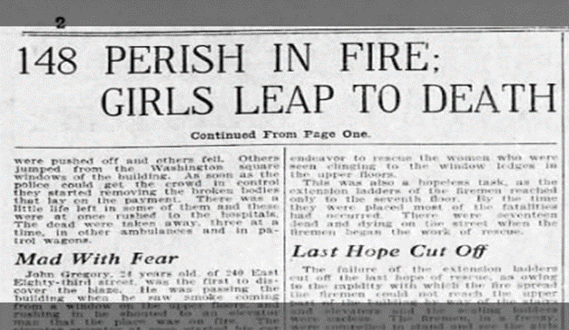**3. ________________________________________**

**4. ________________________________________**

**5. ________________________________________**

**6. ________________________________________**

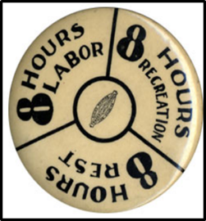**7. ________________________________________**

**Workers Seek a National Voice**

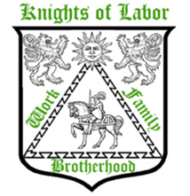**Rise of Labor Unions:**

**Knights of Labor -** Terrence Powderly 1869

Nationwide union

Skilled and unskilled workers welcomed

Black Americans, women and farmers welcomed

**Demanded**:

__________ hour workday

higher ___________ and job ____________ codes in factories

Opposed child _____________ and ______________ (seen as competing to work for lower wages)

Preferred __________________ than strikes to settling labor disputes

Why did the Knights of Labor fail?

1._________________________________________________________________________________________________

2. ________________________________________________________________________________________________

3. ________________________________________________________________________________________________

4. ________________________________________________________________________________________________

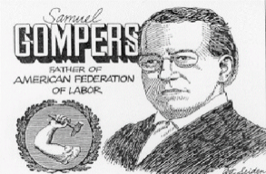**American Federation of Labor 1881**

Who was the leader of the AFL?

Consisted of separate _________________________ workers unions only.

Gompers wanted a **_________________________shop**, where workers **had** to join the union in order to work.

Why did the AFL fail?

**The Tactics of Labor and Management**

* **Picket line**- union workers carried signs outside their place of employment to win public support and prevent the use of **strike-breakers** (temporary workers hired by management to operate the factory while the regular workers were on strike).
* Management (employers)- fired the striking workers on the spot.
* **Lockout**- if management did not agree to worker demands, they closed the factory to keep workers from their jobs.
* **Strike-breakers (scabs)**- temporary workers hired by management to operate the factory until the strike was settled.
* **Yellow Dog Contracts**- workers were forced to sign an agreement promising not to join a union
* **Blacklisting**- Union leaders and members were often fired. Their names might be circulated to other employers so that they could not get another job.
* **Pinkertons**- were hired private detectives to spy on union leaders and break up strikes sometimes with violence and even murder.
* **Injunction**- employers would seek a court order prohibiting a strike. Once the court issued the order the government (police, state troopers) would break up the strike

**Categorize (list)** the tactics used by labor and management.

Fill in the table below.

**Labor Tactics Employer’s Tactics (management)**

|  |  |
| --- | --- |
|  |  |
|  |  |
|  |  |
|  |  |
|  |  |
|  |  |
|  |  |
|  |  |

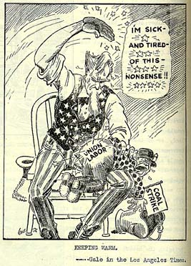

Government leaders were critical towards unions, they favored business over labor.

More than 20,000 strikes occurred between 1880 and 1900, some were violent.

Government officials feared union strikes would have a negative impact on the USA’s economy.

**The Role of Government**

At first, the government did little to regulate big business.

Government and business leaders believed in ***laissez-faire*** – the theory that government _______________________________________________________________________________________________

Government attitude towards unions were not always favorable. Anti-union bias, such as unions drove up cost of ___________.

Violence associated with strikes, like **H___________ R _________** brought negative attention to unions.

Only a s___________ number of workers were unionized.

Govt leaders saw their role as p____________ of private p____________ and unions seemed to threaten the security of ______________ property.’

Public opinion was hostile towards unions. Many people believed that union demands would raise prices.

Union activity was associated in the public mind with violence, **anarchism, socialism** and other ideas brought over by European immigrants.

* Business made huge political c_________________ for the re-election of campaigns of many politicians
* Govt leaders feared the disruptive effects of strikes. ***In 1895, the US Supreme Court applied the S__________________ Anti- Trust Act to union activities- ruling that strikes were an illegal interference with interstate commerce.*** Police and soldiers were often used to put down strikes.

**Union Strikes and the Public pg. 88**

* Public opinion also favored the idea of**_______________-faire** policies, of little government involvement.
* Most believed that businesses had the right to h__________ and f______________ whoever they wanted.
* They feared unions would lead to higher prices.
* **The Haymarket Affair** of 1886 emphasized the violence that had become associated with union strikes.

Striking workers at the McCormick Harvest Machine Co. began fighting with scabs until police fired into the crowd, killing several demonstrators.

**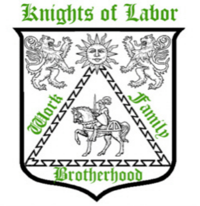*Anarchist-*** *leaders called for a rally for the next night. Anarchist believe in the absence of government altogether with only small self-governing communities.* On the evening of May 4th, the rally started peacefully. Police approached and ordered the crowed to disperse. A bomb was thrown into the police, killing one policeman instantly. The police opened fire as the crowd ran in all directions. Six other police were killed and four demonstrators later died from their wounds.

***The public associated this violence with the Knights of Labor, which soon dissolved afterwards.***

Pg. 88 **Cause(s) of the** **Haymarket Riot Results (Effects)**

|  |  |
| --- | --- |
|  |  |
|  |  |
|  |  |
|  |  |

**Homestead Strike (1892)**

Owners and managers would hire private security to harass or injure workers that had gone on strike….

As in the case of the ***Homestead Steel Strike***

* Steel workers went on strike because ________________________________________________________________________________________

________________________________________________________________________________________

* *Pinkerton ____________________________* went in to break the *picket __________________*but failed
* State national guard was called in, and succeeded in busting up the *_____________________ line*
* *_____________________* were hired to replace the now fired striking workers
* Striking workers were fired and *_____________________________-*  list of people, organizations, etc., that are disapproved of or that are to be punished or avoided.
* The worker’s union collapsed.

***George Pullman***- invented a railroad car in which passengers could sleep.

* Located in Pullman, Illinois a ***______________ town-*** a town in which the company owned the workers houses- charged rent and owned all the stores- workers got into debt quickly and had to work to pay off the “store credit”- they became indentured servants in a never ending cycle of debt.
* Workers went on strike when Pullman __________________ their wages but refused to lower rent or food prices in the stores he owned.
* ***Eugene V. ____________-*** union leader ARU- American Railway Union- called on all union members not to handle any train with Pullman cars.
* This action brought all trains to a _________________ in the western USA
* Pres. Cleveland sent in the _________________________ to guarantee the delivery of the mail. The mail was never in any danger of not getting delivered.
* US govt used a court ***_____________________ (a court order)*** to stop the strike on the grounds that the strike interfered with interstate commerce.
* Govt & general public had little empathy towards unions. But this will change.

In all three strikes listed above, what was the outcome and how did it affect their respective unions?

______________________________________________________________________________________________________________________________________________________________________________________________________________________________________________________________________________________________________

**The Rise of Ideologies**

* 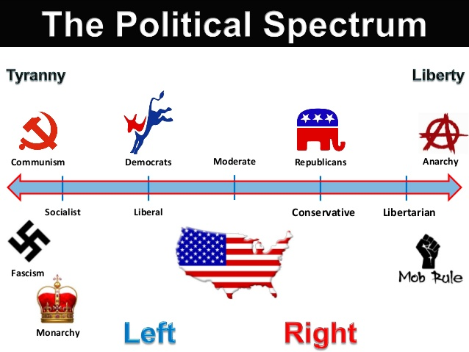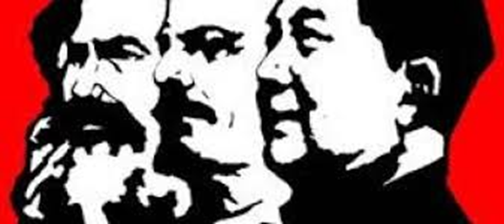Ideology- a system of related beliefs and ideas about p______________, s______________, e________________ and g______________________.

**Capitalism-** an economic and political system in which a country's trade and industry are controlled by private owners for profit, rather than by the state. Operates invisibly– **the invisible _________-** competition and __________- ____________ regulates capitalism.

**Social Darwinists**- influenced by **evolution**. Their beliefs stems from Charles Darwin who first formulated the theory of ________________________ and the notion of survival of the fittest to adopt to their surroundings and survive.

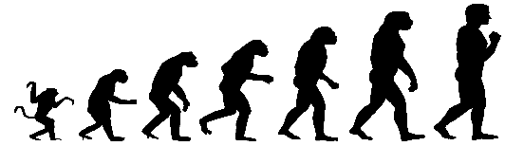Some people might suffer, it was only natural that the best and strongest people would rise to the top. Likewise, it was only fitting that advanced societies like the USA should ___________________ over less advanced ones.

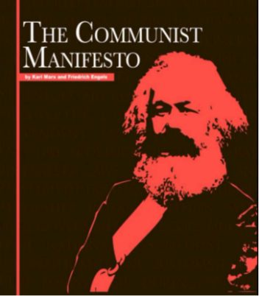**Communism-** followed the ideas of **Karl Marx.** Wrote a book- The ________________ Manifesto. Called for violent revolution by Workers (**______________**) to overthrow the **________________**(the owners) and establish a classless society- everyone is equal- no one is rich or poor. U__________________- heaven on earth.

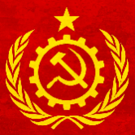

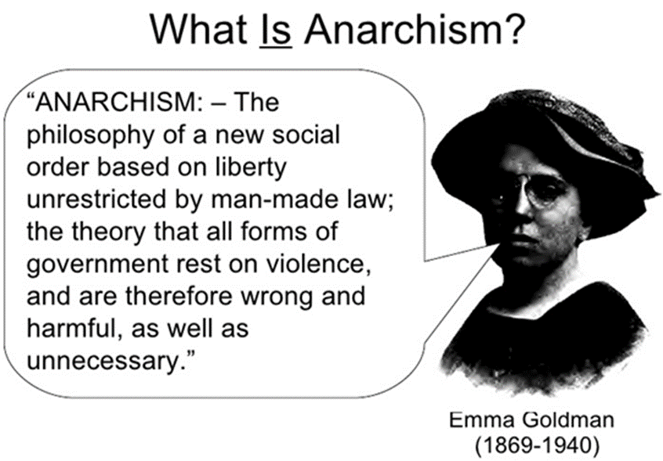

**Anarchism**- opposes all forms of _____________________ in favor of self-governing communities

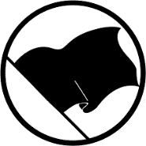

Anarchism will eventually devolve into chaos. **______** government means **_____** police means **_____** way of keeping order.

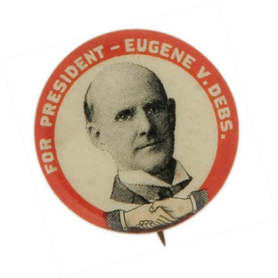Out of this chaos a single strong ruler always emerges and the anarchist society becomes a **tyrannical dictatorship similar to ______________________**

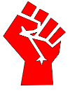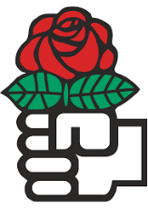

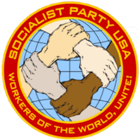**Socialism-** An economic system in which the production and distribution of goods are controlled substantially by the g____________________________ rather than by private enterprise, and in which co-operation rather than competition guides economic activity. Govt control of key industries- such as banks, railroads, etc.

Did not favor violent revolution but work within the political system i.e. - elections.

**EOC PRACTICE**

1. In the late 1800s, many employers used blacklisting to

(1) end the use of sweatshops (3) restrict the use of open shops

(2) discourage workers from joining labor unions (4) promote child labor reform

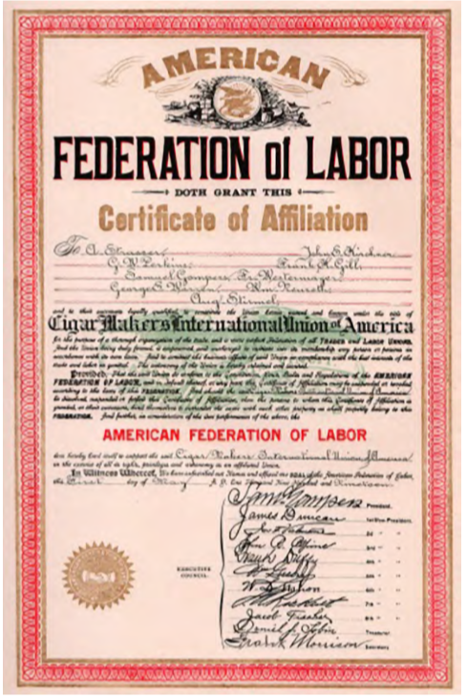

Use the image on the right to answer question 2

2. What was the primary goal of the organization that issued this certificate?

a. to assist in the transition from a capitalist to a socialist society

b. to obtain better pay and conditions for skilled workers

c. to help cigar makers obtain better housing and U.S. citizenship

d. to replace separate unions with a single national union for all workers

3. How did labor unions affect the lives of many workers during the late nineteenth century?

A. They won shorter hours and better pay for workers.

B. They helped workers take over ownership of factories and mines.

C. They worked with lawmakers to pass pro-business legislation.

D. They welcomed workers of any race or gender to join in their strikes.

**Eight hour workday**

**Eliminate Child Labor**

**Limit Immigration**

4. The above listed items would most like be favored by

1. Labor unions c. Big Business
2. The working class d. The Congress