Cities, Immigration and Farmers Chpt. 6
__________________________-movement of people from country side into the cities.
An important result of ___________________________ was the rapid growth of cities.
In 1865, only two cities had a population over 500,000 – N________ York and Ph_________________.
By 1900, this number increased to six cities as Americans were moving to more urban areas.
By 1920 _________________ of all Americans lived in cities.
Reasons for Urbanization
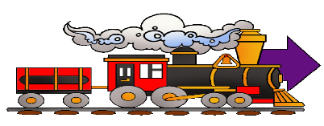
_________________________ and improved roads
Cultural opportunities and variety of city life-music halls, museums, libraries, universities
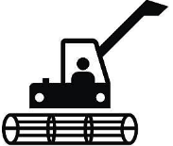
The rise of factories and the needs of growing urban population create more ____________________.
Farm workers were being replaced by ________________ and many unemployed farmers went to the cities to find _____________.
Problems Caused by Urbanization
- Overcrowding and congestion caused a lack of housing, transportation, and clean water.
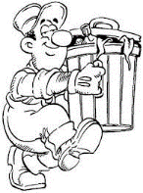
- Many families were forced to crowd into ___________________ housing- low cost rental housing barely meeting minimal living standards
- Lack of sanitation- lacking sewer systems and pollution from factories
- NO or rarely any ____________________ collection
- It also brought about an increase in the spread of d___________________ and c____________________.

Traffic congestion- horse drawn carriages, pedestrians, and cars on the streets, at the same time competing for space. Ouch!
Political Corruption
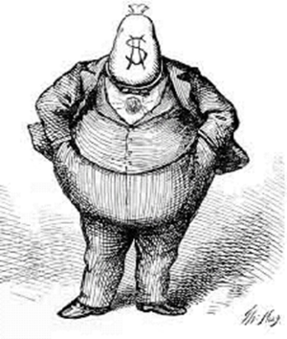
Politicians also formed _________________ ________________________.
These political machines were run by powerful politicians who did favors for people in return for __________ and _________________.
These political machines were corrupt and took advantage of immigrants, if you wanted a job, you had to pay the ‘boss’.
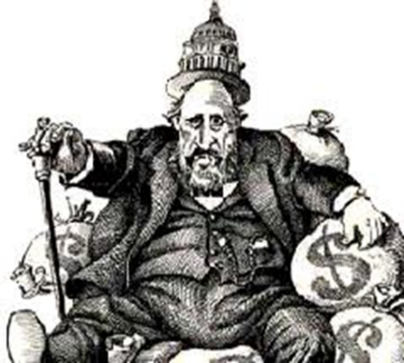
But at the same time they also helped them get things they wanted or needed-j_____, h_______, f____, etc. What we call today welfare, the machine provided.
One of the most famous political machines was Tammany Hall in New York City, it was run by Boss T______________. (shown as a fat money grabber)
Boss Tweed made a vast fortune from _________________ or bribe money. ________________or outright theft of city funds was also a way he made money.
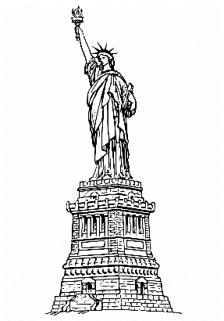
George Washington Plunkitt became head of Tammany Hall after the fall of Boss T_______________ and most of his money through land _________________________, which he knew would be needed for public projects. He would buy such parcels, then resell them at an inflated price. He called this “honest g______________.
Immigration
The flood of immigrants coming into the USA, from Europe mostly came through _____________ Island, NY.
They came looking for the American Dream, to find a job, escape oppression and poverty,
or to reconnect with family. Circle the correct factor: PUSH or PULL
Before 1890 most of these immigrants came from Western and Northern Europe, spoke English and were protestants. Old immigrants
The “New Immigrants”
In the late nineteenth and early twentieth century, the United States was flooded with millions of “New Immigrants” from ______________ and ________ Europe, which included countries such as ____________, __________, and _______________.
Native born Americans tended to resent the “New Immigrants” for several reasons:
- They didn’t understand or speak __________________.
- Their home countries lacked traditions of ________________ government.
- Their religions (_________________, ______________, ______________) were largely alien to native born Americans.
- They provided a steady supply of ______________ _______________, which undermined efforts by labor unions to get better wages.
- Immigrants settled in areas of the cities where others of the same nationality lived.
- These ethnic neighborhoods were called ____________________- to be segregated or separated.

Americanization
Some adult immigrants did attend night schools to learn English, but they were mostly too busy working.
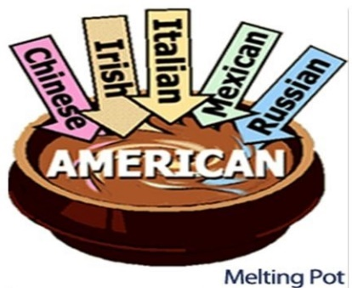
It was the immigrant children that would become ___________________ - learning to dress, speak, and act like other Americans.
These immigrant children would become _______________________– they became similar to other Americans.
America became a “melting pot” in which immigrants were melted down and reshaped.

Immigrants from Asia
Asians-primarily Chinese, arriving on the U.S. West Coast were processed at ____________ Island immigration station in San Francisco Bay, California between 1910 and 1940.
1848-_____________________ by warfare and economic hard times and ____________________ by the lure of gold Chinese immigrants began arriving in California.
Hundreds of thousands of Chinese had migrated to California, Chinese workers had even helped build part of the Transcontinental Railroad.
After the transcontinental RxR was completed many Chinese moved to San Francisco where they lived in “Chinatown”
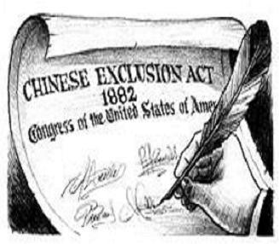
Faced with discrimination, many left their jobs and started their own businesses- especially Chinese laundries, restaurants, massage parlors.
Early Restrictions on Immigration
The Chinese _________________ Act (1882) banned anyone from immigrating from China to the USA.
The first federal law to ___________________ immigration into the USA.
It also placed new restrictions of those Chinese already living here by restricting their travel.
Chinese children born in the USA were denied _______________________.
Many believed this violated their 14th Amendment rights.
Gentlemen’s Agreement
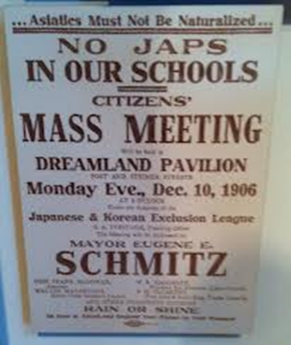
Now, Californians blamed the Asians for their economic problems.
In San Francisco the Board of Education in 1906 took all Asian school children and placed them special Asian Schools. As a result Anti-American riots broke out in Japan. In 1907-1908 an agreement was reached in which
Japan agreed to limit Japanese emigration to the U.S. and in return and San Francisco withdrew its segregation orders. This agreement was reached by President Theodore Roosevelt, Japan and the city of San Francisco.

The Immigrant Experience
As more immigrants came to the USA, more Americans began to hate on these new immigrants.
These immigrant haters became known as _______________, they thought they were here first and wanted the immigrants to go back where they came from.
Nativists hated on immigrants because they felt immigrants:
Increased the crime rate
Brought diseases to this country
Took j______________ from real Americans and brought l_______________ wages
Competed for limited resources. Afraid new i____________ would not a____________ or become Americanized.
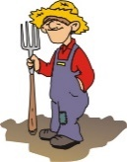
Farmers
In the 1870s farmers moved onto the Great Plains, they introduced improved machinery and fertilizers to produce more than ever before.
Improved technology led to an abundance of crops which then led to a decrease in the ___________ received by the farmers at the market.
But farming expenses remained, high, the farmers were going broke!
The Problems of Farmers: 1870 - 1900
Overproduction of crops - due to improved machinery, fertilizers, and new lands in the Great Plains caused an increase in food production this led to a _______ in prices (deflation) and a drop in farmers income.
International Competition- RxR & steamship transportation created an international market for food crops. Wheat growers faced _______________ competition from Canada, Argentina, etc, further ________________ food prices.
Scarcity of money- Govt stopped minting silver dollars. But population of US grew, value of its goods and services grew. There was not enough money supply and p___________ dropped.
Profits of Middlemen- Farmers did not sell crops directly to consumers. They used middlemen (____________) who connected them with urban markets for a fee. Farmers believed that brokers took advantage of them who bought grain when prices were low at harvest and re-sold at much higher prices. Also, some brokers were grain elevator owners, and charged high storage rates on their grain.
Transportation Costs – western farmers had to ship their crops to the Eastern markets, railroads took advantage of limited or no competition to charged high rates. RxR were a monopoly and charged __________ shipping rates.
High Cost of Manufactured Products- expensive to buy farm equipment, high t_______________ kept cheap imports out, and trusts did not help
Indebtedness – farmers were in debt from borrowing money to buy new machinery or make improvements. They used their farm land as collateral. If farmers did not pay the loans, banks would seize the land (f____________________)
Because farmers had high debts, they favored cheap money- inflated money. If prices rose, the real value of a farmer’s payments to a bank would be less. But the economy was experiencing _________________ (opposite of inflation).
Natural Disasters – droughts, floods, hail storms, insects might wipe out a entire year’s crop.
Rural Isolation- farm families were miles from their nearest neighbor and towns. NO telephone, radio or car. Social isolation was a problem.
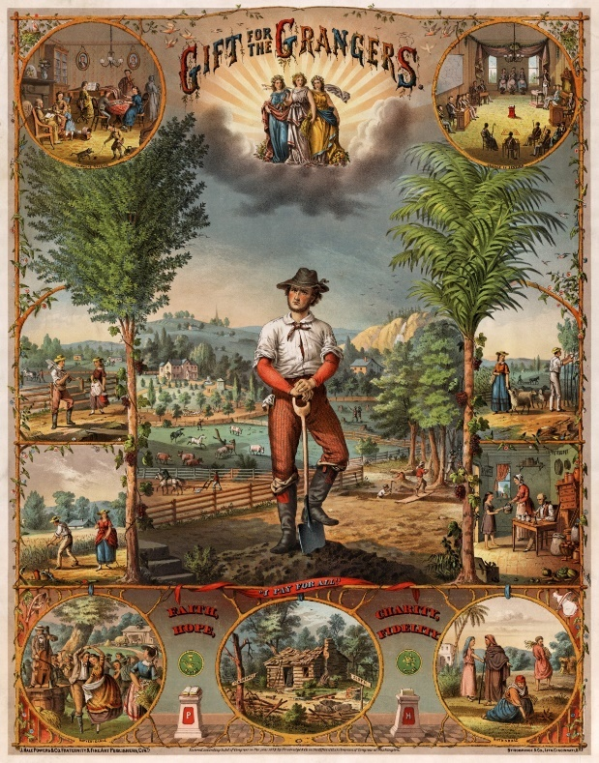
The Agrarian Movement
In 1867, the G____________________ Movement was founded by Oliver Hudson Kelley
Its original purpose was to serve as a social club for farmers.
Its aim was to overcome the isolation of the rural farmer and to spread information about new farming techniques.
Soon the Grange had over a million members who now supported _____________ and ____________ reforms.
Formed _______________________ (co-ops)- these co-ops bought machinery, fertilizes, and manufactured goods in bulk at a discount and passed the savings to the farmers.
Farmers mainly blamed the r_____________________ for their problems.
The Farmers A____________- group of farmers who came together to negotiate lower shipping rates.
Farmers felt they were being overcharged by railroads and grain storage facilities.
Farmers who belonged to the Grange elected congressmen who promised reforms.
Midwestern states passed laws regulating the rates railroads and grain storage facilities could charge.
The Granger Laws
- Munn v. Illinois (1877), the Supreme Court upheld the r________ of the s_______ to regulate businesses that affected public interests w___ the state.
- Wabash v. Illinois (1886) US Supreme Court ruled that states could ____ regulate RxRs running through s_______ states since this was i_______ commerce. Only C________ could regulate i__________ commerce. The Wabash decision i___________ many G________ Laws.
- Interstate Commerce Act (1887), prohibited railroads from charging m________ for short hauls than l_______ hauls over the same route. RxR (monopolies) were hurting small business owners.
It also banned p____________ (price fixing agreements) or charging more for short hauls along the same route. RxR had to publish their rates which had to be “fair and reasonable”
- I_______________ C______________ C________________ was created to enforce the new law, it became the first federal government agency to r____________ unfair b____________ practices.
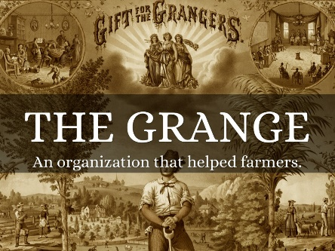
The Populist Party: 1891-1896
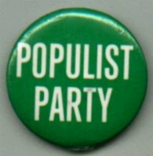
Farmers (mainly _________ members) formed the Farmers A__________ in the NW and South. Mainly focused on local politics.
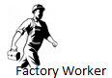
In 1891, a new political party arose from the Farmers Alliance and the Grange and gained support from the ‘c____________ m______, it was the ___________ Party or the People’s Party. It focused on _____________issues.
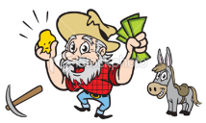
Populist Party means ___________Party
The farmers, m__________, and w__________ battled against the rich, bankers and railroad owners.
For the first time w__________ also played an important role in politics.
Populists believed that the rich had a stranglehold on _____________and they wanted the government to end poverty, ___________, and __________laws.
Populist believed that the ____________ and ______________ Party both had sold out to the banking interests on _____________ Street
Populist believed that the bankers were using their control of govt. to restrict the ___________ supply so that their own gold would _____________ in value.
The Goals of the Populist Party
OMAHA PLATFORM 1892
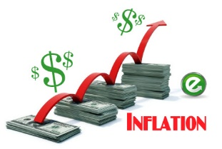
Unlimited Coinage of Silver – instead of gold coins, make more silver coins, it would help raise farm ________ and make loan repayments easier. They favored _____________ not deflation.
Term Limits for President – only a single 4 year term.
Secret ____________ – to stop intimidation of voters.
Government Ownership of Utilities – like ____________, telegraph, and telephone companies. (kind a Socialist sounding)
Immigration Restrictions – have quotas (limits) on how many people could come from each country.
Graduated Income ____________– taxes wealthy at a higher rate. The more income you earn, the income taxes you pay.
Shorter Work Day – just 8 hours.
Populists wanted to increase/expand democracy:
____________- voters could directly introduce bills into state legislatures
____________- voters could repeal a law already passed by the legislature.
Direct Election of S____________ – elected by the people of a state not the state legislature. Gave people more participation in government.
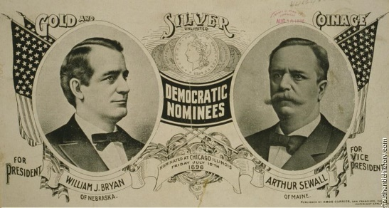
Populists and Election Campaign of 1896
1896 Election – Populists supported William Jennings ___________ for President due to his “Cross of ________” speech in which he supported the unlimited coinage of ___________, instead of gold. The Democratic Party and the Populist Party both nominated Bryan to run for President for both political party. Awkward. Lost to the Republican William _____________.
Free ___________ was a major policy issue in late 19th-century American politics. Its advocates were in favor of an ______________monetary policy using the "free coinage of __________" as opposed to the deflationary gold standard. Its supporters were "__________ites".
Plains farmers supported bimetallism because expanding the money supply would create inflation, making it easier for them to pay their debts. Bimetallism describes a monetary standard that accepts both ___________ and _______. It establishes a fixed rate of exchange between the two metals. This would never work- Gresham’s Law.
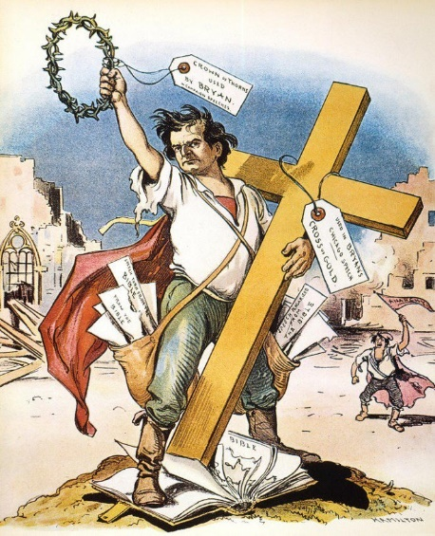
The Cross of Gold Speech
“They tell us that the great cities are in favor of the _________ standard. We reply that our great cities rest upon our broad and great prairies”.
“Burn down your cities and leave our farms, and your cities will spring up again as if by magic; but destroy our farms, and the grass will grow in the streets of every city of the country”.
“You shall not press down upon the brow of ___________ this crown of thorns; you shall not crucify mankind upon a cross of _______________”

The Legacy of Populism
Many Populist ideas were later adopted by the larger political parties, such as:
________________________________
________________________________
________________________________
________________________________
________________________________
________________________________
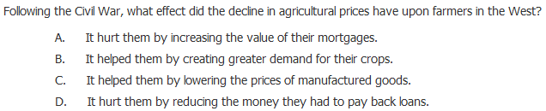
1

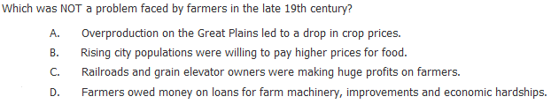
2

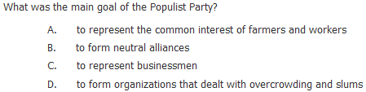
3

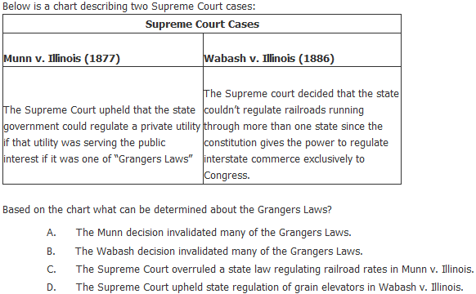

4

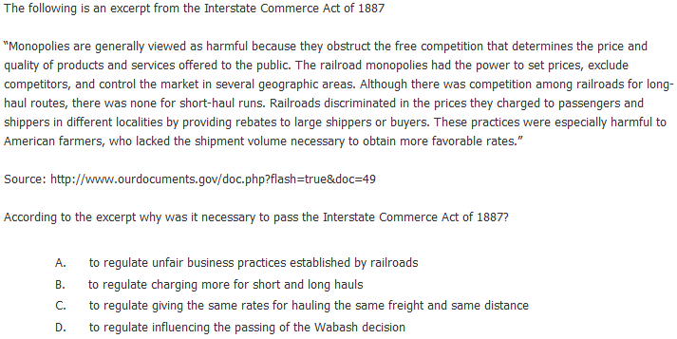
5

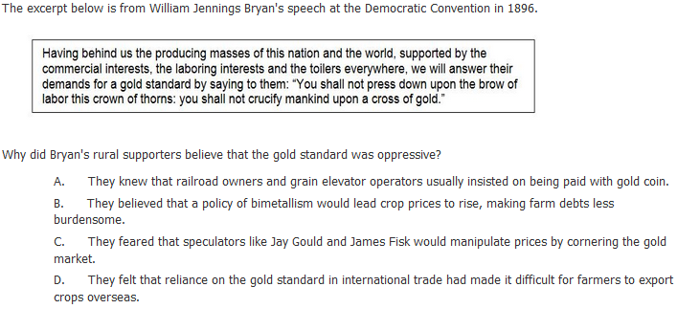
6

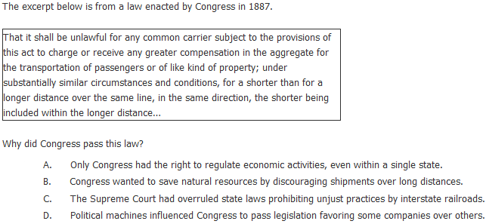

7

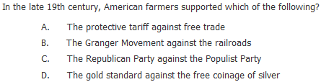
8

9. | How did railroads influence the growth of western territories?
A. | The ability to bring in goods deterred industrial development.
B. | Settlers moved away from Native American lands to follow the railroad routes.
C. | Railroads spurred the foundation and expansion of towns along the western rail route.
D. | Towns at the ends of railroad lines became ghost towns when the lines were extended.

10. | In the late 1800s, how did railroad monopolies create economic hardships for farmers?
A. | by claiming productive land for business leaders to develop
B. | by charging high prices to ship agricultural goods to market
C. | by separating farmers from profitable markets in western cities
D. | by isolating farmers from technological developments in eastern cities

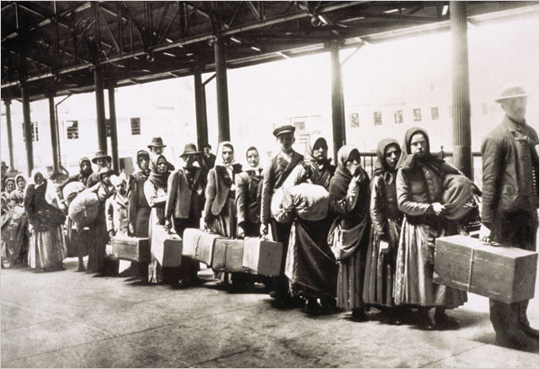

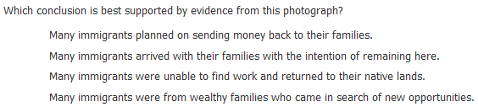
11.

a.
b.
c.
d.

12. The federal government reacted to the Supreme Court’s ruling in Wabash, St. Louis & Pacific Railway Co. v. Illinois (1886) by
(1) passing the Interstate Commerce Act
(2) weakening the influence of banks over big business
(3) abandoning the government’s attempts to break up monopolies
(4) encouraging railroad employees to form unions

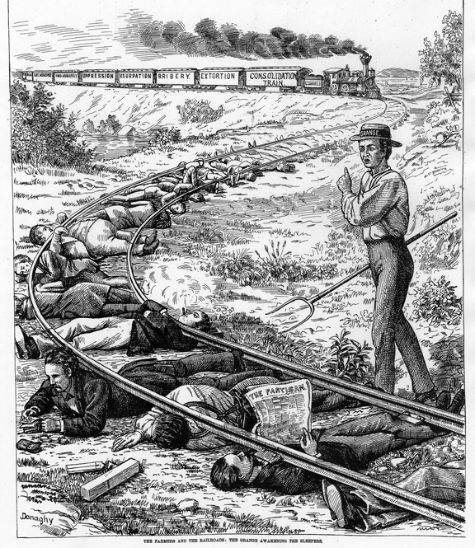

GRANGE CARTOON, 1873
“The Grange Awakening the Sleepers” – An American cartoon (1873) – Inspired by the Vanderbilt system of secret rebates, showing a farmer trying to rouse the country to the railroad menace
Questions:
- What words are written on the train cars? ________________________________________________________________________
- Who is the individual with the pitchfork? ________________________________________________________________________
- Who are the individuals under the train tracks? ________________________________________________________________________
- What is the meaning of the political cartoon? ________________________________________________________________________

