Unit 4 Topic 4.7-4.10 Political Ideologies and Public Policy Chpt. 14 AMSCO pg. 445-90
Explain how ideologies of the two major parties shape Policy.
The Democratic Party (D or DEM) platforms generally align more closely to liberal ideological positions, and the Republican Party (R or GOP) platforms generally align more closely to conservative ideological positions.
POLITICAL IDEOLOGY
A cohesive set of b_______ about p________, public p______, and the r______ of government that shapes a person’s views
A person who identifies themselves as a conservative or liberal varies according to age, race, gender, and socioeconomic status.

The meanings of l______________ and c_____________ have changed over time. Nineteenth-century liberalism was associated with the principles of laissez faire—government should keep its hands-off business. Conservatives opposed change and put their trust in t______________ institutions such as the m____________ and the c______________. In this regard, our founders were very l_________________.
In the 21st century in the United States, l_____________ have called on the f___________ government, in particular, to r____________ the economy in the public interest and help those who can’t help themselves; they strongly oppose any government attempt to restrict personal freedom.
C_________________, on the other hand, favor l___________ intrusion from Washington, and want power to flow back to s__________ and l___________ governments; they believe that the government does have a role to play, however, in promoting certain types of social behavior (for example, programs that encourage abstinence). Libertarians, usually considered to be on the political right, believe in m_________________ individual freedom and severely curtailing the power of the state; they reject both the liberal government as regulator and the conservative government as moral arbiter.

LIBERAL IDEOLOGY - GENERALLY DEMOCRATS
CARDINAL ATTRIBUTES OF LIBERAL IDEOLOGY
- P_____________ uses of g______________ to bring about justice and equality of opportunity (larger government) such as social programs in the past-LBJs Great Society -war on poverty
- Emphasis on protection of i________________ rights and liberties
- Emphasis on h______________ rights in issues regarding foreign aid
- Less emphasis on m_______________ spending
- Higher t____________ for the rich than for the poor
- Larger government
- Believe in possibility of progress, better future, equality of opportunity, minimum i_______________ level
- Liberals charge that conservatives act in self-interest, concerned with rich; Liberals concerned government should take care of weak
- Liberal view holds all people equal; wish to lessen impact of great i____________________ of wealth
- Corporations seen as chief threat to l_____________; Need for a strong central gov’t to “smooth out the rough edges of capitalism”
- Set up programs to help criminals
CRITICISMS OF LIBERAL IDEOLOGY
- Too much r____________ on g_______________ solutions, higher taxes, and bureaucrats
- Forgets that government has to be l________________
- When government grows too big, it tends to start d________________ us
- Too m________ governmental c_____________ and too much t_____________ undermine the s________-help ethic
- Welfare and regulatory state pushed by liberals will d_____________ true equality of economic opportunities

CONSERVATIVE IDEOLOGY (GENERALLY REPUBLICANS)
CARDINAL ATTRIBUTES OF CONSERVATE IDEOLOGY
- Private property rights and belief in f_______ enterprise (free market economy), laissez-faire
- Keep government s__________ except in the area of national d______________
- Government needs to ensure o____________; more pessimistic about h_____________ nature
- Preference for the status quo and desire ch__________ only in m_____________
- Taxes should be l______ for everyone
- P___________ in public schools should n_______ be banned
- Abortion is the m__________ of a fetus
- Strong d_____________ budget
- Don’t make America a w____________ state
- Lock up criminals for crimes
- Human needs cared for by f______________ /c_____________
- Emphatically pro-business
- Favor dispersing power b______________ to avoid c______________ of power at the national level
- Subordinate economic and social equality to l____________ and f___________ Government social activism has been expensive and counterproductive

CRITICISMS OF CONSERVATIVE IDEOLOGY
- Hostility to government as counterproductive and inconsistent
- Conservatives have a s__________________ opposition to government
- Government d_______________ grew during the 1980s when conservatives were in control
- I__________________ to the social needs of the homeless and mentally ill
- Too much faith in our market economy
- Failure to acknowledge and e_______________ policies that deal with racism and sexism
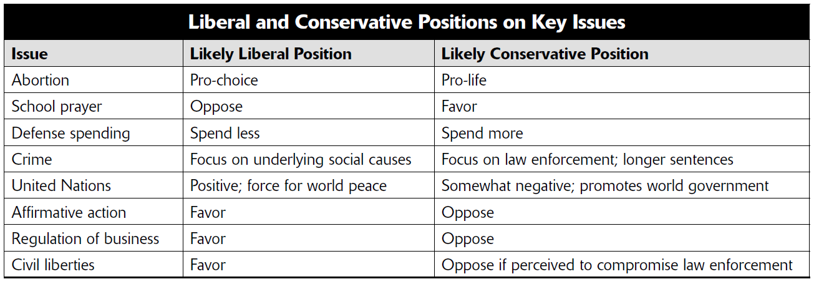

LIBERTARIANISM
- An ideology that cherishes i___________________ liberty and insists on a sharply limited government (Federal government should only be used for national defense)
- Preaches o_______________ to government and just about all its programs
- Opposes all government regulation
- End government subsidies for businesses and farmers
- No gun laws, no drug laws, no gambling laws

Most Americans are m____________, meaning somewhere in b___________, and never fall fully into one camp or the other. Many others may think conservatively on some issues and have liberal beliefs on others.
Off the Line AMSCO pg. 447-448
Cleavages, or g______ (d__________ in society), in public opinion make understanding where the public stands on issues even more difficult. Few people, even regular party members, agree with every conservative or every liberal idea. Many people simply do not fall on the linear continuum but rather align themselves with one of several other notable political philosophies:
Libertarian- a high regard; s_________ interpretation of the Bill of R_________; for civil liberties, conservative on economic issues, liberal on moral or social issues.
Populist- of today favor small gov unlike their populists’ brethren of the past century. Favor g________ regulations for job safety and farm subsidies.
Progressive- Modern progressives are aligned with labor unions. They believe in workers’ rights over corporate rights, and they believe the w____________ classes should pay a much larger percentage of taxes than they currently do.
Did you know that you could be a liberal and a conservative at the same time?
You could be a fiscal conservative and a social liberal? Or vice-versa
Explain how and give examples.
- List five tenants of a liberal ideology.

- List five tenants of a conservative ideology.

TOPIC 4.8 Ideology and Policy Making
Explain how U.S. political culture (e.g., values, attitudes, and beliefs) influences the formation, goals, and implementation of public policy over time
Because the U.S. is a democracy with a diverse society, public policies generated at any given time reflect the attitudes and beliefs of citizens who choose to participate in politics at that time.
The balancing dynamic of individual liberty and government efforts to promote stability and order has been reflected in policy debates and their outcomes over time
Liberal ideologies favor m_____ governmental regulation of the marketplace, conservative ideologies favor f_______ regulations, and libertarian ideologies favor l______ or n__ regulation of the marketplace beyond the protection of property rights and voluntary trade.
TOPIC 4.9 Ideology and Economic Policy
Describe different political ideologies on the role of government in regulating the marketplace.

Ideological differences on marketplace regulation are based on different theoretical support, including K_________ and s___________-side positions on monetary and fiscal policies promoted by the president, Congress, and the Federal Reserve.
Explain how political ideologies vary on the government’s role in regulating the marketplace

FREE ENTERPRISE: 2016 ELECTION
Hillary Clinton: | Donald Trump
She argued that employers should be required to pay men and women the same salary for the same job. With that stance, Clinton placed value on equality of opportunity over free enterprise, arguing that giving companies that discretion usually results in unequal pay on the basis of gender. | He argued that employers should not be required to pay men and women the same salary for the same job because there are a number of factors that go into determining salaries, like education level and prior experience. He placed value in free enterprise, giving companies the discretion and power to decide how much they pay their workers.
POWER TO MANAGE THE ECONOMY - PRESIDENT
- No formal powers over t_______________ and s____________________
- I_________________ over the federal budget has expanded dramatically over time
- Most important role is submission of the b___________ >> Outlines the president’s p___________ and spending recommendations

POWER TO MANAGE THE ECONOMY - CONGRESS
- Power to t_____________
- Power to pay the d_____________ of America
- Power to “provide for the c____________ defense and g_____________ w________________”
- Power to borrow m___________ and appropriate m______________
- Congress is not bound by a balanced-budget requirement >> U.S. government regularly runs large d______________
- Congress must a_______________ of the president’s budget

TOPIC 4.10 Ideology and Social Policy
THE BUDGETARY PROCESS
Executive Branch
- Agencies prepare their estimates of budget needs and present them to the Office of M_____________ and B__________ (OMB = charged with overseeing the budget process on behalf of the p_______________).
- Amount requested is typically based upon the amount granted in the p_________________ year.
- OMB reviews these requests and makes r________________________ to the President.
- P________________ reviews OMB recommendations and then submits a b______________ to C________________.
- The president's close control over both the preparation and execution of the budget is a major factor in his ability to c_____________________ the huge executive branch
- OMB monitors the spending that Congress appropriated.

Presidential action
- President s________ or v_________ entire taxing and spending bills – no l__________ i____________veto
- Congress can o___________ a veto with ___ /___ vote in both h__________
Congress (Constitution grants Congress the “power of the purse”)
- C__________________ B________________ O________________ (CBO) provides an independent analysis of the President's budget -- a c_________ on OMB
- Roles of Budget, W________ and Means, Finance, and A________________ Committees
- Input and l______________ from agencies
- M________________ vote needed in both houses
- G______________ A________________ Office (GAO) is a congressional watchdog agency that ensures money is spent as prescribed by law

What is the power of the OMB?

Political influences
- Political party differences
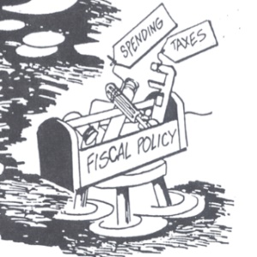
- Interest group/PAC influence
- Iron triangles
- Public opinion

TWO TYPES OF ECONOMIC POLICIES
Fiscal Policy
Refers to the t____________, s______________, and b________________ activities of the national government
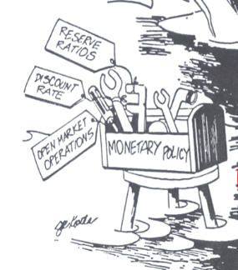
Conducted by the P_________________ and C___________________
President proposes the budget and Congress passes it
Monetary Policy
- Refers to the regulation of the m_____________ s_______________, controlling i_______________, and adjusting i_____________ rates
- Controlled by the “Fed” or F_____________ Reserve Board/Bank

FISCAL POLICY
FISCAL POLICY – DEFINITION
- Fiscal policy affects the economy by making changes in government’s methods of raising money and spending it
- Policy that describes the impact of the federal b____________ (including t__________, s_____________, and b______________) on the economy

TOOLS AND IMPACT OF FISCAL POLICY
Governments try to stimulate the economy to prevent a recession/depression
- Governments can lower taxes >> stimulates the economy by encouraging consumer spending or by encouraging investment
- Government can increase its own spending; which offsets declines in consumer demand >> Keynesian economic policy
- Economy is growing too quickly, and economists fear i______________ may increase >> government can attempt to cool the economy down by i_____________ taxes or by reducing its own s________________
Inflation by definition it too much money in the economy and causes prices to increase.

WHERE THE MONEY COMES FROM (SOURCES OF FEDERAL REVENUE)
- Individual income taxes
  - The individual income tax is the federal government’s l___________ source of r_________________
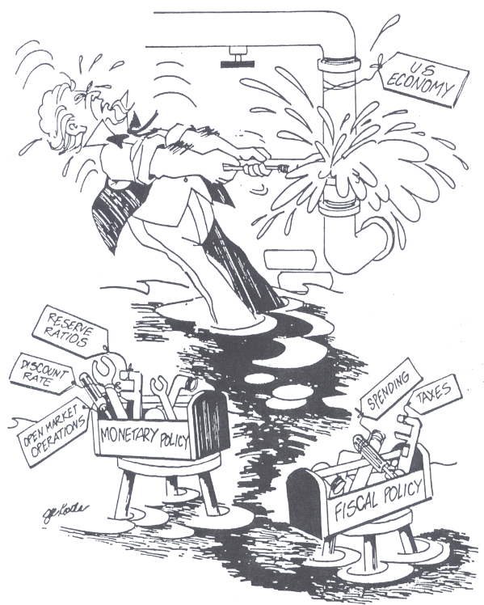
- Payroll taxes
  - Tax that an employer withholds from an employee's salary and pays on behalf of his employees
  - Pay for social insurance (S__________ S________ and Medicare)
- Corporate income taxes
  - Tax on corporate profits
- Excise taxes
  - Taxes on the consumption of liquor, tobacco, gasoline, telephones, air travel, and other so-called luxury items
- Other
  - Estate and gift taxes
  - Tariffs - taxes on imports
- Borrowing
Federal Reserve Bank
  - Budget deficit - borrow money
  - Selling Treasury notes and savings bonds
- Adds to national debt
President and Congress

Types of Spending
Discretionary spending-spending for federal programs that m__________ receive annual a______________
Mandatory Spending (non-____________-federal spending authorized by l_______ that continues w______ the need for annual approvals of Congress
Social Security and Medicare/ Medicaid are 67% of the federal budget.
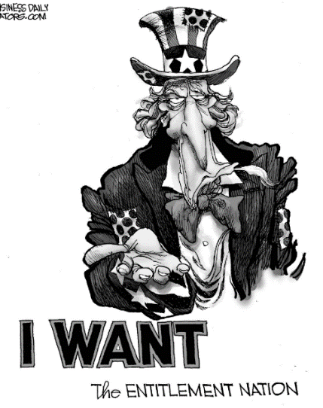
FISCAL POLICY – ENTITLEMENTS
- Entitlements
  - Federal money that is provided to those who meet e______________ requirements and is automatically spent each year without congressional review
  - Also known as “u________________”
  - Some have a built in COLA (c______ of l___________ a______________), also without annual review. This in turn creates additional budget pressures.
Examples: Social Security, Medicare, federal pensions. Social Security and Medicare/ Medicaid are 67% of the federal budget.
- These account for about ___/___ of the federal budget, which causes difficulties of b____________ the budget.
- Attempts to change/reduce/alter extremely difficult >> many v________ s________ these programs (especially old people- they vote the most)

MONETARY POLICY
THE FED (THE FEDERAL RESERVE BANK/ BOARD)
MONETARY POLICY – DEFINITION
- Monetary policy is the government’s control of the money supply. The government can control how much or how little is in circulation.
- The powerful arm of government that controls the money supply is the F__________ R_________ S_________, which is headed by the Federal Reserve B_________. The board is designed to operate with a great deal of i_______________ from government control. One important way that the “Fed” controls the money supply is by adjusting i__________ rates – h_________ rates d___________ borrowing money, and l______ ones e____________ it.
- The Federal Reserve Board’s seven members are a_____________ by the p________________ are approved by the S___________ for ______-year, nonrenewable terms, and the president may not remove them from office before their terms are up. The chair is elected by the board for four years and may be reelected. The Board heads the Federal Reserve System, which was created by Congress in 1913 to regulate the lending practices of banks. It consists of 12 regional banks, which in turn supervise a total of about 5,000 banks across the United States.
- Established by Congress in 1913 to help govern the nation’s monetary policy through an independent and apolitical process
- Overseen by a seven-member B_________ of Governors
  - Members of the board are a____________ by the p___________ and confirmed by the S__________ to 14-year terms and cannot be r_____________
  - The length of their t________ intended to i_________ the Fed from p___________ pressures from both the president and the Congress
  - The Fed’s primary role is to regulate the nation’s m__________ s__________. Priority is placed on l____________ the rate of i____________ and p_____________ recessions.

How does the Fed control monetary policy? MUST KNOW this. It also appears in AP Mcaroeconomics
- Open-market operations
- Refers to the efforts by the central bank to b______ or s______ government b_________
- This is the most c___________ form of m________ policy and is generally used to try to control short-term i__________ r__________
- By s_______________ bonds, the Fed effectively r_____________ money from circulation, slowing the economy
- By p_______________ bonds, the Fed effectively e_____________ the money supply, encouraging economic activity

- Reserve ratios
  - The Federal Reserve establishes the minimum cash r____________ any bank must hold.
  - By i____________ the ratio, the Fed can effectively r__________ the amount of money in circulation, s___________ the economy down.
  - By contrast, r_____________ the requirement i_____________ the amount of money in circulation, generally leading to an e____________ of economic activity.

- Federal funds rates
  - I____________ rate at which banks trade reserve balances held at the Federal Reserve
  - This rate is an important benchmark, as many other interest rates, including credit card rates and home mortgage rates, are often based on the federal funds rate
  - I_____________ the federal funds rate thus makes b_____________ more e___________, slowing economic a__________. This is done to slow down i______________
  - L______________ the federal funds rate makes borrowing cheaper, i______________ economic activity. This is done to prevent a r_________________.
- Discount rate- c________ banks pay to borrow money from the F___________ Reserve Bank
- By r____________ the discount rate, the Fed makes it more attractive for banks to b____________ money, effectively increasing the amount of money in circulation and encouraging economic activity. By contrast, increasing the discount rate generally s_________ the economy down

DEVELOPMENTS IN ECONOMIC POLICY
- Great Depression of 1930's led to even greater regulation of economy by Congress: Unemployment rate of 25%, bank failures, and deflation demanded aggressive actions.
- Keynesian Economics
  - During Depression, New Deal was influenced by of British economist John Maynard K___________.
  - Keynes suggested that government could manipulate the economic health of the economy through its level of spending.
    - In h_______ times, govt. should i___________ spending (even if it means running large deficits) to stimulate economic health.
    - In inflationary “b_______” times, govt. should d_________ spending to “cool down” the economy.
  - Difficulty posed by Keynesian Economics: Once govt. spending rises, it is politically difficult to cut it (consider the fights in recent years over entitlement reform). This helps to explain why we have such high budget d__________.

- Great Depression of 1930's led to even greater regulation of economy by Congress: Unemployment rate of 25%, bank failures, and deflation demanded aggressive actions.
- Supply-Side Economics
  - Definition: Cuts in t___________ will produce business investment that will compensate for the loss of money due to the lower tax rates. Tax rates will be l________, but business will boom, unemployment will go d_______, i_____________ will go up, and more money will come into the Treasury.
  - Most associated with the Reagan Administration (1981-1989).
  - Unfortunately, the Reagan tax cuts were not accompanied by spending cuts, so the national debt tripled from $1trillion to $3 trillion.

The push for a Balanced Budget Amendment
- High deficits have led some to believe that Congress needs to be “tied down” to a constitutional amendment that would require that spending not exceed income.
- Supporters say that this is the only way to end the “spending bias” of Congress, and that it is the only way to overcome the political difficulties of cutting spending.
- Opponents say that such an amendment would be “tinkering” with the Constitution: It would decrease needed flexibility in times of crisis, and Congress would figure out a way of evading the amendment anyway.
- This amendment was proposed in the Senate but was voted down by the House in 1992.
- The line-item veto could have precluded the need for such an amendment. Wasteful spending could be deleted with a “stroke of the pen.” Declared unconstitutional by the Supreme Court.

- What is the difference between monetary policy and fiscal policy? Who is in charge of controlling monetary policy? Fiscal policy?

- What is the difference between Keynesian economics and supply-side economics? Which ideology generally favors each idea?

- Explain the cartoon. Which economic theory is portrayed?

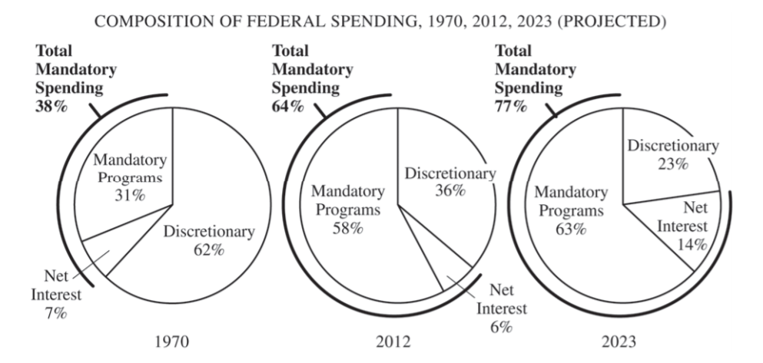
Answer the FRQ below in the OLD FORMAT AND THE NEW FORMAT
OLD FORMAT

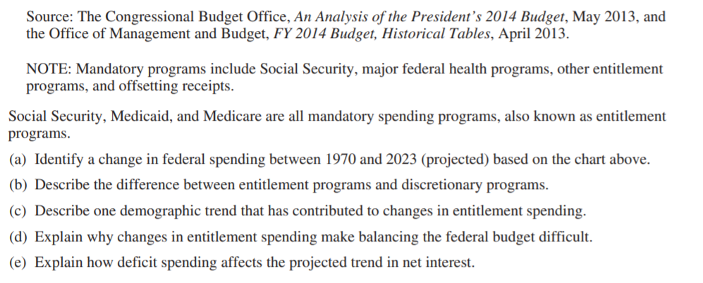

New Format QUANTITATIVE ANALYSIS
- Identify the data trend pattern presented in the pie charts above.

- Explain how the data in the pie chart could influence how a candidate running for Congress would shift his or her campaign positions on entitlements based on voter demographics as illustrated in spending patterns.

- Explain how the data in the pie chart could affect policy making interactions between the president and Congress.

