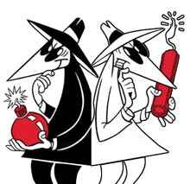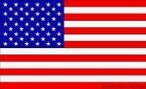**­­The Cold War Review Chpt. 13**

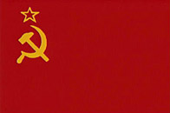

**V.**

Why were they called SUPERPOWERS? ______________________________________________________________________________________

­­­­­­­­­­­­­­______________________________________________________________________________________

Why was it called a Cold War? ______________________________________________________________

A **proxy war** is a conflict instigated by opposing powers who do not fight against each other directly. Instead, they use third parties to do the fighting for them. ... However, a direct large-scale **war** between them would cause enormous damage to all belligerent powers.

The purpose of the of USA during the Cold War was to stop the spread of C__________________.

**The Roots of the Cold War**

The roots of the Cold War lay in the competing ideological systems between the U.S.A. and the Soviet Union.

The **____________ ___________** wanted to spread its system of **D______________ (the people rule)** and free enterprise.

The **___________ ______________** (USSR or Russia) wanted to see nations adopt **C_______________ (the government rules)**.

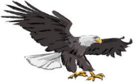**Democracy versus Communism**

USA

|  |  |  |
| --- | --- | --- |
| **Category** | **American Democracy** | **Soviet Communism** |
| **Political System** |  |  |
| **Economic System** |  |  |
| **Religion** |  |  |
| **Individual Rights** |  |  |
| **Organization** |  |  |



USSR

**The Yalta & Potsdam Conferences**

In February 1945 as the end of the war neared, the Big Three of Roosevelt, Churchill, and Stalin met in Yalta.

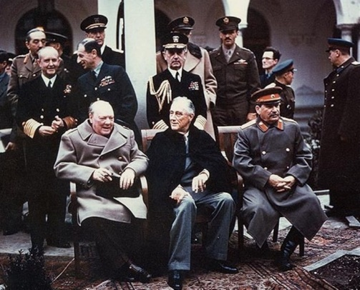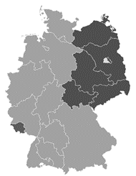They agreed on:

The formation of the U_________ N _______________, a plan on how G______________ would be divided up at the end of the war.

The nations they had liberated would have free e________________.

Stalin even agreed to let P______________ have free elections, ya right!

**The Cold War Begins**

* ***Potsdam Conference***- Potsdam, Germany. July- August 1945
* 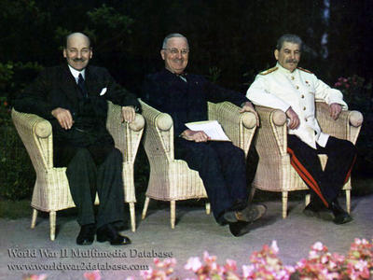Agenda:
* 1. Treatment of G_____________________
* 2. War against J_________________
* 3. the future of E________________

It was here, that Stalin promised open and free elections in Soviet occupied Europe, starting in **Poland**. He lied. Thus, the **COLD WAR started**. US and UK agreed that USSR could not be trusted.

United Kingdom **Prime Minister Clement R. _________** (January 3, 1883 - October 8, 1967) **Harry S. ________** (May 8, 1884 – December 26, 1972) and **Josef V. _________** (December 18, 1878 – March 5, 1953)

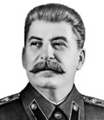**The Cold War Begins**

After World War II, the Soviets saw a growing threat from the capitalist governments in the West.

To insure a **b_________** zone between the W______ and the E______, Stalin set up communist governments in these **s______________ nations**’(dependent states) he now controlled.

The Soviets occupied these nations and prevented free ____________, seized industrial properties and *controlled all parts of the lives of the people of the USSR and **eastern Europe nations**.

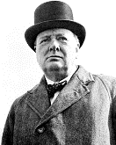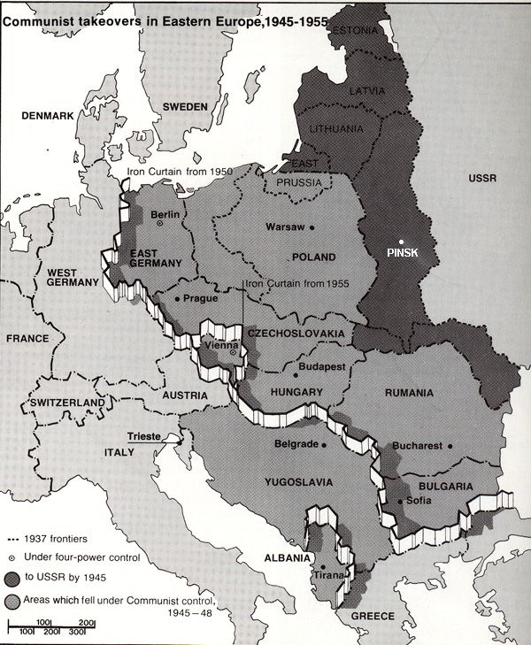Churchill said an ‘**Iron ________**’ has fallen over Eastern Europe, cutting it off from the freedoms of the West.

*“From Stettin in the Baltic to Trieste in the Adriatic, an iron curtain has descended across the continent.*

*Behind the line lie all the capitals of the ancient states of Central and Eastern Europe …*

*The Communist Parties, which were very small in all of these Eastern states, are seeking everywhere to obtain totalitarian control.”*

***Churchill’s “Iron Curtain” Speech,******5 May 1946***

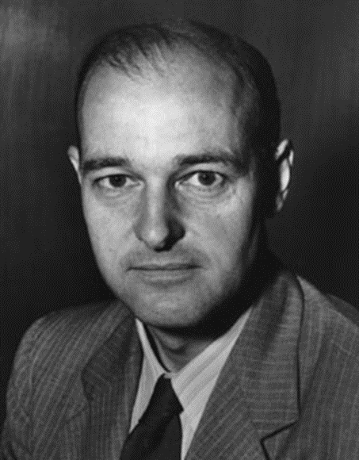**George Frost Kennan**

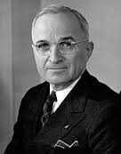His writings inspired the **T__________D___________** and the U.S. foreign policy of **"c______________"** the Soviet Union. His **"Long T_______________"** from Moscow during 1946 and the subsequent 1947 article "The Sources of Soviet Conduct" argued that the Soviet regime was inherently **e____________** and that its influence had to be "**c_____________**" in areas of vital strategic importance to the United States.

**The Truman Doctrine: Fighting Communism in *Europe***

**“I believe it must be the policy of the U.S. to support free peoples who are resisting attempts by armed minorities or by outside pressures.”**

Harry S. Truman

1. ***Containment Policy***-

Included: economic and military aid to any nation threatened by communist takeover in ***Europe***. First European countries to receive aid under the Truman Doctrine of containment were G______________ and T_____________________.

Truman promised to support any country fighting C______________________.

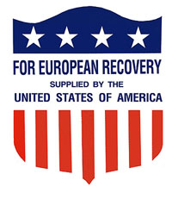**2.** **The Marshall Plan, 1948**

Secretary of State George Marshall proposed a plan to aid the war-torn nations of Europe to prevent the spread of c______________________________.

**How did this plan benefit the USA?**

**The Division of Germany**

At the end of WW II, Germany was divided into an eastern bloc and a western bloc.

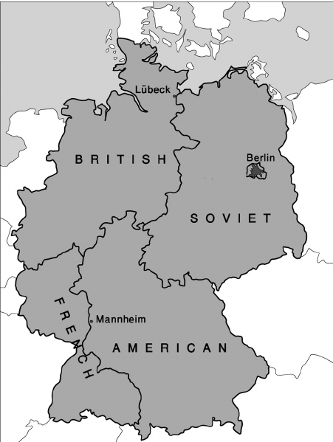The Soviets controlled the e___________ bloc, E________ Germany.

The USA, Britain, & France controlled the western bloc aka West Germany.

The city of Berlin was located entirely within the country of E________ Germany.

Berlin itself was divided into a W________ Berlin and an E_________ Berlin.

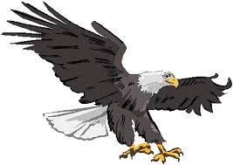**The ‘_________ curtain’ separated east from west, Communism from Democracy**

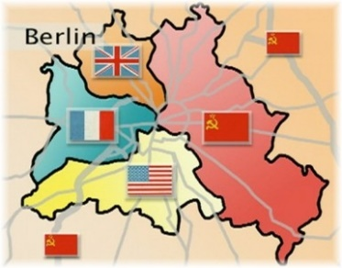



**USA v. USSR**

**The Berlin Blockade & the Berlin Airlift**

Berlin is located entirely within communist E_______ Germany.

In 1948 the USA had created the **Federal Republic of Germany** (West Germany, capital city in Bonn). The USSR saw this as a threat’

The USSR responded by limiting access to U.S. sector of the city.

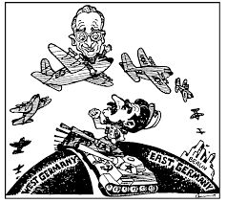The U.S. had been trucking in all needed supplies to West Berlin before this ‘**Berlin B_____________**’ by the Russians.

The U.S. responded to this blockade with the ‘**Berlin A_____________**’.

The U.S. flew tons of food, fuel, and other materials into West Berlin.

**3. N.A.T.O. - North Atlantic Treaty Organization**

In response to the Soviets blockade of Berlin, the U.S.A. and other non-communist nations that surrounded the North Atlantic Ocean, formed a military alliance called NATO in 1949.

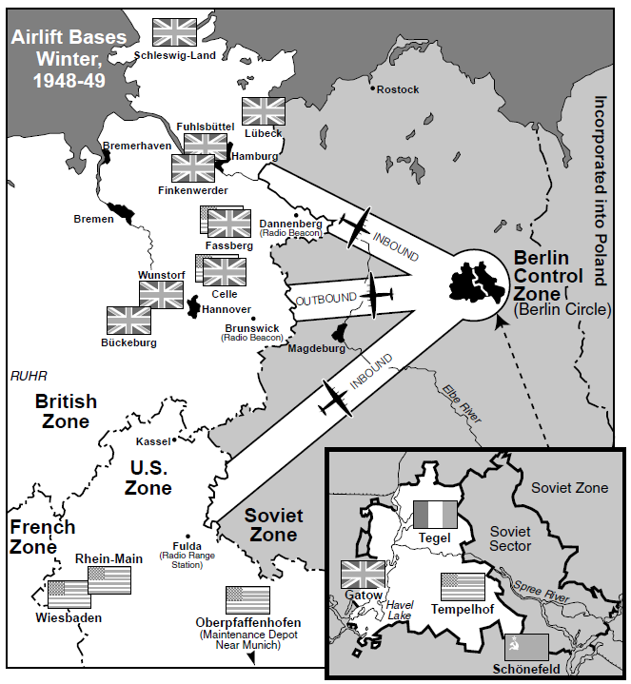NATO was based on the concept of collective _____________, where each NATO member pledged to defend other NATO nations from attack.

The **Soviet Union** responded by creating the **W________ Pact** with its eastern allies and ***satellite*** nations in 1955.





**USA v. USSR**

**Containment *FAILED* in Asia**

America believed the policy of containment was working and stopping the spread of Communism in Europe.

Then in 1949, China the world’s most populous nation became ______________.

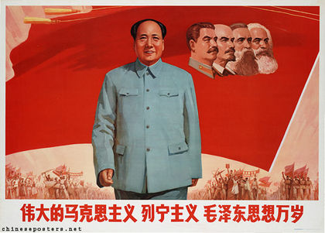**Communist China** led by **_________ Zedong**, and helped by the Soviets, overthrew the Nationalist government.

Pres. Truman refused to **r_____________** the Communist government in China. Non-communist Chinese flee to Taiwan and establish a new government in exile.

The U.S. also prevented Red China from entering the United Nations.

Instead, U.S. puts T__________ in the UN Security Council as a permanent member. USSR protests and w_______out of UN. Costly mistake on their part.

**The Korean War, 1950-1953 aka Police Action**

The Korean War is referred to as a **P________ ACTION** because C_________ never declared war.

**Korea**, a former colony of Japan, was divided into two zones after World War II.

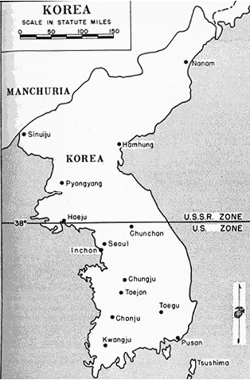**North Korea** became a c______________ nation supported by China and the U.S.S.R.

**South Korea** became a d______________ nation supported by the U.S.A..

The dividing line was the **38th Parallel line.**

**The Korean War Was a P_______ War**

Behind the scenes, the S_____ and the C______ were arming and financing North Korea to fight South Korea and the U_____

* 1950, North K_______ invaded the South.
* These aggressive actions reminded Pres. Truman of the Nazi during WW II.
* Pres. Truman sent U.S. troops into South Korea to resist the invasion.
* The U.S. was able to pass a resolution in the U______ Nations to send U.N. troops (mostly Americans) to South Korea. First time USA fought as a member of U______ Nations forces.
* USSR did not V______ the UN S_________ Council resolution to stop North Korea. USSR was b________ UN Security Council in protest over its failure to sit communist China on the Council
* Korean War became the first war to use an international p______ keeping force (United Nations) to halt an aggression.
* C_______ War just turned H______

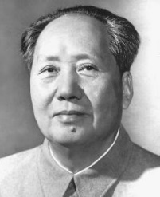**Who are those guys down there?**

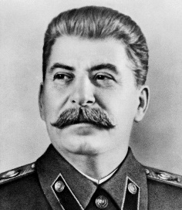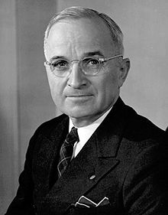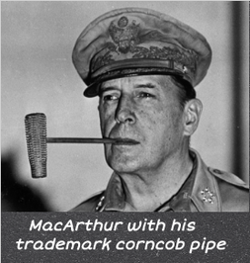

**_______________ ____________ ____________ ____________**

**End of the Korean War 1953**

1952, Dwight ________________is elected President of U.S.A..

“Ike” was popular and won on the campaign promise of ending the K_____W ____.

1953, the U.S. and North Korea signed an *a__________* ending hostilities.

The agreement called for a *DMZ*, (d_____________ zone) as a buffer between the two Koreas at *38th Parallel*.—*s___________. The war ended right where it started.* The agreement was signed at P__________, a village sitting on the DMZ.

***The result of the war was that the border between the two, remained the same as before the war began. Korea remains d____________ into North Korea and South Korea.***

***No official peace treaty has ever been signed with North Korea. Officially, a state of w_____ still exist to this day.***

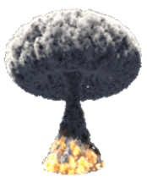**Nuclear Proliferation and the Arms Race**

Nuclear Proliferation refers to the s________ of nuclear weapons and technology.

This is dangerous for several reasons:

1. Tremendous destructive power of nuclear weapons
2. With the spread of this technology comes the increase likely hood that someday they could be used
3. Accidental explosion
4. Terrorists obtaining such weapons

In 1945 at the end of WW II, the U.S.A. was the sole atomic power in the world. The U.S. refused to give up the secret of the bomb.

By 1949, the U.S.S.R. had developed their own A-bomb. The nuclear ‘_______ race’ had begun.

1952 the USA develops the h____________ bomb. Much more powerful than any A-bomb. Less than a year later. USSR exploded their H-bomb.

During the 1950s, the U.S. leaders (Eisenhower) decided to rely more on n____________ weapons for defense, rather than building up a large military force.

**Brinkmanship: _________________________________________________________________________________**

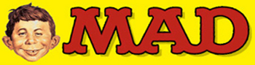**Arms Race**

With the USA & USSR in possession of large nuclear stockpiles, each side could destroy each other: this was known as **M______________ A_____________ D____________ (MAD).** MAD kept the balance, and none dare use nukes.

**Massive Retaliation**

* The U.S. used its nuclear weapons as a **d_____________** to stop the U.S.S.R. from attacking.
* The reason it worked was because we threatened to ‘nuke’ the Russians if they attacked us.
* **Massive R_______________** was cheaper than a large military, but it doesn’t always work in every situation.
* Soon we realized that such mass destruction could only be used if our nation’s survival was at stake.

By 1959, both the USA & USSR developed rockets called i ___________________ b____________________ m_________________ (**ICBMs**) that could deliver nuclear warheads to distant targets.

**To combat American fears of a nuclear attack, the U.S. government responded in several ways**:

National and local governments prepared citizens for a Soviet nuclear attack on the United States

Citizens built f______ shelters in their backyards.

Cities and schools practiced building evacuations and “**d______& c______**” drills.

**The Cold War on the Home Front- The 2nd Red Scare**

Following World War II, Americans feared a Communist takeover from within the U.S.A., another (2nd) **Red __________**.

Pres. Truman ordered creation of **L___________ R___________ B_________** to investigate un-American activities, like being in the Communist Party.

Many Americans were accused of ‘un-American’ activities, often with little evidence they were Commies.

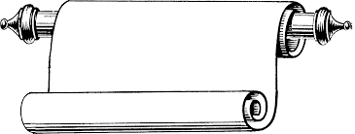

Constitutional

These investigations often violated an individual’s **c________________ rights**.

The **“H__________ Un-A_____________ A______________C________________”** aka **HUAC** was created by Congress to identify current or former members of the Communist party.

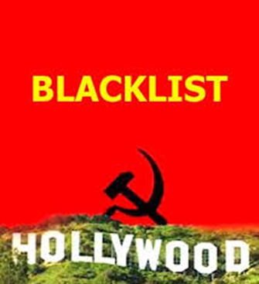HUAC investigated the “**Hollywood T_________**” made up of movie actors, directors, and writers about their possible Communist sympathies.

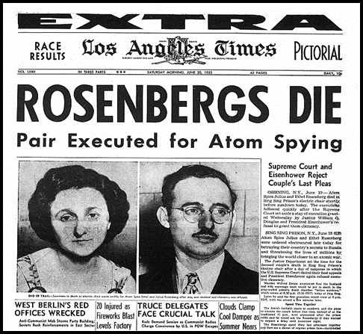Those identified as commies were ‘**b_______________**’ and lost their jobs.

State Department employee Alger Hiss was convicted of spying for the USSR

J_____ & E_____ Rosenberg were executed for passing a_______ bomb secrets to the USSR

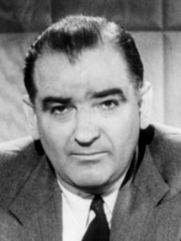**The McCarthy Hearings**

In the 1950s, **Senator Joseph ____________________** led the hunt for Communists in America!

McCarthy used his power, unproven claims, and wild accusations as he ruined the lives of people he claimed were communists.

McCarthy claimed to have hundreds of names of communists and created an air of fear like the **Red S_______** of the 1920s, but he never provided any **real p__________**.

*Sen. Joseph McCarthy*

***Like the Red Scare of the 1920s, many Americans c______ r________ were violated.***

The bullying tactic used to destroy a person’s reputation without evidence is called **M____________________**.

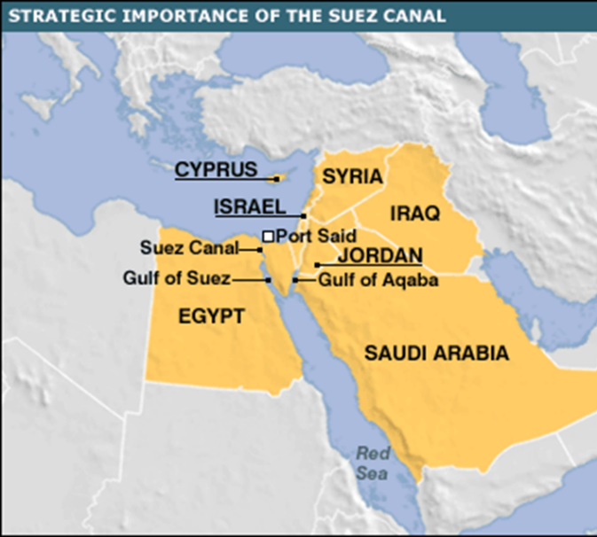**Eisenhower Doctrine**

Pres. Eisenhower gave control of foreign policy to **John Foster D__________**, a devoted anti-Communist who wanted to stop the _____________ of Communism and prevent Soviets from gaining additional influence.

Under D_________ direction, Pres. Eisenhower announced he would send U.S. troops to any Middle East nation asking for help in fighting Communism.

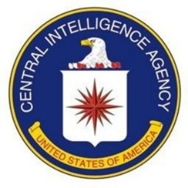**Eisenhower D__________** was an extension of the **Truman D____________** (C______________) into the **Middle E_______** to protect the Suez Canal.

**CIA- USA Spy agency- C_________ I_________ A_________**

**KGB- ________________________________________________**

**Sputnik and The Space Race**

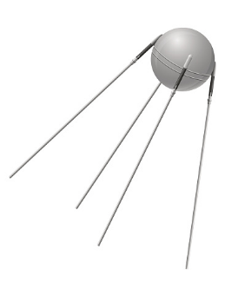In 1957, the USSR used its first ICBM to launch S________, the first satellite into space. Sputnik shocked Americans who f**________** the U.S. had f________ behind the USSR in science & technology.

As a result, the USA reacted by passing/creating the:

**1.** **National Defense E__________ Act-________________________________________________________________________________**

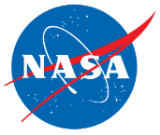**________________________________________________________________________________**

**2. N______________ A____________________ S___________________ A___________________**

On May 1, an American high-altitude U-2 spy plane is shot down on a mission over the Soviet Union.

After the Soviets announce the capture of pilot **F________ G______ P_________**, the United States recants earlier assertions that the plane was on a weather research mission.

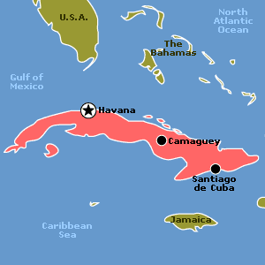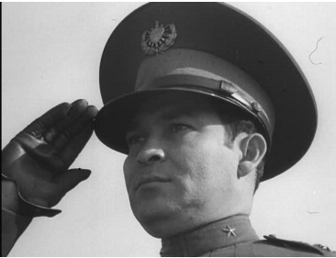**Eisenhower and John F. Kennedy’s Foreign Policy**

JFK opposed ­­­­______________________, pledging to **contain** it as previous Presidents had.

JFK’s first challenge came from just 90 miles south of Florida, in ___________.

*General Fulgencio Batista, President of Cuba before Castro*

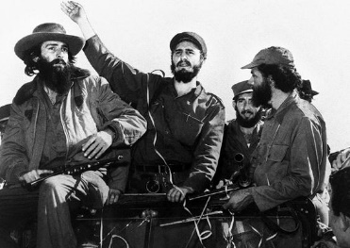Fidel Castro led an uprising that overthrew Cuba’s brutal dictator General _______________.

Fearing a US i_____________ in Cuba, Castro soon aligned Cuba with ________________ and became communist.

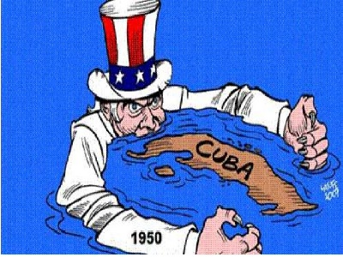Under JFK, the U.S.A. would break off relations with Communist Cuba that have lasted to this very day.

US cut off all trade with Cuba and issued a trade e__________.

**JFK and ‘The Bay of Pigs’ Invasion, 1961**

In the 1950s, Pres. Eisenhower planned an overthrow of Cuba’s dictator Fidel Castro.

The plan included secretly training ____________ exiles on how to invade Cuba.

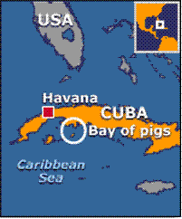Pres. Kennedy continued with the plan, but he refused to provide air _____________ for an invasion that might tie the U.S. to the plan.

[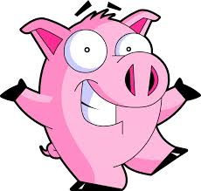](http://www.google.com/url?sa=i&rct=j&q=&esrc=s&frm=1&source=images&cd=&cad=rja&docid=9yOaibDGSF2UMM&tbnid=gI8S1uFD-SOLOM:&ved=0CAUQjRw&url=http://www.sunnyskyz.com/top-ten.php?type%3Djokes&ei=UrjzUsDDOMXZrAGdk4GgDQ&bvm=bv.60799247,d.aWc&psig=AFQjCNEasfOQJW0FqQnUEHkfS4uD7kH2UQ&ust=1391790535844294)The planned invasion sight was called the Bay of ___________.

Cuban exiles landed in Cuba and were defeated by the Cuban military.

The ‘Bay of _________’ turned out to be an embarrassing failure for JFK.

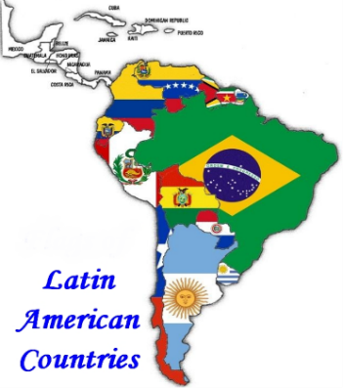**Alliance for Progress**

JFK’s pledge of support for Latin America

Considered a “Marshall Plan for brown people.”

* + $20 billion to support internal improvements.
  + Supported education and schools
  + Built hospitals and promote health care
  + Helped distribute land

Pros: __________________________________________________________________

Cons: __________________________________________________________________

**Cuban Missile Crisis, 1962**

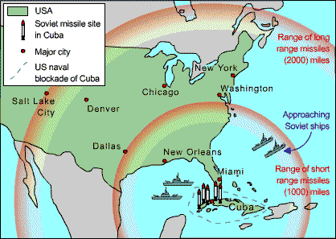The failure of the ‘Bay of ­­­­­­________’ invasion had made the Cubans and the Soviets aware of the U.S.A.’s invasion attempt.

The Soviets took steps to help protect Cuba from another invasion attempt by the U.S.

U.S. spy planes flying over Cuba discovered that Cuba was secretly preparing _________ sites for nuclear weapons supplied by the Soviet Union.

Soviet nukes were 90 miles away.

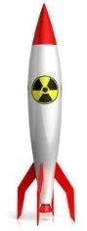Oct. 14, 1962 – U-2 flights showed 65 sites for offensive medium-range ballistic missiles – could reach the U.S. in 3 minutes.

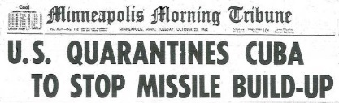 When surveillance photos revealed nukes ready to launch in Cuba, JFK said the U.S. would respond to any attack from Cuba with an all-out nuclear retaliation against the Soviets.

JFK ordered a naval q__________ of the island (used the word “q__________” rather than “b__________” since b__________ was an act of war.

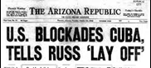Oct. 22 – JFK went on national television informing the Soviets of American policy and demanded their retreat.

American forces around the globe went on alert.

The world was on the brink of nuclear war.

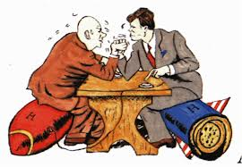

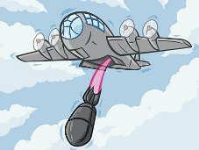The Cuban Missile Crisis put the two nuclear powers face to face against each other. On the brink of n_______ war.

Who would blink first in this game of b______________?

Finally, Khrushchev backed down and removed the nukes from Cuba, narrowly avoiding war.

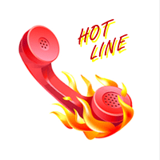The U.S. agreed not to invade C________ and would pull our weapons out of Turkey that we had aimed at Russia.

A special h_______ ________ was set up by the two nations to avoid further confrontations and reduce the likelihood of a nuclear war

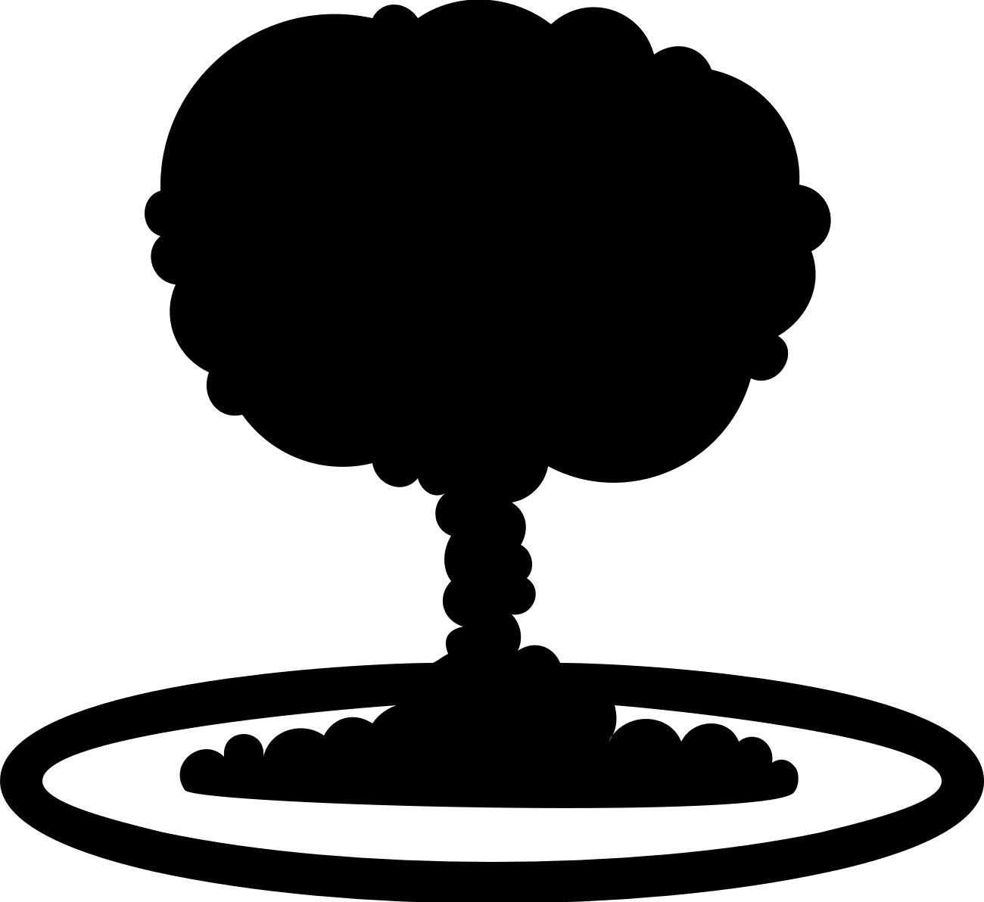

U.S. and Russia agree to a t____ b____ treaty. It banned all testing of n______ weapons except underground. Cold war tensions seemed to be easing.

**What is the Kremlin? _____________________________________________________**

**The Berlin Wall, 1961**

In **August** **1961**, the Soviets starting building what would become known as the **B_______** W_____

**The Berlin Wall was not designed to keep West Berliners out, but to keep the East Berliners in!**

USSR was embarrassed by large number of East Berliners leaving to the West. After all communism was better than c______.

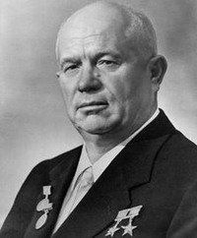B____________- a wall of concrete, barbed wire, guarded by machine gun towers.

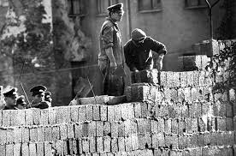The Russians built the Berlin _______, not to keep those from the West out, but to keep their own people from leaving to freedom in capitalist West Berlin

The Berlin Wall became the physical barrier representing the ‘Iron ___________’.

*Nikita Khrushchev*

Those who tried to escape from the east to the west were put in p_______ or s_______!

**Berlin: A Divided City**

* In **1961**, the Soviets starting building what would become known as the **B_________ Wall**.
* **The B________ Wall was not designed to keep West Berliners out, but to keep the East Berliners i__!**
* USSR was embarrassed by large number of East Berliners leaving to the West. After all communism was better than capitalism

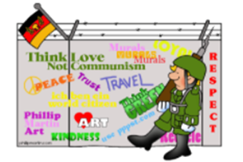**The Berlin Wall became a physical symbol of the iron c________ and the separation of d____________ from c____________.**

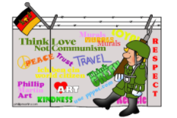

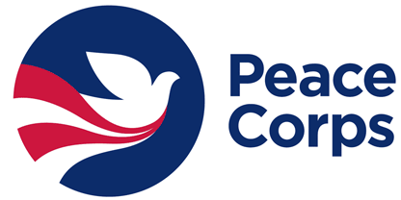

Kennedy also started the ________________ _____________

In which young Americans provided economic and social assistance to developing countries and to prevent the spread of c____________ around the world.

*“… And so, my fellow Americans: ask not what*

*your country can do for you—ask what you can do*

*for your country.…”*

— President John F. Kennedy, Inaugural Address, January 20, 1961

**How the Cold War Impacted Florida**

Guatemala:

Cuba: LIST and briefly describe three major events of the Cold War in Cuba that impacted Florida.

1.

2.

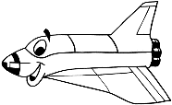 3.

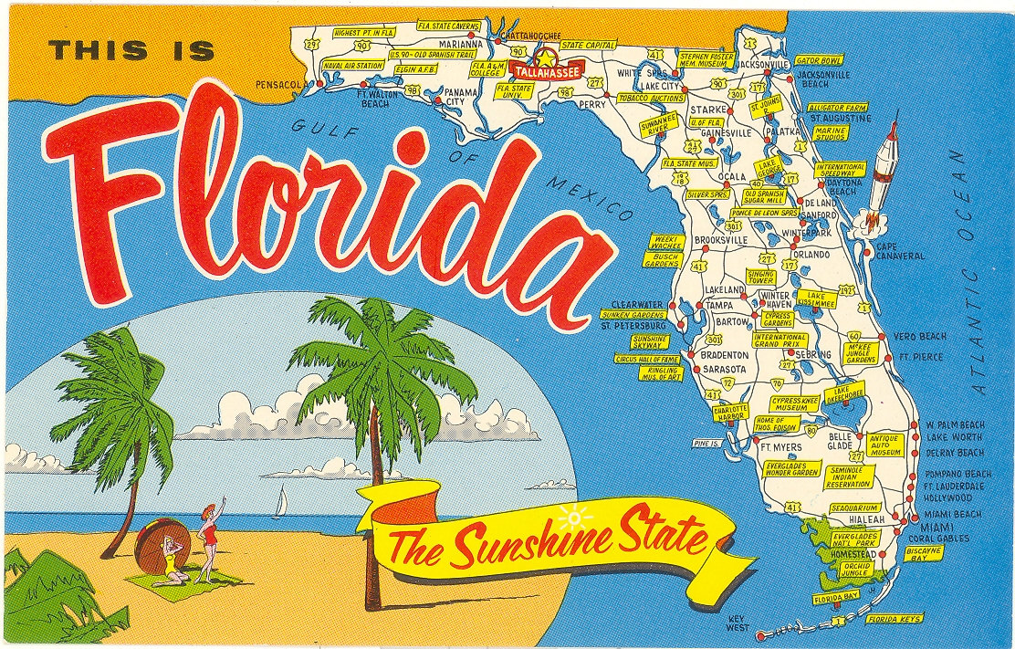**Florida’s Cape Canaveral:**

Why was Cape Canaveral established by the US Air Force?

NASA

Kennedy Space Center

1. McCarthyism of the early 1950s resulted in

(1) the end of the arms race (3) increased discrimination against returning veterans

(2) reduced spending on national defense (4) damage to the reputations of many innocent people

2. During the 1950s, United States foreign policy was shaped by

(1) the principle of nonalignment nations (3) a willingness to compromise with communist nations

(2) a return to pre–World War II isolationism (4) the emergence of two world superpowers

3. The formation of the North Atlantic Treaty Organization (NATO) and the Southeast Asia Treaty Organization (SEATO) were attempts by the United States and other nations to

(1) create mutual defense pacts (3) decrease the number of nuclear weapons

(2) increase tariff rates between members (4) provide economic aid to poor nations

… I do not believe that the American people and the Congress wish to turn a deaf ear to the appeal of the Greek Government.… As a result of these tragic conditions, a militant minority, exploiting human want and misery, was able to create political chaos which, until now, has made economic recovery impossible.… Meanwhile, the Greek Government is unable to cope with the situation. The Greek Army is small and poorly equipped. It needs supplies and equipment if it is to restore the authority of the Government throughout Greek territory. Greece must have assistance if it is to become a self-supporting and self-respecting democracy.… — President Harry Truman, Address to Congress, March 12, 1947

4. Congress responded to the situation described in this passage by

(1) sending combat troops to the Mediterranean region

(2) calling for creation of the North Atlantic Treaty Organization

(3) sending military and economic aid to Greece and Turkey

(4) supplying troops to a peacekeeping operation

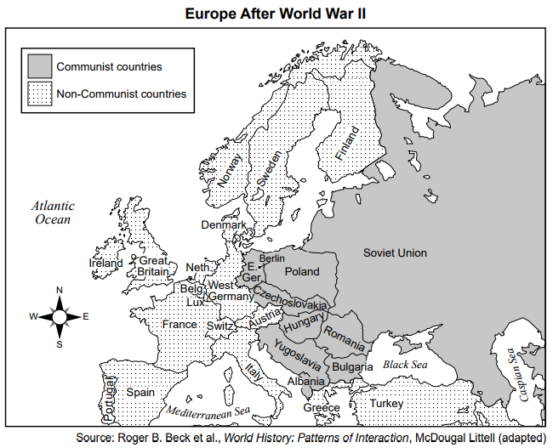

5. As a result of the situation shown on the map, the foreign policy of the United States during the administration of President Harry Truman was dominated by the belief that

(1) communist expansion in Europe should be contained

(2) cooperation with the Soviet Union should be increased

(3) satellite nations of the Soviet Union should not be recognized as legal states

(4) economic aid was not likely to help nations in Western Europe

6. One action taken by the United States in response to the situation shown on the map was to

(1) return to a foreign policy of isolationism

(2) attack Soviet-controlled territories

(3) help form the North Atlantic Treaty Organization (NATO)

(4) sign trade agreements with nations taken over by the Soviet Union

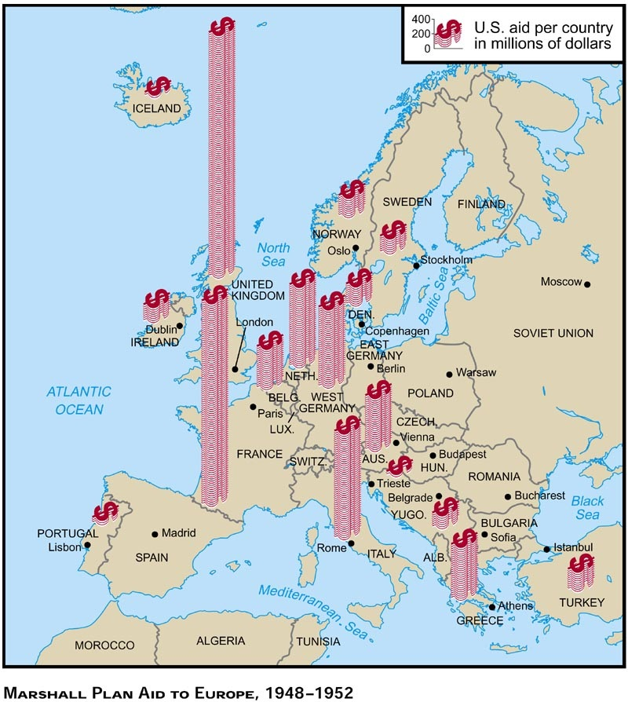

7.

