UNIT 5 Topic 5.1-5.2 AMSCO chpt. 15 Voting & Voting Behavior
TOPIC 5.1 Voting Rights and Models of Voting Behavior
Factors associated with political ideology, efficacy, structural barriers, and demographics influence the nature and degree of political participation.
Describe the voting rights protections in the Constitution and in legislation
Legal protections found in federal legislation and the 15th, 17th, 19th, 24th and 26th amendments relate to the expansion of opportunities for political participation.
LINKAGE INSTITUTIONS
- Linkage institutions are channels that allow individuals to communicate their preferences to policy-makers:
- What are the four linkage institutions?
  - Elections - Elections give “we the people” the most direct way to i___________ our government and its decisions. When our candidates win elections, we feel that our i___________ will be r______________.
  - Political Parties
  - Interest Groups
  - Mass Media
  - How do you let the government know about your opinions and beliefs?

SUFFRAGE = RIGHT TO VOTE
VOTING
- P_____________ A___________________ OFTEN ENGAGED IN BY AMERICANS (WHY?)
- Originally the Constitution left the individual s______________ free to determine the question of who could vote; eligibility standards for voting have been expanded by legislation and constitutional amendments
  - R__________ (eliminated by state legislatures)
Any time you see an amendment, you need to know it!!
  - P__________ (eliminated by state legislatures)
  - R_______ / ethnicity (eliminated by 15th Amendment)
  - G_______ (eliminated by 19th Amendment)
  - I_________ (eliminated by 24th Amendment banning poll tax)
  - L_________ (eliminated by Voting Rights Act of 1965)
  - Minimum of age 2__ (eliminated by 26th Amendment)

CURRENT QUALIFICATIONS
IN ORDER TO VOTE, YOU MUST:
- Have c__________________ status
- Be a r_________________ of the s_________________ you are voting in
- Meet the a________________ requirement of your state
- Be r_______________ in your voting area (in all states but North Dakota)

VOTING
1957 Civil Rights Act: First such bill since Reconstruction, addressed d_____________ in voter r______________ and established the U.S. Office of Civil Rights, an enforcement agency in the Justice Department.

1965 Voting Rights Act: The most effective bill to bring the black populace into the political process. This act outlawed the l_____________ tests and put states with low voter turnout under the watchful eye of the Justice Department. The law gave the department jurisdiction over states that had any type of voting test and less than 50 percent turnout in the 1964 election.

OTHER FORMS OF POLITICAL PARTICIPATION
(INVOLVEMENT O___________ THAN V__________)
- Petitions
- D_______________/m______________/r_______________
- Local party meetings
- Making campaign contributions
- Writing letters to the editor (or the internet equivalent)
- Trying to persuade others

TOPIC 5.2 Voter Turnout

Voter turnout is the total number of v________ cast for the highest office on the ballot. When we say that voter turnout is low in the United States, it means that the number of p___________ who actually v_________ is considerably less than the nation’s total voting a________ population (Note: The voter turnout number is not the same as the number of eligible voters because it includes noncitizens.)

Voter turnout is lower in m______________ elections, when all the seats in the House of Representatives and a third of the Senate are contested, and lower still in many l___________ and s______________ races.

VOTER TURNOUT IN U.S. AS COMPARED TO FOREIGN NATIONS
- One of the lowest of any industrialized nation
- U.S.: In the 50% range in presidential elections; 30% - 40% range in midterm congressional elections
- Declining since 1960 (why?)
- Deceiving because the U.S. doesn’t penalize for not voting

REASONS FOR LOW VOTER TURNOUT
- Institutional barriers
  - Registration
    - Voter r______________ d________________ voting
    - Registration laws v_______ by s___________, but is required in order to v____________
    - The most important provision of voter registration is the closing d_______ (no state can stop registration more than 30 days before election)
    - Effect of “m_________ voter” bill?
      - Allows people to r___________ when applying for a r___________ of driver's license
      - States can also use schools/libraries/city/county offices as r_______________ sites
      - States can permit m________ registration
      - Most registered claim to be I________________ – thus neither party helped
      - Does not appear to have i__________ voter turnout
- Institutional barriers- structural barriers
  - Registration
    - Explain how voter r_______________ d____________ voting.
    - Registration laws vary by state, but is required to vote
    - The most important provision of voter registration is the closing date (no state can stop registration more than 30 days before election)
Studies have shown that r________________ is the major h___________ to voter t__________. If you’ve m________ from one state to a___________ or from one c___________ to another since the last election, you have to r__________ again. This involves filling out an a_______________ and submitting it before the d____________, which varies from ten days to a month before the election. Only a handful of states allow you to register and vote on the same d_______.
REASONS FOR LOW VOTER TURNOUT
- L___________ ballot
- W_________ voting (T______________)
- Weakness of p____________ in m______________ voters
- Type of election
  - General election turnout > primary election turnout
  - Chief executive election turnout > legislative election turnout
  - Presidential elections have h_____________ turnout
  - National election turnout > state election turnout
- Difficulties in obtaining absentee ballots
- Too m_____________ elections
- Voting in 19th century was filled with f_________ – turnout may have been overstated – Progressive reforms (registration, Australian ((secret)) ballot) may have reduced fraud and therefore “turnout”

Because the overwhelming majority of those who register actually v_________, the focus in improving turnout has been on making it easier to r___________. The N____________ V_____________ Registration Act (M_______ V________ Act), which Congress passed in 1993 and became effective in 1995:
■ Allowed eligible voters to register when they applied for or renewed their driver’s l_________ (hence, the popular name, Motor Voter Act)
■ Directed the states to make registration services available at various g______________ offices
■ Provided for registration by m____________
■ Resulted in the creation of the National Mail Voter Registration Form, which allows a person to register from anywhere in the c______________.

REASONS FOR LOW VOTER TURNOUT
- Political reasons
  - Lack of Political e____________
  - “Costs” of voting seem to outweigh benefits to many
  - Dissatisfaction with candidates, parties, and politics in general
  - Y___________ people tend to have the lowest turnout. When the ______^{th} Amendment was ratified, turnout “naturally” declined.
- What is the 26th amendment?________________________________________________________________

Political e__________ is the belief that ordinary people can i______________ the government. Political efficacy effects v__________ t____________ because if the people believe they c______ influence the government (high political efficacy) they are more likely to vote while low political efficacy would have less people that vote because they don't think their vote will do anything. This can lead to voter a______________.

- Why does registration pose such a big problem when it comes to voting?

- What can we do to change that?

TURNOUT
- Turnout is highest in p__________ general elections
- Turnout in g_________ elections > turnout in primary elections
- Turnout in p__________ general elections > turnout in midterm general elections
- Turnout in p____________ primary elections > turnout in midterm primary elections
- Turnout in elections in which candidates for f__________ office are on the ballot > turnout in state
elections in years when there are no federal contests
- L_______ elections have lower turnout than state elections, and local primaries have even lower rates of participation
WHO VOTES?
- Educational level
  - H__________ levels of e_______________ achievement are more likely to vote than those with low levels, because they feel they have something vested in the system, understand how the system works and that the system works for them. Why? ____________________________________________________________
  - Greatest predictor of voting that cuts across other factors
- Race
  - Whites vote at a higher rate than Blacks
  - Blacks vote at a higher rate than Hispanics. Middle-class African Americans vote at a slightly higher rate than whites. The candidacy of Barack Obama clearly was a positive factor in African American turnout in 2008.
- Gender
  - Women voters e_________ that of men. The more significant fact is that women tend to be D______________ and men tend to be R_____________. The so-called “g___________ gap” is a factor in presidential politics.
- Income and career
  - H_________ family incomes are more likely to vote than those with l________ incomes. Usually have higher levels of education.
  - Higher-status c__________ are m________ likely to vote than those with lower-status jobs

- Age
  - O________ people, unless they are very old and perhaps infirm, are m_______ likely to v_______ than younger people
  - Persons 18 to 24 years of age have a p________ voting record; so do persons over 70

Why don’t politicians seem to care about young(er) people?

Why do politicians cater to certain demographics when it comes to running a campaign and making laws?

VOTING ON THE BASIS OF POLITICAL PARTY AFFILIATION
- Party Identification – Our sense of identification or a____________with a political party

- Party-line voting – Supporting a party by voting for candidates from one p_____________ party for all public offices across the ballot
Straight-ticket voting, also known as straight-party voting, enables a voter to select one political party's complete slate of candidates for every office by making a single mark on his or her ballot. As of March 30, 2020, six states provided for straight-ticket voting. The term may also be used informally to refer to the practice of a voter individually selecting candidates belonging to a single party

- Traditionally the strongest predictor of how someone is going to vote
  - Geography (Red States & Blue States)
    - South: Republican (because of Civil Rights Acts in 60s)
    - Great Plains: Republican
    - Rocky Mountain Region: Republican (Colorado swinging Democratic)
    - New England: Democratic
    - West Coast: Democratic
    - Great Lakes Region: Swing
    - Metropolitan/Urban Centers: Democratic
    - Rural Areas: Republican

VOTING ON THE BASIS OF CANDIDATES
- Candidate appeal – how voters feel about a candidate’s background, personality, leadership ability, and other personal qualities
- More people now “vote the m_______, not the party” than in the past; has led to an increase in I_______________
- In the past - Straight ticket voting
- Voting for candidates from the s__________ p__________ party for e_________ office on the b________
- Easier to do with party-column ballot
- D___________ in recent years (“vote the m_________, not the party”)
- In the present - Split ticket voting
- Voting for candidates from t______ different p__________ parties
- Easier to do with office-column ballot
- I______________ in recent years (“vote the man, not the party”)

VOTING ON THE BASIS OF ISSUES
- Issues
  - i.e. economy - can be good or bad
  - War is traditionally a R___________POINT (something we all rally around)
  - Rational-choice voting: Voting based on what is perceived to be in the citizen’s individual i______________
- Rational-choice voting: Voting based on what is perceived to be in the citizen’s individual i___________________
- Retrospective voting: Voting to decide whether the party or candidate in power should be r___________________ based on the recent past
- Prospective voting: Voting based on p____________ of how a party or candidate will perform in the future

VOTING BASED ON GENDER
- Women are more likely to vote D_____________, especially if they are s____________
– More l_____________ on issues such as military action, capital punishment, gun control, social programs such as Social Security, education funding, and environmental initiatives
- Men are more likely to vote R________________
- Sex-sensitive issues (e.g., abortion, pornography, gun control, war) provoke different views among the sexes
- GENDER GAP – Refers to the difference in the percentage of w___________ and the percentage of m__________ voting for a given candidate.

VOTING BASED ON RACE (Ethnicity)
- Whites: more c_____________, greater support for R_______________
- Blacks: more l____________, STRONGEST SUPPORTERS of D___________________ Party (~90% Dem. in recent presidential elections)
- Hispanics:
  - Mexican-Americans and Puerto Ricans more liberal and supportive of D_________________
  - Cubans more conservative and supportive of R__________________
  - Asians: supportive of D____________________

VOTING BASED ON OTHER FACTORS
- Social class
  - Lower: more likely than upper to vote D________________ (although changing)
- Upper: more likely than lower to vote R____________ (although changing)
- Religion
  - Protestant: more likely to vote Republican
    - Evangelicals, especially, are most conservative on social issues
  - Catholic: had been more likely to vote Democratic, but some slippage in recent years
    - White Catholics vote Rep in last presidential election (60/27 R)
    - Non-white Catholics vote Dem in last presidential election (67/26 D)
    - Jewish: more likely to vote Democratic- s________ vote

How do different genders vote? How do different religions vote? How do different races votes?

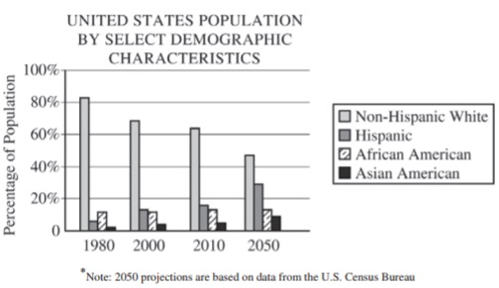

The United States is experiencing a dramatic change in the makeup of its population. These changes have political consequences for political institutions.

- Identify a trend depicted in the chart.

- Assuming that recent voting patterns continue, explain how the trend identified in (a) is likely to affect the electoral success of either the Democratic Party or the Republican Party.

- Explain how the demographic changes shown in the chart above are likely to affect the way in which parties operate in Congress.

- Describe two specific actions that presidents can take to respond to the demographic changes in the chart above.

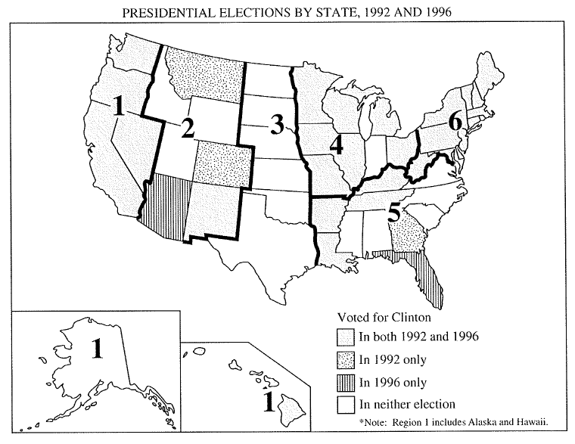

(a) Using the map, identify one of the numbered regions with strong support for the Democratic presidential candidate and identify and explain two factors that contribute to that support.

(b) Using the map, identify one of the numbered regions with strong support for the Republican presidential candidate and identify and explain two factors that contribute to that support.

