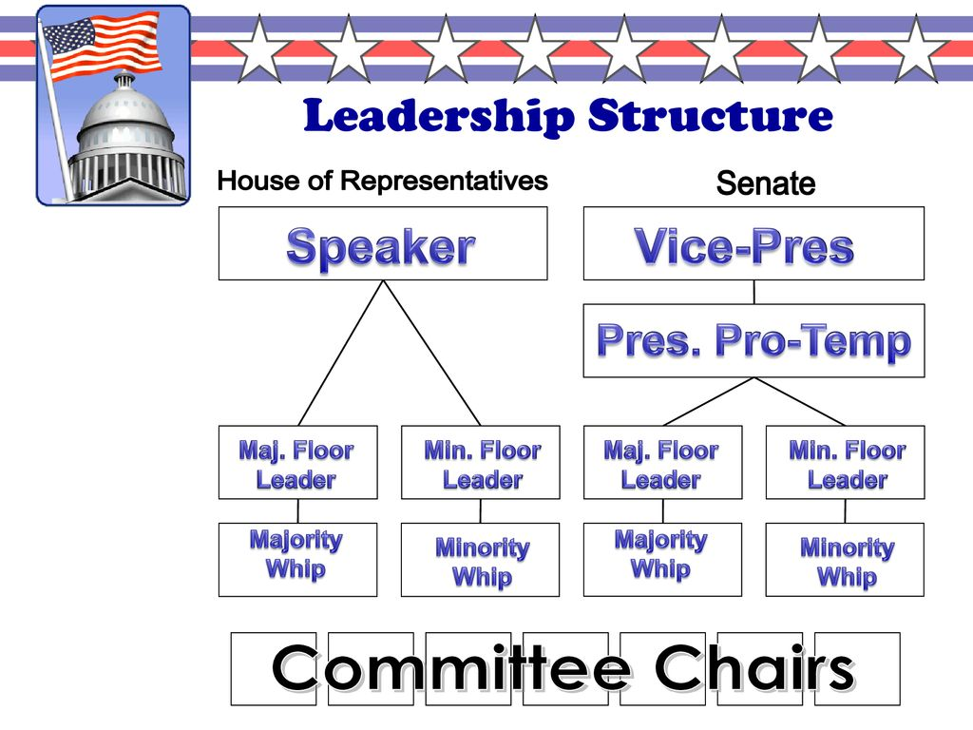
Chpt. 4 Topic 2.2 Congress: Structures, Powers, & Functions of Congress AMSCO pg. 108-123

Organization of Congress is very PARTISAN. Most members vote along party lines 90%+ of the time.
HOUSE OF REPRESENTATIVES
SPEAKER OF THE HOUSE
- Presides over House (Most powerful member) – always e_________ from majority party in H______
- A________ select and conference committees’ members
- Appoints Rules Committee members and its chairman
- Assigns b_______ to c_________
- T_______ in line for presidency after V.P.
- Informal powers, e.g., access to m________
- Inﬂuences a________ of the House

MAJORITY LEADER/MINORITY LEADER
- Partisan positions chosen by party members
- Floor leaders and legislative strategists

MAJORITY WHIP/MINORITY WHIP
- A_______ ﬂoor leaders
- Inform party leaders on "mood" of House
- Keep nose count on important votes
- P________ party members to vote with party
- L______ between party l_______ and r______ and f_____ membership

SENATE August Body- marked by M__________ D_________ OR GRANDEUR (upper house)
PRESIDENT OF THE SENATE
- Vice President of the U.S.
- Presides over Senate
- Votes in case of t_____
- Ceremonial job (h___________)

PRESIDENT PRO TEMPORE
- Ceremonial job/ h__________
- Presides in a__________ of V.P.
- F_______ in line for presidency

MAJORITY LEADER
- True leader in Senate
- Recognized ﬁrst for all debates – w/power to f__________, this gives Majority Leader strong inﬂuence on bills
- True leader of majority party
- I_________ committee a___________ of senators
- Inﬂuences Senate a________, along with Minority Leader
- Informal powers, e.g., of using the media

MINORITY LEADER AND PARTY WHIPS
- Same as House

DIFFERENCES IN OPERATION
The HOUSE of Representatives
- More formal—stronger leadership from Speaker
- R______ Committee
- Power less evenly distributed
- Members are highly specialized
- Emphasize tax & revenue policy & budget

The Senate
- Less formal—weaker leadership
- F_________
- Power more evenly distributed
- Members are generalists
- Emphasis on foreign policy
- Longer terms—focus on bigger picture

THE COMMITTEE SYSTEM
• Real work of Cong. is done in c__________ and s_________, not on the floor of the House or Senate.
• Before a bill even reaches the floor, it must first pass through a c_________, unless the committee has resisted "r________ out" the bill and the House votes to "d_________" it onto the floor for consideration on by the full body. (Senate committees lack the power to prevent bills from reaching the floor).
• Once in s________ committee, usually passed to sub_________ where they can be a________, p_______ or k________.
• Majority bills die in c__________ (p__________ v. discharge petition can be used to get bill out of committee. Seldom succeeds. Requires 218 signatures (majority) of House members. Good luck with that!!
• Subcommittees
– Where majority of legislative work is done
– Where bills are mainly marked up
– Hold Congressional Hearings
• Committee functions:
1. Analyze l___________
2. Conduct i________________ of executive branch on as-needed basis
3. Conduct o______________ /investigations of executive branch agencies on an ongoing basis

Congressional Oversight
Congressional oversight refers to the r_________, m_________, and s___________ of federal EXECUTIVE agencies, programs, activities, and policy implementation. Oversight is done through the c__________ system.

SELECTION OF COMMITTEE MEMBERS
- Importance of getting on the right committee, i.e., one in which a member can b______ s_______ his c_______, and thus increase his/her chances of r__________.
- Members are a____________ to committees by either the Committee on Committees or the Steering the Policy Committee.
- Whichever party has m_________ in the house will have a m________ on each committee. Party membership is very important in Congress. It determines the agenda, which then can become public policy.
- Committee c_________ is of m___________ party; “r__________ member” is most senior (longest serving) member of minority party on a committee

SELECTION OF COMMITTEE CHAIRMEN
- Power of chairmen is substantial over:
  - Selecting committee agenda
  - Hiring staﬀ
  - Membership on subcommittees
  - Jurisdiction of subcommittees
  - Chairmen are selected by s________ ballot in party c________ or conferences (of party leaders) at the beginning of the term.
  - Generally, the s___________ system is followed, i.e., the person of the majority party with the most seniority on THAT COMMITTEE is chosen chairman.
- Advantages of seniority system:
  - Experience.
  - Stability.
  - Expertise.
  - Reduces inﬁghting among those who would be rivals for chairmen.
  - Disadvantages of seniority system: Increases inﬂuence of 1 party states and decreases inﬂuence of competitive states. No new ideas. Out of touch. Seniority rule (system) unlikely to be abolished, because those members with the real power to abolish it are also the ones who reap the largest benefits from it.

COMMITTEE SYSTEM
- Standing – Committees are the p_________ committees of Congress.
  - Most important with 20 in House and 16 in Senate
  - Focus on legislation in a particular area (i.e. foreign policy, agriculture)
    - Develops expertise among its members
- Select – Special panels, usually t___________… set to i__________ / r_________ issues
  - Ex: Investigate Watergate, Organized Crime, Iran-Contra Affair
- Joint – Members of House and Senate
  - Similar to Select Committees; often focus public attention on major issues
- Conference – Temporary comm. to iron out diﬀerences between versions of similar bills
  - B_____ must pass House & Senate in e______ same form
IMPORTANT STANDING COMMITTEES
- HOUSE
  - Rules: Most p_________ of all.
    - Sets legislative calendar and establish “rules” for d_______ and a________; Set guidelines for ﬂoor debate; Limits t_______ for debate
    - Controlled by S___________; called “T_______Cop”- controls the f______ of legislation (bills). The R_______ Committee can speed up, slow down, or bury legislation/bills.
    - Determines the type of amendments that will be allowed on a bill
– Closed rule v. Open Rule
Closed Rule: A rule issued by the House Committee on Rules, in which there is a strict time limit for debate and no amendments can be offered.
Open Rule: In the House of Representatives, a rule that allows any amendments to a bill, regardless of whether they’re relevant to the legislation.
  - Ways and Means: deals with t____ bills.
  - Appropriations: deals with s_______ bills.
    - Authorization bill allows for money to be spent.
    - Appropriation bill provides the actual funding for the program.
    - “E____________s:” special projects set aside by members to beneﬁt home districts or states. Dramatic rise of these in recent years. Too much “PORK”
  - Budget
  - Armed Services

IMPORTANT STANDING COMMITTEES IN THE SENATE
- SENATE
  - Finance: deals with tax bills.
  - Appropriations: deals with s__________ bills.
  - Budget- financial plan for US gov
  - Foreign Relations: Highly prestigious
    - Senate has larger role in foreign aﬀairs than House because of treaty ratiﬁcation, ambassador, conﬁrmation provisions in Constitution
  - Judiciary: Screens j________ nominees (judges to federal court system)
    - Careful scrutiny given because of the power of the modern judicial branch and the fact that federal judges have l________ terms. Presidents Clinton and Bush 43 both criticized the committee by holding up numerous judicial nominations. Some delays under Clinton lasted many months, and in some cases, years. The Judiciary committee approves pres nominations of fed. judges and refer to the full S___________ for approval or NOT!!
CONFERENCE COMMITTEES
- T__________ committees comprised of members from b_______ houses to i_____ out diﬀerences between versions of similar b______ (b/c bills must pass House & Senate in e_____ same form)
- Develop c__________ language on a bill when House and Senate versions diﬀer (about 10% of the time).
- After conference committee s______ bill back to each house, n__ a____________ are allowed, and the bill generally passes.
- The power of these committees is such that they are often called the "t____ house of Congress."

- What types of committees might a representative or senator from Florida want to sit on & why?

- Committees often over-represent constituencies with the greatest stake in committee's business. How does this contribute to the Iron Triangle?

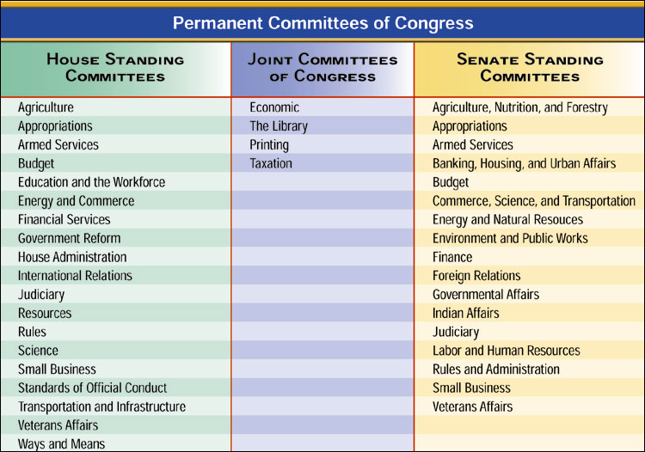
THE BILL PROCESS
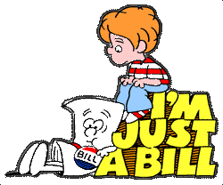
- Most important power of Congress
– Lengthy, deliberate, fragmented, characterized by n___________ and c____________
- Anyone can write a bill…O_______ a m_________ of C________ can i________ a b_____
- A bill can be intro. in the H______ or the S_______, but all t_____ bills must originate in H_____ of Rep.
- Bill must pass b_____ h_______ in the s_____ form to move onto the P__________

The Bill Process: House of Representatives
- Bill Introduced
  - Receives #/Reading… HR 123
  - S________ of the House sends bill to a___________ Standing Committee (may set time limits on comm.)
    - Speaker may also decide n_____ to refer bill to committee at all, eﬀectively k_________ the bill
- Standing Committees…Critical Step
  - Often report to subcommittee…hold h__________, may call expert witnesses, etc
  - Most bills die in committee… p_______________
Discharge Petition…what is it? can be used to get bill out of committee. Seldom succeeds. Requires 218 signatures (majority) of House members. Good luck with that!!
  - Bills that receive consideration…
    - Bills approved by subcommittee then returned to full comm. where members can m____ up or add items to bill
- Standing Committee Options:
  - Report Favorably “____ Pass”
  - Pigeonhole/T_____- bill dies in committee
    - Requires discharge petition to resurrect bill.
  - A_________ and report in new form
  - Report w/ u___________ recommendation- bill dies
- Rules Committee (HOUSE ONLY)
  - Once bill out of Standing Committee in the House…sent to the R______ Committee
  - S__________ of the House appoints ___ /13 members
  - Functions of Rules Comm.
    - Comm. must grant a “______” (set time for appearance/debate)…failure to do eﬀectively k______ a bill
    - Restrict or loosen time limits for debate, even p________ amendments (c________ rule)
    - Only way to get around Rules Comm…d_________ petition/vote to suspend rules
- Rules on Bills:
OPEN RULE In the House of Representatives, a rule that allows any amendments to a bill, regardless of whether they’re relevant to the legislation.
CLOSED RULE A rule issued by the House Committee on Rules, in which there is a strict time limit for debate and no amendments can be offered.
There are variations of both rules.
- Only g__________ amendments (amendments r__________ to the substance of the bill) are allowed under the modified open rule.
- The m____________ c_________ rule (also called the s__________ rule) may limit amendments to a particular section of the bill as established by the Committee on Rules.
There is no equivalent to the Committee on Rules in the S__________; a bill goes from the committee directly to the Senate floor for action.

THE BILL PROCESS: SENATE
- Mirrors house, but more i________ (no r_____ committee)
- Referred to Committee by Senate Majority Leader
  - Senate M________ Leader may decide not to refer bill to Committee, eﬀectively k________ it.
- After committee, bills called to f_________ by majority leader (no R______ Committee)
- U__________ debate…ends with unanimous consent
  - F__________, not in the Constitution. It is a S_______ Rule ONLY and not in the Constitution.
    - Delay or prevent action on a bill by using long speeches/unlimited debate to “t_______ a bill to death”, used by m________ party to stop a bill. Minority does not have the v________ to vote a bill out of existence.
    - So e___________, most bills now need 60 votes…why?_____________________________________
Cloture- Process to end a ﬁlibuster. It takes 16 senators to ask for a cloture vote
    - 60 votes needed to end a ﬁlibuster. Good luck with that!!!

Why is a filibuster an effective way to kill legislation?

THE BILL PROCESS: SENATE UNANIMOUS CONSENT AGREEMENT
Unanimous Consent Agreement - A unanimous consent request setting terms for the consideration of a speciﬁed bill or other measure. These agreements are usually proposed by the majority leader or ﬂoor manager of the measure, and reﬂect negotiations among senators interested in the measure.
– Many are "time agreements," which limit the time available for debate and specify who will control that time. Many also permit only a list of speciﬁed amendments or require amendments to be to the measure. Many also contain other provisions, such as empowering the majority leader to call up the measure at will or specifying when consideration will begin or end.
THE BILL PROCESS: SENATE HOLD
- The Senate HOLD - An i__________ practice by which a senator informs his or her ﬂoor leader that he or she does not wish a particular bill or other measure to reach the ﬂoor for consideration. The majority leader need not follow the senator's wishes but is on notice that the opposing senator may f_________ any motion to proceed to consider the measure.
- The Senate “hold” is an i____________ practice whereby Senators communicate to Senate leaders, often in the form of a letter, their policy views and scheduling preferences regarding measures and matters available for ﬂoor consideration. Unique to the upper chamber, holds can be understood as information-sharing devices predicated on the unanimous consent nature of Senate decision-making. Senators place holds to accomplish a variety of purposes—to receive notiﬁcation of upcoming legislative proceedings, for instance, or to express objections to a particular proposal or executive nomination—but ultimately the decision to honor a hold request, and for how long, rests with the majority leader. Scheduling Senate business is the fundamental prerogative of the majority leader, and this responsibility is typically carried out in consultation with the minority leader.
- The inﬂuence that holds exert in chamber deliberations is based primarily upon the signiﬁcant parliamentary prerogatives individual Senators are aﬀorded in the rules, procedures, and precedents of the chamber. More often than not, Senate leaders honor a hold request because not doing so could trigger a range of parliamentary responses from the holding Senator(s), such as af____________, that could expend signiﬁcant amounts of scarce ﬂoor time. As such, eﬀorts to regulate holds are inextricably linked with the chamber’s use of unanimous consent agreements to structure the process of calling up measures and matters for ﬂoor debate and amendment.
MISCELLANEOUS FEATURES
Riders: is a provision not likely to pass on its o_____ m________ that is attached to an important measure certain to pass. Its sponsors hope that it will r_______ through the legislative process on the strength of the m_____ measure.
A bill with numerous riders is often called a C____________ tree bill
  - New laws added to a bill that may or may not be related to the subject matter of the bill…Why?
    - Usually controversial measures that can’t pass on their own or “gift” to interest group
    - Earmarks/Pork Barrel Spending
  - Appropriations bill that beneﬁts a speciﬁc constituency
  - How does this help w/ reelection? _________________________________________________________
_____________________________________________________________________________________
  - “An earmark is money your Congressman wisely brings home to your district. Pork is money that some other Congressman wastefully brings home to his district.”
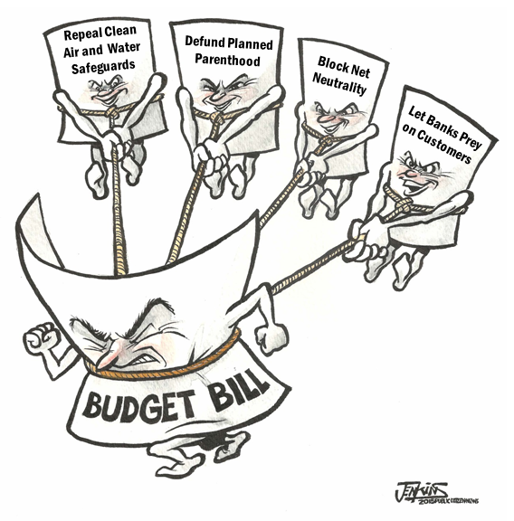

A bill with numerous riders is often called a Christmas tree bill also called an o___________ bill
In the Senate, no limits exist on amendments, so Senators try to attach riders that will benefit their home state.

WHY DO SO MANY BILLS DIE? For the AP exam, you must know the different ways a bill can die in HR and S.
- Why do so many bills die?
  - Speaker and Senate Majority Leader can kill a bill by not referring it to a Committee
  - Most bills die in Committee (tabled or pigeon-holed)
    - Either the Committee never schedules it for a vote; or the vote fails to receive a majority in Committee
    - Bills could also be altered by Committees to make them more likely to fail on the ﬂoor (amendments)
  - Any Senator can block a vote with a f_____________ or the threat of one.
  - In the House, the R_______ Committee can block a bill by never granting it a “r_____” (scheduling it for debate) or setting restrictions on debate.
  - The president can kill a bill
    - Veto or Pocket Veto
    - Or the t________ of a Presidential v_______ is enough to stop a bill in its tracks
  - A bill may fail to receive a s_______ majority vote on the ﬂoors
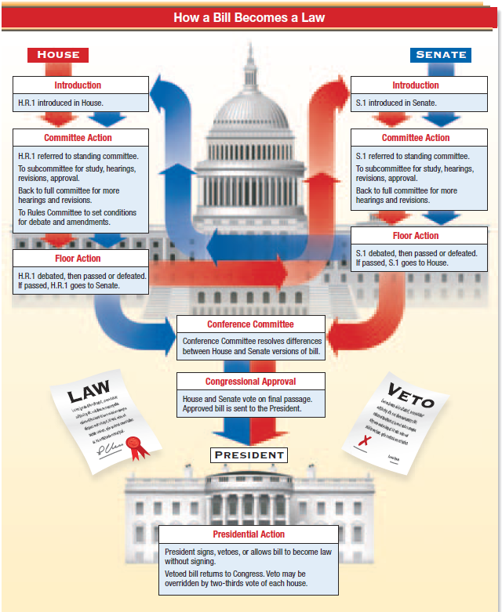

Generating a Budget
Congress must generate a budget that addresses both d____________ and m_____________ spending, and as entitlement costs grow, discretionary spending opportunities will decrease unless tax revenues increase, or the budget d_________ increases.

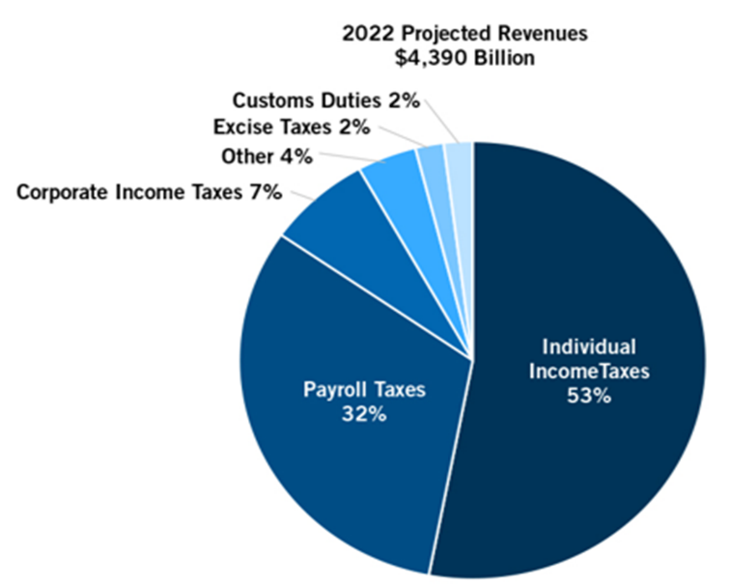
C_______________ B___________ O_________- created by Congress to help in preparing the nations b________. Non-p___________ accountants. Serves as a c________ on the President’s OMB- Office of Management and Budget, created by Congress to help the President prepare and present a budget to Congress.

Sources of Government Revenues
For fiscal year 2019 the gov expected to take in $2.3T. Gov revenue comes from 5 sources:
1.
2.
3.
4.
5.

Mandatory Spending
Government spending the budget for fiscal year 20l9 called for spending $4.4 trillion. Each year spending falls into three categories: m_______________ spending, i_____________ on debt, and d_____________ spending.
Mandatory spending is payment r__________ by l______; m___________, for certain programs.
- S__________ S___________
- M___________/ M_____________
Are the largest spending expense for the gov.
In 2016, US gov collected $3.3T in revenues but spent $3.99T running a deficit- gov spent more than it collected in taxes. Add up all the deficits and you get the national debt. The nation debt now stands at $29.9Trillion.

Discretionary Spending
Discretionary spending is money f__________ a___________ by the President and v_________ on by Congress during the a_______________ process each year. Largest discretionary budget item is national d______________.
