Unit 5 Topic 5.8 Electing President Chpt. AMSCO Chpt 18 pg. 587-595
Explain how the different processes work in a U.S. presidential election.
Explain how the Electoral College facilitates and/or impedes democracy.

WHAT DOES T HE CONSTITUTION SAY ABOUT WHO CAN BE PRESIDENT?
- N____________________ born citizen
- Minimum age of ___________
- U.S. r_______________ for ______ years.
STEP 1: PRIMARIES AND CAUCUSES
Primary Season and competing for delegates
HOW TO BECOME THE PARTY NOMINEE
Presidential Incumbency Advantage
In 2020 there was one Republican challenger to Pres. Trump
Presidents have incumbency advantage.
- _______________________________
- _______________________________
- _________________________________________________
- _________________________________________________
- _________________________________________________

The nomination game is an e_______________ contest. The goal is to win a majority of d____________’ support at the national party c_____________. Who were the eventual winners of each party for the 2020 Presidential Election?
- The primary season includes both state p____________ and state c___________
- The main feature of a presidential primary is that the v_________ of a particular s_________ are deciding which “d_____________” they will send to the national party convention
  - Delegates may be selected on a p__________________ basis or
  - Delegates maybe selected on a “w__________-t_________-a_____” basis
  - S________________
    - Used by the D_______________
    - Party l__________ and party o_____________ (Reps, Senators, Governors) and others
    - Not pledged (can vote for whoever they want)
    - Designed to pick c____________ with best chance to win the g__________ election

During the primary season (February – June 2016), the candidates are c______________all over the country to secure enough d_____________ votes to win the party’s n____________. Some candidates will s___________their campaigns after p________ performances in the early stages.
- Most states hold a p____________, in which voters from every p___________ party cast s__________ ballots for the best c______________ that will r_____________ their party in the g______________ election
- Used by more than t__________-fourths of the states
- More power to the people because of increased use of p______________ (more d___________ form of democracy)
  - Political p____________ have l________ control over n_____________
  - More m___________ is spent on elections to win peoples’ votes
- Importance of the N_____ H____________ Primary: 1st state to hold primary each election year
- “S___________ Tuesday” – Date in which m__________ southern states hold their p_____________ early in the election season.
- “Front-Loading” trend – the b___________ of primaries e_________ in an e__________ y____________
- “Front-Loading” trend – Primaries are held earlier in the year for s__________ to be more r___________
- This is where voters can cast their vote to determine who will represent each p________.

It gives candidates with name r___________________ and m_______________ a distinct advantage, because the candidates need to get their messages across in so many states so early, which is expensive.

If a candidate is less successful in a primary than the pundits expect, his or her sources of money will likely dry up and support will fade. But the opposite is also true: A candidate who does surprisingly well can very quickly move from d________ h________ to front-runner in the eyes of the public.

In some states, a caucus is held to select the best candidate from each party through discussions and open votes.
- A caucus is a m___________ of p__________ members and supporters of various c______________; it centers on the p____________ organization
- The process starts at l__________ meetings open to all p__________ members, who take positions on candidates and issues and elect d_____________ to represent their views at the next level; this process r___________ until national nominating convention delegates are chosen
- Importance of Iowa Caucuses – f__________ in nation (even b__________ New Hampshire primary)
- Local Caucuses >> District Convention >> State Convention >> National Convention. Each level selects d____________ to attend higher level.

If a candidate is less successful in a primary than the pundits expect, his or her sources of money will likely dry up and support will
fade. But the opposite is also true: A candidate who does surprisingly well can very quickly move from d________ h________ to
front-runner in the eyes of the public.
In horse racing, a "dark horse" is a horse that wins a race when no one expects it to.
Which states hold caucuses? Alaska, Colorado, Hawaii, Kansas, Maine, Minnesota, Nevada, North Dakota, Wyoming and I_______.
HOW TO BECOME PRESIDENTIAL NOMINEE
Have you ever been with a large group of people trying to order a pizza? The process usually creates a difficult situation, as individuals want very different things. Imagine your teacher has just told you that he is going to order a pizza for your entire class; however, your teacher presents your class with only two options for how you will go about choosing what you want on your pizza.
#1 - You have the choice between a pizza with cheese, pepperoni or pineapple. There is no discussion on this matter, just a simple vote. Each member of the class will cast one vote.
or
#2 - You have the opportunity to discuss with your classmates what toppings you would choose for the pizzas and come to some sort of agreement on your own.
Which option would you choose, the first or second? Why? What are the advantages for each? Disadvantages?

What is the difference between a primary and a caucus?

What are the advantages and disadvantages to each?

STATE PRIMARIES AND CAUCUSES – 2016 EDITION
Remember, during the primaries and caucuses, it’s (D) vs. (D) and (R) vs. (R). Candidates are trying to win as many delegate votes as possible.
Started with Iowa on February 3, 2020
California voted on March 3, 2020
- Super Tuesday
- 14 states voted that day
Primary voting ended in August (usually ends in June)

Who are the “delegates” and how many votes does each state get?

State Primaries and Caucuses
2016 EDITION – Democratic and Republican Delegates
For the Democratic Party | For the Republican Party
3,979 delegate votes total  1,991 delegate votes needed to become party nominee | A simple majority 2,550 delegates votes total  1,276 delegate votes needed to become party nominee
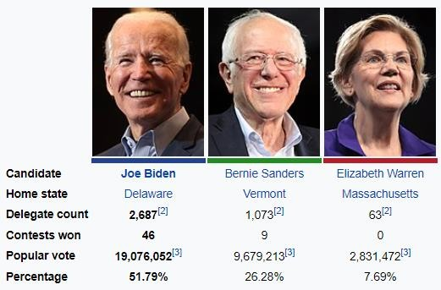 | 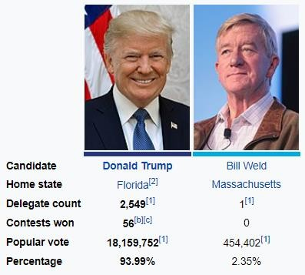

- What is the difference between a primary and caucus?

- Which one is better for the “democratic process”?

STEP 2: NATIONAL CONVENTIONS
Officially Become the Party Nominee

Now it’s time to officially decide who will be the presidential and vice-presidential candidate for each party.

HOW TO BECOME PRESIDENTIAL NOMINEE

Each party holds a n___________ convention. The delegates v________ to OFFICIALLY SELECT a final presidential nominee. The candidate that wins the m___________ of the overall delegate vote is the party’s nominee.
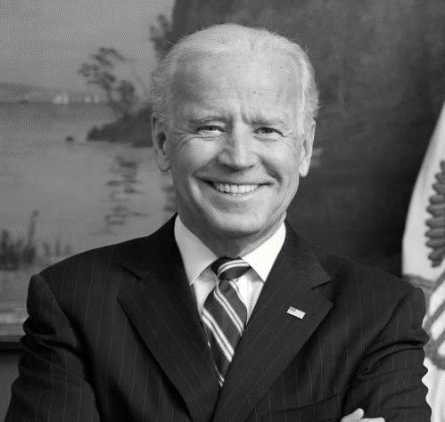

Republican nominee: Donald Trump
Democratic nominee: Joe Biden

At the convention, the presidential candidate announces a running mate (vice presidential candidate).

The presidential candidate chooses a running mate who will “b______________ the ticket”. That is someone who can strengthen his chance of being e______________ by virtue of certain ideological, geographic, ethnic, gender or other characteristics.

What does it mean when the presidential candidate chooses a vice president to help “balance the ticket”?

Why did Joe Biden choose Kamala Harris as his VP?

Why did Donald Trump choose Tim Kaine as her VP?

How does a candidate become the official nominee for a political party? (In other words, what happens at the National Convention?)

STEP 3: GENERAL ELECTION
The people vote for the e_________in November. We don’t v________ directly for the president or vice president.

The presidential candidate’s campaign throughout the country to win the support of the general p_____________. Much of the candidates’ time, particularly in the later stages of the campaign, will be spent in the contentious “S____________” states.

The presidential debates are generally considered the last big opportunity to move voters before the election.
They offer rare moments for Americans to do some head-to-head comparison shopping between two candidates on the same stage discussing the issues.

- C__________ cast their votes in N_____________ to select groups of e_____________ who will represent their states in the electoral c_____________.
- These e______________ will meet in their s________ and formally v__________ to elect the president and vice president in D______________.
- E____________ votes are formally counted at a j_________ session of C____________ on January 6, 2017. The P______________ of the S_____________ formally announces the result.

ANALYSIS OF PRESIDENTIAL NOMINATING SYSTEM
Pro:
- Highly participatory: caucuses, primaries, conventions
- Highly representative
- Weeds out weaker candidates
Con:
- Low rates of turnout
- Too lengthy
- Does not test candidates for qualities they need as President. Too much emphasis on media game – horse race.
- Delegates at caucuses and conventions tend to be unrepresentative: more ideological, more activist, more educated, less moderate, much wealthier.
- Voters in primaries tend to be better educated and more affluent than those in general elections à more ideological

FRQ Practice11

Nominees for the presidency of the two major parties are chosen by delegates at national conventions. How these
delegates are chosen varies across states and between the political parties.

a. Define each of the following methods used by states to choose delegates to party conventions.
• Open primary
• Caucus
b. Republican Party rules permit winner-take-all primaries. Describe one consequence of this rule for the
Republican nomination process.

c. The Democratic Party has used superdelegates in the presidential nominating process since 1984. Explain
why the use of superdelegates increases the influence of party leaders in the Democratic nomination process.

d. Explain why a candidate’s strategy to win the nomination is often different from the strategy developed to
win the general election.

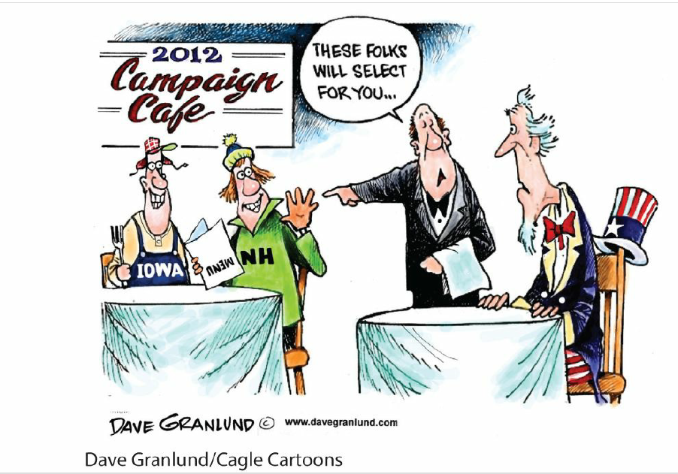
FRQ Practice
Use the cartoon and your knowledge of U.S. Government and Politics to answer parts A, B, and C.
A. Describe the viewpoint expressed in the cartoon.
B. Describe one criticism of front-loading in the nomination process.
C. Explain one way in which a candidate might benefit from front-loading.

TOPIC 5.8 Electing a President The Electoral College

Explain how the Electoral College facilitates and/or impedes democracy.

The winner-take-all allocation of votes per state (except Maine and Nebraska) under the setup of the Electoral College compared with the national popular vote for president raises questions about whether the Electoral College f________ or i______ democracy.

QUESTION OF THE DAY
Is the Electoral College an outdated model that needs to be scrapped or revamped, or is it fine just the way it is? Be ready to defend your position.

RATIONALE FOR SUCH A SYSTEM AT THE CONSTITUTIONAL CONVENTION
- Poor communication >> common people would lack essential i___________
- Desire to have the nation’s elite select the President. Fear that d__________ might sway the common people (m________).
- A compromise by those who wanted direct election and those who wanted the Congress to elect the President
- The Electoral College also reflects the federal nature of the Constitution
  - Ensures that the states have a role in selecting the president
Elite Democracy-
Demagogues excite the p____________ of the mob against the m____________, thoughtful customs of the society of society.

Demagoguery is an appeal to people that plays on their e_________ and p__________ rather than their rational side. Demagoguery is m__________ approach often associated with dictators and sleazy politicians that appeals to the w_______ nature of people.

THE ELECTORAL COLLEGE
In the Electoral College system, each state gets a certain number of electors based on its r_____________ in C__________. These electors vote for the president and vice president.
- Total of _______ Votes (435 House Reps + 100 Senators + 3 for District of Columbia)

GOOD THINGS ABOUT THE ELECTORAL COLLEGE
- Represents our f________ system, with its emphasis on the states and their representatives.
- Every s________ to have a voice, including the small states. These states might be overlooked if the election was decided by the results of the popular vote.
- Prevents s__________ by requiring a winning candidate to have support from throughout the country.
- Contributed to political stability by promoting the t____-party system. That system encourages the major parties to represent a w______ range of interests.
- May strengthen the power of organized interest g_______, (p_______ democracy) such as women voters or minority voters. These groups can play a powerful role in deciding the outcome of close elections.
CRITICISMS OF THE ELECTORAL COLLEGE
- Concentration of campaigning in a few large, swing states to tip the
balance of the electoral college
- The allocation of electoral votes in the winner-take-all system exaggerates the margin of victory
- President can be elected with only a p_________, rather than a majority, of popular votes, especially with presence of strong 3rd party candidates
- Possibility of a “minority” President (1824, 1876, 1888, 2000, 2016)
- “F_________ Electors” - no Federal law requires electors to vote the way they are “supposed” to vote
- Small states proportionally over-represented; Small states ridiculously over-represented if election goes to the House (Wyoming would have same voting power as California)
- I________ development of t_______ parties

ALTERNATIVES TO THE ELECTORAL COLLEGE
- D_________ P________ Election: Everyone’s vote would be worth the same. Majority of popular vote wins.
- District System: Candidate who wins a congressional district wins that district’s electoral vote; Candidate who wins the overall state popular vote wins the two “Senate” electoral votes (Maine and Nebraska currently use this system)
- Proportional System: Candidate gets same % of electoral votes as popular votes
- Alternative Vote System: Method of election (also called instant runoff) in which voters rank candidates in order of preference. If any single candidate receives a majority of first-preference votes, that candidate is deemed elected. If no candidate clears this hurdle, the last-place candidate is eliminated, and that candidate’s second preferences are reapportioned to others and so on until a candidate clears the threshold of 50 percent of the vote plus one.
- Keep electoral votes but abolish the electors themselves

Electoral College Argumentative Assignment Deconstruct
The framers of the Constitution created the electoral college as the means of electing the president.
Take a position on whether the Constitution should be amended to abolish the electoral college and replace it with a direct popular vote.
Use at least one piece of evidence from one of the following foundational documents:
- Article 5 of the United States Constitution
- Brutus I
- The Federalist 10
In your response you should do the following:
✓ Respond to the prompt with a defensible claim or thesis that establishes a line of reasoning.
✓ Support your claim with at least TWO pieces of specific and relevant evidence.
• One piece of evidence must come from one of the foundational documents listed above.
• A second piece of evidence can come from any other foundational document not used as your first piece of evidence, or it may come from your knowledge of course concepts.
✓ Use reasoning to explain why your evidence supports your claim or thesis.
Thesis/ Claim:
Rebuttal, refutation, or concession (circle the one you chose to write):
Article 5
Brutus I
Fed 10
Evidence: Examples from history or gov Concepts learned in class

