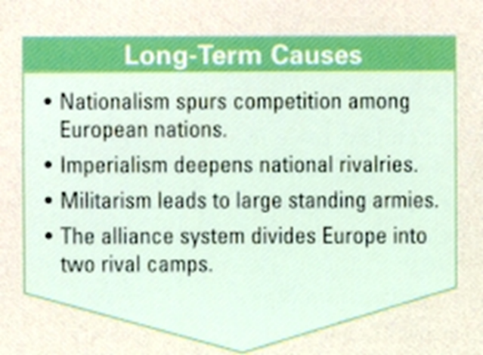
World War I 1914-1918 Chpt. 9
Causes of World War 1
There were 4 major causes of why the war happened:
  - Militarism- _____________________________________________
  - Alliance system- _______________________________
  - Imperialism-_____________________________________________
  - Nationalism-___________________________________

The Flashpoint:
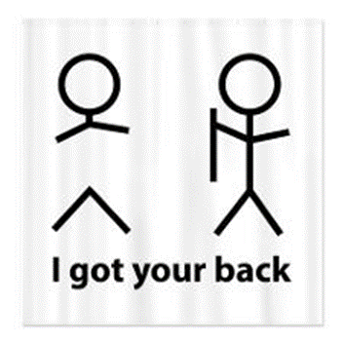
Archduke Franz ________________________ of Austria was assassinated by a Serbian nationalist in 1914.

Following the assassination, alliances were invoked, leading to a full-scale war with Britain, France, and allies on one side and Germany and allies on the other.
bruh!!
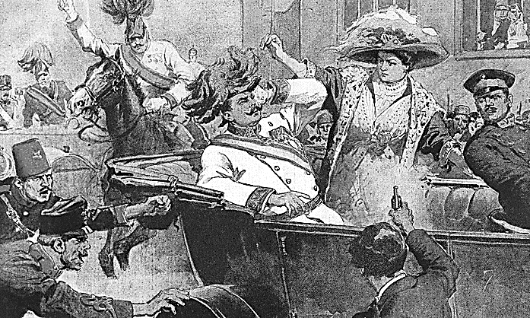

Alliance System – agreements between nations to aid one another if they were attacked. Meant to keep a balance of ______ but any dispute involving any two of these countries threatened to involve all others.
By 1890s, Europe was divided into two alliances, all based on the Balance of Power theory- national security is enhanced when military capability is distributed so that no one state is strong enough to dominate all others.
Allied Powers (friends) Central Powers (enemy)
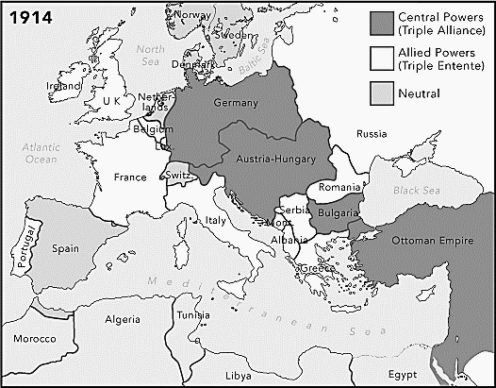
1914-1917 U.S. maintains a policy of n______________.
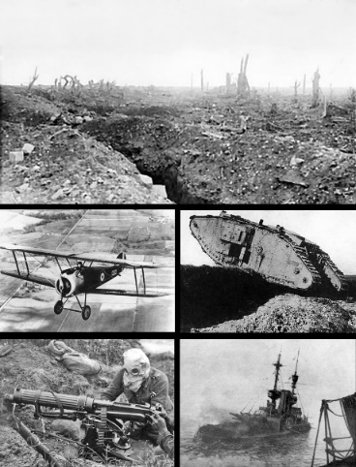
USA enters war on Allies side in 1917

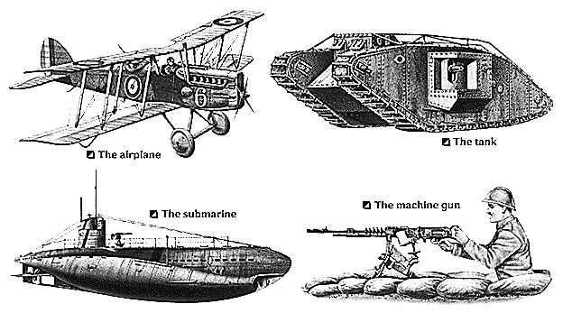
Fighting In Europe
Both sides predicted the war would be over soon, both would be wrong.
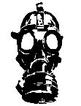
New weapons were introduced:
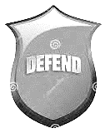
machines ______, poison _______, submarines or U-b______, air_______, & tanks.
These weapons made it easier to d_________ a position rather than attack.
T___________ were dug along France’s eastern border with Germany, it was called the ‘W__________ Front’. The same happened on the E________ Front with Russia and Austria-Hungary and Germany.
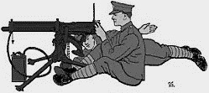
The Western Front would become a very deadly area.

Trench Warfare was a new and strange form of war no one had ever seen before.
Men dug trenches that were separated by barbed wire and land mines, and defended with m__________ guns. The area between them was called ‘N_____ M______ L_______’ and was a killing zone.
Soldiers would spend years in the trenches because neither side could advance causing a s____________, a situation in which no progress can be made or no advancement is possible and drawing out the War. On the Western Front there were 1500 miles of trenches from Belgium to Alps near Italy. Same was happening on the Eastern Front with over 2000 miles of trenches.
The death toll would be horrendous.

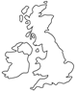
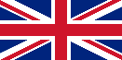
TRADE Naval Warfare: The British naval blockade of Germany and the German counterblockade with U-boats of Great Britain made it difficult for the U.S. to carry on trade with Europe as a neutral power. As a result, trade with _________ __________ quadrupled.
“He kept us out of ______________________” Wilson’s 1916 Re-Election Slogan
PROVOCATIONS Three things prompted the U.S. to enter the war:
Great Britain
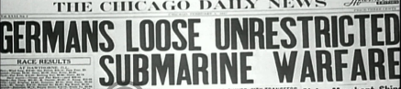
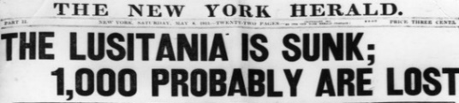
- Cruise Ship: Sinking of the _______________________ (1915)

- Submarine: Un_______________ submarine warfare. This violated the principle of “freedom of the _______”, or the right of neutral nations like the USA to ship non-military goods to nations at war.
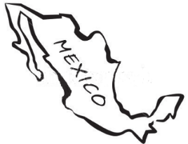
- Freedom of the s_________
- Telegram: The Z______________ Note from Germany to M________________
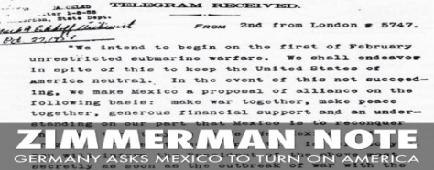
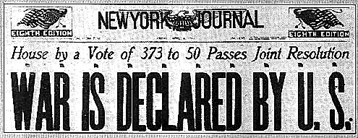

US Declares War on Germany April 2, 1917
Wilson: The U.S. is fighting to “make the world safe for d ______________.”
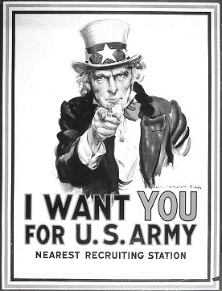
To fight the war, Pres. Wilson was given increased powers by Congress.
US not ready for war.
To solve the problem of a lack of military personnel the United States Congress passed the S__________ S_________ Act. The Selective Service Act required all males aged 21 to 30 to r_______ for the d_______ or military c___________. You could potentially be s__________ for military service. The draft put about 3million men into uniform.
Some men refused to serve, because it violated their religious beliefs. They were called c______________ objectors.

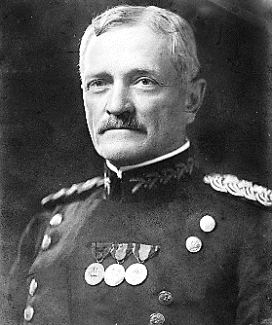
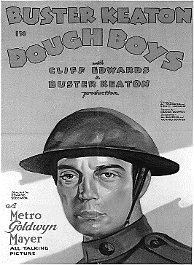
To fight the war, US create AEF-A_________ E___________ Force. One million strong Army unit to fight in France under US command of General John “Black Jack” _____________.
USA not ready for war. USA had to ____________-bring into use America’s vast resources. It would take USA over a year to get 1million soldiers into France- May 1918.
US soldiers were called “D_______ B____” because of the flour or pipe clay which the soldiers used to polish their white belts.
General John J. Pershing
The Home Front, 1917-1918
The war saw a vast expansion of the federal govt. Wilson was given sweeping power by Congress to regulate wartime production.
New Agencies of the Fed Govt.
1. Committee for Public Information- _______________________________________________________________________________________________
2. War Industries Board- _______________________________________________________________________________________________
3. Food Administration- _______________________________________________________________________________________________
4. Fuel Administration- _______________________________________________________________________________________________
5. Railroad Administration- _______________________________________________________________________________________________
6. Emergency Ship Corporation- _______________________________________________________________________________________________
7. War Labor Board- _______________________________________________________________________________________________
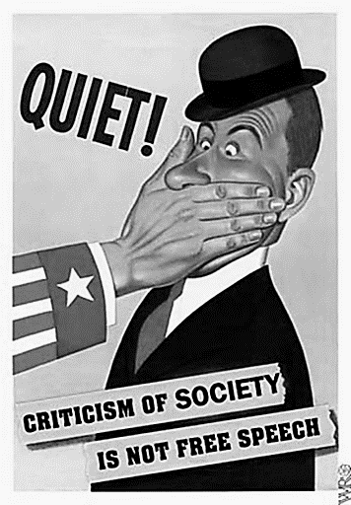
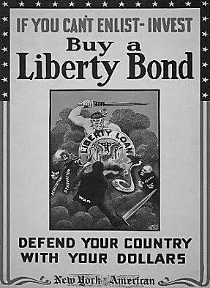
Paying for the War
The war cost about $30 billion, was paid for with increased ________ and the sale of war _______. A _______ is debt, the holder of the _________ is lending money (creditor). The _________ issuer owes the money plus interest (debtor)
US war bonds were called ________ Bonds
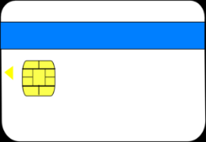
As much as 1/3 of the money spent on the war was lent to the Allies. As a result, the US went from a debtor nation to a c__________ nation.
Creditor Nation
The Home Front, 1917-18 Civil Rights
The Espionage and ___________ Acts banned Americans from undermining the war effort by speaking out against the war and doing anything else (discouraging the purchase of war bonds, opposing the draft, etc.) that could undermine the war effort.
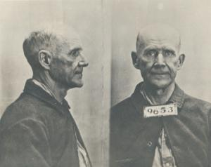
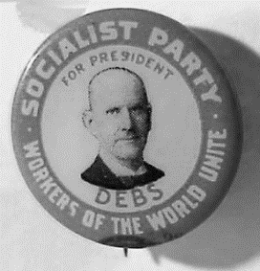
Eugene Debs (1918)- the former __________ Party candidate for President- gave an anti-war speech in Ohio and was arrested.
Claimed 1st amendment right to F________ of speech but was jailed all the same.
He was convicted under the _________ Act of 1918 and sentenced to a term of 10 years. President Warren G. Harding commuted his sentence in December 1921.
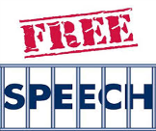
Schenck was charged with violating the _________ Act of 1917, which made it a crime to, among other things, “obstruct the recruiting or enlistment service.”
Schenck challenged his conviction on ___^{st} Amendment grounds (free speech).
Supreme Court ruled that in ordinary times his actions would be protected under __^{st} Amendment, but when a nation is at war many things that might be said in time of peace are a hindrance to its effort and can be limited. The Supreme Court introduced the “C_________ and P_________ Danger Doctrine”. Simply stated, you can’t yell FIRE in a crowded theatre. Today you can’t scream I have a BOMB at the airport. That would put people in DANGER.
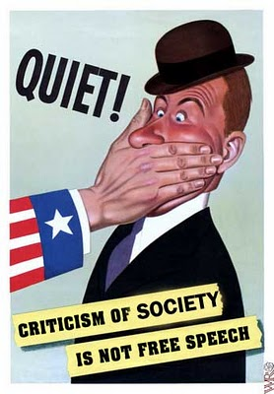  PROPAGANDA | During World War I, President Wilson believed that the nation’s war effort would be threatened if dissenters were allowed free s__________  The most important note to come out of the case Schenck v. The United States is that free speech is not actually unlimited. After the case the "clear and present danger" test was devised to determine when speech is not protected. This test was used to decide whether a speech created a clear and present danger. If so, it was not protected under the First Amendment. The test was later revised to the more flexible "bad tendency" test and eventually to the "imminent lawless action" test.  The U.S. government launched a massive propaganda campaign with FOUR GOALS in mind:

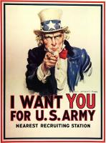 | 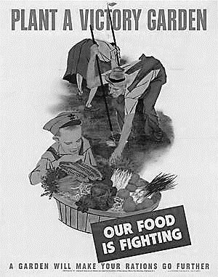 | 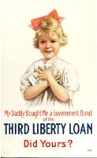 | 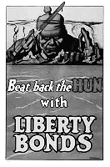
________________  Soldiers, Sailors, Nurses | ________________  Food and Resources | ______________  the War (Liberty Bonds) | ______________  the Enemy (the Hun)
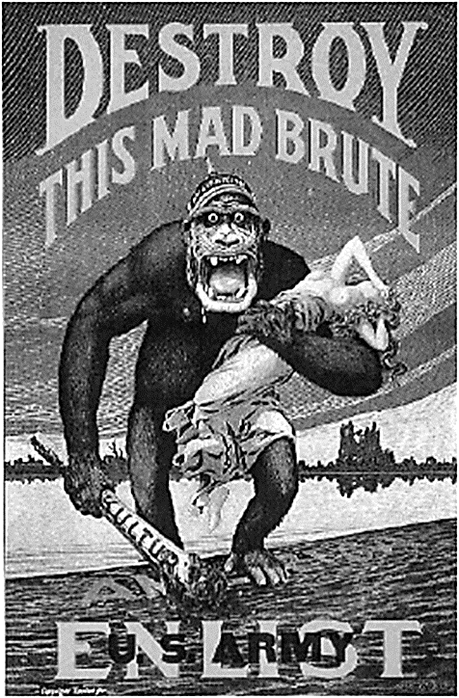
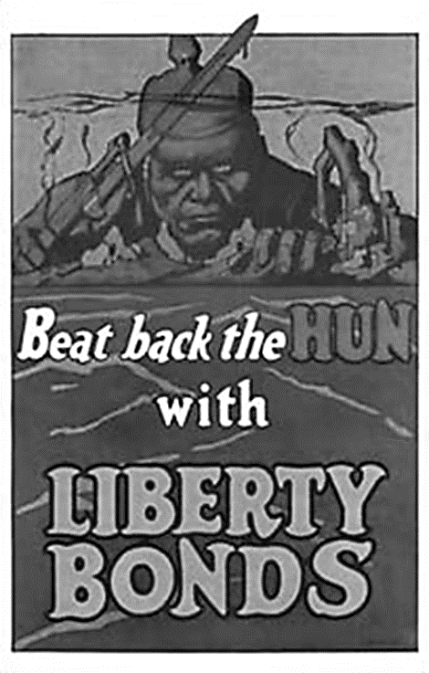
De-humanize the
Enemy

Generate recruitment Support for the war effort
Generate Financial Support for the war effort
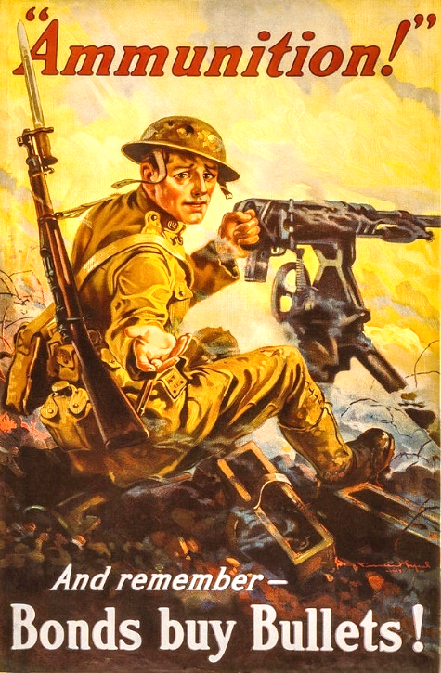
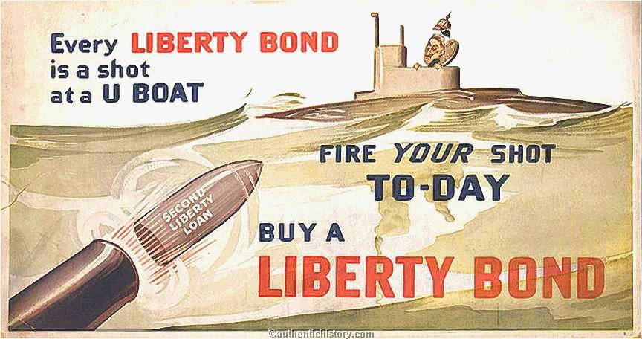

Anti-German Sentiment: Prejudice against German Americans became widespread. Up to 25% of US population could trace their ancestors back to Germany.
This is a h_______ d________! | DON’T TEACH THIS! | DON’T DISPLAY THIS!
Frankfurter | 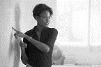  German Language | 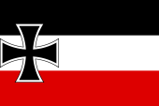  Flag of Germany

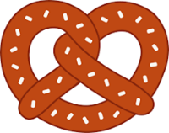
This is a _____________________
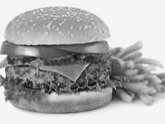
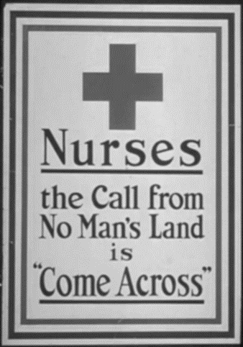
Hamburger
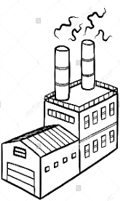
Experiences of Women and Minorities– at Home and Overseas
Women would play a vital role in the war as millions of men left their jobs to fight the war. Because of the labor shortage, many women took men’s _________ jobs.
Army ___________ served overseas for the first time.
African Americans were not allowed to fight in the A__________ E__________ F ________, but did serve under French leaders. Because of Supreme Court ruling of ‘Plessey v. Ferguson, African Americans served in ____________ units.

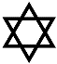
The efforts of women in the workplace helped them gain support for suffrage. (___^{th} Amendment)
Jewish Americans

Anti-D____________ League- (1913) was established to stop anti-Semitism and religious prejudice.
Hispanic Americans- Because of ________ _________during the war, US officials made it easier for Mexican workers to enter the US. Mostly settled in SW USA- Texas, So. California, Arizona, New Mexico. Many became farm workers.
During the war, Congress gave citizenship to those Puerto Ricans who volunteered for military service.
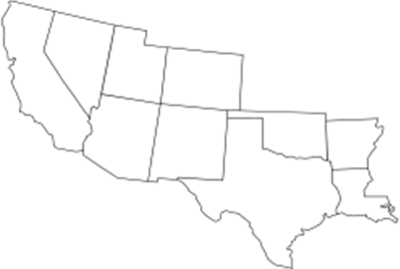
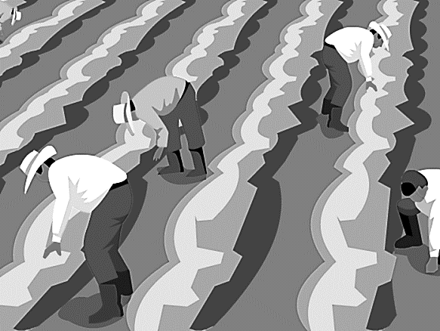
Fill in the names of the STATES

South Western United States

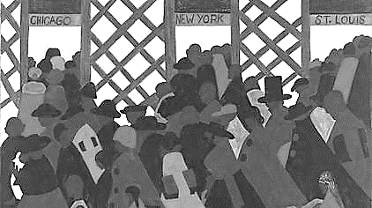
The Labor Shortage and the Great Migration
When men left for combat training, this created a labor shortage back home.
Many African Americans in the south left to find w______ in northern factories. Wanted to escape _______ _______ laws (Black ________ ) and rural p________
Known as the Great M__________ the movement of 6 million African Americans out of the rural South to the urban Northeast and west began in 1910 and continued on and off until 1970.

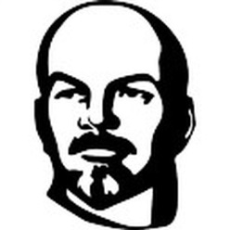
“Over There”- Allied Victory in Europe
US entered war April 2, 19___. Germans launched aggressive submarine warfare.
Needed a big push before US troop presence would make a difference
Union of Soviet Socialist Republics
Russia drops out of war when Reds (_____________) take over in October 1917 under Vladimir _______ & re-named the country U_______ of S________ S__________ R___________ (USSR) or Soviet Union for short
Vladimir Lenin
Germany transfers 1000s of troops from the ________ Front (Russian Front) to the _________ Front (France) to make a final push (offensive) for Paris but they failed.
US troops began arriving in France June 1918 about 10,000 a day. About 2 million US troops arrived in France. By N_______ 1918, Germany surrenders
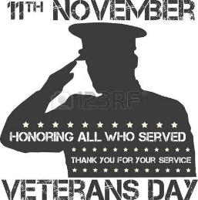
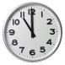
ARMISTICE- an agreement made by opposing sides in a war to stop fighting for a certain time; a truce.
_______/_______/1918 at ____:00 AM
- The Russians, although they had fought on our winning side, were not i___________ to the peace talks. Russia had become c______________!

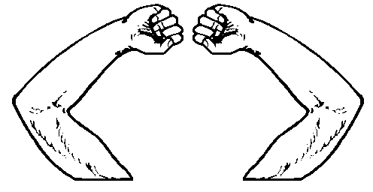
It is on this day Nov. 11 that we celebrate _____________’s Day in remembrance to all US soldiers who never came home.
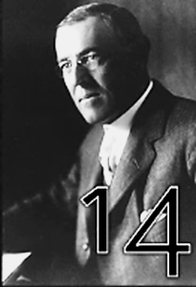
WILSON’S ______________________ POINTS:
- Freedom of the _______
- Reduction of a________
- Open Di______________
Most Important
to Wilson
- ____________-______________ of Peoples
- L____________________ of N_____________________
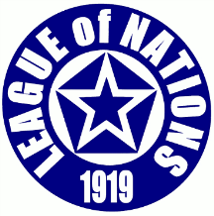
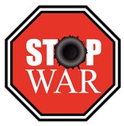
Wilson’s Goal: ___________________________________________________
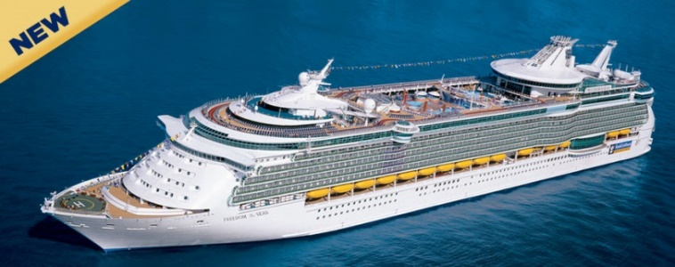
Freedom of the Seas
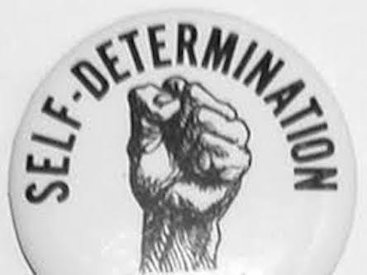

Of Peoples

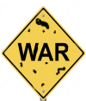
Terms of Treaty of Versailles
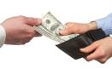
The Treaty of Versailles Although President Wilson exercised a leadership role at the Paris Peace Conference, he had to make concessions to the Allies, who insisted on a “w__________ g_____________” Clause blaming Germany for the war and the payment of r___________________ from Germany to the Allies.
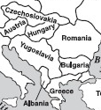
However, the Treaty of ______________________ also included Wilson’s Fourteen Points, including re-drawing new national borders in Central Europe along e________________ lines, although it failed to accommodate every European ethnic group (What is a Yugoslavian?).
Poland
The Treaty also created a L__________________ of N_____________, which Wilson believed to be the most important thing to prevent future wars.

USA Loans $ to Germany
- US began a loan program to help Germany at the end of WW1. This was done to promote p____________ and e_____________ stability in E__________.
- It was called the Dawe’s Plan. More about that in the next chapter.

The Versailles Treaty Controversy
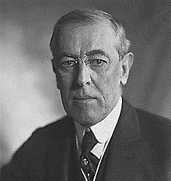
Although President Wilson played a leading role at the Paris Peace Conference, he had an even bigger task when he returned to the United States:

Convince the U.S. S__________________ to ratify the V_________________ Treaty.
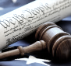
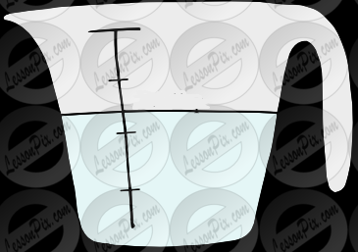
According to the Constitution, ____ / ____ of the Senate must approve any treaty negotiated by the President. Wilson, a Democrat, had an uphill battle since the Republican Party had a majority in the Senate.
2/3
Factions in the U.S. Senate

Internationalists | Reservationists | Irreconcilables
Mostly Senate Democrats | NOTE: The Republicans were divided into two camps.
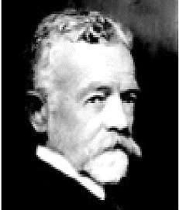
Opponents of the League of Nations argued that it would drag the USA into unwanted military commitments.
Senator Henry _________ _______ (R) strongly opposed the creation of the League, saying the USA would lose its freedom of action (sovereignty).
The United States Senate refused to ratify (ok) the Treaty of Versailles and the USA
never joined the L_________ of N__________.
Senator Henry Cabot Lodge (R)

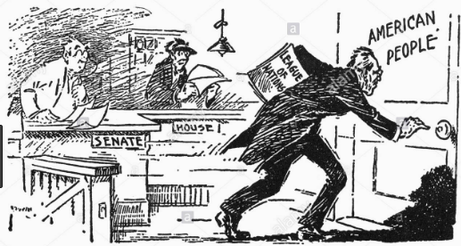

President Wilson taking his case for the Versailles Treaty to the American People
The treaty was defeated by the isolationists in the Senate, 1919. Explain why the Versailles Treaty was defeated.

American Isolationism
- America turned to a policy of i_______________ – ‘separating themselves from other countries’ affairs’.
- America turned its back on E_________ by:
  - Raising t__________ on imports to protect US businesses
  - Restricting E_________ i__________, especially from E______ & S_______ Europe. (New Immigrants)
  - R___________ the Treaty of Versailles.
  - Refusing to join the L_______ of Nations.
These were all signs of America’s decision to isolate themselves from the rest of the world (Europe).
But America remained an active global player from 1920-1941 in preventing future wars, as we shall see in the next chapter.
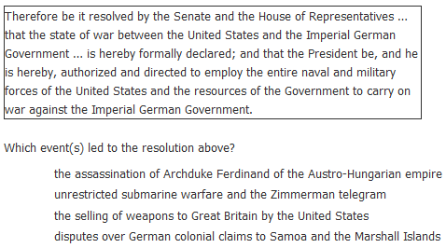
EOC Practice

a.
b.
c.
d.

- Europe 1914 Europe 1920
a.
b.
c.
d.
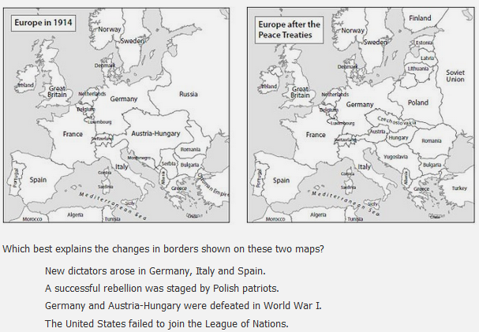

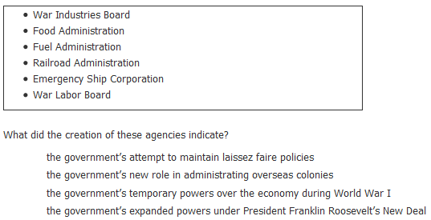
3.

a.
b.
c.
d.

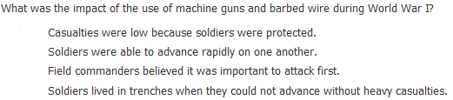
4.
a.
b.
c.
d.

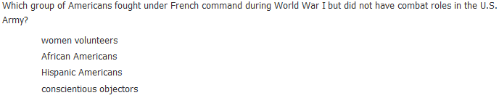
5.
a.
b.
c.
d.

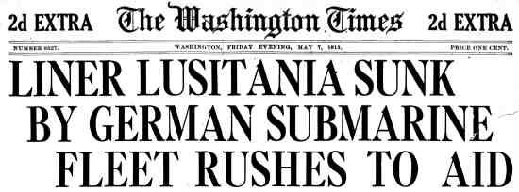
6.

