Unit 2 Chpt. 6 Topic 2.8-2.11 The Judiciary
Required Foundational Doc: Federalist #78, Art III of the Constitution, Required Supreme Court Case: Marbury v. Madison (1803)

Topic 2.8 INTRODUCTION TO THE FEDERAL COURTS
JUDICIAL POWER
- Is passive
  - Courts c_____________ reach out and “take” cases >> Cases must c_____________ to them
  - There must be an actual c___________ (“controversy”) for a court to make a ruling >> Courts c___________ “create” cases
    - Can’t settle political issues/political questions between the president and Congress (must be a c_____________ issue)
- Only those with S________________ may challenge a law or government action
  - One who has sustained or is near sustaining an “i______________” may bring a case to court
  - One cannot challenge a law simply because one does not happen to like it

JUDICIAL LAW-MAKING
- Judges, contrary to what some may think, are not simply impartial referees who only carry out the law. Judges i______________ the law, and in so doing in fact m___________ law. It is necessary that they make law because:
  - S____________ are often b__________-worded, u_____________, or c_______________
  - The Constitution is certainly broadly-worded, and requires i________________
- Thus, interpretation of statutes and the Constitution is, in eﬀect, making law. Evidence of judicial law making:
  - Courts have ruled >1,000 state laws as being unconstitutional
  - Courts have ruled >120 federal laws as being unconstitutional
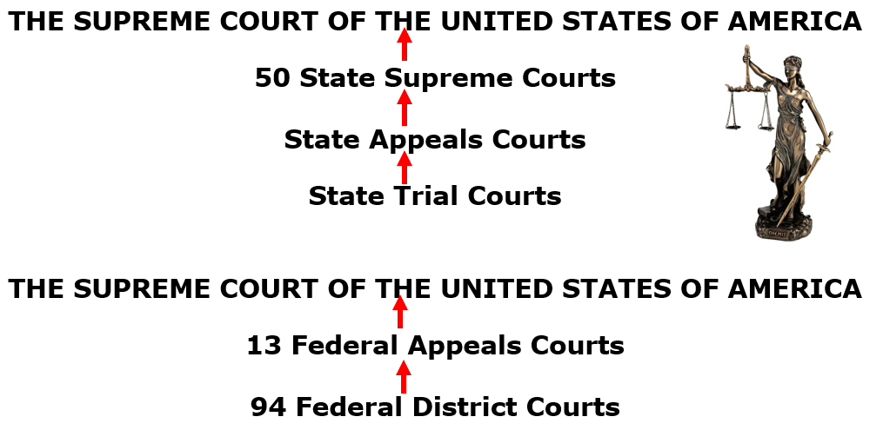
  - The Supreme Court has reversed itself >140 times since 1810

AMERICA’S DUAL COURT SYSTEM
- The U.S. has two separate court systems (STATE AND FEDERAL) because it is a federal system
- Each state has its own court system (97% of all criminal cases are heard in state courts)
- AP test will be only about the f___________ court system
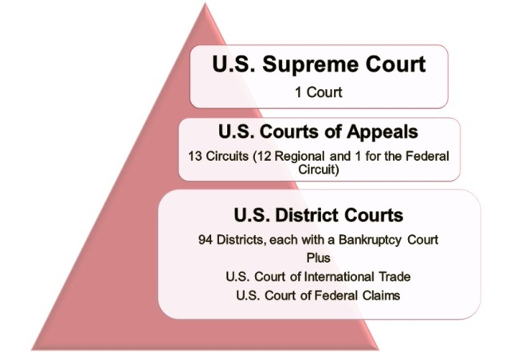
Federal Court System
the authority of a court to hear and review decisions made by lower courts in that system.
Appellate Jurisdiction
Limited Original Jurisdiction
Appellate Jurisdiction

Original Jurisdiction
the authority of a court to act as the first court to hear a case, which includes the finding of facts in the case.

ARTICLE III (3) – JUDICIAL BRANCH

JURISDICTION — the a___________ to h_____ and d______ cases

The Supreme Court’s original jurisdiction is limited to: over all disputes between s_______ and the n_________ government, between two or more s________, and between c_________ of d___________ s_________.

Combined with the s__________ clause in Article ____, Clause 2 of the Constitution, which declares that national t________ and l_______ “shall be the s__________ law of the Land,” the f________ courts emerged as s_________ to s______ courts and laws.

Section 1
- The judicial Power of the United States shall be vested in one supreme Court, and in such inferior Courts as the Congress may from time to time ordain and establish. The Judges, both of the supreme and inferior Courts, shall hold their Oﬃces during good Behavior, and shall, at stated Times, receive for their Services, a Compensation, which shall not be diminished during their Continuance in Oﬃce.

In the above excerpt, underline the power that Congress has over the Supreme Court (checks and balances)

What is the only crime mentioned, defined and described in the Constitution? Why is that?

STRUCTURE OF THE FEDERAL COURT SYSTEM

ARTICLE III – THE FEDERAL (CONSTITUTIONAL) COURTS
- The S______________Court is the only court speciﬁcally m_____________ in the C____________________
- The P______________ has the power to a_____________ all f_____________ j_____________
- Executive branch c_________ on the judicial branch

- The S________________ has the power to c_____________ all f____________ judges
Legislative branch c___________ on the e_____________ branch and j____________ branch

- Congress has the power to create all “inferior” (lower) federal courts
Legislative branch check on the judicial branch

- Congress has the power to change a_______________ j__________________ of f_______________ courts
Legislative branch c___________ on the j___________ branch

- Judges in these courts hold L_________TERMS so that they are f________ from p___________ p___________
Judicial branch check on the legislative branch and executive branch: J_____________ Review

JUDICIARY ACT OF 1789- an ACT is a federal law
Established the basic three-tiered structure of federal courts that still exists
C____________ set the size of the Supreme Court at s_____ justices – later expanded to n_____ in 1869
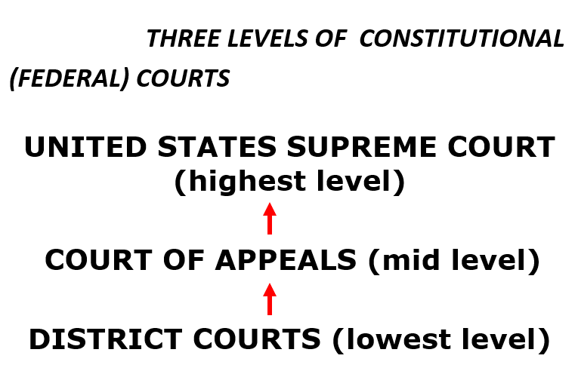

Jurisdiction of the Federal Courts

Jurisdiction = a__________. There are three types of jurisdiction or authority to hear a case. Three types of jurisdiction:
(Exclusive-Those cases can be heard only in the federal courts )
Original- court in which a case is f_______ heard
Concurrent- cases that may be tried in either a f________ court or a state c_________.
Appellate- A court that hears a case on a__________ from a lower court.

Federal courts may try a case if it involves:
- Disputes between two or more states
Jurisdiction
- The Constitution, a federal law, or a treaty
- The U.S. government as a party
- Citizens of diﬀerent states Ambassadors or diplomats

STRUCTURE OF THE FEDERAL COURT SYSTEM The Three Levels Of Constitutional (Federal) Courts

DISTRICT COURTS  - 94 courts w/ ~700 judges  - Handle over 300,000 cases  - Cases are tried by a judge and petit (trial) jury – jury decides outcome of case  -Use grand juries to issue indictments  -Orders that charge an individual with a crime  - Does not mean that one is guilty; it means that one will be tried  - Jurisdiction: o____________  - Most cases end in a plea bargain  - Decisions may be appealed to Courts of Appeals | COURTS OF APPEALS  - 13 “circuit” courts w/ ~160 judges  - 156 judges try >18,000 cases a year  - Cases tried by a panel of three judges  –Do not hold trials or hear testimony – judges review district court decisions  - Jurisdiction: a________________ (hears appeals from District Courts and regulatory agencies)  - Decisions may be appealed to the Supreme Court  Appeals court do not concern themselves with guilt or innocence but rather “were the rights of the defendant/plaintiff violated. | SUPREME COURT  Highest court in the land  - ~10,000 cases are petitioned for a writ of c_________________ – only hear about 80 cases a year  - Cases tried by entire court (currently n_______ judges - # of justices is established by C____________)  - Jurisdiction: o____________and appellate  – Almost all cases are heard on appeal  - Court of last resort  - Supreme Court is the ﬁnal arbiter of the Constitution  - Supreme Court decisions establish precedents that are binding on the entire nation

WHAT IS JUDICIAL REVIEW AND HOW DOES IT CHECK THE POWER OF OTHER INSTITUTIONS AND STATE GOVERNMENTS?

- The foundation for powers of the judicial branch and how its independence checks the power of other institutions and state governments are set forth in:
– Federalist No. 78

FEDERALIST #78 – THE JUDICIARY DEPARTMENT REQUIRED DOCUMENT -Alexander Hamilton, 1788 AMSCO pg. 179-180

- On what grounds does Hamilton argue that the judicial department of government is the least powerful branch of government?

It has the l____________ capacity to annoy or injure the political rights of the Constitution. The executive makes a______________ and holds the s______________, and the l____________ commands the p_____________ and passes the l_________. The judiciary has n_________ force, nor will. All it can do is exercise j_________ and depend upon the e__________ to carry out its j___________.

- Why do you suppose that Hamilton was so careful to point out the relative impotence of the judiciary?

To alleviate fears that this new department of government (there was n__ national j__________ under the Articles of Confederation) would be used to d_______rights of the people.

3. Why does Hamilton consider the independence of the judiciary to be a vital component of constitutional government?
  - Because the courts are the bulwarks of a limited Constitution against the encroachments of the legislature. Without judicial independence, judges would be unable to eﬀectively check the legislature.

4. What arguments does Hamilton use to support life tenure for judges?
  - L______ tenure f________ judges from p___________ pressure that might come from the l____________ or e________________ if periodic appointments were made. Being freed from such pressure enables judges to g________ against laws that are contrary to the Constitution.

  - Being a judge places great demands upon a person. Few men have the necessary abilities to be a judge, and few have the necessary ethical qualities, as well. Periodic appointments would discourage those few who are qualiﬁed and would lead to less competent and less principled judges.

FEDERAL JUDGES:
- Are appointed by P____________ with “advice and consent” of S__________ (majority vote needed for conﬁrmation)
- Are given l_________ tenure subject to good b____________
- May be i___________ and removed by C__________ (very rare)

Advantages of life terms
- Experience
- Stability
- Re-election not necessary
- No fear of removal based on decision
- Interest groups have little inﬂuence

Disadvantages of life terms
- Judicial activism
- Precedent
- Old court
- Ideology; slow to change- think Plessy v. Ferguson 1896. It took Brown v. Board of Ed 1954 to change separate but equal; 58 years later. A life time.

MARBURY v. MADISON (1803) – REQUIRED CASE AMSCO pg. 199-200 Wapples pg. 197-198
Facts
- William Marbury, who had been appointed a justice of the peace of the District of Columbia, was one of the appointees who did not receive his commission. Marbury sued James Madison and asked the Supreme Court to issue a writ of mandamus requiring Madison to deliver the commission.
Issues
- Does Marbury have a right to his commission, and can he sue the federal government for it? Does the Supreme Court have the authority to order the delivery of the commission?
Decision
- The decision in Marbury v. Madison ended up being much more signiﬁcant than the resolution of the dispute between Marbury and the new administration. The Supreme Court, in this decision, established a key power of the Supreme Court that continues to shape the institution today.
- The Court unanimously decided not to require Madison to deliver the commission to Marbury. In the opinion, written by Chief Justice Marshall, the Court ruled that Marbury was entitled to his commission, but that according to the Constitution, the Court did not have the authority to require Madison to deliver the commission to Marbury in this case. They said that the Judiciary Act of 1789 conﬂicted with the Constitution because it gave the Supreme Court more authority than it was given in Article III. Thus, the Judiciary Act of 1789 and the Constitution were in conﬂict with each other.

JUDICIAL REVIEW - MARBURY V. MADISON (1803)
- Framers did not speciﬁcally provide for judicial review
- Court could not enforce an unconstitutional law (Section 13 of Judiciary Act)
- Chief Justice John Marshall reasoned that judges should i_____________ the Constitution, not the President or Congress
- Judicial review became e_____________ due to this case
- A single person may challenge an existing law through judicial hearings
- Eﬀects
  - L____________ sometimes trumps l_____________ as a way to make public policy
  - Examples – Modern-day gun issues
    - District of Columbia v. Heller (2008) - Supreme Court held that a constitutional right to gun ownership - irrespective of service in a state militia - did exist.
    - McDonald v. Chicago (2010) - The Second Amendment right to keep and bear arms for self-defense in one's home is fully applicable to the states through the Fourteenth Amendment.

Checks Over Other Branches and States Judicial Review and Marbury v. Madison
The judicial branch has the power of judicial review to e________ acts of l________ and the e_________ branch to see if they abide by the c__________. This was established in the 1803 Supreme Court case of Marbury v. Madison
The US district courts trying f_______ crimes, such as counterfeiting, mail fraud, and evading federal income taxes crimes defined under the enumerated powers in the constitution. Most violent crimes, and indeed m______ crimes overall are tried in s______ courts. Congress has outlawed some violent crimes Interstate actions, such as drug trafficking, bank robbery, terrorism, and acts of violence on federal property.

THE SUPREME COURT
KEY POWERS
- Power of j___________ review (established by M__________ v. Madison, 1803)
  - Declare state laws, federal laws, and presidential actions u_______________
- Power to i____________ broadly worded l_________ of C_____________
- Power to determine the m___________ and a_____________ of the Constitution
- Power to o______________ earlier Supreme Court decisions (e.g., Brown overturning Plessy)

ORIGINAL JURISDICTION
- The Court’s original jurisdiction only generates two to three cases a year
- The Supreme Court exercises original jurisdiction in cases involving the following:
  - Two or more s_________
  - The United States government and a state g______________
  - The United States and f____________ ambassadors/diplomats

APPELLATE JURISDICTION
- M________cases come under the Court’s a_______________ jurisdiction
  - Cases appealed from both state supreme courts and federal courts of appeals
- Nearly all appellate cases now reach the SC by a writ of c____________________

2.9 LEGITIMACY OF THE JUDICIAL BRANCH AMSCO pg. 188-192
Explain how the exercise of judicial review in conjunction with life tenure can lead to debate about the legitimacy of the Supreme Court’s power
- P_____________ and s________ d___________ play and important role in judicial decision making
- Ideological changes in the composition of the Supreme Court due to presidential appointments have led to the Court’s establishing new or rejecting existing precedents
- Controversial or unpopular Supreme Court decisions can lead to challenges of the Court’s legitimacy and power which Congress and the president can address only through future a_______________, l_____________ changing the Court’s j_________________, or r________________ to implement decisions
- Political discussion about the Supreme Court’s power is illustrated by the ongoing debate over judicial a____________ versus judicial r________________.

FACTORS THAT INFLUENCE SUPREME COURT DECISIONS -- PRECEDENT --
Stare Decisis
- Stare decisis is a Latin phrase meaning “let the d____________ s______________”
- The vast majority of SC decisions are based on p________________ established in e_____________ cases
- Precedents help make SC decisions more u__________, p____________, and e________________
Examples
- In Marbury v. Madison, the Court established the principle of j___________ r___________ as applied to Congress and the president
  - In another case, the Court extended the power of j______________ r______________ to overrule state courts
- In Baker v. Carr, the SC established the principle of one person, one vote in state congressional districts
  - In Wesberry v. Sanders, the Court applied this principle to U.S. congressional districts
Exceptions
- Although precedent is very important, the Court can overturn previous decisions
  - Plessy v. Ferguson permitted segregation if the facilities were “separate but equal”
  - The Court reversed this ruling in Brown v. Board of Education of Topeka, declaring that “segregation is a denial of a the e___________ p_____________ of the l___________”- ______^{th} amendment
The Supreme Court’s Decisions
How has the Supreme Court use of judicial review in conjunction with life tenure lead to debates about the legitimacy of the court?
Continuity or change in the Supreme Court | Effect on the legitimacy of the court
Lifetime tenure | As with the Anti-Federalist many Americans believe that with no power to hold the court accountable, the justices on the Supreme Court are two separated from the real sources of power- the p______ and the l_______- to be legitimate arbiters of democratic law. B________ believed the Supreme Court justices would be placed in a situation altogether unprecedented in a free country t_________ independent
Shifting ideological makeup of the court | The composition of the court changes as seats become v______, and the presidential a___________ to fill them can lead to shifts in i________ of the court. These changes can result in overturning of some p___________, calling into question the r__________ and therefore l____________ of the Supreme Court

2.10 THE COURT IN ACTION
Explain how judicial review in conjunction with life tenure lead to debate about the legitimacy of the supreme court’s power?
Views on the Interpretation of the Constitution
Strict constructionist interprets the Constitution in its o_____________ context. Judicial r__________ court.
Liberal constructionist interprets the Constitution as a l___________ document and considers social c____________ in social conditions since ratification. Judicial a_______ Court
The Warren Court (1953-1969)- Activist Court
Brown v. Board of Education (1954)
Overturned the 1896 P________ v. Ferguson decision, stating the “s___________ but equal” standard violated the 14th Amendment’s equal protection clause. (See Topic 3.11.)

Mapp v. Ohio (1961) Ruled that evidence illegally obtained would be inadmissible in court. (See Topic 3.8.)

Engle v. Vitale (1962) Upheld the e_____________ clause of the First Amendment. Public school-sponsored prayer was unconstitutional. (See Topic 3.2.)

Gideon v. Wainwright (1963)
The court stated that all citizens must be provided a l___________, even if they can’t a___________ (__________) one. (See Topic 3.8.)

Miranda v. Arizona (1966) An arrest suspect had to be formally i_____________ of his or her rights—sometimes called Miranda rights. (See Topic 3.8.)

Tinker v. Des Moines Independent Community School District (1969) Allowed for students to participate in non-disruptive s_____________ speech in schools. (See Topic 3.3.)

HOW CASES REACHES THE SUPREME COURT
WRITS OF CERTIORARI- from the Latin “to be more i____________”
• A writ of cert is an o__________ by the Court directing a lower court to send up the record in a given case for its review
• The c___________ process enables the SC to c__________ its own c____________.
• Cases must involve a serious c____________ issue or the i_______________of a f________ s________, action, or treaty
• Denying a decision may mean any number of things:
– Case lacks a substantial federal issue
– Party lacks standing
– Court agrees with a lower court
THE RULE OF FOUR
• SC clerks screen the approximately 9,000 petition that come to the SC each term
• The justices conduct weekly conference meetings where they discuss petitions prepared by their clerks
• For a case to be heard on appeal, at least f_______ of the nine justices must agree to hear the case (the R_____ of Four)
FILING BRIEFS
• Each party is required to file a b_________, or detailed w___________ statement, arguing one side of the case
• Briefs cite relevant facts, legal principles, and precedents that support their arguments
• Interested persons and groups that are not actual parties to the case may file a_________ c_______ (“friend of the court”) briefs
– Cases involving controversial issues such as affirmative action and abortion attract many a______ c______ briefs
– Interest groups use a________ c_______ briefs to lobby the Court. These briefs contain information to try to influence the court’s decision.
LISTENING TO ORAL ARGUMENTS
• Oral arguments are open to the public
• Attorneys are allowed exactly 30 minutes to present their case
DISCUSSION AND VOTING
• The justices discuss each case in a c__________ meeting held on Friday. Closed meetings is a check on Congress and President.
• The Chief Justice (John Roberts) presides over the meeting
https://www.uscourts.gov/about-federal-courts/educational-resources

OPINIONS and CASELOADS
WRITING OPINIONS
- After reaching a decision, the justices must write a formal opinion. Opinions present the issues, establish precedents, and set guidelines for lower courts.
- Types of opinions
  - M__________ opinion – oﬃcially known as “the opinion of the Court,” the majority opinion is the law of the land
  - C___________ opinion – supports the majority opinion but stresses diﬀerent constitutional or legal reasons for reaching the judgment
  - M__________ or d___________ opinion – expresses a point of view that disagrees with the majority opinion. Dissenting opinions have no legal standing
EVADING COURT DECISIONS
The Supreme Court is the highest court in the land, but it is possible to evade Court decisions:
  - A___________ the Constitution; Court cannot strike down something as unconstitutional if it is written in the Constitution.
  - When a decision is made, it is “remanded” to a lower court to carry out the SC’s decision
    - The lower court will have a certain amount of leeway in doing this
  - The executive branch may simply not c_________ o______ the decision
  - State and local governments may simply n____ c_________ it out, either (e.g., desegregation, school prayer)

2.11 EXPLAIN HOW OTHER BRANCHES IN THE GOVERNMENT LIMIT THE SUPREME COURT’S POWER?
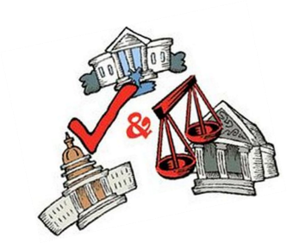
- Restrictions on the Supreme Court are represented by:
  - L__________ (Congress) impacting court j______________.
  - Congressional legislation to m__________ the impact of prior Supreme Court decisions
  - Constitutional a_____________. Example: 16th amendment- i_________ t___
  - Judicial conﬁrmations (by the S_________)
  - The president and states e__________ or i___________ Supreme Court decisions
  - Legislation impacting court j_____________. Congress created the t_____ courts.
FACTORS THAT INFLUENCE SUPREME COURT DECISIONS -- JUDICIAL PHILOSOPHY --
Judicial Restraint
- Philosophy that the courts should allow the s___________ and the other _______ branches (Leg and Exec) of the federal government to solve social, economic, and political p_______________
- Courts should merely i_________________ the law rather than m_____________ law. That’s Congress’ job.
- Original intent suggests that courts should follow the intentions of the Founding Fathers
Judicial Activism
- Philosophy of judicial making whereby judges allow their p________ views regarding a public policy instead of constitutionalism.
- Idea that judges ought to freely s_________ down laws that are i_________ with their understanding of the Constitution
- Courts should uphold the “g____________ ethic” (guardian of people)
- Examples of judicial activism:
  - Striking down Topeka School Board’s policy of segregation in Brown v. Board (1954)
  - Striking down a Texas law that banned ﬂag burning in Texas v. Johnson (1989)
  - Striking down the Gun Free School Zones Act in US v. Lopez (1995)
  - Striking down line-item veto in Clinton v. NY (1998)
  - Striking down a DC city ordinance banning handguns in DC v. Heller (2008)
Is Interpreting Law Making Law?
In the Supreme Court’s ability to interpret law, many would argue that they create law regardless because sometimes the law was not clearly written by the legislature. Let’s take the Plessy v Ferguson case 1896. It established the “s_______ but e_____ doctrine” and l_________ segregation throughout the nation. The Court went against the e_____ p________ clause of the 14th amendment. They did what they “felt” was the need of the time. This is judicial a_______ because the 14th amendment clearly says that no state can, “…deny to any person within its jurisdiction the equal protection of the laws”. The writers of the 14th amendment never intended for separate equality. That is an oxymoron- like saying “pretty ugly”. If the authors of the 14th amendment intended separate equality, they would have stated it.

In 1954, Brown v. Board of Education, the SC reversed itself and ended segregation, declaring the separate facilities were not truly equal. This is judicial activism in the sense that it reversed a previous p_________. This separate but equal issue was sent before SC on several occasions prior to 1954 and the SC let the decision stand-s_______ d________-judicial r________. At that time, the SC figured that either Congress or the states would handle this issue. Neither did and segregation continued for nearly 60 years. In early 1950s, the Chief Justice of Supreme Court died and was replaced by a new Chief Justice, Earl Warren. The changing c_____________ of the SC caused by v__________ and presidential a___________ to the Court can alter the SC‘s judicial p__________ for decades to come The Warren Court, as it became known, was the most liberal court of its time and very active.

FACTORS THAT INFLUENCE SUPREME COURT DECISIONS—Public
Public Opinion
- The Constitution insulated SC justices from direct political pressures
  - Justices are a____________ to serve l_________ terms subject only to g_________ behavior
  - The c______________ process enables the SC to set its own a______________
  - The public has l______ access to Court proceedings. They meet behind c_______ doors to deliberate their decisions.

- The Supreme Court is nonetheless aware of and sensitive to public opinion
  - The appointment and conﬁrmation processes keep the SC from deviating too far from public opinion
  - Congress and the state legislatures can amend the Constitution
  - Congress can change the SC’s appellate jurisdiction
  - Congress has the power to change the number of justices on the Court. SC depends on executive to e________ its decisions.

LIMITING THE SUPREME COURT’S POWER - CONGRESS
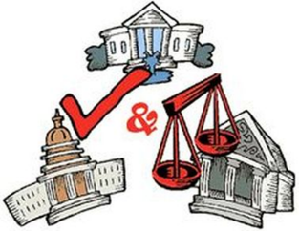
- Legislation impacting court jurisdiction
  - Article _______ of the Constitution left for the Congress to determine the distribution of federal jurisdiction within a system of federal c_________ and between the federal and state courts. Over the past two centuries, Congress has passed numerous statutes redeﬁning the jurisdiction of the federal courts within the limits set by the Constitution. Congress has gone so far as to e___________ a court’s j___________ to review a particular case during litigation.
- Congressional legislation to modify the impact of prior Supreme Court decisions
  - Congress can show their dissatisfaction with Supreme Court interpretations of laws it passes by re-enacting the l______________ to c____________ its original i___________ and o___________ a contrary Court decision.
- Constitutional amendments
  - Congress can show their dissatisfaction with Supreme Court interpretations of laws it passes by proposing a constitutional amendment. Passing a constitutional amendment makes an issue “constitutional” and therefore overrule a contrary Court decision. Congress will re-write the law to meet the SC criteria of legality.
- Judicial conﬁrmations
  - While the president nominates federal oﬃcials, the Senate has the ﬁnal say with conﬁrmation of those nominations. If the Senate is controlled by Republicans with a Democratic president, they would want the president to appoint judges who are closer to the middle.

FACTORS AFFECTING SELECTION OF FEDERAL JUDGES – CONGRESS POWER

Senatorial courtesy
- President will c___________ with the t____ S___________ from the s_________ in which they are to be a_____________. The Senate will then show “________________” to those two senators by not conﬁrming judges to whom the two senators object (does not apply in the appointment of Supreme Court justices).
Senate Judiciary Committee- very important committee
- Hold p______________ hearings on each Supreme Court nominee, and sends a recommendation to Senate ﬂoor for approval or rejection
Senate
- Simple m____________ vote needed for conﬁrmation

LIMITING THE SUPREME COURT’S POWER – PRESIDENT

- The president and states evading or ignoring Supreme Court decisions
The Supreme Court’s majority opinion is oﬃcially known as “the opinion of the Court”. This means the majority opinion is the l_______ of the land, but the Supreme Court has no ability to e__________ this opinion. That responsibility falls on the p____________ and the bureaucracy. If the president doesn’t take any action to enforce a law, then the opinion of the court is w_______________.

In the Cherokee Indians case (1832), Andrew Jackson was infuriated by John Marshall and the Court’s ruling by insisting that Georgia laws that purported to seize Cherokee lands on which gold had been found violated federal treaties. Jackson is famous for having responded: "John Marshall has made his decision, now let him enforce it." Both Georgia and Jackson simply ignored the decision.
President Jackson was in clear violation of the SC decision of protecting the Cherokee Indians. Why didn’t the Congress impeach Jackson for disobeying the rule of law? Clue: Impeachment is politics/political

LIMITING THE SUPREME COURT’S POWER - PRESIDENT
- Judicial appointments
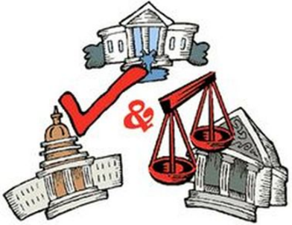
  - The Constitution provides broad parameters for the judicial nomination process. It gives the responsibility for n_______________ f_________ judges and j_________ to the p___________. (It also requires nominations to be c__________ by the S____________.)
  - More than 600 judges sit on district courts, almost 200 judges sit on courts of appeals, and ___ justices make up the Supreme Court. (Because all federal judges have l_______ terms, no single president will make all of these appointments.)
  - Many vacancies do occur during a president's term of oﬃce.
  - The president is likely only to n___________ justices who share his political i___________.

FACTORS AFFECTING SELECTION OF FEDERAL JUDGES
Political parties
- Judges are generally from the s__________ p___________ party as the P_____________
Age
- Since judges have l______________ appointments, judges live on l_______________ after the Presidents who appoint them die (presidential i_______________ continues after they leave oﬃce)
Ideology of prospective judges
- Presidents generally try to appoint people of s________________ philosophy (and judges may try to retire when there is a president with a similar ideology)
American Bar Association- professional organization of lawyers; also lobby group
- Evaluates nominees (Senate J_____________ Committee considers ABA ratings)
Existence of a “paper trail”
- If a prospective judge has written extensively, his writings may be used against him during conﬁrmation hearings
Diversity
- Race (mostly white) and gender (mostly male)
Number of judges
- C_______________ can increase or decrease the number of courts and judges
Interest Groups
- Tactics include p_____________ demonstrations, appearances on TV and radio talk shows, media advertisements, editorials, and e-mails to senators

FEDERAL ATTORNEYS
ATTORNEY GENERAL
- Appointed by President with Senate consent
- Head of Department of Justice
SOLICITOR GENERAL
- Appointed by President with Senate consent
- R__________________ U.S. government in S_______________ Court
- Decides which cases the federal government will a____________ to the Supreme Court
- Decides the federal government’s p______________ in these cases
- Sometimes called the “10th Justice” of the Supreme Court because of his/her inﬂuence there
U.S. ATTORNEYS
- At least one for each District Court, 94 in all
- Prosecutes federal cases, though most cases are settled by plea-bargaining
- Appointed by the President for 4-year terms (key patronage positions)
- Senatorial courtesy applies in their appointments

Executive checks on the Judicial Branch | Legislative Checks on the Judicial Branch
- Presidential appointments for federal judgeships  - The manner in which a president or executive agency carries out judicial orders | - The S________ Judiciary Committee reviews the president's judicial appointments. Sometimes nominees appear before the c___________ to answer senators’ questions about their experience or their views on the law.  - The practice of s__________ courtesy is often used with district Judge appointments, as districts are entirely within a given state. When vacancies occur, s________ typically r__________ judges to the White House.  - Federal judges who act criminally or perhaps unethically, can be i_________ and removed. Impeachment has served as Congress c_____ on judges life terms.  - Congress can write and pass new l_______ to clear up disputes or to better guide executive action.

