Unit 5 Topic 5.3-5.5 Political Parties AMSCO chpt. 16 pg. 523-553
TOPIC 5.3 Political Parties
Political parties, interest groups, and social movements provide opportunities for participation and influence how people relate to government and policy-makers.
- Describe linkage institutions.
- Explain the function and impact of political parties on the electorate and government.
LINKAGE INSTITUTIONS
- Linkage institutions are channels that allow individuals to c___________________ their preferences to policy-makers:
- What are some examples of linkage institutions?
  - E____________________
  - I______________ Groups
  - Political P______________
  - Mass M________________
- How do you let the government know about your opinions and beliefs?

Describe the linkage institutions

WHAT IS A POLITICAL PARTY?
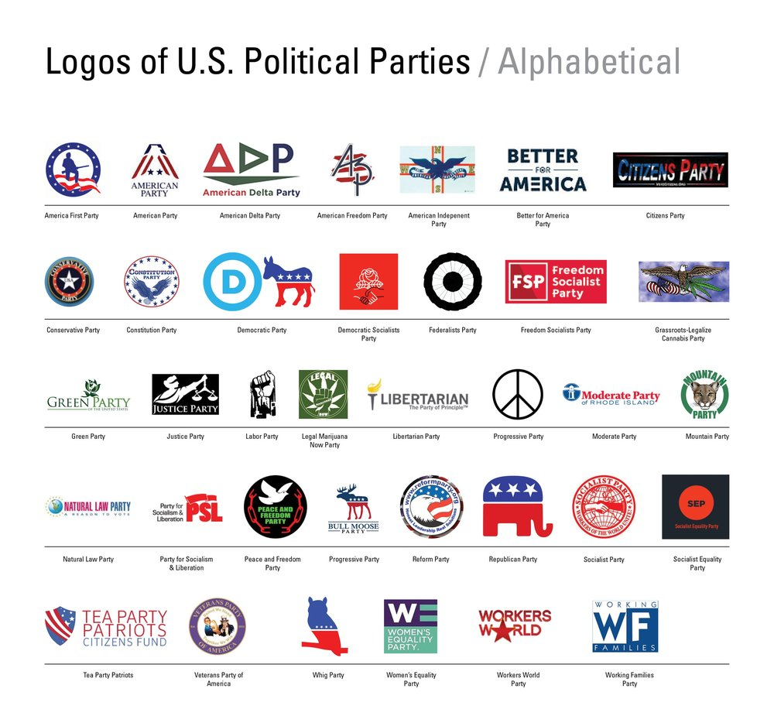
Def: A political party is an organized group of people who have the same i________________, or who otherwise have the same political p________________, and who field c_________________ for elections, in an attempt to get them e___________________ and thereby i__________________ the party's agenda.

THREE COMPONENTS OF PARTIES
Party-in-Government | Party in the Electorate | Parties as Organizations
- Party leaders occupy positions in presidency, Congress, state governors, state legislatures, and local governments (though sometimes these are n_____partisan positions)  - Party p___________ – a set of positions/p__________ objectives that members of political party agree to  - Voted on at the c_____________  - When they win, they begin the process of governing based largely on the s______ platform  - Party leadership c________ is responsible for raising m________ and serves as s___________ person  - Recruitment – the process through which political parties i__________ potential candidates  - Parties help handle the c______ and b_________ of campaign  - Maintain voter d__________ to target in elections | - Party identification – the degree to which a voter is c___________ to and i______________ by a particular political party  - Parties influence voter choice  - “R” or “D” is a cue on ballot  - Straight-ticket voting - Voting for all of the candidates on the ballot from o____ p________ party  - Growing number of i_______________ has led to less party-line voting and more s_______-ticket voting – voting for candidates from d____________ parties in the same election | - U___________ people with shared social, economic, ideological goals  - Find and support c_____________ for office and win e_________________.  - E___________ and m_________ voters  - Raise m__________, develop media strategy  - National party organizations exist to create a streamlined voice (p____________) for the party and get members e______________  - O____________ groups have growing i___________ over candidates compared to p_____________

WHAT ARE THE MAJOR FUNCTIONS OF POLITICAL PARTIES?
- Organize the competition by designating c____________ to run under their label
  - A party's ability to organize the competition is influenced by how states organize their ballots or the type of elections they provide
    - The party column ballot makes it easier for voters to vote a s_____________ ticket
    - The office b____________ ballot makes it harder to cast a vote for all the candidates of a single party
- U_____________ the e_______________ /voters
- N_____________ candidates
  - Previously: caucuses >> nominating conventions
  - Now: p___________ elections
  - With advent of p_________________, nominating function now seriously l________________.
- Control over many of these functions has been d_______________
- Provide “l___________ opposition”
- Act as Moderating Influence on Government
  - To w_____ elections, parties must usually nominate moderate candidates who appeal to the vast c___________ of the American electorate. F__________ elements squeezed out.
  - Criticism: To appeal to such a wide variety of party members, parties must avoid taking s_________ stands
  - I____________ public about political i_____________ through party p_____________

Political parties are organized at the local, state, and national levels. This doesn’t mean, however, that there is a
S__________ h________________ within the party; indeed, local and state party organizations often function quite i_______________________ from the national organization. Because of different state l_________, parties operate differently from state to s__________.

- Agents of political socialization- process in which p________ develop their p_______ values, beliefs, attitudes and ideology
- L_________ mechanism between p_________ and g_____________.
- Provide Patronage-term is used to describe political patronage, which is the use of state r____________ to reward i________________ for their e____________ support.
- R_____________ voters, mobilize voters, and get them to the polls
- Raise and spend campaign f___________
  - D____________ importance w/advent of “candidate-centered” campaigns.
- Simplify decisions for voters: provide “shorthand” through which busy and uninterested voters can base a voting decision, use of “p______ l________” by voters.
- Inform public about political issues through party p______________
Few people check platforms, which in any case are often broadly worded, i.e., like train platforms: “something to get on rather than something to stand on.”

Explain how political parties serve as a linkage institution.

Explain the function and impact of political parties on the electorate and government

How does the competition between political parties further representative democracy?

TOPIC 5.4 How & Why Political Parties Change & Adapt
RISE OF POLITICAL PARTIES
OUR FIRST PARTIES
- Dangers of factions mentioned by Madison in Federalist #10 and Washington’s warning about the “baneful effects of the spirit of party.”
- Parties became necessary to get things done, e.g., Hamilton’s financial plan and support for Jefferson’s Louisiana Purchase.
- Necessity of an institution that u___________ government in order to o_______________ the systems of separation of powers and checks and balances that divide government.

Historical development: The Six Party Systems in American history. Realignment occurs roughly every 36 years or so.
- 1796-1820: 1st party system
  - Federalists v. Jeffersonian Democratic-Republicans
  - 1824-1856: 2nd party system
  - Jacksonian Democrats v. Whigs
  - 1860-1892: 3rd party system
  - Republican dominance as the party against slavery and the party that put the Union back together.
  - 1896-1928: 4th party system
  - Second period of Republican dominance with its coalition of big business and the working classes against the Democratic rural interests.
  - 1932-1964: 5th party system
  - Democratic dominance begun under FDR and the New Deal. FDR’s grand coalition included urban dwellers, labor unions, Catholics, Jews, the poor, Southerners, Blacks, farmers.

Control of government has shifted back and forth between the parties in periods of r_____________, which is a major shift in a__________________ to the political p______________ that is often driven by changes in the issues that u___________ or d_______________ voters. Periods of r________________ may be ushered in by c________________ elections, a major national election that s_____________ the balance of power between the two parties. Periods when one party wins most national elections are called p___________ eras. Political scientists debate the boundaries of major eras in party control and how decisive a particular election was in signaling a change in those boundaries.

Party coalition- g ___________ of voters who support a political party over time.
Realignment- when the groups (c_______________) of people who support a political party s________ their a_____________ to a different political party.
Critical Election- a major national election that signals a c____________ in the balance of p___________ between the two parties.
Dealignment- process whereby a large portion of the e_______________ abandons its previous partisan affiliation without developing a new one to replace it. Rise of i_____________________
Party Era- time period when o__________ party wins m_________ national e________________.

Historical development: the Six Party Systems in American history. R___________________ occurs roughly every 36 years or so.
- 1968-present: 6th party system
  - Era of D__________ Government and D_____________________
    - Much split ticket voting
    - Presidents of one party (typically Republican) with Congresses of the opposite party (typically Democratic).
    - An era of party dealignment, as voters are moving away from both parties and are increasingly
independent.
    - Nixon (“Southern strategy”) and Reagan built a coalition of disenchanted white suburban middle class, Southern white Protestants, big business
    - Clinton won twice in part because of his resurrection of FDR’s grand coalition, especially Southern
middle class moderates (“Reagan Democrats”). Women’s votes were also decisive.
    - Election of 2000 gave us a Republican president who won only a minority of popular votes, a 50-50 Senate (which became a 50-49-1 Democratic Senate after Jeffords defection), and a House w/a narrow Republican majority.
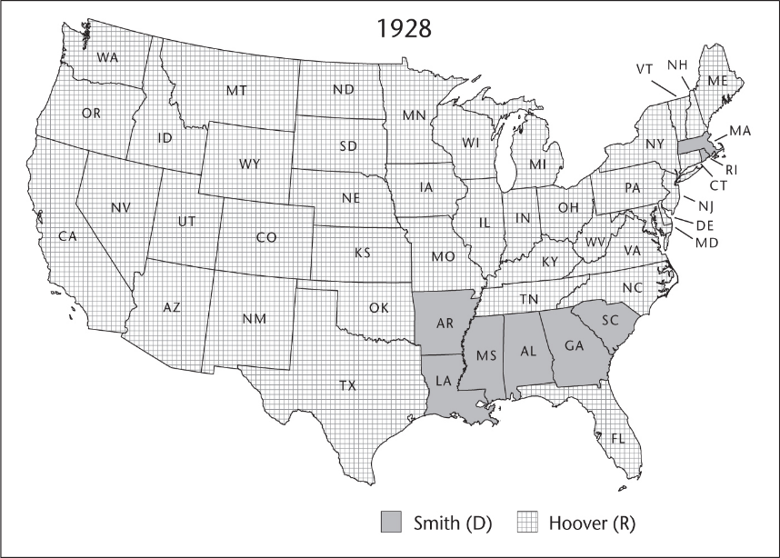
What Realignment Looks Like
Compare these maps of the presidential election of 1928 (top) and the election of 1932 (bottom). This is a clear example of realignment, as a huge number of voters switched their affiliation from Republican (red) to Democrat (blue)

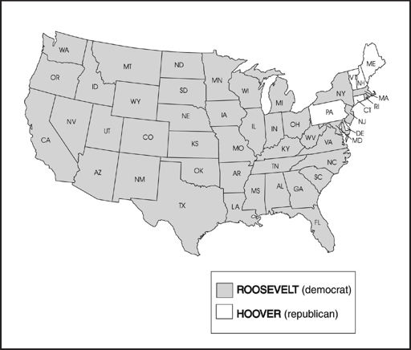
1932

DIVIDED GOVERNMENT
Creates g________________ and nothing gets done
- Since 1953, we have had d________________ government twice as often as we have had one party in control of both legislative and executive branches
- Republican P______________ and a Democratic C_______________ (control of even one house) or Democratic President & Republican Congress (control of even one house)
- Relative party strengths
- National Government 2019-2021
    - President: Republican
    - House: 232 Democrats, 197 Republicans, 1Independent, 5 vacancies (116th Congress)
    - Senate: 53 Republicans, 45 Democrats, 2 Independents (116th Congress)

REALIGNMENT AND CRITICAL ELECTIONS
- Realignment
  - Sharp changes in issues, party leaders, the regional and demographic bases of power of the two parties, and structure or rules of the political system resulting in a new political power structure.
- A "critical" election usually serves as the basis for r____________________.
- Characteristics
  - Intense electoral involvement by the voters
  - Disruptions of traditional voting patterns
  - Changes in the relations of power within the community
  - The formation of new and durable electoral groups
- Four critical (or realigning) elections (each realignment lasts roughly 36 years)
  - 1824: Andrew Jackson and the Democrats
  - 1860: The Civil War and the rise of the Republicans (slavery issue fixed new loyalties in the popular mind)
  - 1896: A Party in transition (economic issues shifted loyalties)
  - 1932: Franklin Roosevelt and the New Deal alignment (economic depression triggered new coalition for Democrats)
– 1968: Nixon?
DEALIGNMENT
Definition: Process whereby a large portion of the electorate a________________ its previous partisan affiliation without developing a new one to replace it. It is contrasted with realignment.
- We are experiencing dealignment
- People have a______________ both parties to become i_________________
- However, most Independents are really p________________ in their voting behavior and attitudes
- D_______________ has led to ticket s___________________ in recent times
- Other factors that have weakened the parties and contributed to dealignment
- C_____________-centered campaigns (especially after FECA)-people vote for the “man” and not the party
- Public disenchantment with parties and politics during the 60's
- Growth of i__________ groups – have taken on some party functions
- Development of m_________ media – candidates rely on media rather than p________ organization to get message across
- Growth of political i________________
- Trend to “vote the man, not the party” and rise of ticket splitting (voting for candidates from both political parties)
- Counter arguments to dealignment theory:
– Even though % of independents has increased, 2/3 of “independents” are actually “leaners.” They are, in effect, “closet Democrats” and “closet Republicans.”

Political parties have changed/adapted since they were first formed.
- They have had to adapt to c_________________- centered campaigns.
  - Candidates now increasingly create their own b______________, relying less on party symbols and messaging.
  - Name r_______________, handsome, glib...is well known and films well!
- P______________ has made it difficult for the old methods of parties to remain successful
- Voters now dislike other side more than they like showing support for their own side
- Candidates in 2016 forced the party establishment to focus on new issues C______________-Centered Campaign
- A trend in which candidates develop their own strategies and raise money with less influence from the p__________ elite
- Party status for picking nominees not as p_____________ anymore

TOPIC 5.5 Third-Party Politics
Explain how structural barriers impact third-party and independent candidate success
- In comparison to proportional systems, w________-take-all voting districts serve as a structural b_________ to third-party and independent candidate success.
- The i______________ of third-party agendas into p___________ of m___________ political parties serves as a barrier to third-party and independent candidate success

MINOR (THIRD) PARTIES
TYPES
- Economic Protest Party- Populist Party

- Ideological
  - Communist Party, Libertarian Party
- Single issue
  - Free Soil opposed the spread of slavery
  - Right to Life opposes abortion
  - Know Nothings opposed Irish-Catholic immigration
- Parties centered around a strong personality (S__________ Party)
  - Teddy Roosevelt’s Bull Moose Party
  - George Wallace’s American Independent Party
  - Ross Perot's Reform Party
MINOR (THIRD) PARTIES
CONTRIBUTIONS OF THIRD PARTIES
- Raise i_____________ that other parties must address, and often i___________________
into their own party platforms. “Champions not of lost causes, but of causes yet to be won” (e.g., Populist Party: direct election of senators, income tax, etc.)
- Voice for the f______________ elements in society
- Safety v____________ for d______________ in society
EFFECTS OF THIRD PARTIES
- Rarely w_____ elections
- Influence the outcome of presidential elections (e.g., 1968, 1992, 2000): “s___________ role”- Third parties may take v_________ from the major two p_________ affecting the outcome of the e____________.
CONTRIBUTIONS OF THIRD PARTIES
- Raise i____________ that other parties must a___________, and often i_________________
into their own party platforms. “Champions not of lost causes, but of causes yet to be won” (e.g., Populist Party: direct election of senators, income tax, etc.)
- Voice for the fringe elements in society
- Safety valve for discontent in society

EFFECTS OF THIRD PARTIES
- Rarely win elections
- Influence the outcome of presidential elections (e.g., 1968, 1992, 2000): “spoiler role”- Third parties may take votes from the major two parties affecting the outcome of the election. S___________ ROLE

OBSTACLES To Winning
- Two-party tradition (because of s___________-member legislative districts)
- In comparison to p__________ systems, winner-take-all voting districts serve as a structural barrier to third-party and independent candidate success
  - Single-member, w___________-take-all, plurality district system for congressional seats, as opposed to the multi-member, proportional system that is common in other countries
- E_____________ College’s W________________-Take-All system: Perot won 19% of the vote in 1992 but had z_________ electoral votes.
- Getting candidates on the ballot
  - Democrat and Republican candidates are a_______________ placed on state ballots
  - Minor party candidates must persuade registered voters to sign p______________ in order to have their names placed on the ballot
- M____________
- M_____________ coverage
- Exclusion from TV debates

INCORPORATION OF THIRD-PARTY AGENDAS
The two major parties frequently i_______________ the platforms of third parties into their o____ platforms; voters who identified with a third-party issue will often vote for a m________ party candidate who has a_____________ that issue because major parties are more likely to succeed.
- The i____________________ of third-party a______________ into platforms of major political parties serves as a b______________ to third-party and independent candidate success
WHY ARE PARTIES LOSING POWER?
- Parties lack s______________ rank-and-file membership/lack strong g__________ roots organization
  - A_____________ can join merely by r______________
  - No duties or dues
  - Most a_____________ occur only at e____________ time
  - Most Americans are mere spectators, rather than p________________, in party activity
  - Small p_________________ of “Strong Democrats” and “Strong Republicans”
  - Increase in percentage of I___________________ (though most of these are “leaners”)
- Parties have lost many of their traditional functions, or these functions have been weakened:
  - Nomination of candidates (now done by p____________ elections)
  - Funding of political campaigns (trend towards candidate-c______________ campaigns).
  - Unifying govt. (we often have d_______________ government, and intra-party conflict can be strong).
  - Providing p______________ (jobs now filled by C___________ Service)
- Weak party discipline
  - S__________ ticket voting (voting for some candidates from one party and candidates from another party). Voters feel less l__________ to parties.
  - Few p_________________ for politicians who s____________ from the party line. Since candidates are nominated by the p____________ rather than by the party bosses, candidates feel l_________ beholden to the p_________.
  - Candidates finance their campaigns on their own rather than rely upon the parties -> more willing to stray from the party line
- I_________-party divisions
  - Between party regulars and candidate loyalists/issue advocates.
  - Between Democratic liberals and moderates (e.g. “Blue Dogs” in Congress).
  - Between Republican conservatives and moderates.

FACTORS THAT HAVE WEAKENED THE PARTIES
- C________________-centered campaigns (esp. after FECA).
- Rise of campaign c_________________ to take over many of the functions of parties.
- Public disenchantment with parties and politics during the 60s.
- Growth of i____________ groups -- have taken on some party functions.
- Development of m_________ media -- candidates rely on media rather than party organization to get message across. The i_________________, especially, has become important for candidate fund raising, candidate web sites, candidate Facebook profiles, candidate advertising on web sites. Candidates can do these themselves and do not need the parties for these things.
IMPACT OF PARTIES ON GOVERNMENT
CONGRESS
- M____________ p_________ controls all committees.
- M____________ p_________ has chairmen on all committees.
- M____________ p_________ controls key leadership positions.
- Staffers are partisan.

EXECUTIVE BRANCH
- Nearly all appointments to White House staff are p___________. Many go to people from election campaigns.
- Nearly all appointments to top positions in other parts of Executive branch are p____________.
- Development of C_________ S___________ System has greatly r____________ party influence over the bureaucracy. Jobs now based on merit and not on party patronage.

JUDICIAL BRANCH
- Nearly all appointments are p____________

INTO THE NEW CENTURY
- A divided nation (Red States vs. Blue States) •
– Areas of party strength
- S___________: R___________ strength (very conservative)
- G_______ Plains: Republican strength
- R________ Mountains: Republican strength
- W______ Coast: D___________ strength
- N______ England: D__________ strength
- S__________ (Battleground, Bellwether) states- states where election outcome can go either way Repub or Dem
- Democrats attracted Hispanics, African Americans, union members, etc.
- GOP did well with white males, r______________ c______________, higher i_____________ voters
- Differences over tax cuts, social issues, privatization of Social Security
- Party p_______________ - the official statement of party policy - is a__________________ by design
- Party platform positions r____________ help elect a presidential candidate, but can h__________ a candidate
- Differences at the national level between the two major parties were very sharp just before the Civil War and again during the New Deal
- Both major parties typically have been m_________________, support a strong defense, a stable Social Security system, and economic growth
PARTY SYSTEMS
- United States' electoral two-party system versus multiparty systems
- United States' winner-take-all system versus proportional representation in multiparty systems
- United States' two-party system tends to create centrist parties versus influence of extremists in multiparty systems
- Two-party systems lead to s____________ governments versus multiparty systems make governments u_____________ (coalitions form and collapse)
Swing States
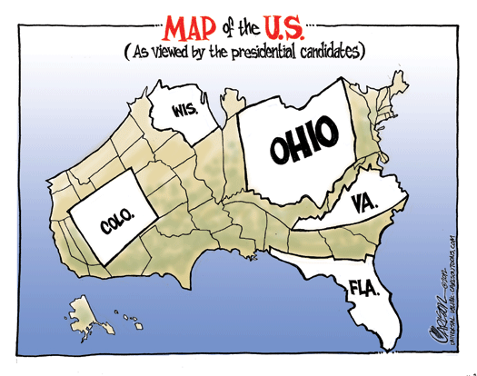
Swing States
US state where the two major political parties have s__________ levels of support among voters, viewed as i______________ in determining the overall result of a presidential e_____________.

Explain how structural barriers impact third-party and independent candidate success

Identify the factors that have weakened political parties as described in this lesson.

FRQ Practice

In this rigged, two-party system, third parties almost never win a national election. It’s
obvious what our function is in this constricted oligarchy of two corporate-indentured
parties—to push hitherto taboo issues onto the public stage, to build for a future, to get a young generation in, keep the progressive agenda alive, push the two parties a little bit on this issue and that.
—Ralph Nader, Presidential 2008 Candidate Green Party

Use the quote and your knowledge of U.S. Government and Politics to answer parts A, B, and C.
A. Describe the viewpoint expressed in the quote.
B. Explain one reason why third parties seldom win national elections.
C. Explain one reason why an individual might not vote for a third party, aside from the fact that third parties rarely win elections.

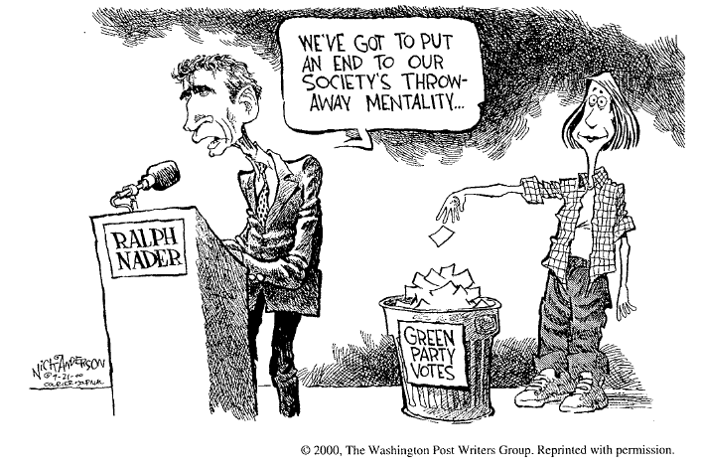

Minor parties (third parties) have been a common feature of United States politics.
(a) Describe the point of view expressed about minor parties in the political cartoon above.
(b) Identify and explain how two rules of the United States electoral system act as obstacles to minor-party candidates winning elections.
(c) Minor parties make important contributions to the United States political system in spite of the institutional obstacles to their candidates' success. Describe two of these contributions.

