Unit 4 Chpt. 12 Topic 4.1-4.4 Citizen’s Beliefs and Political Ideology
4.1 American Attitudes About Government & Politics

Political Culture- the dominant set of beliefs, customs, traditions, and values that define the relationship between citizens and the government. American core political values include i______________, e__________ of o____________, the f__________ e______________ system, rule of l_________ and l_______ government.

American Political Culture
- Individualism- the belief that individuals should be responsible for themselves and for the decisions they make. The fundamental worth and importance of the individual. Enshrined in the Dec of Indep … “they are endowed by their Creator with certain inalienable rights” . The Bill of Rights protects individual rights from government.
- Manifest Destiny- the movement west encouraged rugged individualism
- Equality of Opportunity- Dec of Indep …“all men are created equal”. The equal rights of people to pursue life, liberty, and happiness
- Teddy Roosevelt’s Square Deal- “[E]very man will have a f______ chance to make of himself all that in him lies; to reach the highest point to which his capacities . . . can carry him.”
- 14th amendment equal protection clause- guarantees that people in similar conditions in every state will be treated e__________ under the law.
Civil Rights legislation were all about equal treatment under the law.
Americans value equality of opportunity, they do not support equality of result. The United States has not produced economic equality, in which everyone makes roughly the same amount of money or has the same amount of wealth. Rather, Americans value the opportunity to be rewarded for innovation, hard work, education, and determination.
- Free Enterprise- laissez-faire system-government plays as s_______ a role as possible in the economic transactions among citizens and businesses. America has a m______ economy, in which many economic decisions are left to i__________ and b___________, but the federal and state governments shape those decisions through t____________, s_________, and r___________.
- Rule of Law- the principle that n__ o____, including p________ officials, is above the law. “A government l____ and not of m_____” –James Harrington
Federalist 78- role of an independent judiciary in protecting the rule of law.
Judicial process based on p__________, to insure p____________
Citizens must r____________ the l____ and obey it. This is part of the S_________ Contract.
Transparency in government- the F_________ of I_________ Act allows citizens to access documents and information kept by the government.
- Limited Government-authority comes from the consent of the governed and that citizens are “endowed . . . with certain unalienable rights” such as “life, liberty, and the pursuit of happiness- Dec of Indep
Checks and Balances
All contribute to limiting the power of the government
Separation of Powers
Federalism
Const./ Bill of Rights

How the Interpretations of these values differ between conservatives and liberals
Conservatives- cherish established institutions and seek to preserve them for the good of society. Emphasis on s___________ government, l_______ services to the public. They want to c__________ the good things of gov.
Liberals- push for new reforms to make society more j_______ and e___________. Use g__________to promote the greater good.

Conservatives v. Liberals and how they view American Core Values
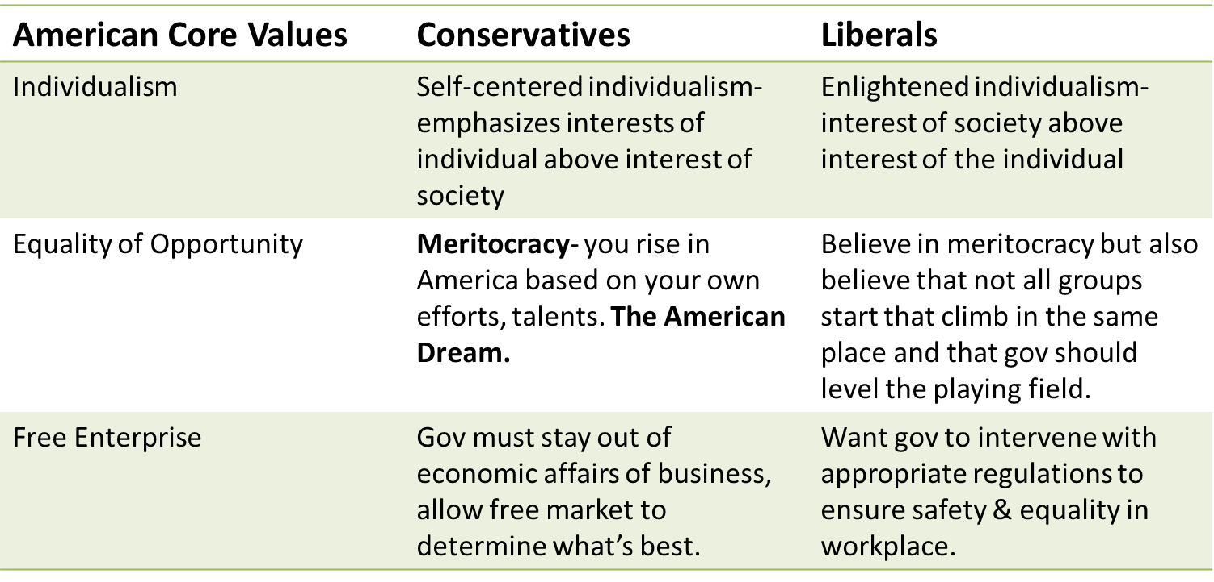

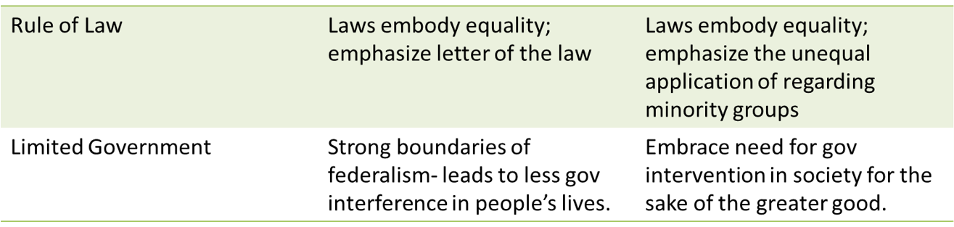

4.2 American Attitudes About Government and Politics
Explain how cultural factors influence political attitudes and socialization.

HOW DO WE GET OUR POLITICAL OPINIONS AND VALUES?
THROUGH POLITICAL SOCIALIZATION
- Def: Process by which an individual acquires his/her p______________ orientations—knowledge, attitudes, opinions
  - occurs at both the individual and community level
  - lifelong process
  - attitudes & values formed early in life
  - variety of agents contribute to shaping
- Political socialization is the process by which citizens acquire a sense of p____________ i___________.

HOW DO WE GET OUR POLITICAL OPINIONS AND VALUES?
Influences that shape their political identities and opinions:
- F___________ and h_________ influences often help shape political party identification. It is strongest when both parents identify with the s__________ political party. If mom and dad are Republicans/conservative, chances you will be also and vice versa.
- S___________ teach patriotism, basic governmental functions and structure, and encourage political participation. AP Government classes indoctrinate young minds! That was a joke, ok!!! Student government is your first step into politics.
- G_________ affiliations (interest groups, labor unions, professional organizations) provide c_________ bonds between people which may be expressed through the group or its activities.
- D______________ factors (occupation, race, gender, age, religion, region of country (g____________), income, education, ethnicity).
- Mass media i___________ the public about issues and help set the political and public a____________.
– Mass Media has been referred to as the “new Parent”
- O_______________ leaders, those individuals held in great respect because of their position, expertise, or personality, may informally and unintentionally exercise influence (think church).
- Events may instill positive or negative attitudes. For example, the Watergate scandal created a mistrust of government.
Social environments:
- religious institutions F_______________/ e____________ believe in a literal interpretation of the Holy Bible. Evangelicals promote the Christian faith. Both tend to take c_____________ positions i.e., anti-abortion and vote Republican. C____________ have traditionally voted with the D_____________ Party, though their vote is less attached to Democratic (Dems p______-abortion) candidates today than in earlier years because the demographics of Catholics have become so diverse. J_______ make up a small part of the national electorate and tend to vote for D______________.
- civic institutions with extreme political views bring only likeminded people together, while other civic institutions bring together people from a variety of backgrounds and viewpoints and help them learn how to work around their differences.
- Geography/ Location:
In the Northeast, liberal Democrats dominate, and more liberal policies prevail.
The South is more influenced by conservative Christian values.
Socialization also influences a worldwide scale. Most of the globalization influence flows from the United States to other countries, through globalization and encouraging immigration. The United States also is exposed to values from other parts of the world.
AMSCO pg. 404-407
Why is family the strongest agent of political socialization?

Why do demographics play a role in political socialization?

4.3 Changes in Ideology
Generational and life cycle effects also contribute to the political socialization that influences an individual’s political attitudes

Generational and Life-Cycle Effects
As you go through different stages in life, your voting behavior will change.
- Generational effect- the impact of historical e________ experienced by a generation upon their p___________ views.
- life-cycle effect the impact of a person’s a_____ and s_______ in life on his or her political views.
Americans are placed into four generational categories to measure attitudes and compare where they might stand on a political continuum:
- Silent Generation
- Baby Boomers
- Generation X
- Millennials
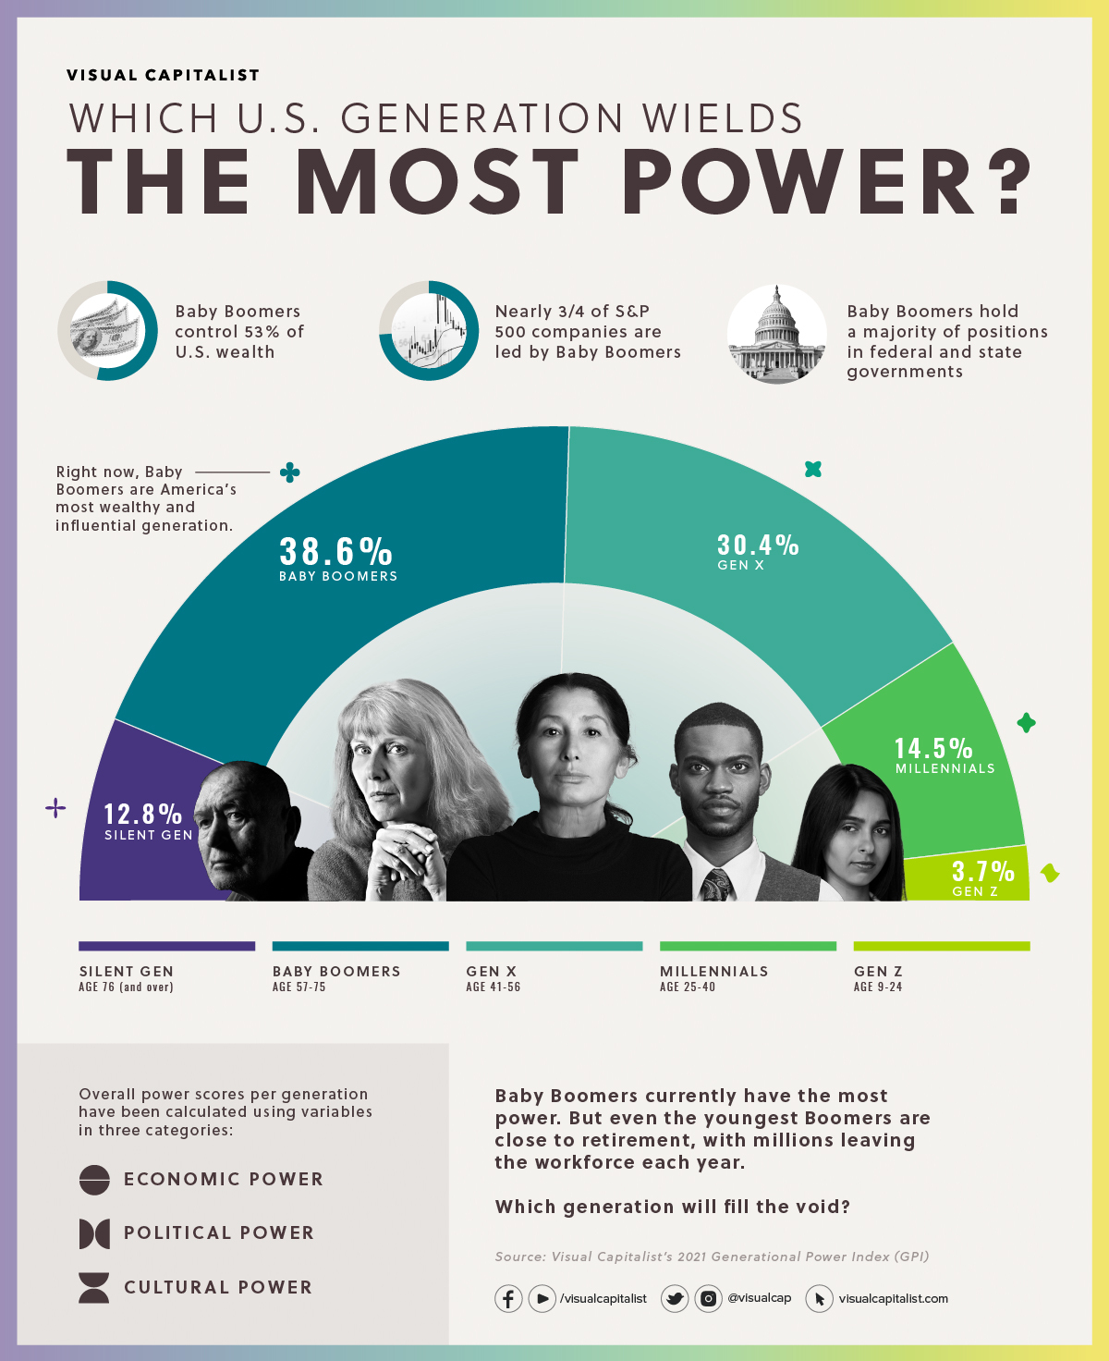
https://www.visualcapitalist.com/ranking-u-s-generations-on-their-power-and-influence-over-society/

4.4 Influence of Political Events on Ideology
Generations | Events | Impact on Political Attitude
Silent Generation and Baby Boomers | Great Depression (1929-41) | Advancing trust in gov & support for the role of gov in economy- further eroding laissez faire- New Deal – social safety net  Majority voted Democratic
 | World War II | The war brought the nation together against fascism, creating a sense of u___________ purpose and a belief in the r____________ of the government.
 | 1960s social unrest and political violence | Mass protests- V___________war, C_________ Rights- were features of time, influenced political socialization. C____________ gov became political norm, people empowered to bring about change
Generation X (1965-1980) | Cold War, Reagan Revolution, | Conservative, mostly Republican. Younger Xers tend to vote Dem
Millennials (1981-96) | 9/11 Attacks | attack on U.S. soil calls for aggressive homeland security and counterterrorism measures. Also, that the event should serve as a wake-up call that the United States should be less involved in the Middle East.

