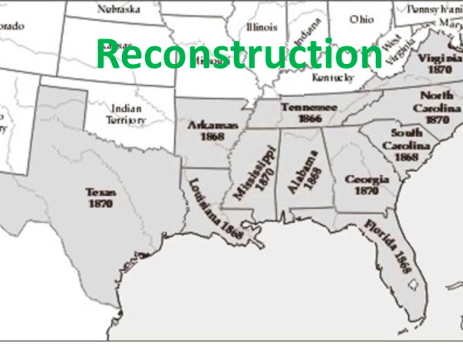
Chpt. 2 Reconstruction 1865-1877
The plan to r_________ /r_______ the South back into the Union of States after the Civil War.
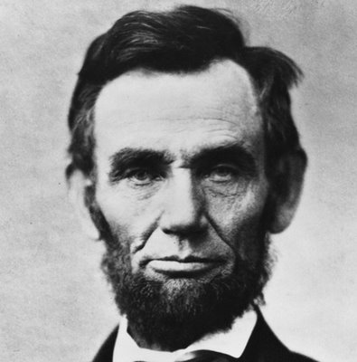
Lincoln’s Second Inaugural Address March 4, 1865
President Lincoln laid out his approach to R___________ in his second inaugural address.
He hoped to reunite the nation and it’s people.
“With m_________ [hatred] toward none, with c_______ for all, with firmness in the right as God gives us to see the right, let us finish the work we are in, to b______ up the nation's w_______, to care for him who shall have borne the battle, and for his widow and for his orphans, to do all which may achieve and cherish a j________ and a l_________ p__________ among ourselves and with all nations”.
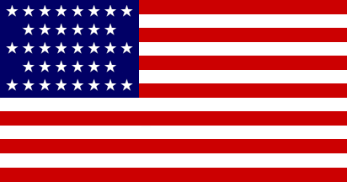
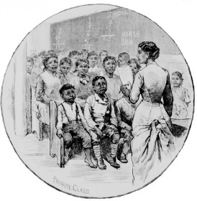
The Freedmen’s Bureau
Government agency designed to help A______ A________
Provided basic e________, j______, clothing, shelter.

Presidential Reconstruction –Abraham Lincoln
Lincoln’s beliefs:
Southern states had never s________, since no state could legally do so
The Rebellion was primarily the work of specific individual Southerners (s______________)
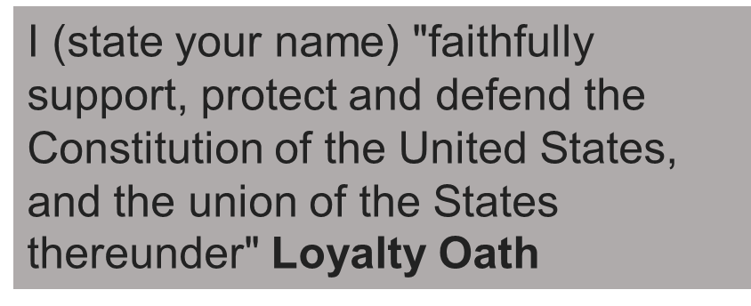
R_________________ was the task of the president because only the president has the Constitutional power to p________ acts against the government. R___________ should be l__________.
The Plan
All southerners (except high C__________ military and government leaders) be p_________ upon taking an o______ of a_____________ (loyalty) to the Union
When _____% had do so, the state was permitted to form a legal state government (_____% Plan)
The House of Representatives r________ Lincolns 10% Plan. They want to p__________ the ex-Confederates.
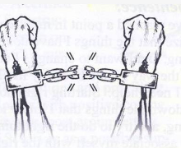
13th Amendment is passed- prohibiting s___________ throughout USA
Just six days after the war ended, on April 15, 1865, President Abraham Lincoln was assassinated while watching a play. The killer was John Wilkes Booth a famous actor.

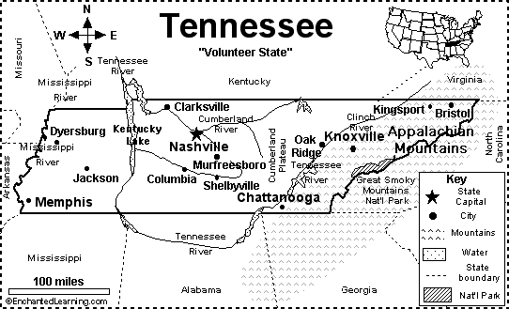
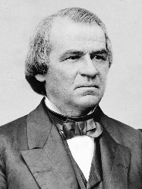
The Politics of Reconstruction
Lincoln’s successor was his Vice President- A________ J_________, a southerner from T_________ and former slave holder.
Johnson was lenient on the ex CSA and issued thousands of p___________ (to be forgiven, as if nothing had happened) to former C____________.
Andrew Johnson
Allowing them to regain their former p_________, US c___________ and positions of p_________. Some got elected to C_____________.
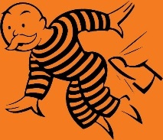
The president soon came under suspicion of many for being too s____________ to the South. Former Confederates became more daring.
Congressional Reconstruction 1866-1873: Radical Republicans- wanted to punish the south
CONGRESSIONAL (aka “____________” REPUBLICANS sought to p______________ former Confederates and p_____________ the civil rights of African-Americans.
Get out Confederates

In early 1866, Congressional R___________, seized control of R_____________ from President Johnson. Congress denied representatives from the former Confederate states their Congressional seats. Gave them the boot.
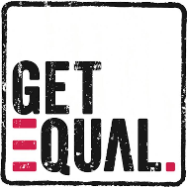
Passed the C______ R_______ Act of 1866- all persons born in the United States were now citizens, without regard to race, color, or previous condition.
Forced the ex CSA to adopt the _________th Amendment to the Constitution, (1868) extending _______________ rights to African Americans and guaranteeing them ___________ protection under the laws. The ______th Amendment also reduced representation in Congress of any southern state that deprived African Americans of the vote.
_____ th Amendment (1870), gave voting rights to black men but no c_______ r_______ guarantees.
President Johnson vetoed all Radical Republican legislation. Congress overrode the veto by a 2/3 majority. Congressional reconstruction wen full speed ahead.
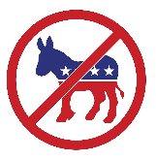
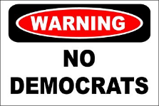
To be readmitted to the Union, each Southern state was forced to ratify the 14th amendment, former CSA leaders were deprived of the right to h________ e_________ office.
Shifted the balance of power in Southern governments to R_________. As a result, many African Americans elected to public office-Senate, House, Governors, etc. African Americans voted Republican -the Party of Lincoln- Ended Slavery.
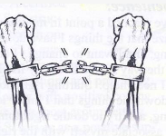
Reconstruction Amendments (13, 14, 15th) Review 1865-1870 13 FREE 14 CITIZENS 15 VOTE
13th – __________________________________________________________________________________

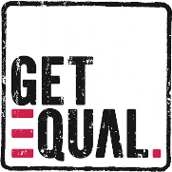
14th- All persons b________ or n___________ in the United States and subject to the j___________ thereof, are c___________ of the United States and of the State wherein they reside. No S_________ shall make or enforce any law which shall a__________ the privileges or i__________of citizens of the United States; nor shall any S________ deprive any person of l_______, l_________, or p___________, without d____ process of law; nor deny to any person within its jurisdiction the e_________ p____________ of the laws.
15th – __________________________________________________________________________________________________________________

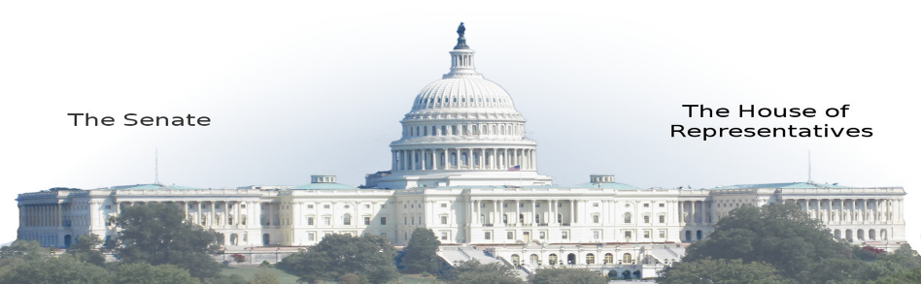
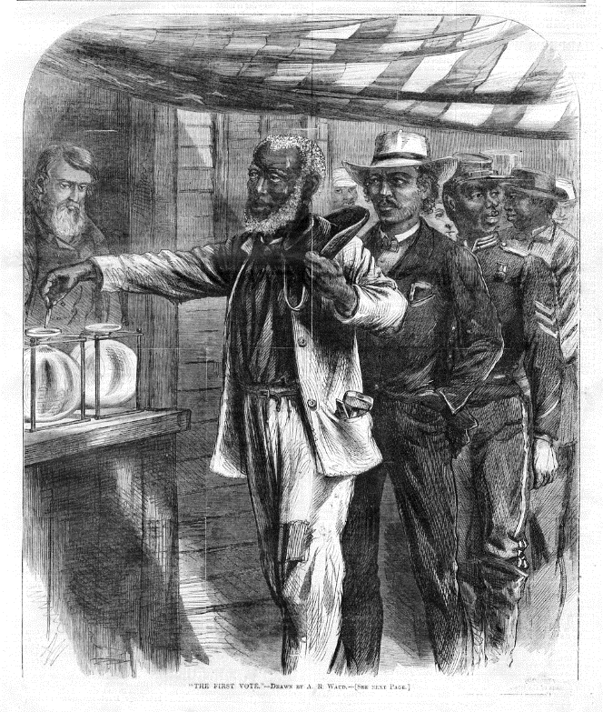
The First Vote- 15th amendment.

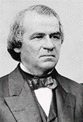
Impeachment
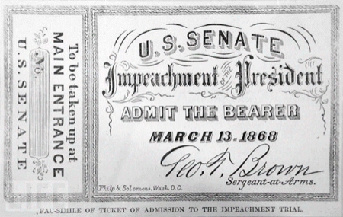

Why was President Johnson Impeached?
________________________________________________________________________________________________________________________________________________________________________________________________________________________________________________________________________________________________________________________________________________________________________________________________________
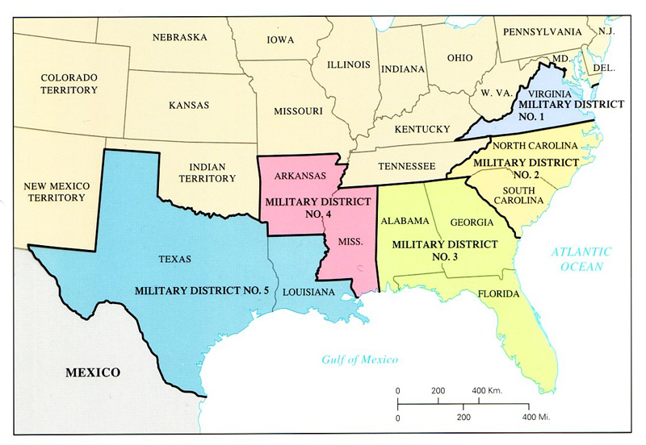
Radical Republicans divided the South (except for Tennessee, which ratified the ___th Amendment voluntarily) into five m_________________ districts. Radical Republicans believed that the defeated South should be treated like “o____________ provinces.” President Johnson v________ the Reconstruction Acts that were passed by the Radical Republicans in 1867, but his vetoes were overridden by Congress. The Radical Republicans voted to i___________ President Johnson over disagreements about Reconstruction plans. Johnson avoided being removed from office by ____ vote.
The 5 Military Districts of South. Occupied by the North (Union) and under direct military control of Union Generals. Tennessee excluded- they approved the 14th amendment.
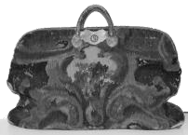
Carpet bags, which were bags made of scraps from carpets or rugs, were a popular form of luggage in the late 19th century – especially for people who were traveling light. After the Civil War, many Northerners traveled South in search of economic gain, political office, or opportunities to provide public services, such as education to both blacks (the freedmen) and whites.
Republican Coalition: During Radical Reconstruction, Southern state governments were dominated by the Republican Party.

“_________________” “_________________” ________________
Southern states were required to create constitutions that allowed voting rights for all men. Freedmen exercised their votes to support the Republican coalition and held office in many states.
This term, which loosely translates to “rascal,” was used to describe Southerners who had supported the Confederacy but cooperated with the Carpetbag Republican governments for personal gain.
During Radical Reconstruction, Southern state governments were dominated by the Republican Party.

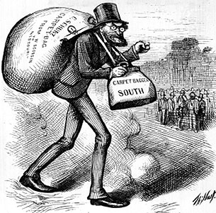
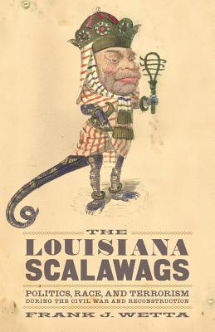

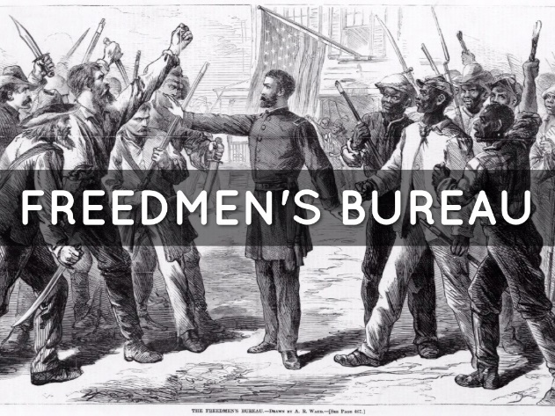

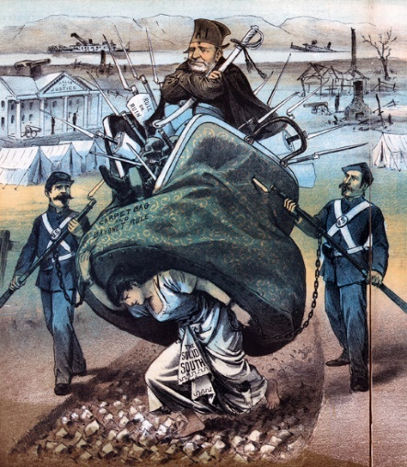
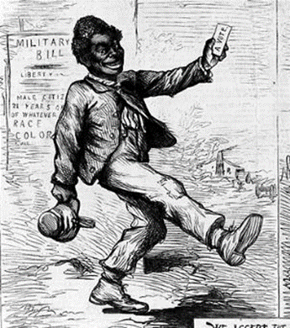

The Economics of Reconstruction: The “New South”
S_______cropping is a system of agriculture or agricultural production in which a landowner allows a t________ to use the land in return for a s__________ of the crop produced on the land. Landlord will provide tools, seed, etc. S_________cropping helped ease the l_________ shortages in the South.
A t________ farmer is one who resides on and farms land owned by a landlord. The farmer pays rent cash or with crops. Must provide his own tools.
Peonage, also called d_________ slavery or debt servitude, is a system where an employer compels a worker to pay off a debt with work. Legally, peonage was outlawed by Congress in 1867. Debt peonage= debt slavery
D_____ BECAME the new S________.

Reconstruction Comes to an End
- Legacy of Racism- Many whites refused to recognize blacks as their social and political equals.
- Economic Dependence of African Americans- Southern blacks remained dependent on their former masters for their economic livelihood– sharecroppers, tenant farming
- The Freedmen lacked Education and Political Experience
- White Terrorism- KKK
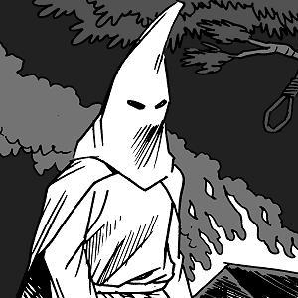
- Loss of Northern Interest in Southern Reconstruction- the economic depression of 1873 and the disputed election of 1876
Resistance to Reconstruction
During Radical Reconstruction, the ______ __________ __________ committed acts of violence and intimidation against carpetbaggers, scalawags, and freedmen.

The Compromise of ________ and the End of Reconstruction
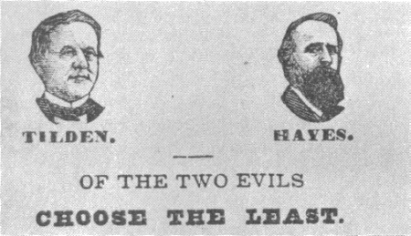
The Compromise of 1877 was an informal agreement that ended Reconstruction in the South after the disputed presidential election of 1876.
Election of 1876
Southern Democrats regained control of state governments and instituted discriminatory policies. The system of racial segregation instituted in the post-Reconstruction South was known as ________________ ________________
____________ Clause / ___________ Tests / Poll __________.
________________ v. ________________ (1896) This Supreme Court decision established the principle of S________________ but E_________________.

OVERTURNED BY Brown v. ______________________________ (1954). Nearly 60 years of Jim Crow in the South.
De Jure Segregation______________________________________________________
De Facto Segregation _____________________________________________________

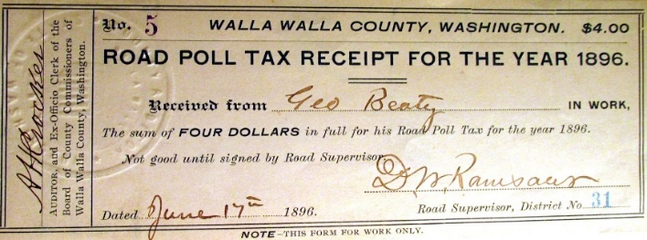
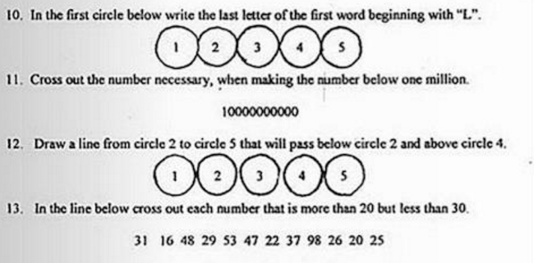
By 1960, African Americans were not only segregate but excluded from society.

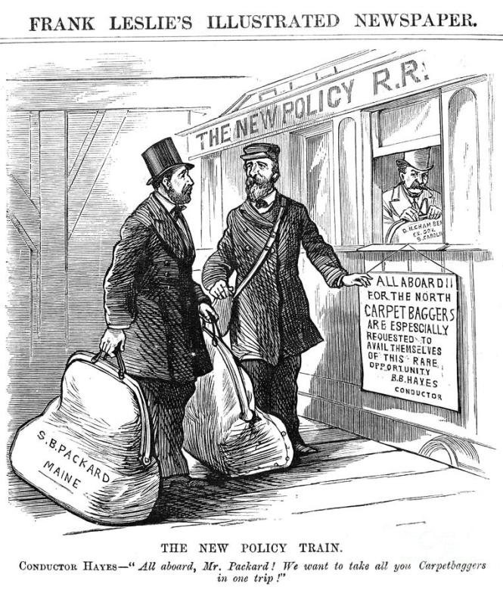
Compromise of 1877
- Who is the train conductor?

- Who is boarding the train North?

- What is the New Policy?

EOC Practice

2.

3.

- Following Reconstruction, the passage of Jim Crow laws in the South limited the effectiveness of

- the 14th and 15th amendments c. Black Codes
- the Freedmen’s Bureau d. tenant farming and sharecropping

5.

6.

7

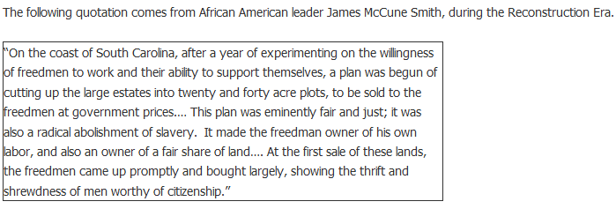

8.

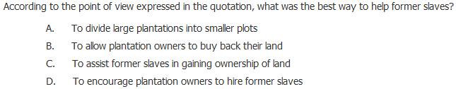

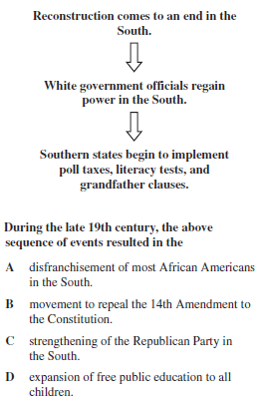
9.

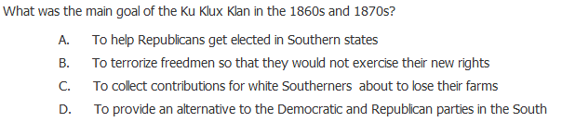
10.

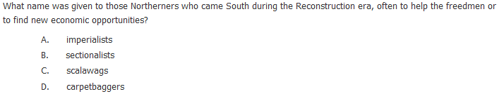
11.

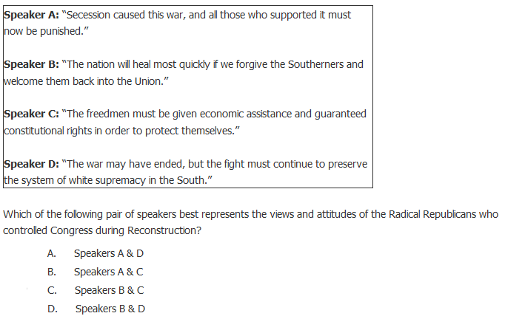

12.

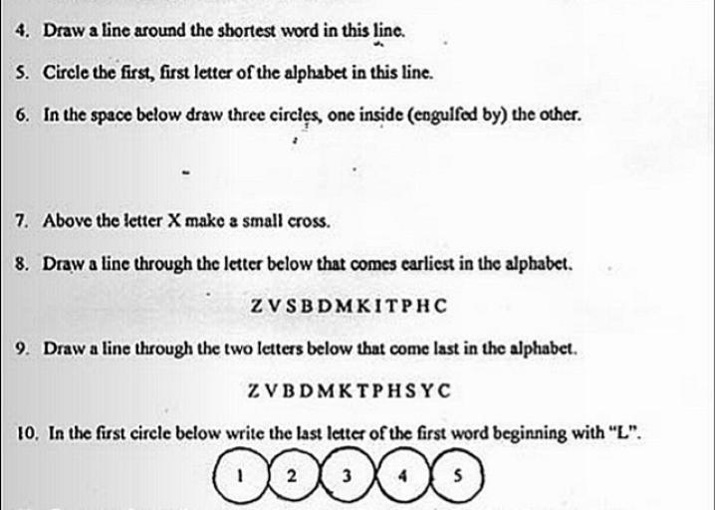
13. LITERACY TEST

