Ctrl F keys to do key word search to find answers.

Period 4 (1800-1848): Politics and Power
Throughout the nineteenth century there was a multitude of continuity and change in politics and power explicated around the United States. Below is a timeline of how the political power in the U.S. constantly evolved.
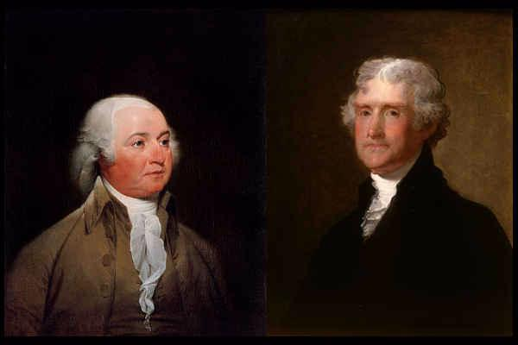
Revolution of 1800- The peaceful transition of power from Adams (Federalist) to Jefferson (Dem-Republican). The beginning of Period 4 focuses on this year. It is extremely significant because this was the year that the election between John Adams and Thomas Jefferson was in. After six days and 36 ballots, Thomas Jefferson was elected the third president of the United States peacefully.
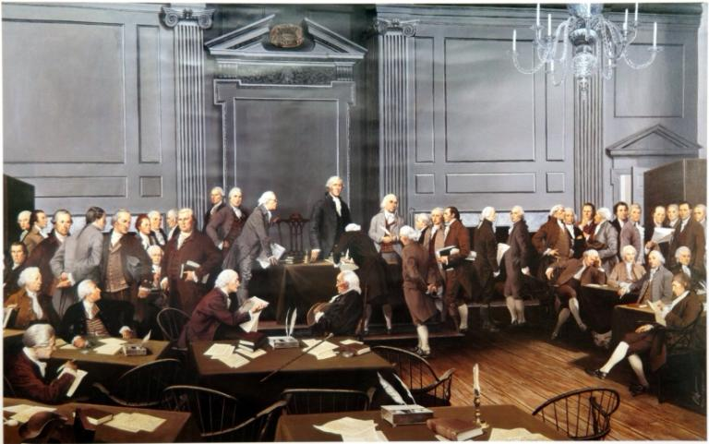

Quiz
1801- Which historical event during this year was the main influence of John Marshal being appointed chief justice and also affected federal courts, judgeship, marshals, and clerks?
- Supreme Court Act 1801
- Marshal Act of 1801
- Judiciary Act of 1801 THIS IS THE ANSWER.
- Lawful Rights Act of 1801
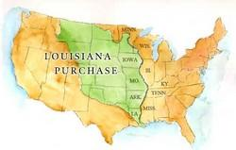

- 1803- The Louisiana Purchase was an extremely important event in Period 4 and it shows how the nation’s growing political power was using its influence to spread across the nation. The relatively cheap purchase made by Jefferson orchestrated his power as a political figure and more than doubled the size of America. Doubled size of USA, secured New Orleans Port & the use of the Miss. River. Removed a European presence from the nation's borders
- Jefferson's hopes for an agricultural society increased

Marbury vs. Madison, 1803
A case by the U.S. Supreme Court that creates the basis for the exercise for judicial review in the United States.

Why was this important?
This was the first important case before Marshall's Court. It set the future for the Supreme Court up to decide whether or not certain laws were constitutional or not. JUDICIAL REVIEW- the power of a court to decide whether a law or decision by the government is constitutional.

What was the result of the Marbury vs. Madison case?
The Judiciary Act of 1789 was unconstitutional because it gave a certain amount of power to the Supreme Court that wasn't allowed due to the Constitution. JUDICIAL REVIEW

The Politics of Dueling
In 1804 the sitting vice-president of the United States, Aaron Burr, kills Alexander Hamilton, the former secretary of the treasury in a duel.

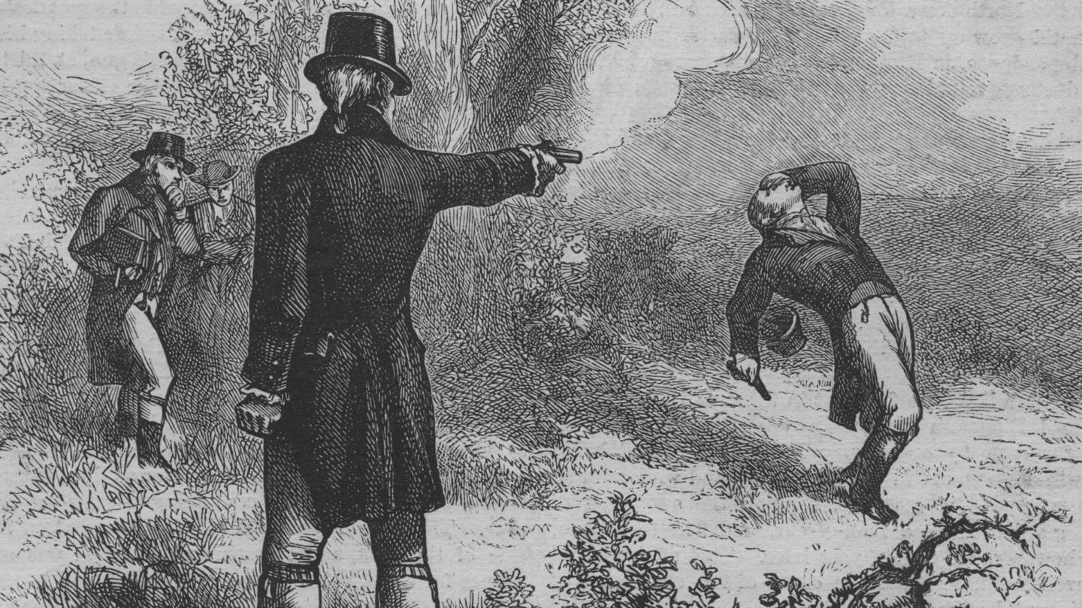

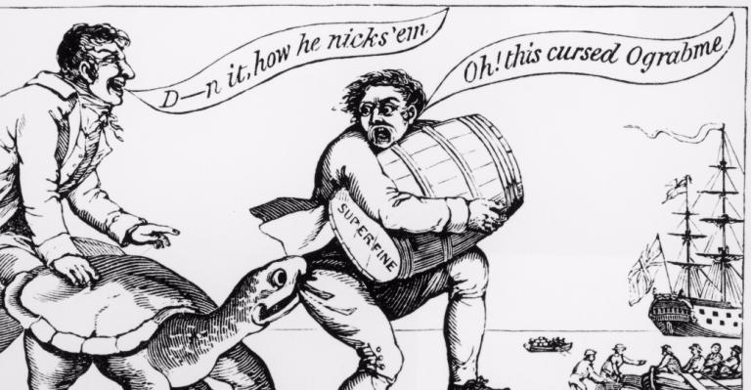

Quiz LOOK Ograbme = Embargo
The Embargo Act of 1807:
- Was Jefferson's attempt to keep the country at peace and avoid further provocative incidents
- Stopped the export of American goods and prohibited all U.S. ships from leaving for foreign ports
- Was denounced by New England merchants and western and Southern farmers alike
- All of the Above IS THE ANSWER.
- The embargo was an unpopular and costly failure. It hurt the American economy far more than the British or French, and resulted in widespread smuggling.

- Did you know?
Later in 1807, Congress actually banned the international slave trade. This was a huge political event that moved closer towards equality in America.

Forum
In your opinion, did the Tariff of 1816 support the United States after the War of 1812 or did the Tariff only make matters worse?

President James Monroe March 4, 1817 – March 4, 1825 Era of Good Feeling
The War of 1812- This war marks a huge political event because the United States government decided to go to war with Britain because of the impressment of American sailors and the seizure of American trading ships overseas.

Treaty of Ghent ended war of 1812 in 1815. Britain had hoped, in its efforts, to establish an Indian nation in the Midwest so that it might maintain its influence in the region. Because of this, many native tribes fought alongside the British. The treaty, however, secured the United States' existing boundaries in the West and defeated many native tribes residing in the region.
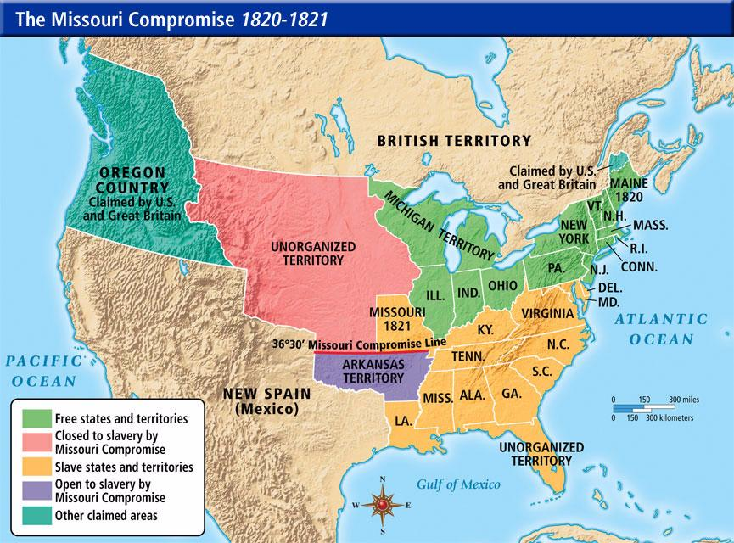

SECTIONALISM

The Missouri Compromise of 1820 happened during a period in which the balance of power containing slaves was balanced. When Missouri wanted to join the U.S. as a slave state, it would've thrown the whole balance off because there were already 11 slave states and 11 free states. To fix this, Missouri was added as a slave state while Maine was added as a free state. Slavery was prohibited in the Northward while slave was allowed Southward. The south did not want to be outvoted in the Senate. In the Senate, every state state gets 2 senators = 2 votes regardless of population size. Unlike in the House of Representatives where representation is based on population where the north had the most population thus the most votes. In the House the south would never win a vote

1823- The Monroe Doctrine was established in which President Monroe stated that European expansion and colonization must stop and he will use force to prevent it in America. Britain sided with US to keep open the new markets of Central and South America.
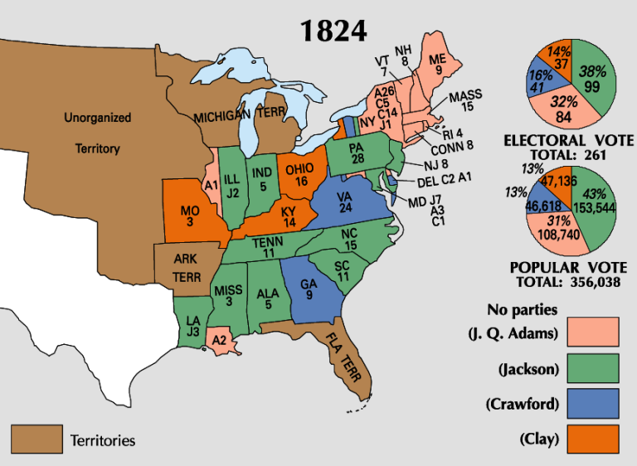

ERA OF GOOD FEELING- cite evidence of the good and bad about this time of “Good Felling” listed below

1824- President Monroe served two terms in the United States and the time that he served is known as the "Era of Good Feelings". The nation was strong and united (nationalism- love of one’s country) especially after the War of 1812. Federalist Party had disappeared but it was time to elect a new President in 1824. The candidates were John Quincy Adams, Andrew Jackson, Henry Clay, and William Crawford.

Only ONE political party Democratic Republicans as the Federalist faded out after 1812. Politics became less contentious but also more boring.

THE AMERICAN SYSTEM (1816-1828) was created by Henry Clay. He promoted a strong banking system, a protective tariff (to protect America's industry from foreign imports), and infrastructure (internal improvements).

Market Revolution

Marked a change from small self-sufficient (cottage industries-work from home; Jeffersonian view) farms towards producing goods to for others far away (Hamiltonian view).
Created the MODERN INDUSTRIAL COMMERCIAL ECONOMY. What enabled this change to occur?
    - New Technologies- transportation and communication
- Better roads- National Road
- Canals/steamboats by 1839 3,000 miles of canals
- Rail Roads- Baltimore & Ohio (1807) by 1860 30,000 miles of rail roads in USA
- Telegraph- faster communications on orders, sales, prices etc
- Factory system evolved
- Modern banking system to finance all the business activities
- Corporations and the advent of Big Business
    - Government helped in this growth
- Encouraged competition
- Built roads, canals
- Supreme Court cases that were friendly towards business, example: Gibbons v. Ogden 1824
- Sates set up incorporation laws to help create corporations in their states
- Issued BONDS to help finance canals, roads and deals to build rail roads
Wage workers eventually felt trapped in these factories and moved WEST

Foreign affairs
Canada- Diplomatic differences of Treaty of Ghent
1) Rush Bagot Agreement - an agreement between Britain and America. This agreement limited naval weapons and equipment on the Great Lakes; furthermore the agreement limited places on the border fortifications: The United states and Canada border was the longest unprotected border in the world.
2) Treaty of 1818- It improved United States and Britain relations
3) 1819 Florida-Spain had control of western Florida but after the war they had trouble maintaining the rest. USA purchased Florida from Spain for $5 million under the terms of the The Adams–Onís Treaty.

WHAT WAS THE PANIC OF 1819?
It was a time period in which the first economic crisis happened due to the Second Bank of the United States. Banks failed, mortgages were foreclosed, which forced people out of their homes and off their farms. This led to unemployment issues.

Causes of the Panic of 1819:
- Bank loans - people used credit to buy land, causing them to loan money in order to get their land. When the economy came to a stop, people didn't have money to pay off their loans.
- The War of 1812 - economic expansion stopped after the War of 1812. The British and United States had a conflict over British violations. It ended with the Treaty of Ghent.

Effects from the Panic of 1819:
- unemployment, imprisonment, and bankruptcies increased
- Nationalistic beliefs were weary
- Economic crisis changed many voters' political outlooks
- Democratic-Republican party had internal problems
- Federalist ideas were adopted, such as the need for a large army and navy, as well as a national bank

Was the Era of Good Feeling really that good? Make sure you can defend this statement with evidence

1828- Tariff of 1828 and The Nullification Crisis—GROWING SECTIONALISM
The tariff of 1828 raise taxes on imported manufactured goods from Europe. ... The result was that goods from Europe were more expensive. Because England could not sell as many goods to America they could not purchase as much of the agricultural products of the south. The south was hurt badly by these tariffs.
In Washington, an open split on the issue occurred between Jackson and Vice-President Calhoun. On July 14, 1832, Jackson signed into law the Tariff of 1832 which made some reductions in tariff rates. Calhoun resigned on December 28 of the same year.
The reductions were too little for South Carolina. In November 1832 the state called for a convention. By a vote of 136 to 26, the convention overwhelmingly adopted an ordinance of nullification drawn by Chancellor William Harper. It declared that the tariffs of both 1828 and 1832 were unconstitutional and unenforceable in South Carolina. While the Nullification Crisis would be resolved with a compromise known as the Tariff of 1833, tariff policy would continue to be a national political issue between the Democratic Party and the newly emerged Whig Party for the next twenty years
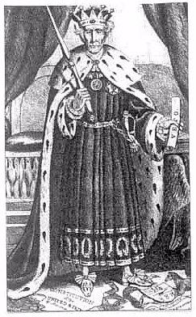
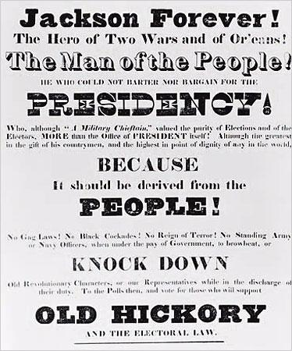

JACKSONIAN DEMOCRACY: Suffrage extended to poor white men. Era of the Common Man
This is a primary source of the election of 1828. Andrew Jackson's supporters published these campaign signs which told the people about how Jackson was part of the people and a man of the people and for the people. He became president in 1828.
JACKSONIAN DEMOCRACY
Party Nomination Conventions
Popular Election of Presidential Electors
Two Party System
Rise of Third Parties
Veto of the BUS- BUS seen as elitist and undemocratic
NOT JACKSONIAN DEMOCRACY
1830- The first political power that Jackson thoroughly expressed was the removal of Indians off of the land. This was known as the Indian Removal Act in 1830. TRAIL OF TEARS

Cult of Domesticity- women still seen in their traditional roles

Formation of the Whig Party
1834-The Whig Party was formed by members who were Anti-Jackson and believed that he was using his power too much and hurting America. Whigs tended to be educators and professionals, manufacturers, business-oriented farmers, British and German Protestant immigrants, upwardly aspiring manual laborers, free blacks, and active members of Presbyterian, Unitarian, and Congregational churches. Henry Clay became the recognizable face of the party.

1830s and on - Massive Influx of European Immigrants

IMMIGRATION
The first half of the 19th century saw a mass migration of Europeans to the United States. The major push factors were overcrowding in Europe, crop failures (potato famine Ireland), the industrial revolution the United States was experiencing, and thus, job opportunity, and religious and political chaos. The major pull factors were freedom, economic opportunity, and plentiful land, especially in the West.

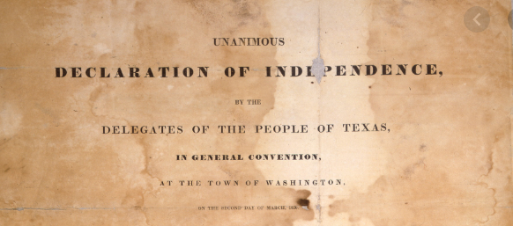
War for Texas Independence October 2, 1835 – April 21, 1836
This is a primary source of the Texan Deceleration of Independence from Mexico in 1836. A long feud between Mexico and the United States had finally come to an end at The Alamo and with the signing of this document.

REPUBLIC OF TEXAS ESTABLISHED (1835)
The Republic of Texas was the result of the Texan Revolution--the war between America and Mexico over Texas' independence. It was an independent sovereignty from 1836 to 1840. Its annexation was incredibly significant because it most directly led to the Mexican American War.
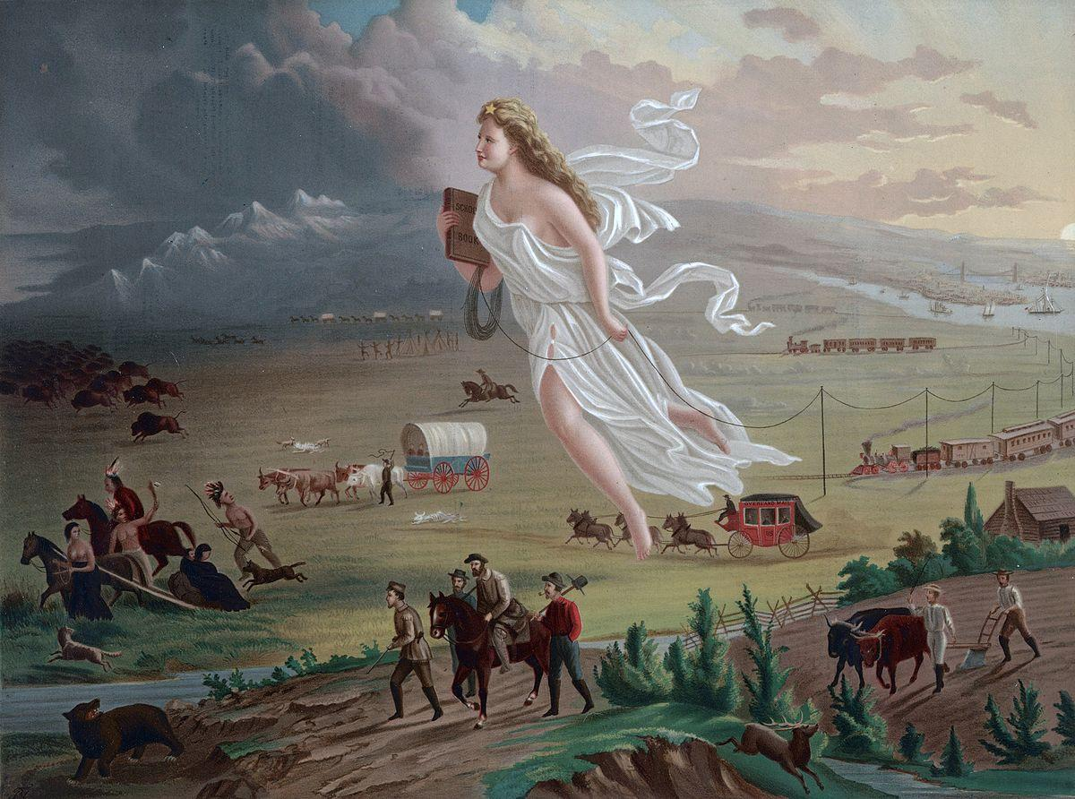

1845 - John O'Sullivan coins "Manifest Destiny"
The phrase "Manifest Destiny" described the belief that marked 19th century expansionism - that the expansion of the US throughout its continent was inevitable and justifiable, as it was ordained by God that his "chosen people" held the right to spread civilization.

Why did everyone begin moving westward anyways?
There was a lot of rich farmland that people wanted, but unfortunately, it was land owned by American Indians. The settlers had support from the federal government and fought many wars with the Indians. Settlers took the Indian lands anyways while the Indians struggled to protect their land.

Problems with westward migration: GROWING SECTIONALISM: Industrial North, Agricultural South
SLAVERY
How was this problem fixed?
The Missouri Compromise 1820

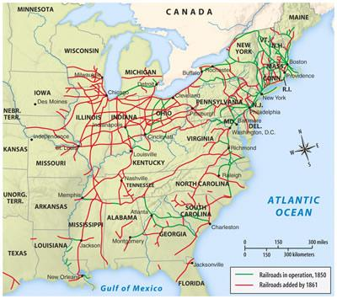
1840s - 1850s - Railroad Industry Flourishes
By the 1840s, the Baltimore & Ohio Railroad and the South Carolina Railroad Had been built and the railroad emerged as the fastest means of moving goods. The railroad system in the 1840s was not yet cohesive and completed connected, nor was it transcontinental. By the 1850s, however, the beginnings of such a system took shape, and the Northeast and Midwest were far more connected.
Can you see SECTIONALISM?

MEXICAN-AMERICAN WAR April 25, 1846 – February 2, 1848
1848 - Treaty of Guadalupe Hidalgo, Gold Rush Begins
The final year of Period 4 saw the end of the Mexican-American War, which gained the US new territory in the West. As a result, a new era of western expansionism began, as the discovery of gold in California by James W. Marshall in this year saw the start of the Gold Rush 49ers, which prompted the emigration of over 300,000 people to California in just a few years. This led to California's hasty development and admittance as a state in 1850.

Society 1820-1860 THE SECOND GREAT AWAKENING
THE SECOND GREAT AWAKENING led by Christians
The Second Great Awakening was an important social, religious, cultural aspects in The United states. It was a period of religious revivals, where church membership soared a lot of people had conversion experiences which was where they realized their relationship with God and that they wanted to become more religious and they needed to stop their ways as sinners. The idea of social equality that came about with the advent of the new nation trickled down to religion. Pre- cursor to Social Gospel movement during the Progressive Era.

It was all about REFORMING SOCIETY

WOMEN’S RIGHTS MOVEMENT: The Seneca Falls Convention in 1848 was the last major political event during Period 4. This convention consisted of a large gathering of women fighting for Women's rights. "Declaration of Sentiments" stated that "all men and women are equal". This event is a significant ending to this period because it introduces a new issue of women's rights that will be fought for in Period 5.

THE ABOLITIONIST MOVEMENT CAME ABOUT...
The abolitionist movement was a social and political push for the immediate emancipation of all slaves and the end of racial discrimination and segregation. Underground rail road is created. Fredrick Douglas- The North Star, William Lloyd Garrison- The Liberator ABOLITIONIST NEEWS PAPERS.

ASYLUMS AND THE MENTAL HEALTH FIELD OF STUDY WAS REFORMED...
The Dorothea Dix Hospital was opened in 1856 in Raleigh, NC. Mental hospitals provided professional treatment for mental patients in order to improve the unsanitary conditions that patients had experienced. Dix's reforms brought attention to the care of the emotionally disturbed that were often linked to the increasing numbers of criminals. With professional care and new facilities, there was hope to cure the odd behavior of patients.

SCHOOLS UNDERWENT REFORMS
Before the mid-1800's, no uniforms educational policy existed in the United States. MA and VT were the only states before the Civil War to pass a compulsory school attendance rule. In the 1830's Americans began to demand tax supported public schools. Horace Mann established teacher training programs and curriculum reforms, and doubled the money the state spent on school. Soon, other states other than MA began to follow. Colleges allowed women to attend such as Oberlin College also allowed black men to attend.

AMERICAN TEMPERANCE SOCIETY IS FORMED 1826
The temperance movement was an attempt at discouraging drunkenness and excess. Americans must temper their consumption. Amassed 1,250,000 members in just over 10 years. The movement would later manifest itself in the prohibition movement in the early 1900's and lead to PROHIBITION 18th amendment in 1919 and take effect Jan 1920.

Transcendentalism
Transcendentalist believed that people were good but they were corrupted by society and that they should strike for Independence and self-reliance. Ralph Waldo Emerson and Henry Thoreau were two transcendentalist that were well known. Thoreau demonstrated peaceful protests against laws he thought were unjust, which spread to many others.

Ralph Waldo Emerson Writes "Self Reliance"
This essay by the transcendentalist writer Emerson expresses the beauty of individualism and spiritual enlightenment
Transcendentalism became a profound movement in the first half of the 19th century, as people sought to separate themselves from the industrial world. This would begin to change, however, when people began to get more involved in society during the progressive era.

The Temperance Movement
The Temperance movement was an idea that Americans drink way too much alcohol and that they needed to temper their consumption down so the United States wanted to get rid of alcohol. Families were affected by alcohol. People could not be drunk at the job or else they would get injured and the boss would notice you being less productive. The use of alcohol was a big issue so the American Temper Society was created. It was where men had to make a pledge to stop drinking.
Their goal was to make illegal the consumption of alcohol. This was seen as NOT democratic.

