AP® U.S. Government and Politics Study Guide Watch – What Were the Articles of Confederation (2:28)

THE ARTICLES OF CONFEDERATION (1777)
The Articles of Confederation and Perpetual Union was the first constitution formed among the thirteen original states of the United States. It was approved by the Second Continental Congress in 1777 but did not come into force until 1781.
KEY TERMS
Sovereignty
Sovereignty refers to the authority to provide
governance. The Articles of Confederation reserved most of sovereignty for the states. It established a very weak central government that did not have the sovereignty
to compel states to furnish armies, effectively negotiate foreign policy, or collect taxes.
Confederation
A confederation is a group of entities united under a shared cause. The Articles of Confederation united the new states in a “league of friendship” that stressed the
independent nature of each of the states. The confederation that it formed was based on voluntary cooperation.
Ratification
Ratification is the act of giving formal consent. For the Articles of Confederation to be ratified, it took almost four years for all thirteen states to agree to the document.

SUMMARY OF THE ARTICLES OF CONFEDERATION
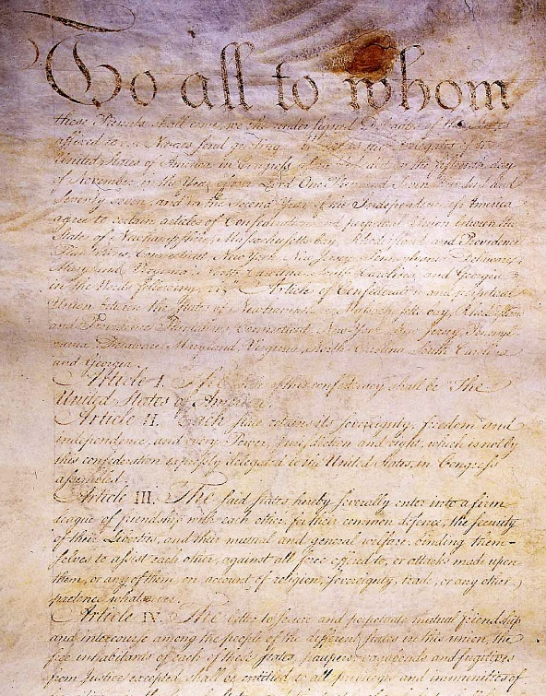
The Articles of Confederation was the first attempt by the newly independent American colonies to form a cohesive union governed by a written constitution. It established that the states were united in a “league of friendship” and that they mutually agreed to cede some sovereignty to a central government. While it represented an important step in establishing the political structure of the United States, it was plagued
with many problems because the federal government that it established was too limited to effectively govern the new nation. The limitations of the Articles of Confederation were resolved when it was put it aside in favor of the U.S. Constitution.
One of the major flaws of the Articles of Confederation was

that it established a very weak executive. The president of the
The Articles of Confederation and Perpetual Union, 1777

NOTES

United States in Congress Assembled (the official title of the executive of the document) could not act independently in any way. They were a ceremonial figurehead that primarily served as the chief administrator of Congress. They also served a relatively short one-year term. When the flaws of the Articles of Confederation became apparent, Alexander Hamilton argued in Federalist No. 70 that the
U.S. government should adopt the exact opposite model than what was included in the Articles by having a unitary executive who could act independently.

Under the Articles of Confederation, Congress (legislature) was the only branch of government (unicameral). It consisted of 13 states and each state had one vote.
Not having a real unitary independent executive had far reaching implications. The fact that Congress was responsible for all major decisions (Congress was the ONLY branch of government) hindered the new nation’s ability to develop effective foreign policy. Under the Articles of Confederation, Congress needed to have the consent of 9 of the 13 states (a quorum) to approve any treaties, legislation or amendments. This rarely occurred, so treaties and foreign policy decisions, and proposals for political alliances often languished in Congress for months.
Congress also lacked any way to compel the states to act. Without any enforcement mechanisms at its disposal, the federal government could not compel states to provide troops for military actions or collect taxes. Without either the “power of the purse” or control of the military, the federal government could not take meaningful action on a national scale. This lack of power became apparent after Shay’s Rebellion when the central struggled to marshal enough troops to put calm the disturbance.
Also, by not having a federal court system, there was no way to settle disputes between the states.
By 1787, it was clear that the Articles of Confederation needed to be significantly revised. The states called a convention, later called the Constitutional Convention, which initially intended to rewrite the document. It soon became apparent that more significant changes were needed than just a few edits. The Constitutional Convention set themselves to developing the U.S. Constitution, which would replace the Articles of Confederation.

KEY PASSAGE
Article I. The Stile of this Confederacy shall be “The United States of America.”
Article II. Each state retains its sovereignty, freedom, and independence, and every power, jurisdiction, and right, which is not by this Confederation expressly delegated to the United States, in Congress assembled.  Article III. The said States hereby severally enter into a firm league of friendship with each other, for their common defence, the security of their liberties, and their mutual and general welfare, binding themselves to assist each other, against all force offered to, or attacks made upon them, or any of them, on account of religion, sovereignty, trade, or any other pretense whatever. | What is the relationship between the states and the federal government according to the Articles of Confederation?
 | What does this mean? Can you put it in your own words?
Article IV. The better to secure and perpetuate mutual friendship and intercourse among the people of the
different States in this Union, the free inhabitants of each of these States, paupers, vagabonds, and fugitives from justice excepted, shall be entitled to all privileges and immunities of free citizens in the several States; and the people of each State shall have free ingress and regress to and from any other State, and shall enjoy therein all the privileges of trade and commerce, subject to the same duties, impositions, and restrictions as the inhabitants thereof respectively, provided that such restrictions shall not extend so far as to prevent the removal of property imported into any State, to any other State, of which the owner is an inhabitant; provided also that no imposition, duties or restrictions shall be laid by any State, on the property of the United States, or either of them. | What is the benefit of free movement of people across the nation? Does this stipulation apply to slaves?
If any person guilty of, or charged with, treason, felony, or other high misdemeanor in any State, shall flee from justice, and be found in any of the United States, he shall, upon demand of the Governor or executive power of the State from which he fled, be delivered up and removed to the State having jurisdiction of his offense.
Full faith and credit shall be given in each of these States to the records, acts, and judicial proceedings of the courts and magistrates of every other State.”
Watch – What Were the Articles of Confederation (2:28)
QUESTIONS. Answer on a separate sheet of paper.
- What was the Articles of Confederation?
- What is a confederation?
- Under the Articles of Confederation, what was the only branch of government? How many votes did each state get?
- Why was it difficult to pass laws and amendments?
- Why did the Articles of Confederation create a government with no executive branch?
- Under the Articles of Confederation, the federal government wasn’t able to collect taxes. What problems did this cause?
- 7. Why was Shays’ Rebellion seen as such a big problem?

THE ARTICLES OF CONFEDERATION IN THE CED
LOR-1.A: Explain how democratic ideals are reflected in the Declaration of Independence and the U.S. Constitution.
CON-1: The Constitution emerged from the debate about the weaknesses in the Articles of Confederation as a blueprint for limited government.
CON-1.B: Explain the relationship between key provisions of the Articles of Confederation and the debate over granting the federal government greater power formerly reserved to the states.
CON-1.B.1: Specific incidents and legal challenges that highlighted key weaknesses of the Articles of Confederation are represented by the:
- Lack of centralized military power to address Shays’ Rebellion
- Lack of tax law enforcement power
The left side lists the weaknesses of the Articles of Confederation, and the right side lists some possible consequences of those weaknesses. Identify each weakness from the left to match it to its likely effect on the right.
WEAKNESSES OF THE ARTICLES | EFFECTS OF THE WEAKNESSES
(A) Congress had no executive power to enforce laws.  (B) Congress had no sole power to coin money.  (C) Congress had no power to levy taxes.  (D) Congress had no power to regulate commerce (trade).  (E) Congress had no power to amend the Articles w/out a unanimous vote. | 1. _____ NO NEW CHANGES - New attempt at revising the Articles fails to garner enough votes for approval  2. _____ YOUR MONEY IS WORTHLESS - Connecticut says it will no longer accept Rhode Island’s “worthless currency”  3. _____ NOT FOR SALE HERE - Virginia bans all goods from Maryland and North Carolina  4. _____ STATES CHALLENGE NATIONAL LAWS - A Georgia citizen disobeys a congressional resolution, but the Georgia legislature says, “O.K.”  5. _____ DEBT ON THE RISE - France sends collection notices for war debts; Congress petitions Virginia for a loan

