Ctrl F keys to do key word search to find answers. APUSH Period 5 1844-1877
SEE PERIOD 4 NOTES pg 7-8: War for Texas Independence October 2, 1835 – April 21, 1836
REPUBLIC OF TEXAS ESTABLISHED (1835), ANNEXATION of Texas
Manifest Destiny is very important in this period

1844 : Beginning of Period 5 -
James Polk was elected as the 11th President of the United States. The Whig Candidate, Henry Clay, lost by a small margin. Polk embraced American territorial expansion, and sparked the idea of "Manifest Destiny". This was a political transformation because the President before him was a Whig, John Tyler.

AMERICAN IN THE WORLD

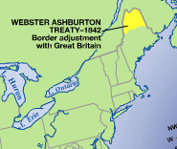
Webster- Ashburton treaty 1842
By the 1840's Canada was still under British rule and Americans wanted to annex Maine which caused conflict with Britain
- Open fighting between America and the British in Canada began
- America saw the British as a threat
- The Webster-Ashburton Treaty was created by Daniel Webster and it split Maine in half giving half to America and ending the dispute

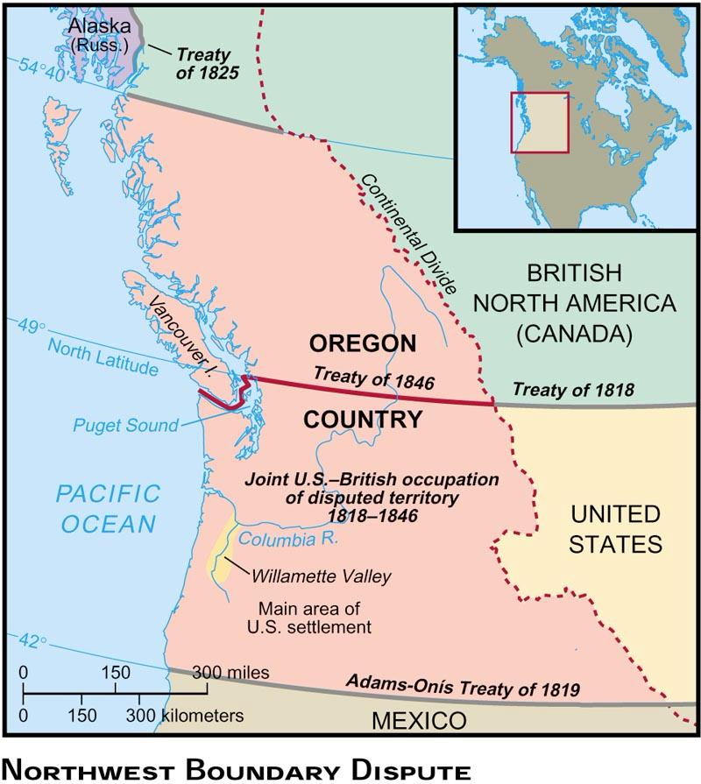
Boundary Disputes With Oregon 1846
Oregon was stretched all the way to the border of Alaska and was split between Spain, Russia, Great Britain, and the United States
Farmers who moved to Oregon had such success that it caused other Americans migrate to Oregon on the Oregon Trail
The Election of 1844 made Americans want to obtain all of Oregon
The slogan "Fifty-four or Fight" was the democrat James Polk's slogan of this election which meant America wanted to expand their border
Polk had to back down from that slogan once he won his presidency because he could not go into war with Britain and Mexico
He settled for the bottom half of Oregon and divided it on the 49th parallel. This pushed greater conflict between the northern and southern states of America because the fight of the new territories being free or slave (sectionalism).

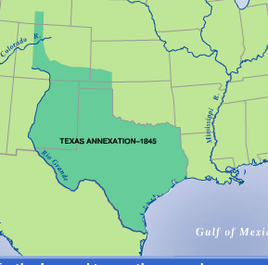
Annexation of Texas 1845
America was still pushing for further expansion into the western territories MANIFEST DESTINY
-White farmers and enslaved blacks outnumbered the Mexican population in Texas
-These American settlers in Mexico did not obey the Mexican laws of, no slavery and converting to Catholicism
-By 1845 Texas was annexed by Mexico
Annexation of Texas 1845
-America was still pushing for further expansion into the western territories
-White farmers and enslaved blacks outnumbered the Mexican population in Texas
-These American settlers in Mexico did not obey the Mexican laws of, no slavery and converting to Catholicism
-By 1845 Texas was annexed by USA

The Election of 1844
Candidates: Henry Clay (Whigs- in an upset over Van Buren) and James Polk (Democrat). Polk favored expansion, demanded that Texas and Oregon be added to the US and Clay had already spoken out against annexation. Polk won the election by the difference of one state (NY, because some of its votes went to the Liberty Party candidate, losing Clay the state). December 29, 1845-Texas was annexed under joint resolution and becomes the 28th state.

War with Mexico 1845
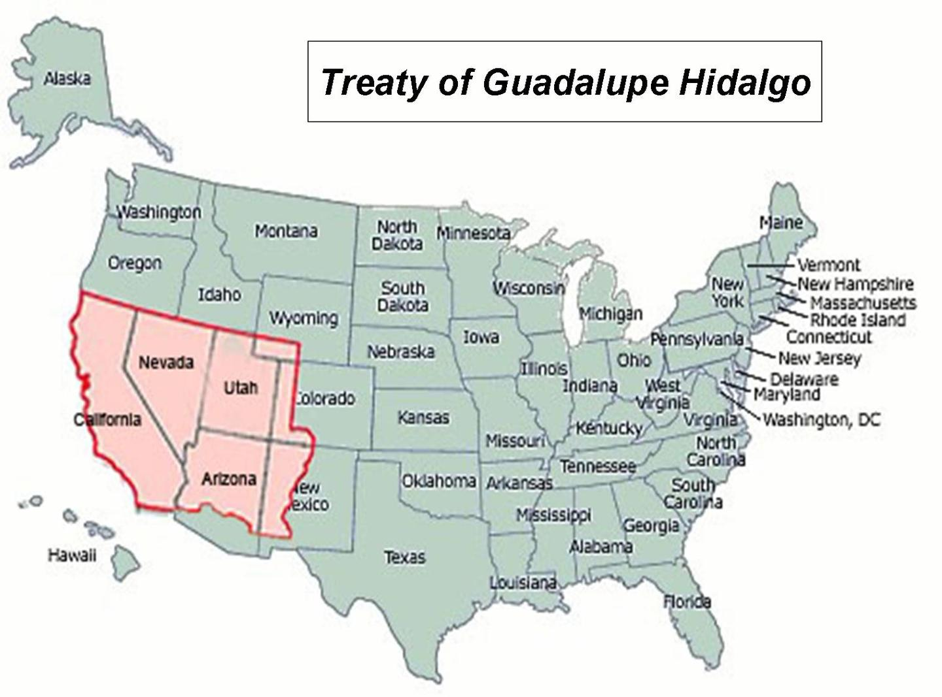
Treaty of Guadalupe Hidalgo 1848
Further American expansion into Texas led to conflict with Mexico
Once president Polk took office in 1845 he sent John Slidell and his military to Mexico to settle disputes
The goal was to persuade Mexico to sell them California and territories of New Mexico and settle the Mexico-Texas boarder dispute
Polk and Slidell were trying to compromise the Texas border to be the Rio Grand and while they waited for Mexico's response they sent Zachary Tayler and his military down to the Rio Grand
After many American's died in a skirmish with the Mexican Army by the Rio Grand, Polk took that as a cause to go to war
After winning battles all throughout Mexico, America won the war which resulted in the Treaty of Guadalupe Hidalgo
This treaty recognized the Rio Grand as Mexico's southern border and the US gained Mexico's territories in California and New Mexico for $15 million
Wilmot Proviso
Bill proposed after the Mexican War that stated that neither slavery no involuntary servitude shall ever exist in any territory gained from Mexico. It passed in the House but not in the Senate. What does that say about US population/ division? SECTIONAL DEBATE\

Manifest Destiny to the South 1850s
Ostend Manifesto 1854: secret plan by Southerners for the U.S. to buy Cuba from Spain
• Free Soilers denounced this plan
• Northerners increasingly fear that the south was attempting to create a slave empire or “slaveocracy”
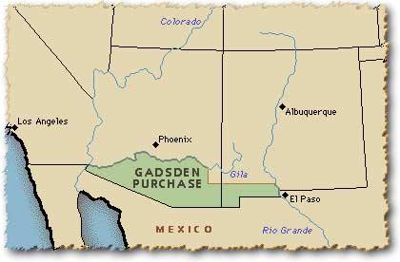

The Gadsden
Purchase was made in 1853 to obtain Mexican land for a route for the transcontinental railroad through the south. Land of southern New Mexico and Arizona.

Election of 1848
- Of course, the whole territories-slavery deal was the big issue of the Presidential Election of 1848, e/t both sides tried very hard to keep the issue away.
- The Democrats ran Senator Lewis Cass of Michigan and General William Butler of Kentucky [Polk said that once was enough]. Cass had come up w/the idea of popular sovereignty for the territories, but the party platform still held that Congress couldn’t interfere w/slavery.
- The Whigs nominated General Zachary Taylor, a Southern slaveowner and war hero, and Congressman Millard Fillmore of NY – and they likewise claimed that Congress couldn’t do anything.
- The issue just wouldn’t disappear, though, and a new party even formed b/c of Northern concern over slavery. The Free-Soil Party [“Free Soil, Free Speech, Free Labor, Free Men”], which formed from former Liberty Party supporters and antislavery Whigs, nominated Van Buren as its candidate and got 10% votes.
- The election, which Taylor won [as some Southern Democrats voted for him e/t he was a Whig]

Compromise of 1850:
1) CA free state (free states have more power in Congress),
2) no slave trade in D.C.,
3) Popular sovereignty in rest of territory (Utah and New Mexico)- the right of the people living in a newly organized territory to decide by vote of their territorial legislature whether or not slavery would be permitted there.
4) strict new fugitive slave law
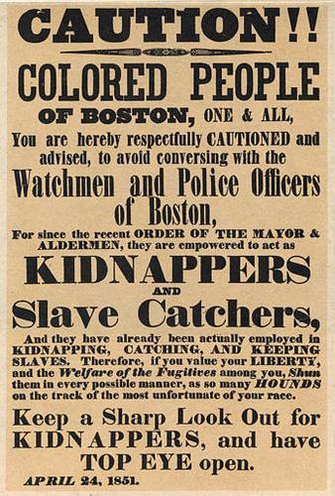
The Fugitive Slave Act, part of the Compromise of 1850, forced Northerners to return runaway slaves to their owners in the South, continuing the idea of the morality and justification of slavery in both the North and South.
Northern states rebel against Fugitive Slave Act
• Personal Liberty laws: Did not allow use of local jails for housing fugitive slave
• Vigilance Committees: goal to protect fugitive slaves from the slave catchers
• Underground Railroad helped slave escape north and eventually into Canada
Anti-Slavery Books
1853- Uncle Tom's Cabin by Harriet Beecher Stowe.
“Uncle Tom’s Cabin” by Harriett Beecher Stowe (1852)
• Inspire many northerners to resist the Fugitive Slave Act
• Brought morality argument to the slavery debate – Exposed the horrors of slavery to a Northern & European audiences
• Lincoln: “So you’re the little woman who wrote the book that made this great war.”

Impending Crisis of the South
Used statistics to demonstrate to fellow Southerners that slavery weakened the South's economy.

SECTIONALISM Increases: The Kansas Nebraska Act and “Bleeding” Kansas
The Kansas Nebraska Act
Senator Stephen A. Douglas proposed that the area west of Iowa and Missouri—which had been set aside as a permanent Indian reservation—be opened to white settlement. Southern members of Congress demanded that Douglas add a clause that specifically repealed the Missouri Compromise, which had prohibited slavery north of latitude 36°30' north. Instead, the status of slavery in the region would be decided by a vote of the region’s settlers (popular sovereignty). In its final form, Douglas’s bill created two territories (Kansas and Nebraska) and declared the Missouri Compromise “inoperative and void.”

Bleeding Kansas
After the passage of the Kansas-Nebraska Act, supporters of both sides flooded into the territory of Kansas, where violence soon erupted.
Rival governments (Topeka- free soil and Lecompton- pro slave govt.) of anti-slavery settlers and pro-slavery Missouri transplants battled it out to claim popular sovereignty in favor of their side.
In retaliation for the sack of the free-state town of Lawrence on May 21, 1856, the abolitionist John Brown led a brutal attack on a pro-slavery settlement at Pottawatomie Creek. The violence alienated many anti-slavery backers.
The Dredd Scott Decision 1857
Dred Scott v. Sanford – African Americans are not citizens – Slaves are property = cant be taken away without due process (5th Amendment) – Congress could not ban slavery from the territories (MO Compromise was unconstitutional)
John Brown’s Raid on Harpers Ferry 1859
John Brown was an abolitionist who practice armed insurrection to end slavery. He encourage slaves to arm themselves and fight for their freedom. He wanted a slave revolt. He was captured, tried, found guilty and hung. South is outraged and one of the immediate causes of secession.
Lincoln-Douglas Debates for Senate 1858- Lincoln lost election but wins Presidency in 1860
Lincoln challenges Douglas on Dred Scott decision: Could slavery be prevented in the territories
- Dred Scott decision said no
- Douglas takes the position (Freeport Doctrine) that territories could limit slavery
Freeport Doctrine- that slavery could not exist in a community if the local citizens did not pass laws (slave codes) maintaining it. His views angered Southern Democrats because, from their point of view, Douglas did not go far enough in supporting the implications of the Dred Scott decision i.e. slavery could exist anywhere.

Republican Party is formed as a response to the Kansas-Nebraska Act
Lincoln and the Republican Party platform- what the party stands for and hope to achieve if they win election
– For the free-soilers: no extension of slavery in territories
– For the northern manufacturers: a protective tariff
– For the Northwest: a Pacific railroad
– For the farmers: free homesteads (land) • Southern secessionist threaten to leave Union if Lincoln wins

Election of 1860
Republican party wins the Presidency for the 1st time
• But Lincoln is a “minority” President
Southerners see him as a sectional President
Not on ballot in 10 southern states

SECESSION
• South Carolina votes to secede in December 1860
• Eventually 7 southern states leave the union before Lincoln even takes office
– See him as a sectional President hostile to slavery
• Confederate States of America is formed
– Jefferson Davis chosen as President of the CSA
• Lame Duck President Buchanan does nothing to stop secession
– From November 1860 to March 1861
– Does not believe secession is legal

CRITTENDEN COMPROMISE
Last ditch attempt to avoid a major crisis
Hope to calm southern fears: – The return of the Missouri Compromise idea
Slavery prohibited in territories north of 36°30′
Slavery allowed in territories south of 36°30′
– Lincoln rejects this
Position of Republican party was no extension of slavery in the territories
Before Lincoln even takes office 7 southern states have left the union!

Civil War 1861-1865

Civil War Strategy of the North and South
Right before Lincoln takes office, 11 of the southern states secede. They created their own confederacy under the leadership of Jefferson Davis. The North kept their name as the union. The first shot was fired at Fort Sumter which led to the North declaring war.
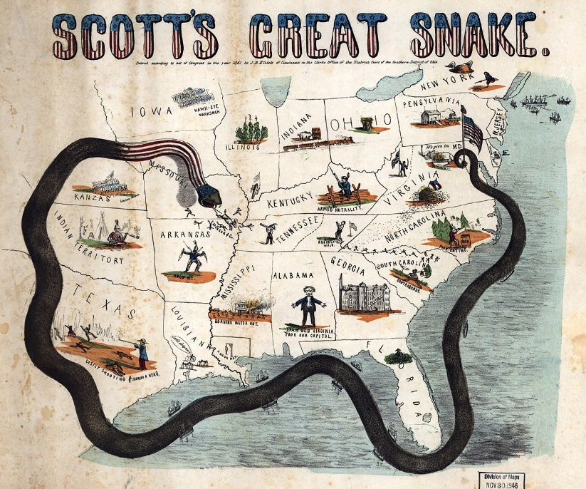
Northern Strategy: ANACONDA PLAN
- Blockade southern ports
- Gain control of the Miss. River
- Capture the capital, Richmond VA
- Destroy confederate communication and transportation lines
Keep Border States in the Union-Mo., Ky., Md

Southern Strategy:
- Fight a defense war- tiring out the union
- Getting European nations to help
- Break the blockade
-Having the home court advantage

7 southern states had already left the Union before Lincoln took office in March 1861
• Lincoln’s Inaugural Address: pledged NOT to interfere with slavery
– No right of secession
• Lincoln says sending provisions to Fort Sumter, not reinforcements
Confederacy attacks Fort Sumter in April 1861 – Civil War begins!

ADVANTANGES and DISADVANTAGES
 | Union | Confederacy
Strengths | Population of 22 million  More farmland  Industrial base- factories  Large Army  Navy  Railroads  Money, Banking system | Defending their homeland  Good leaders  Fighting for independence
Weaknesses | Had to conquer a large area  Invading unfamiliar land | Few factories  Population of 9 million  Few Railroads  More than 30% of population was enslaved  Poor navy  No banking system=no money  Weak gov structure-remember Articles of Confederation?

Lincoln proclaimed he was not fighting the war to end slavery-claimed to be fighting to preserve the Union. Why?
Secession was not legal
Needed to keep support from Border states
Fear from white workers in the north
Political concerns: Northern Democrats

Road to Emancipation
• Two reasons to free the slaves
– Military: liberate the slaves undermines the economic foundation of the south
– Ideological: right thing to do, pressure to do so.
• Radical Republicans had been pressuring Lincoln to make the war about slavery
– Charles Sumner
– Thaddeus Stevens
– Benjamin Wade
• Confiscation Act (Aug. 1861) slaves used for “insurrectionary purposes” declared free.
– Incentive to escape to Union camps
• 2nd Confiscation Act (July 1862) freed all slaves who were enslaved by anybody engaged in rebellion against the U.S.

Emancipation Proclamation- and executive order by President Lincoln ending slavery
Following the Battle of Antietam (Sept. 1862) Lincoln decides to move forward with announcing emancipation.
• Emancipation Proclamation was justified as a military necessity
– Declared slaves free in rebel territory (Confederacy)
• DOES NOT FREE SLAVES IN THE BORDER STATES
• Impact
– Strengthened the moral cause of the North
• Not just a war against secession- against slavery MORAL CAUSE
– Helped keep Europe from aiding Confederacy
– Gave the Union new soldiers for Union army
• Limits:
– North had no authority in the Confederacy
– Did not apply to border states and zero slaves were freed.
USE OF EXECUTIVE POWER

Civil liberties are oftentimes reduced during times of national crisis
• Lincoln suspends the writ of habeas corpus in Maryland & other states
– People arrested without being informed of the charges against them & held without trial
• Presidential power oftentimes increases during times of war
– Ordered a blockade without approval of Congress
– Increase size of Federal Army without approval of Congress

POLITICS DURING THE WAR
Challenges for Lincoln | Challenges for Confederacy
Radical Republicans vs. Moderates  • War Democrats: support war but criticized Lincoln’s handling of it.  • Peace Democrats (Copperheads): opposed the war & wanted negotiated peace  Election of 1864  • Lincoln beats General McClellan a peace Dem | Cotton Diplomacy: Hope for European intervention  – Europe obtained cotton from other sources  – Failure at Antietam (Sept 1862)  – Emancipation Proclamation in Jan 1863  • Tradition of states rights makes fighting the war  difficult  – Conflict with central government

Republican majority in Congress
1861 – Morrill Tariff Act- help pay for war & protect northern industry
1862 – Homestead Act- set up sale of land in west and encourage settlement
1862 – Legal Tender Act- printing of paper money “greenbacks”
1863 – National Bank Act- financial landmark that sought to est. a unified banking system
1863 – Pacific Railway Act- est. northern route of transcontinental railroad
Impact of the Civil War
• Over 600,000 lives lost
• Southern economy destroyed and northern industrialization accelerated by the war
• Republican laws passed
• Union preserved
– Ideas of secession and nullification defeated
– Civil War was ultimate test for American democracy
• 4 million slaves freed by the 13th Amendment-made slavery illegal
Surrender at Appomattox: April 9th 1865 brings war to an end

President Lincoln Assassinated
- John Wilkes Booth: While a famous actor in his own lifetime, Booth is best remembered for orchestrating the assassination of Abraham Lincoln on April 14, 1865 at Ford’s Theater. Booth and his co-conspirators had tried on multiple occasions to assassinate Lincoln. In fact, other key cabinet figures were supposed to be killed simultaneously with Lincoln, but those plots failed for varying reasons. Shot while attempting to evade capture in the ensuing manhunt.

Reconstruction

- Reconstruction: A period (1865–1877) of rebuilding and reforming the South following the Civil War. It is considered a failure, as African Americans were left destitute and disenfranchised for another century. See: Black Codes, Civil Rights Bill of 1866, Civil Rights Act of 1875, Freedman’s Bureau, Military Reconstruction Act, Ten Percent Plan, Wade-Davis Bill.
- Andrew Johnson: Seventeenth President. Served 1865–1869. One of only two presidents to be impeached; like Bill Clinton, he was not convicted. Took office after Lincoln’s assassination. A Democrat who had run with the Republican Lincoln, he was disliked by Congress, especially for his mild terms for Reconstruction and disinterest in protecting newly freed slaves; this all led to Radical Republicans passing the Civil Rights Bill of 1866 and the Fourteenth Amendment.
- Ten Percent Plan: Also known as the “Proclamation of Amnesty and Reconstruction,” Lincoln proposed this plan in 1863 as a way to bring Southern states back under the wing of the federal government. The plan reestablished state governments and required at least 10 percent of the states’ voters to swear an oath of loyalty to the United States and the Constitution. Lincoln was also prepared to grant complete pardons to any former Confederate, but required an oath of allegiance and agreement to eliminate slavery. See: Wade-Davis Bill.
- Wade-Davis Bill: Passed by both houses in 1864 in response to Lincoln’s Ten Percent Plan. It required that 50 percent of Southern state voters take the loyalty oath, and it allowed only those citizens who had not been active members or supporters of the Confederacy to approve of the new state constitutions. Exercising his executive power, Lincoln pocket-vetoed the bill by refusing to sign it.
- Freedman’s Bureau: A government program created in 1865 to help manage and assist newly emancipated slaves. The bureau provided assistance in the form of food, shelter, and medical attention to African Americans. Eventually, the bureau would establish schools across the South to help educate large numbers of former slaves. The Freedman’s Bureau struggled as Congress refused to increase its funding, which expired in 1872.
- Black Codes: Laws passed by Southern legislatures in response to legal emancipation of slaves. These codes restricted the actions, movements, and freedoms of African Americans. Under these codes, African Americans could not own land, so they were tied instead to small plots leased from a landowner. This began the system of sharecropping. See: Jim Crow laws, Reconstruction.
- Sharecropping: Sharecroppers would lease land and borrow supplies to till their plots, while giving a significant portion of their harvest to the landowner as payment for the loan. This exploitative system ensured that farmers were never able to harvest enough to pay the landlord and feed their families. Generations of African Americans remained tied to their plot of land until the civil rights movement of the 1950s and 1960s. See: Black Codes, Great Migration.
- Civil Rights Bill of 1866: It was designed to end the Black Codes by giving African Americans full citizenship. As expected, Johnson vetoed the bill, and Congress overturned his veto. Many Republicans were concerned that a future return of a Democratic majority might mean the end of the bill they had worked so hard to pass. Therefore, they needed a more permanent solution in the form of the Fourteenth Amendment.
- Fourteenth Amendment: A response to the lackluster Reconstruction efforts by President Johnson. Proposed in 1866 and ratified in 1868, it protected the rights of all U.S. citizens, granted all African Americans full citizenship and civil rights, and required states to adhere to the due process and equal protection clauses of the Constitution. Furthermore, it disallowed former Confederate officers from holding state or federal office. It would decrease the proportional representation of any state that denied suffrage to any able citizen.
- Military Reconstruction Act: Passed in 1867 by a Radical Republican Congress, it placed the South under martial law, dividing the South into five districts that would be governed by a Union general stationed in each. The act further tightened the readmission requirements of former Confederate states by requiring petitioning states to ratify the Fourteenth Amendment and provide for universal manhood suffrage. The act was a response to the leniency displayed by President Johnson toward the Confederacy.
- Tenure of Office Act: An 1867 law. It disallowed the president (Johnson) from discharging a federal appointee without the Senate’s consent. With the act, Republicans in Congress attempted to protect their positions from Johnson. The president chose to ignore the act and fired Republican Secretary of War Edwin Stanton. The House promptly submitted articles of impeachment to the floor by charging Johnson with 11 counts of “high crimes and misdemeanors.”
- Edwin Stanton: Secretary of State (1862–1868) under the Lincoln and Johnson administrations. A Radical Republican, he supported Congress over Johnson when it came to Reconstruction. His firing violated the Tenure of Office Act, which provided the Radical Republican Congress an excuse to impeach the Johnson. The Senate also reappointed Stanton as Secretary of War, although he resigned following the failure to convict Johnson.
- Thaddeas Stephens: He was a Radical Republican member of the House, serving until his death in August 1868. A firebrand abolitionist and proponent of civil rights for African Americans, he was at the forefront of pushing a sterner Reconstruction agenda over President Johnson’s objections. He served as chairman of the House Ways and Means Committee during the Civil War, giving him significant leeway to tackle his goals.
- Charles Sumner: U.S. Senator from Massachusetts (1851–1874). A Radical Republican abolitionist, he pushed for the protection of civil rights in Southern states. Famously caned on the floor of the Senate by Preston Brooks.
- Fifteenth Amendment: Ratified in 1870, in barred any state from denying a citizen’s right to vote on the basis of race, color, or previous servitude. However, it did not ban poll taxes or literacy tests, which would be a loophole exploited by whites after the end of Reconstruction to suppress African American voters.
- Civil Rights Act of 1875: The last of the Reconstruction-era civil rights reform made it a crime for any person to be denied full and equal use of public places, such as hotels, rail cars, restaurants, and theaters. Unfortunately, this act lacked any wording to enforce it, and it was therefore ignored by most states, both Northern and Southern. See: Plessy v. Ferguson.
- Scalawags: Coined by Southern Democrats, it was a derogatory term for Southern Republicans that meant they were pirates who sought to steal from state governments and line their own pockets. See: carpetbagger, Reconstruction.
- Carpetbaggers: A pejorative term for the stereotype of the Northerner who packed all of his worldly possessions in a suitcase made from carpet, with the aim of moving to the South during Reconstruction to make a fortune. In the present day, the term is used to describe politicians who move to an area they have no previous connection with in order to gain election.
- Ku Klux Klan: An underground society of whites who ruthlessly and successfully used terrorist tactics to frighten both white and black Republicans in the South. While quashed by the Force Acts of 1870 and 1871, the organization survived, resurfacing and spreading throughout the country in later years. See: Redeemers.
- Force Acts: Laws passed in 1870 and 19871 that authorized the use of federal troops to quell violence and enforce the Fourteenth and Fifteenth Amendments. While these acts were moderately successful in limiting the KKK’s activities, the group continued to exist, resurfacing in the 1920s in response to an influx of Southern and Eastern European immigrants.
- Redeemers: A political movement that sought to return control of the former Confederacy to white Southerners. Their policy, Redemption, sought to purge the South of the influence of Republicans, carpetbaggers, and newly emancipated slaves. See: Compromise of 1877, Jim Crow laws, Ku Klux Klan.
- Exodusters: A term for thousands of former slaves who uprooted their families and moved toward Kansas between 1878 and 1880. These migrants called themselves Exodusters, because they believed that their promised land lay somewhere in the West.

Compromise of 1877

- Rutherford B. Hayes: Nineteenth President. Served 1877–1881. While a Civil War veteran and a Republican, he ended Reconstruction as part of the Compromise of 1877 to resolve the disputed 1876 election. Enacted modest civil service reform. Ordered federal troops to break up the Great Railroad Strike of 1877. Pledged not to run for reelection and returned to Ohio.
- Samuel Tilden: A Democratic governor from New York, he had a reputation for political reform, largely from fighting Tammany Hall corruption. With civil service reform a hot button issue after the corruption of the Grant administration, he became the Democratic nominee in the 1876 Presidential election. Won the popular vote but lost the election. See: Compromise of 1877.
- Filibuster: An act of obstructionism that prevents the normal workings of the legislature. An elected official while continue talking rather than allow debate on a bill to be closed, thus preventing a vote from taking place. In the U.S. Senate, it was never used until 18 37.
- Compromise of 1877: A deal that resolved the hung election of 1876. It provided that Rutherford B. Hayes would become president only if he agreed to remove the last remaining federal troops stationed in South Carolina, Florida, and Louisiana. The end of martial law in the South signaled the end of Reconstruction in the United States. See: Samuel Tilden.

