Chpt. 5 TOPIC 2.5 Checks on the Presidency, AMSCO pg. 148-157
Only t______ constitutional duties for the VICE PRESIDENT
- B________ President or Acting President if the oﬃce of President is v___________.
- P_______ over the S__________, v________ only in case of a t________.
Traditionally, the V.P. is a dull, do-nothing job
The job of a V.P. is basically what the President says it is
- Often involves unappealing work (e.g., attending funerals of foreign leaders)
- V.P. is often selected not on basis of qualiﬁcations, but on basis of b_____________ the t_________ with respect to g______________ representation, c_______________ to important blocs of voters, or experience.
- After he has "done his job (i.e., helped win votes)," the V.P. is often "put out to pasture" for dull work.
Importance of the oﬃce:
- 9/44 Presidents have not ﬁnished their terms of oﬃce.
- V.P. can become a________ president if the president is d___________.
- In recent years, Presidents (e.g., Carter, Reagan, Clinton) have made more eﬀective use of the V.P. This is especially true of Bush-Cheney.
- Vice presidency can be a s______________ to the presidency, e.g., Bush 41.

The Cabinet & the Bureaucracy

- Cabinet oﬃcials are constitutionally banned from also being members of Congress.
- Each Cabinet department is h__________ a by a s_________, i.e., Secretary of State runs the Department of State, a___________ by the President with S__________ c_________. Often leads to c_________ with the Senate. C______ and b________.
- The Cabinet meets i_________. Only at the call of the President.
- They a_________ the President on a wide range of policy issues.
- Cabinet secretaries are more interested in d__________ /enlarging their own departments than they are in meeting together to hammer out public policy. Many newly elected Presidents speak of enlarging the Cabinet's role, but then think better of it as time goes on. Presidents r_______ l______ on their cabinet for advice.
  - A reason for this is the d_________ l______ of Cabinet oﬃcials: Are the Secretaries most loyal to the President? To the C____________ (which f_________ the departments)? To c_______ g________ (which depend upon the departments)? To the employees within the departments (with whom the Secretaries must deal daily)? Which one do you think he would be most loyal to?
  - Another reason is that the President’s goals often conﬂict with Cabinet Dept. goals, i.e., the President may want to c________ spending, but Cabinet Secretaries generally want to see their departments grow rather than shrink.

FEDERAL APPOINTMENTS
Who gets appointed to federal positions?
- As mentioned, the number of appointments is large, but the percentage of appointed positions in the federal government is small. (Less than 10%).
- Presidents often do not know their appointees well -- They depend heavily on staﬀ recommendations.
Background of appointees:
- Tend to come from p_________ industry, universities, law ﬁrms, think tanks, Congress, state/ local government.
- Most have had some federal experience.
- Some have had some federal experience just prior to appointment.
- Some are "in-and-outers," i.e., people who alternate between jobs in the public sector and private sector -- the "r__________ d_______."

CABINET Secretaries
Factors aﬀecting selection of Cabinet secretaries:
- P________ aﬃliation
- I_________ group inﬂuence
- R________
- G_______
- Geographical diversity
- “C_____________” in the Senate

Presidential i______________ over the Cabinet is limited: This a c_________ on Presidential power
- Presidents can, of course, f________ the political appointees within a d____________.
- However, Presidents have little c__________ over the c_________ s_________ employees of a department. These account for > 90% of all the people who work within the Cabinet departments, and it is exceedingly d__________ to ﬁre them from their positions.
CABINET Secretaries
- Sect of State-

- Sect of Treasury-

- Sect of Defense-

- Attorney General-

EXECUTIVE OFFICE OF THE PRESIDENT
- White House Oﬃce/White House Staﬀ
  - Immediate staﬀ of President
  - Oﬃce space in West Wing of White House –> proximity to President.
    - Rule of Propinquity: Power is wielded by people who are in the room where decisions are made.

  - Appointments to the White House Oﬃce
    - e.g. Chief of Staﬀ, generally d___ n____ require S___________ c__________
    - Oﬃcials are less subject to testifying before Congress since they have a greater degree of executive privilege protection.
    - Presidents typically seek people who will be loyal – less divided loyalties are compared to Cabinet positions.

- OMB (Oﬃce of Management and Budget)
  - Prepares the annual b___________ and reviews federal programs for the President. The OMB overseas the e_____________ of the budget. The president's close control over both the preparation and execution of the budget is a major factor in his ability to c_________ the huge e_____________ b______________.

- NSC (National Security Council)
  - Coordinates foreign/military policy
  - Increasing importance of the National Security Adviser since the Nixon presidency

- CEA (Council of Economic Advisers)
  - Three-person advisory group on economic policy

Overall, the president engages with White House staff more frequently than with cabinet secretaries.
Interactions with Other Branches
President's agenda is not always in line with Congress’s agenda intentions often arise between the branches.
The President's Inherent Powers
Inherent powers are powers that a president can a_________ to have as a necessary to the working ability of the govern ment or office but not l__________ in the Constitution
Examples of President’s Inherent Powers:
- the power to go public- b______ p_______- to command the media to gain popular support for his agenda in order to persuade Congress
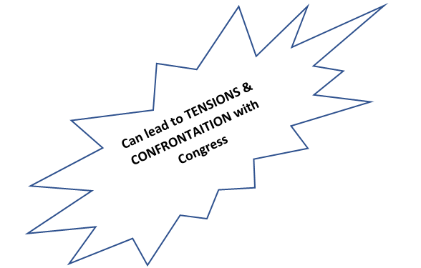
- power of persuasion
- make e___________ agreements- similar to t__________ but D__ N____ require S_______ approval
- executive orders
- issue signing statements
- use the bureaucracy
- personality and leadership
- make legislative proposals
- The most common & controversial inherent powers are E__________ P___________, exercised only in times of great need. Therefore, Congress is hesitant in declaring war.

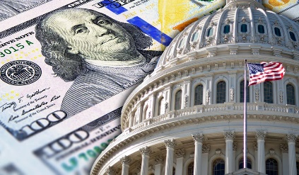
CHECKS on PRESIDENTIAL POWERS
- Traditional, constitutional checks:
  - Congress- o___________/ investigations, power of the p__________.
  - Courts- judicial review
- Informal checks:
  - Congressional leaders
  - Cabinet members
  - Bureaucrats- can slow down (d_________) or “m___________” presidential action.
  - Political parties
  - Interest groups
  - Media: a___________ journalism, “g__________” journalism
  - Senators’ use of “h_______” and f__________ on presidential nominations
  - Divided government

RECESS APPOINTMENTS
Because the founders did not anticipate that Congress would convene as frequently as it does in modern times, they provided for RECESS APPOINTMENTS. If the Senate is not in s____________ when a vacancy arises, the p__________ can a_________ a replacement who will serve u________ the Senate reconvenes and votes on that official. This recess appointment is particularly necessary if the appointee is to handle urgent or sensitive work.

Removal
The President can r________ all u________-level e________ branch officials including all c__________ secretaries, a___________, federal district a___________ at will, e________ those that head the independent regulatory agencies. (More on this in Chpt7 Topic 2.12-2.15)
Judicial Interactions
As Chief Executive, the president e________ j_______ orders/ decisions.
As Chief Executive President Eisenhower used his power as C__________-In-Chief, President Eisenhower had to e__________ the Supreme Court decision in B_________ v. Board of Education (19___).
He sent in the 101st Airborne US Army Paratroopers (19____) to make sure that decision was enforced.
The federal government would either send F_______ Marshalls or US A_____ troops to enforce c_______ rights.
Judicial Appointments
Senate confirmation is an important check on appointment powers, but the president’s longest lasting influence lies in life-tenured judicial appointments.
The Justices faces in the Supreme Court are of President Ronald Reagan. Reagan appointed 4 Justices, including elevating William Rehnquist to Chief Justice. Reagan appointed a total of 383 judicial appointments, the most by any president.
This allows a president’s i__________ on public policy long after he l__________ office.
SOURCES OF CONFLICT BETWEEN THE PRESIDENT AND CONGRESS
- SEPARATION OF POWERS AND CHECKS AND BALANCES
  - The Constitution is "an invitation to struggle between the President and Congress." There is supposed to be conﬂict.
- EACH REPRESENTS DIFFERENT CONSTITUENCIES:
  - Members of Congress represent s_______ and l__________ interests ("All politics is local").
  - The President, however, represents the n_____________ interest.
- DIFFERENT TIMES OF ELECTION
  - Diﬃcult for either to gain excessive power for any great length of time
    - Clinton was elected in '92 with a majority of Democrats in Congress, but just two years later the Republican captured a majority of both houses. M____- t________ elections.
PARTISANSHIP
- Since 1952, Presidents have often faced a Congress that has had a majority of the o___________ party.
- Even when the Congress has a majority of the same party as the President, i______-party s________ are common. With the weakening of political parties, the President does not have a strong "hold" on members of his own party in Congress. For example, some congressional Republicans wanted a stricter immigration policy than Bush 43.
- “TWO PRESIDENCIES” THESIS
Congress tends to be more c____________ with the President on f_________ policy and national security issues (esp. in a crisis), but is less c____________ on d_________ and e___________ issues.

SOURCES OF PRESIDENTIAL INFLUENCE ON CONGRESS
- USE OF MEDIA
  - Media focuses more on a s_______ person than on 5___ m__________ of Congress
  - President can easily go directly to the people with his case.
- "M_________ FROM THE PEOPLE" after winning election by a large margin.
- PATRONAGE
  - Enables a President to carry out policy his way.
  - Enables a President to cultivate members of Congress by seeking their input on appointments.

CHIEF OF PARTY ROLE
Convincing members of Congress to act in interests of "party unity."
Personal lobbying of members of congress
- Use of both favors and punishment for cooperative or uncooperative members.
Veto, or its threat
- 93% of vetoes are not overridden, so even the threat of a veto carries weight.
Presence of a national emergency

Explain how the president's agenda can cause confrontations with Congress? Cite evidence to support your thesis.

