Chpt. 4 Topic 2.3 Congressional Behavior AMSCO pg. 124-137

INFLUENCES ON MEMBERS OF CONGRESS on how they vote on a Bill

The Voting Model Different Role Conception
Senators and representatives are elected to represent people. As legislators, they have four voting options: trustee, delegate, partisan, and politico. Each voting model can influence the way a member of Congress will vote.
1. Trustee: Decisions made by elected official using their own p__________ views or decisions made by the elected official based on the p________ good and not on the basis of c____________ views
2. Delegate: Decisions made by the elected official m________ the constituents’ views, represent constituents’ views, or do what v__________ tell them to do.
3. Partisan: Lawmakers who owe their a__________ to their political party first vote along p_________ lines.
4. Politico: Legislators should follow their own judgment (that is, act like a trustee) until the public becomes vocal about a particular matter, at which point they should follow the dictates of constituents. It’s a combo

- OTHER MEMBERS OF CONGRESS
  - e.g., party leaders, committee leaders, state delegations, other members with a similar ideology, other members with similar districts. If a member votes according to these, he is said to engage in organizational voting.
    - Use of r___________ among members (exchange of favors)
    - Use of l____________ among members (exchange of votes)
- CONGRESSIONAL STAFF MEMBERS
  - As society has grown more complex, and Congress has taken on more responsibilities, Congress has needed to add staﬀ to deal with these realities. Staﬀ can:
    - Control information that members receive
    - Control access to members
    - Help to set committee agenda
    - Make recommendations on legislation
    - Help to write legislation
    - Discuss pros/cons of staﬀers representing an undemocratic aspect of Congress

- INTEREST GROUPS/LOBBIES/PACS
  - Inﬂuence through:
    - campaign contributions through their PACs
    - "report cards"
    - targeting
    - providing i_____________
    - testifying before committees with expert testimony on specialized issues

- CONGRESSIONAL CAUCUSES
  - e.g., black caucus, Hispanic caucus, blue collar caucus, women's caucus
- THE PRESIDENT
  - Can reward or punish members, particularly those within his own party by:
    - Campaigning for or against members
    - Attending or not attending members' fund raisers
    - Speaking out for or against members
    - Using his "electronic throne" to gain leverage (“going public”), b______ pulpit

- CAMPAIGN CONTRIBUTORS
  - Again, the evidence here is mixed. Some studies show that contributions aﬀect voting behavior, but others have downplayed this, citing other inﬂuences such as party membership.
  - If contributions do aﬀect congressional voting, they probably have the greatest eﬀect on narrow issues that are not well known or publicized.

- THE MEDIA
  - e.g., through its "watchdog" role

- IRON TRIANGLES- this comes up in another lesson in detail.
  - Also known as subgovernments, issue networks, policy networks: a congressional committee, the related federal agency, and the impacted interest groups.
  - For example, on the issue of airline deregulation, an iron triangle might consist of:
    - Public Works and Transportation Committee
    - Federal Aviation Administration (FAA)
    - Numerous interest groups such as the Air Transport Assn., mechanics' unions, pilots' unions, etc.

- PARTY MEMBERSHIP OF MEMBERS
  - This seems to be the best p____________ of congressional voting – party unity scores are quite strong. Party a____________ is a particularly strong i_____________ on economic and social welfare issues, and less of an inﬂuence on foreign policy and civil liberties issues.
- CONSTITUENT CONVICTIONS
  - If a member votes according to these, he is said to act in the d________ role and engage in representational voting.
    - Of course, it is often diﬃcult to gauge constituent opinion on a given issue.
    - Most constituents are not even aware of the issues faced by Congress.
    - Another complication is the diversity of interests throughout districts and states.
- MEMBERS' OWN CONVICTIONS
- If a member votes according to these, he is said to act in the t_______ role and engage in a_______ voting.

Gerrymandering- Redistricting
- If a state has a change in the number of seats OR if the population has signiﬁcantly changed within the state, its district boundaries must change.
- This is known as REDISTRICTING and is usually carried out by the p_______ in p___________ of the s_________ legislature.
- A form of redistricting is gerrymandering: r____________ boundaries to favor the party in power of the state legislature.

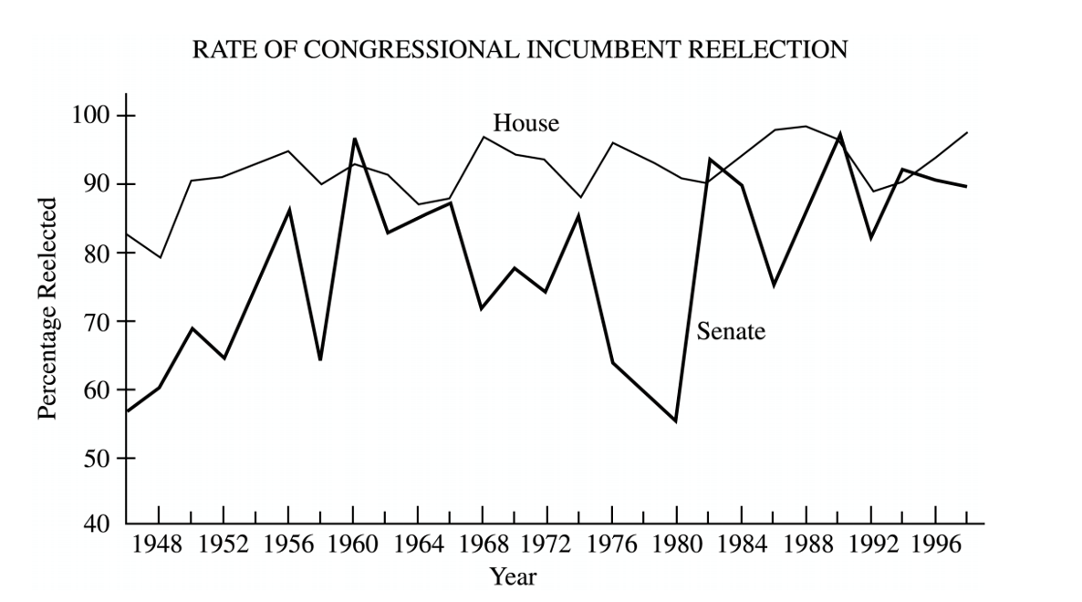

Gerrymandering
The party in p_______ can get a m__________ of seats in the House by: (gerrymandering is very P__________ )
  - "P__________:" drawing the district lines in such a way as to c__________ the opposing party in a few districts, thus preserving a majority of seats for itself.
  - "C__________:" drawing the district lines in such a way as to d_________ the opposing party throughout the state and thus d___________ that party's strength in order to preserve a majority of seats for the majority party.
  - Eﬀects
  - The party in power STAYS in power
  - "Safe" seats are created for incumbents, leading to further diﬃculties for challengers
  - Communities of interest may be broken up
  - Strangely shaped districts
  - "Majority-minority" districts created by racial gerrymandering
What are the goals of gerrymandering?
- Enhance party p________.
- to protect i______________ and discourage challengers. Define INCUMBENT
__________________________________________________________________________________________
- increase minority representation /decrease minority representation
- To reward friends and punish foes
All of this is done with c__________ and p_________ techniques. THE PERSON IN POWER STAYS IN POWER

REQUIREMENTS for Gerrymandering to be Legal
  - District lines must be c______________.
  - R___________ gerrymandering is p________ (Shaw v. Reno, 1993). Race may not be the p_________ factor in drawing district lines (but it can be a factor).
  - Cannot d________ racial minority voting strength
  - “Communities of interest” may be kept intact

- SUPREME COURT REDISTRICTING REQUIREMENTS
  - Districts must be as near equal in population as possible.
    - Baker v. Carr, 1962: "one man, one vote" principle applied to state legislative districts to correct overrepresentation (malapportionment) of rural areas.
    - Wesberry v. Sanders, 1964: applied same principle to House districts.
    - Even if the number of rep’s to which a state is entitled does not change, it redistricts anyway because of g______________ shifts in population that may have occurred within the previous ten years. This solves the problem of m________________.
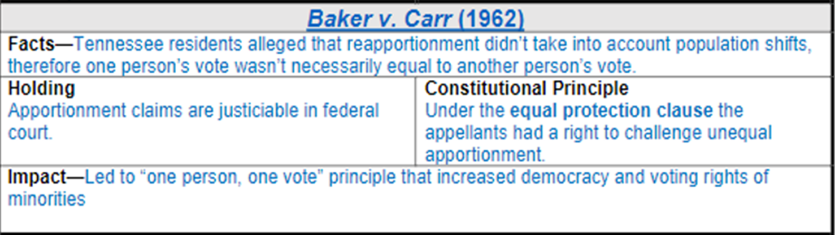

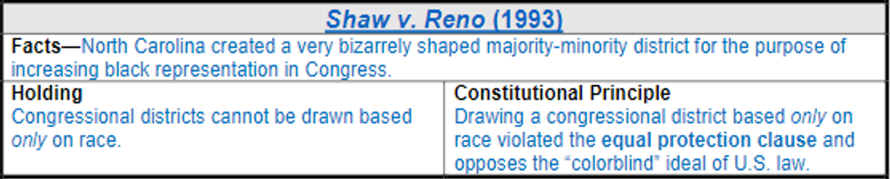
Why it matters
Districts cannot be drawn only with the intent of putting those of the same race into voting districts.

Why it matters
1. States were required to apportion the representatives in a way that equally represented all the peoples so that no votes counted any more than others.
2. Fundamentally altered the nature of political representation across the USA. Many states had to re-draw their districts to be in compliance.
3. Got Supreme Court involved in political questions. This is an area mainly left to Congress and the President.

The Trend Towards Party Polarization in Congress- MORE PARTISAN
- Two parties more ideologically pure (Republicans more c____________, Dems more l_________)
- Strict party-line voting the norm i.e. majority of Dems oppose majority of Reps/vice versa
- Fewer moderates in either party (especially GOP)
- G__________ House districts major cause

Consequences of Party Polarization
- Toxic atmosphere in Congress > lack of cooperation
- Failure to compromise or build consensus
- More extreme positions on issues by parties
- Legislative g________ > “nothing gets done”, divided government
- Party polarization,
- Partisanship, refusal to compromise, = G________________
Where are all the moderates?

How can checks and Balances facilitate Gridlock?
Checks and balances l_______ the ability of one branch of government to c________ out its responsibilities and thus facilitate gridlock.

How do the mid-term elections contribute to gridlock?

INCUMBENCY ADVANTAGE: GERRYMANDERING adds to gridlock. Better know how!!

- Number of Rep's per state is determined by population
- Census conducted every 10 years
  - Census will show population changes in states
  - These changes must be reﬂected in state representation in House
    - If a state gains signiﬁcantly in population, it will probably gain some seats
    - If a state loses population or does not gain as much as other states, it will probably lose some seats
- Congressional reapportionment - Reallocation of 435 seats in the House of Representatives based on changes in residency/population found in census
  - Total House seats set at 435 by the Reapportionment Act of 1929
    - Increase/decrease state’s e_________ vote
    - Increase/decrease state’s i__________ in Congress because of the number of reps=number of votes.
For every 710,767 people in a district = 1 Representative (2010 Census)

How does gerrymandering contribute to gridlock?

INCUMBENCY ADVANTAGE: GERRYMANDERING Key Terms Review

Apportionment- the d___________ of the 435 seats in the HR among the 50 states based on each state’s population.

-Every state gets at least 1 seat; states with higher populations get additional seats

Reapportionment- the process by which congressional d_________ are r_______ and seats are redistributed among states in the house. Reapportionment occurs every ten years, when census data reports shifts in the population of districts.

Redistricting- r___________ of congressional and other legislative district lines following the census, to accommodate p_____________ shifts and keep districts as equal as possible in population.

Gerrymandering- the drawing of legislative district boundaries to benefit a p_______, group, or i_______. This is done by s_______ to b________ the party in power.
https://www.youtube.com/watch?v=N-dEYhcR2LY 1:35

