**Chpt. 16 George HW Bush, William Jefferson Clinton and George W. Bush**

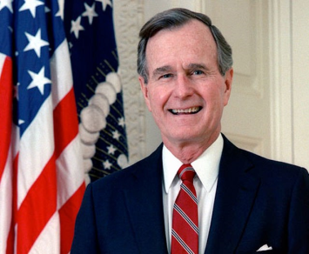**Pres. George H. W. Bush (1989-1993) 44th President Foreign Policy**

**George H.W. Bush** had served two terms as Reagan’s V.P., before being elected as President.

**Pres. Bush’s Foreign Policy**

**Pres. Bush’s Domestic Policy**

**ADA** or **A_____________ With D__________ Act (1990)** signed by Pres. Bush prohibited discrimination against the disabled in employment and public facilities.

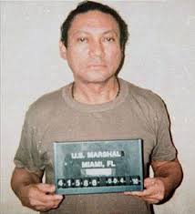

*Manuel Noriega, former President of Panama at time of his arrest*

1989 – USA invaded **____________** and removed the drug dealing dictator ***Manuel _________*** from power and put him in a U.S. prison.

1989 – 91 the **Cold War** came to an end with the fall of the **___________ Wall** and the reuniting of East and West Germany.

1991-USSR fell apart and communism came to an end in Russia o__________ ending the C____ War.

Anti- Govt protests in East Germany, Poland and other Eastern European countries

Soviet leader Gorbachev refused to use force to end the protests

Nov. 1989 Berlin Wall was torn down, allowing West and East Germans to pass freely

P__________ became 1st country behind the Iron Curtain to elect a non-communist president

Soon other Iron curtain countries did the same

Oct. 1990 W_____ Germany united with E____ Germany. Germany was one nation once again since 1945

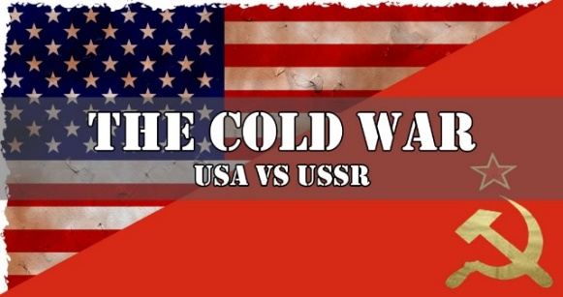On Christmas Day 1991, the Soviet flag flew over the Kremlin in Moscow for the last time. 11 Soviet republics announced that they would no longer be part of the Soviet Union. Instead, they declared they would establish a C__________________ of Independent States.

** **The Soviet Union collapsed, and the Cold War officially came to an end.**

The fall of the Soviet Union and the end of its dominance over Eastern Europe exposed the United States to many smaller international conflicts that had been obscured by the Cold War. This will be an ongoing challenge.

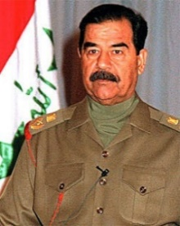1990 August 2-4 Iraq invades Kuwait. USA responds with O_________ Desert S____________ preparations leading to Operation Desert Storm

Known as Operation D_________ S______, the US leads a massive coalition defeating the Iraqi army by February 1991 and they leave Kuwait.

1991 – The G**____________** Warwas Pres. Bush’s greatest success as the USA forced **Iraq’s S___________ H____________** to leave **K______________.**

**Saddam Hussein**

**Pres. Bush’s Foreign Policy- AFRICA**

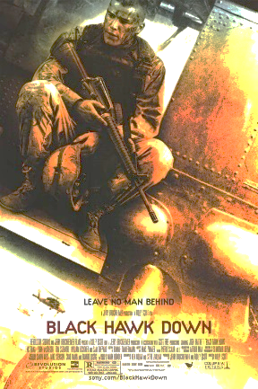1992 – Pres. Bush sent US troops to **____________** (Africa) on a humanitarian mission to stop starvation and genocide. Later, this mission would serve as the basis for the movie “**Black Hawk Down**.”

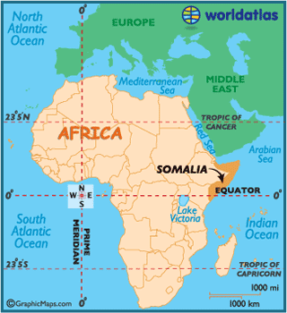

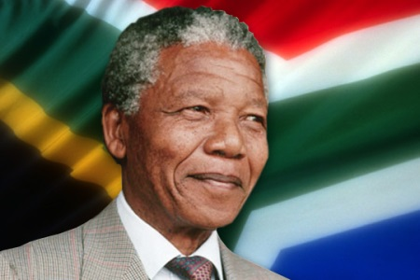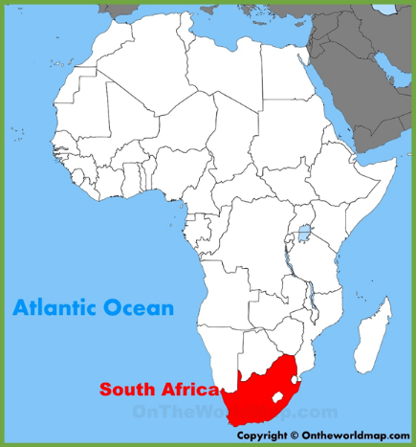**South Africa**- In a system called **_____________** laws strictly segregated white citizens from the vast majority of black South Africans.

Many Americans **_______________ (refused to buy)** South African goods along with people from many other countries.

*Nelson Mandela, President of South Africa 1994-99*

**Constructive ________________**: USA would continue to do some business in South Africa while putting pressure on South Africa to make changes.

South Africa ended ***apartheid*** after the collapse of the Soviet Union

Anti-apartheid leader **Nelson ____________** was released from prison. He would later become South Africa’s president.

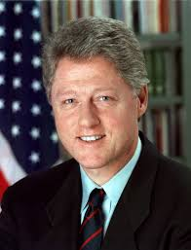**Pres. Bill Clinton (1993-2001)**

* Pres. Clinton cut federal spending, raised taxes on the rich, and lowered taxes on the poorest Americans.
* Clinton proposed _______________________ but failed to get them passed into law.
* The end of the Cold War saw our national debt drop as military s___________ decreased. P________ dividend.
* The U.S. economy prospered as:
  + Unemployment went down
  + Consumer spending increased
  + Business profits were at all time highs, especially the c______________ industry

**Pres. Bill Clinton’s Impeachment**

* In 1999, Pres. Clinton faced a major scandal and for just the second time in history a President faced i_______________ proceedings.
* Clinton had a sexual affair with a White House intern and then lied (p__________) about it.
* I______________ means the removal from office under the following rules:
  + House of Representatives vote to i___________
  + S__________ holds the impeachment t_________ requiring a two-thirds vote to convict and remove President from office.

The Senate failed to c____________, but once again the American public felt they could not t_______ their leaders.

**Pres. Clinton’s Foreign Policy: Tension in the Balkans**

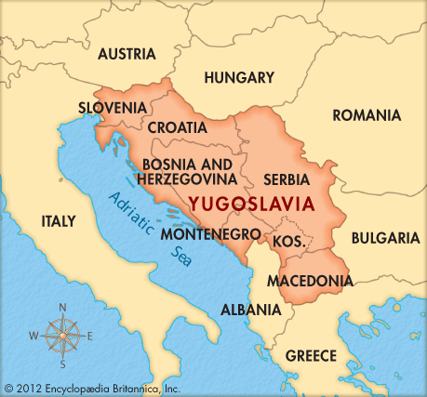**Yugoslavia, Bosnia, & Kosovo (Balkans)** – following the end of the Cold War, there was an increase in tensions between several nations (ethnic groups) on the Balkan Peninsula. (Same place WW I started)

Serbs attempted to massacre Muslims living in Bosnia and Kosovo in a policy called ‘*_________ cleansing*’.

Fearing g__________, like the H________ might be repeated, and to prevent further e_________ conflict from resulting in broader p________ and e_________ instability, Pres. Clinton sent U.S. troops and used **N** airstrikes to stop Serbians from attacking Kosovo.

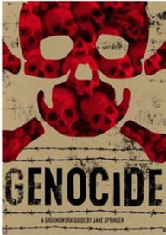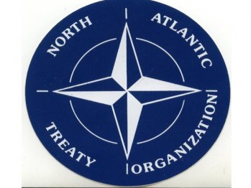

*The Balkans are countries in southeastern Europe. Including the once Yugoslavia as seen above.*

**First Woman Secretary of State**

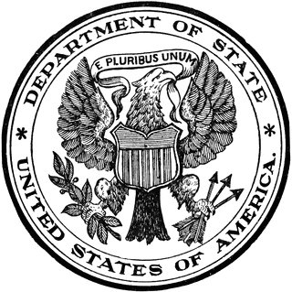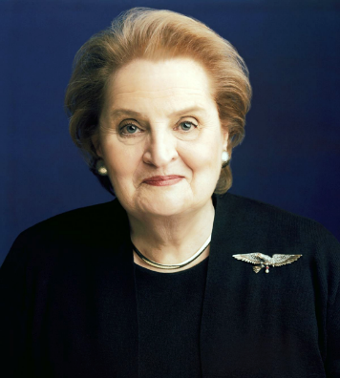Czechoslovakia-born **M____________ A____________** became the first foreign-born woman to serve in the Cabinet when she was appointed Secretary of ________ in 1997. Her appointment also made her the highest-ranking female Cabinet member at that time.

The Sect. of State runs the Department of State- which carries out USA foreign policy.

Another case of near **genocide** occurred in **­­­­____________**, a small country in Africa.

In 1994 one of its **ethnic** groups, **___________**, began killing another group, the **___________.** The US and other western nations were slow to act and to 850,000 people were killed.

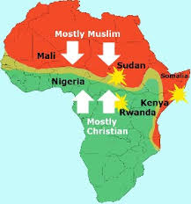**Genocide**: __________________________________________________________

___________________________________________________________________

**Challenges in Africa:** Based on the map on the right, what is a major source of conflict in Africa? ___________________________________________________

Like former President C________ (Camp D______ Accords), Clinton tried to broker peace for Israel.

* In 1993, Clinton welcomed Israeli and Palestinian leaders to the White House to shake hands and sign the **O**______ **Accords**. But citizens on both sides felt they had made too many concessions, and two years later, the Israeli Prime Minister was assassinated by a dissatisfied countryman. Before long, the entire agreement had broken down and the violence was as bad as ever.

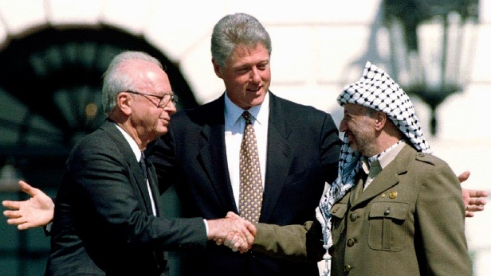



*September 1993,****Israeli Prime Minister Yitzhak Rabin****,* ***President Bill Clinton****, and Palestine Liberation Organization (****PLO****)* ***Yasser Arafat***

**Haiti**-

(1994) when military leaders overthrew the democratically elected leader, Clinton sent troops to restore the elected leader **Jean**-**Bertrand _____________.**

**Pres. Clinton’s Foreign Policy NAFTA**

* Pres. Clinton pushed through **NAFTA** (**N_______ A_________ F_______ T_______ A_____________**).
* 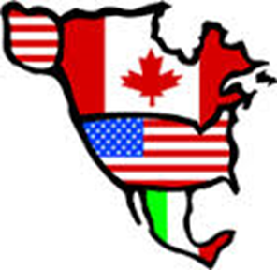NAFTA opened trade between the **USA, M________**, and **C________** by **lowering *tariffs*** *and regulations (to reduce or eliminate all trade barriers) with the hope of increasing trade and stimulate the economies of the three nations involved.*
* *US wanted to create a trade organization to rival the European Common Market.*
* ***WTO****-* ***W________******T________******O__________*** *was created to help oversee international trade and settle trade disputes.*

*China invited US companies to invest in China. Trade between US and China grew.*

* Some say this caused a loss of U.S. j________, because other nations have lower w_______, fewer government regulations, and fewer environmental concerns. US labor _______ did not support this idea.

**Entrepreneurs**

An **Entrepreneur** is someone who takes the risks of starting a business in hopes of making a profit.

 The following are some examples:

* **Bill Gates** – _______________________________
* **Sam Walton** – _____________________________
* **Estee Lauder** – _____________________________
* **Robert Johnson** – ___________________________
* **Lionel Sosa** – _______________________________
* **Steve Jobs & Steve Wozniak-** __________________

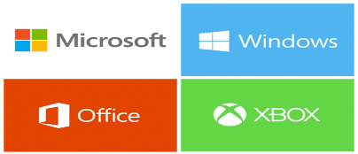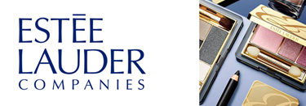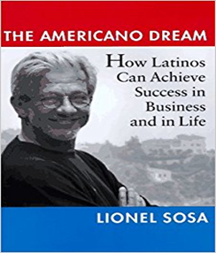

**EOC PRACTICE**

1. In 1991, President George H. W. Bush committed United States troops to fight in the Persian Gulf War in order to

(1) remove Iraqi forces from Kuwait

(2) help Great Britain take control of Middle Eastern oil fields

(3) assist Iran in its war with Iraq

(4) keep the Suez Canal open to all nations

**“President Lincoln Declares Martial Law”**

**“President Roosevelt Issues Executive Order to Detain Japanese Americans”**

**“President Bush Orders Terrorist Suspects Held at Guantanamo”**

**Headline News**

2. These headlines best demonstrate that

(1) the system of checks and balances equalizes the powers of governmental branches

(2) presidential power often increases during times of crisis

(3) presidents act forcefully during periods of economic depression

(4) presidential decisions made to resolve national crises are rarely controversial