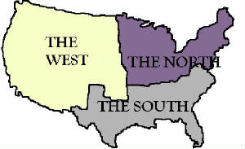
Causes of the Civil War: 1861-1865
1. SECTIONALISM pg. 4
The NORTH EAST

_______________________________________
_______________________________________
Tension between the North and the South as each “section” of the country places its own interests above the country as a whole
_______________________________________
Pg. 4-5
South –

The (North) West-

The North East-

Economic Specialization in the USA, 1850

Section | Population | Leading Economic Activities
North East
(______ states)
South (____ states)
North West (____states)

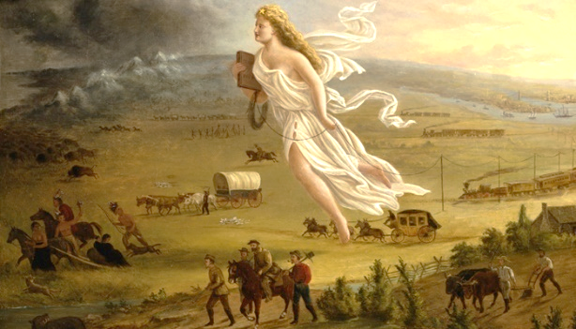
The question soon became: as the nation expands westward, would the new territories be FREE or SLAVE ?
Fill in the different SECTIONS of the westward expansion of the USA.
C.

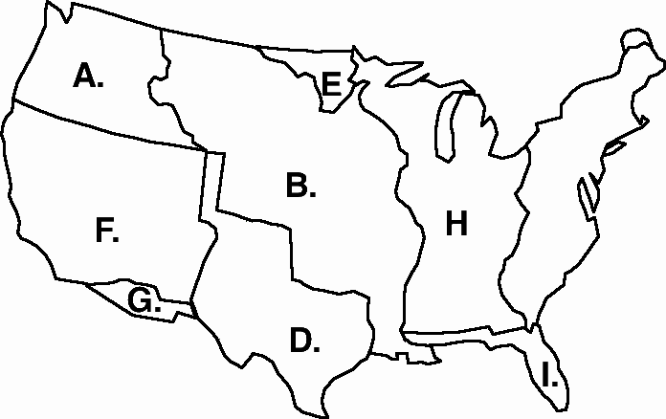

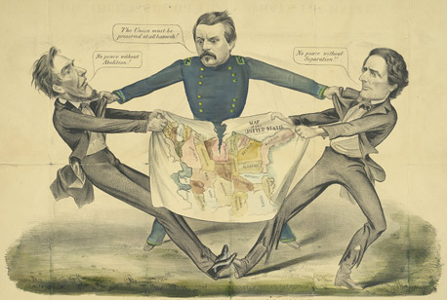
2. Slavery pg. 5

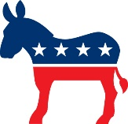

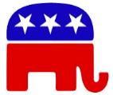
S ____________was the most divisive issue in the 1800s. Southern D_____________ supported the e____________ of slavery into w___________ territories.

The northern R____________ Party is formed to oppose the expansion of slavery. Several attempts at compromise are attempted to keep the union together.

Abolitionists __________________________________________________________________________________
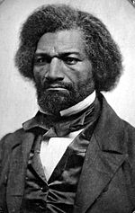  1818-1895 | 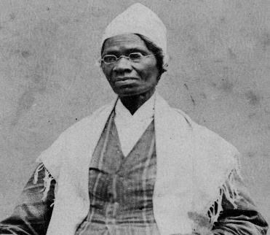  1797-1883 | 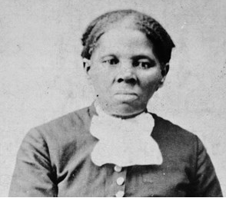  1822-1913 | 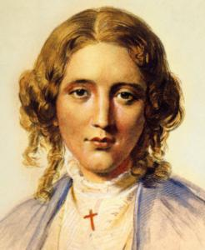  1811-1896  Wrote Uncle Tom’s Cabin which created __________  outrage against slavery across much of the North.
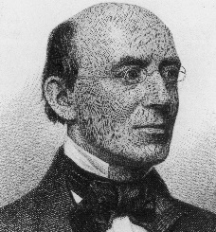  William Lloyd Garrison | 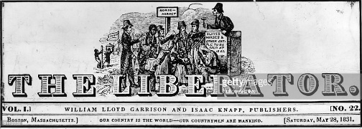  Anti-Slavery newspaper published by Garrison | 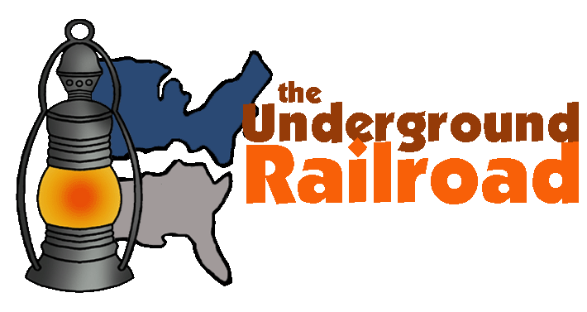 | 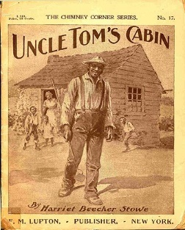  1852
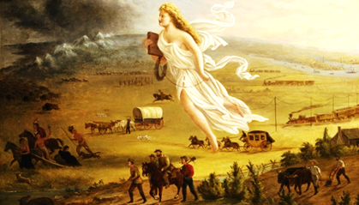
All events above strengthened the resolve of the abolitionists

Manifest Destiny
3. Westward Expansion-
As the US expanded w_____________, tensions between the north and south increased as to the question of slavery in these new territories.
Many Northerners were appalled at the s___________ of slavery.
S________________ believed only by extending slavery into these t_____________ could they keep power in the S___________. All states have e___________ votes in the Senate. In the House of Representatives, state votes are based on the p_______________ of each state. In House of Representatives, the South would never win a vote as they had less population and thus less votes in the House. But, in the Senate all states regardless of population have two senators per state or 2 votes. All states are equal in the Senate.

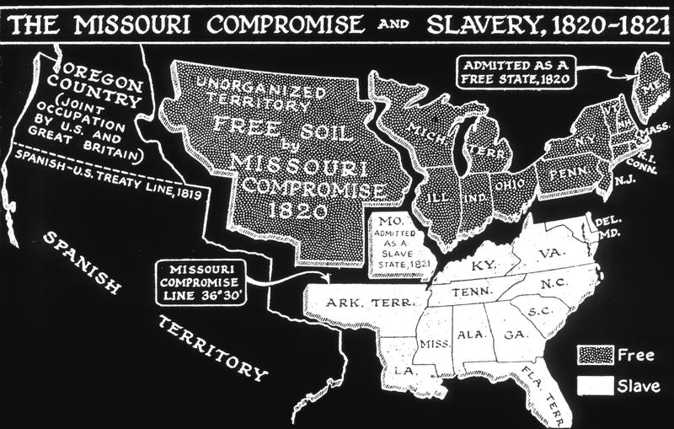
4. Break Down of Compromise
Missouri Compromise (1820) – Missouri was added as a slave state while M________ was added as a free state. Also, a compromise line was drawn to decide the question in the future. Above the line would be ________, below the line would be _______.

Compromise of 1850 pg. 7
The Compromise of 1850 had four provisions:

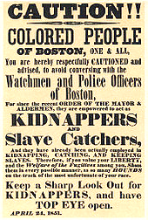
1. ________________________________________________________

2. ________________________________________________________

3. ________________________________________________________

4. ________________________________________________________

5. ________________________________________________________

Kansas–Nebraska Act (1854)– It was decided the territories of Kansas and Nebraska would allow voters to decide whether or not to allow slavery (popular s___________). This overturns earlier compromises listed above.
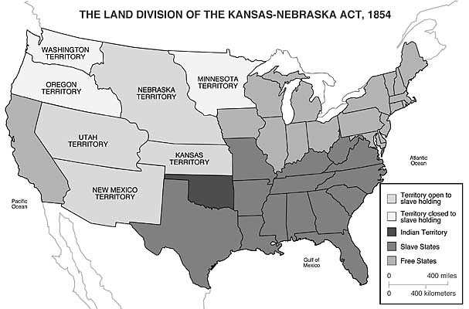

5. Differences in Constitutional Interpretation: States’ Rights
Southerners believed in nullification __________________________________________________________________
__________________________________________________________________________________________________
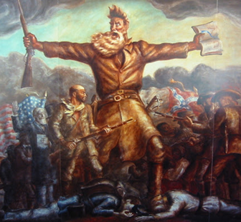
Northerners did not agree with this.

SECTIONALISM: ISSUES & EVENTS
Bleeding Kansas 1855-56 –Popular s____________ would decide the slavery question in the territories. Slave supporters began moving into Kansas to vote for slavery. Soon, two rival state governments were formed one pro slavery and one anti- slavery. There were soon clashes with the a_____________ who lived there. The bloodshed in Kansas over slavery foreshadowed the fighting of the Civil War.
Dred Scott v. Sandford (1857) – Dred Scott, a slave, sued for his freedom. In arguably the worst decision ever, the Supreme Court ruled:
John Brown – abolitionist who fought against slavery in Kansas and later at Harper’s Ferry, VA.

1)Slaves were not c___________
2)Slaves were p___________
3)Slaves could not s_______
4)Slavery could not be p______________ in the territories. As a result, the Missouri Compromise was found to be u___________________. This ruling angered many northern abolitionists and further divided the nation.

John Brown’s Raid Oct 16, 1859 – Oct 18, 1859
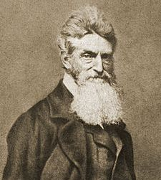
Abolitionist John Brown leads a small group on a raid against a federal armory in Harpers Ferry, Virginia (now West Virginia), in an attempt to start an armed slave revolt and destroy the institution of slavery.
Although the raid failed, it inflamed sectional tensions and raised the stakes for the 1860 presidential election. Brown’s raid helped make any further accommodation between North and South nearly impossible and thus became an important impetus of the Civil War. John Brown was convicted of murder and executed in Dec. 1859
“I, John Brown, am now quite certain that the crimes of this guilty land will never be purged away but with blood.” Note passed to guard by John Brown just before his execution.

Union and Confederate Advantages

 | UNION Advantage | CONFEDERATE Advantage
Population
Manufacturing
Economy
Money
Defense
Military Leadership
Political Leadership

Union War Plan
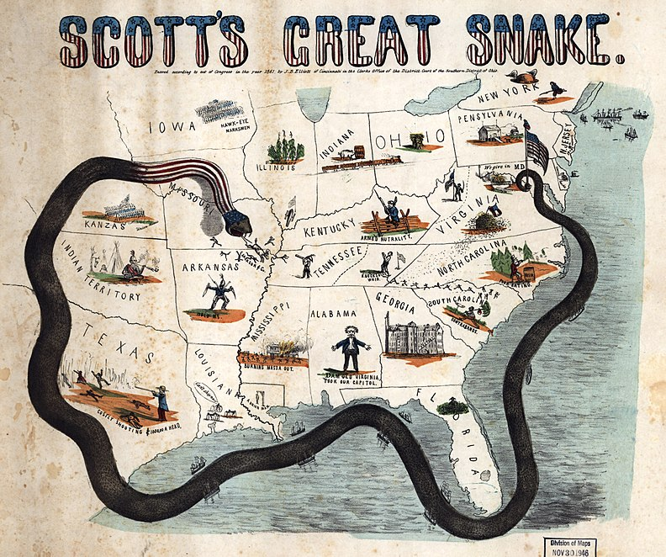
While the C___________ (south) planned to fight a d______________ war, the U___________ (north) had a more detailed plan. Gen. Winfield Scott devised “The Anaconda Plan” which called for b__________ the coast and cutting off the south from all aid. Taking control of the M_____________ River and splitting the South, then squeezing the southern economy until they surrendered.

Civil War Immediate Causes:
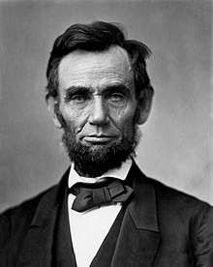
Election of Lincoln – Slavery was the main issue in the election of 1860. The Democratic Party was split between northern and southern democrats. Lincoln, a Republican, also ran for the office.
Southern states, afraid Lincoln would take away slavery, promised to s___________ (to leave the UNION OF STATES) if he was elected.
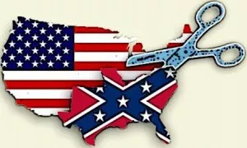
Because of the split in the Democratic party, the Republican party (Lincoln) won the election.
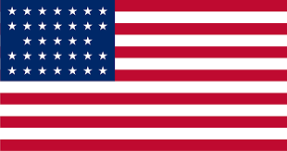
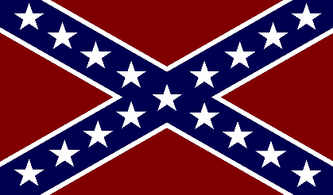
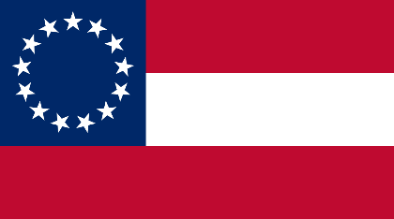
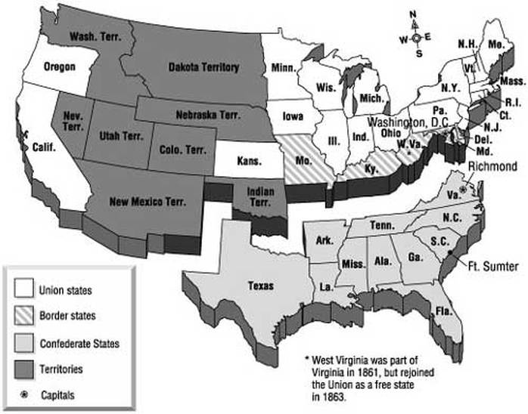
As soon as Lincoln was elected in November 1860, six southern states seceded from the Union.
CSA. Confederate States of America-the South
Flag of the Confederate Army
Flag of United States of America. The Union of States. The NORTH
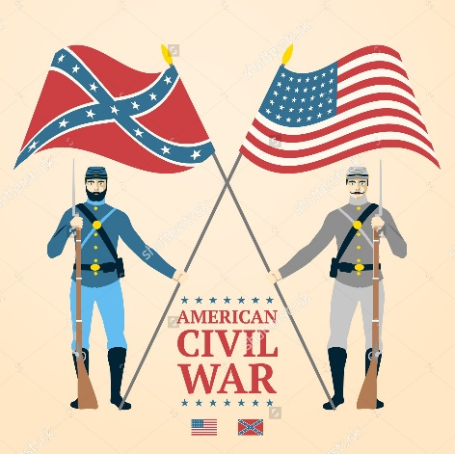

April 12, 1861 – First shots of the war were fired at Fort S____________ in Charleston, SC.

The Emancipation Proclamation pg. 13 ended slavery but DID NOT prohibit slavery. That comes later with the 13th amendment to the Constitution.

EFFECTIVE DATE: _________ _____, __________

Why didn’t Lincoln issue the Emancipation Proclamation sooner? ____________________________________________________________________________________________________________________________________________________________________________________________________

Which slaves were freed by Lincoln’s Emancipation Proclamation? ___________________________

How many slaves were freed on January 1, 1863? ___________________

What value did it have, then? _____________________________________________________

By what authority did Lincoln free these slaves? ______________________________________

Lincoln defined the proclamation as a “necessary measure to d_______________ the South and
Preserve the Union.”

Turning Points of the War
July 1863 – Battle of G and Battle of V______________. The Union won two big victories. Gettysburg stopped the Southern invasion of the north. Vicksburg gave the Union control of the M_____________ river and split the C___________________ south in two.

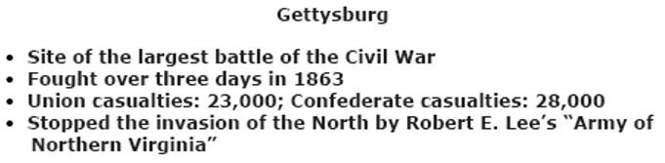

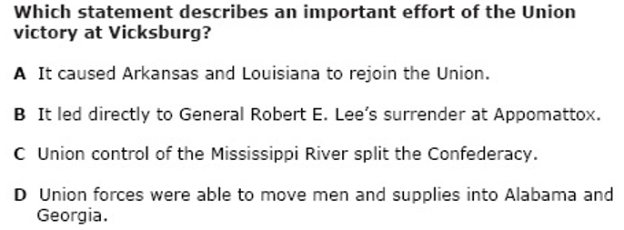
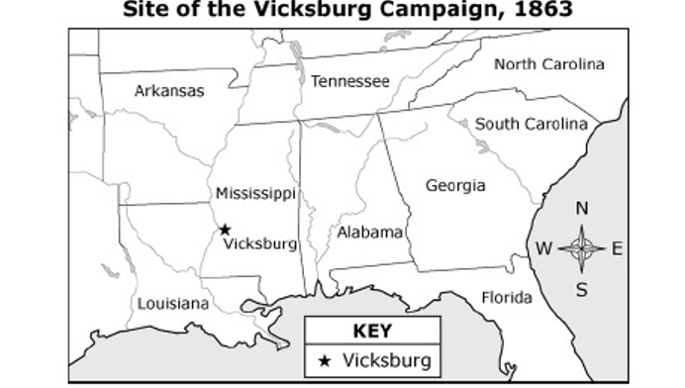
Last Year of the War 1864-1865
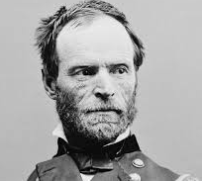
Gen. William T. Sherman – Grant’s second in command. He was most known for his destruction of Georgia and the burning of Atlanta on his “March to the S_______”

Gen. Ulysses S. Grant – Union General during the Civil War. His strategy of total war would finally force the South to give up. Was appointed supreme commander of all Union forces by President Lincoln in 1864.

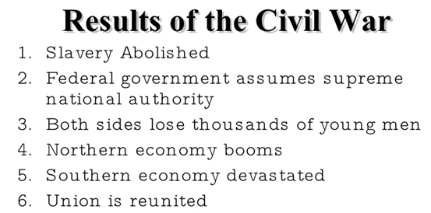
Appomattox Courthouse – Site of the Lee’s surrender to Grant signifying a Union victory in the Civil War in April 1865. War ends. CSA defeated. Union Preserved.

7. Northern industries grew rapidly

Federal government, National government, Central government all mean the same thing--- the government in
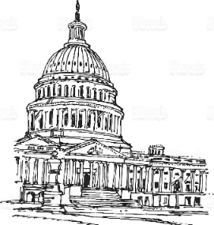
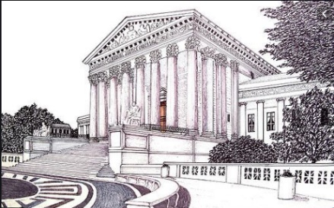
Washington DC
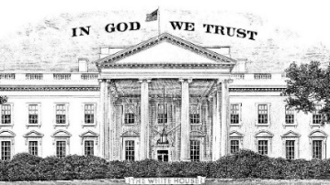

EOC Practice

1.

2.

3.

4

5.

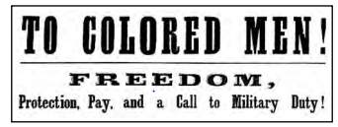

6. Which government action most directly prompted the publication of this poster?
(1) issuance of the Emancipation Proclamation
(2) passage of the Kansas-Nebraska Act
(3) rejection of the Wilmot Proviso
(4) adoption of the Missouri Compromise

7. At the start of the Civil War, President Abraham Lincoln stated that the major reason for fighting the war was to
(1) break the South’s economic ties to Great Britain
(2) uphold the Constitution by preserving the Union
(3) enforce the terms of the Compromise of 1850
(4) punish the Confederate states for leaving the
Union

8. Passage of the Homestead Act in 1862 encouraged settlement of the Great Plains by
(1) providing free land to farmers
(2) removing barriers to Asian immigration
(3) supplying land to build transcontinental railroads
(4) placing Native American Indians on reservations

Use the quotes below to answer the question.

“The slaveholding states will no longer have the power of self-government, or self-protection, and the federal
government will become their enemy. . . .”
—South Carolina legislature, Declaration of the Causes of Secession, 1860

“The Union is older than any of these states, and, in fact, it created them as states.”
—Abraham Lincoln, 1861

9. These quotes represent two sides in which important conflict in American history?
A. the conflict over how much independence states should have in the federal system
B. the conflict over what level of representation small states should have in the federal legislature
C. the conflict over an amendment to the Constitution that would allow slavery in the territories
D. the conflict over whether or not to forcibly remove Native Americans from their lands in the West

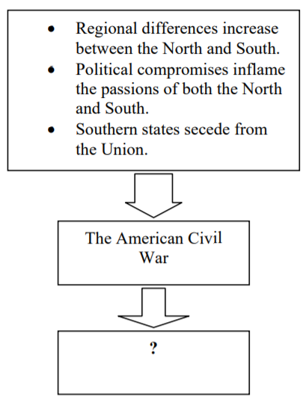

10. Which of the following “effects” should appear where you see the question mark?
A. Regional differences are peacefully resolved.
B. Congress changes earlier compromises to reduce tensions.
C. Slavery spreads into western territories.
D. The United States enters into the period of Reconstruction.

11. The Civil War directly affected the Northern economy by
(1) causing a severe depression
(2) destroying much of its farmland
(3) greatly expanding the canal system
(4) stimulating the growth of factories

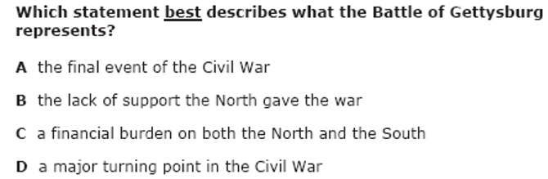
12.

