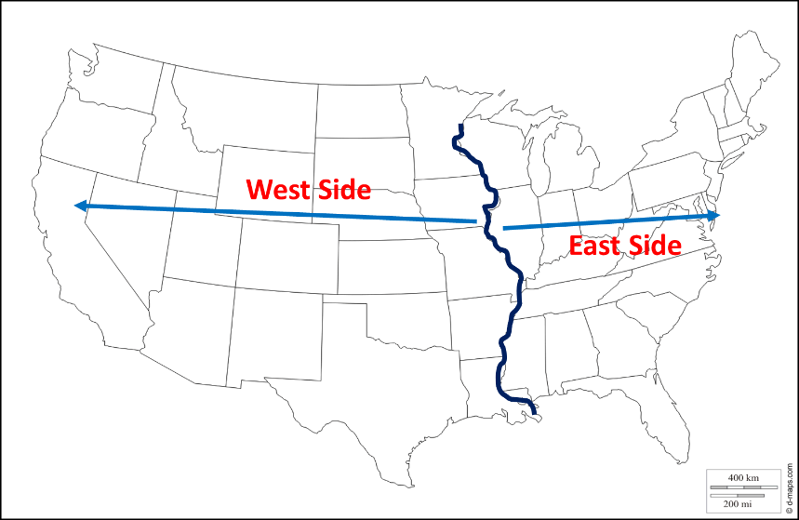**Chpt. 3 “Go West” America’s Last Frontier**

The last American frontier, **THE _________ PLAINS** was transformed by the USA’s rapid population growth and the industrial development.

The **Frontier;** akathe **_______**; the **Great Plains**; **Where the ________Roam;** mostly described as areas not settled by technologically advanced societies, but instead was home to the Native ____________. Semi-arid with little ________, treeless and flat. Home to millions of buffalo and Great Plains Indians

Miss. River

The _____________River was the most common dividing line.

**Why People moved West**

Pull Factors – things that make a person want to move West.

**1. ___________________________________________________________________________________**

**2. ___________________________________________________________________________________**

**3. ____________________________________________________________________________________**

Push Factors – things that force people to leave their home country for another

**1. ___________________________________________**

**2. ___________________________________________**

**3. ___________________________________________**

**4. ___________________________________________**

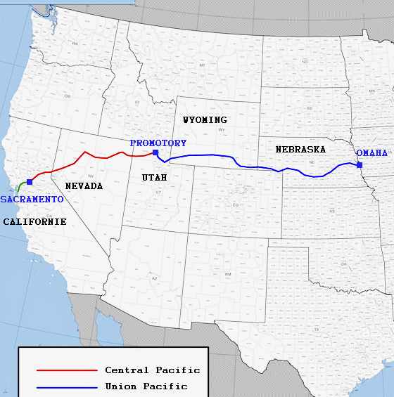In 1869, the **Transcontinental Railroad** was completed.

This line connected the Eastern USA with the Western USA.

Travel time dropped from 6 ________ by sea to just 10 _______ by train.

Made settlement of the west easier

Railroads sold land grants they had received from the govt to settlers to ______________ for the RxR contstruction

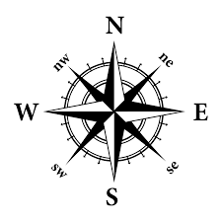Farmers and Ranchers were able to sell their goods back east, by shipping them on the trains.

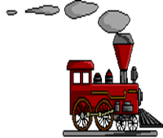

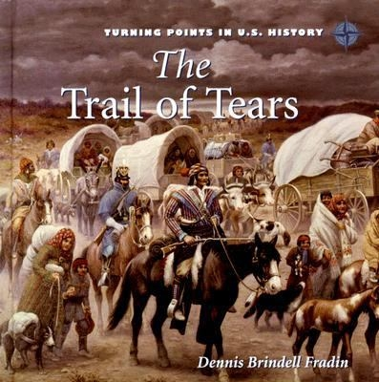**Relocation of the American Indians**

In 1830, the U.S. Congress passed the Indian _________ Act that forced all Native Americans living east of the Mississippi River to move ____________.

The Cherokee, and other tribes of the southeastern USA, were forcibly moved to Indian Territory, now called ______________.

One fourth of these Cherokee died on the way on a journey known as the Trail of ___________.

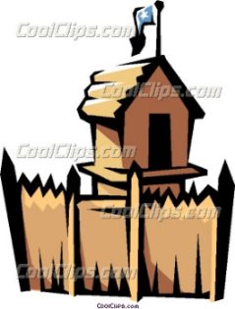The lure of good _________had brought settlers onto the lands of the Native Americans.

After the Civil War, Union troops were stationed in ________ along the frontier.

These Unions troops fought many wars with the Indians of the Great Plains and Southwest.

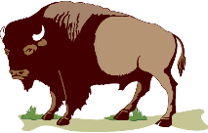Some of these soldiers were African American known as the **___________ Soldiers**

* The defeated Indians lost their lands and their way of life as they were forced onto **_________________**.

The govt **“reserved”** particular lands for the tribe and signed a treaty. The tribe promised not to go beyond the borders of its lands. The govt would provide seed, blankets, and food through its Indian Agent who more often cheated the Indians.

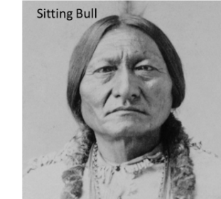Reservation lands were usually **__________** and located in **________________** areas.

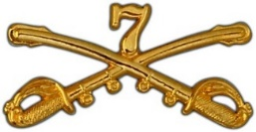***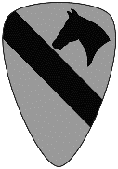*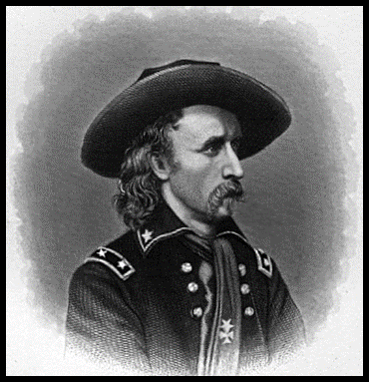**In 1875, the discovery of __________ in the Black Hills of South ______________ caused friction between settlers and the Sioux Indians, it would eventually erupt into war!

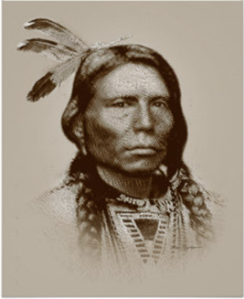

Crazy Horse

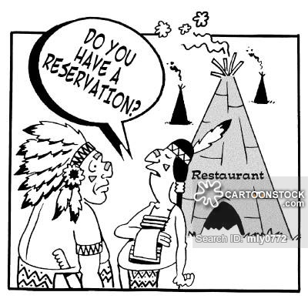The U.S. 7th Cavalry led by **Gen. George Armstrong __________** was wiped out by the Sioux Indians led by **Sitting _______** and **___________ Horse** at the Battle of Little ____________ ______________.

***General George A. Custer***

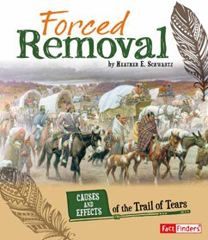**Government Policy & the Indians**

During the 1800s the U.S. government followed a policy of pushing the Native Americans from their traditional lands.

It included:

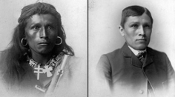1. F________________ R____________________

2. R___________________________

3. A___________________________

**Before After**

How did the transcontinental railroad impact the Indians of the Great Plains? ____________________________________________________________________________________________________________________________________________________________________________________________________

**Availability of Cheap Land**

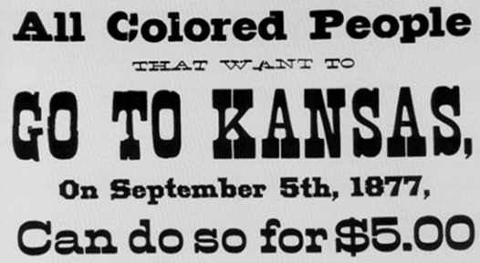The slaughter of the b___________ and the removal of the Indians into r______________, opened up vast tracts of new land for settlement.

The ______________ Act (1862) allowed settlers to get land if they lived on the land, grew crops, and made improvements. It promised settlers 160 acres of land for $1.65 an acre or for free if they farmed it for 5 years.

Many European immigrants were attracted to this offer of free land and almost 1.4 million would eventually established homesteads under this law.

Thousands of ***African***-Americans moved ***west*** in 1879 in an effort to find a better life.

This was known as the “**Exodus of 1879**”, and the participants were called “***___________________***”.

**Stages in the Evolution of the American West**

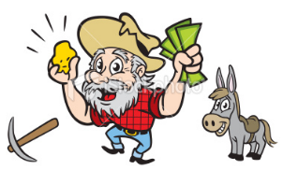America’s “last frontier” generally evolved through a series of stages based on different economic activities and on the available resource. The stages were:

**Pull Factor**

1. __________________________

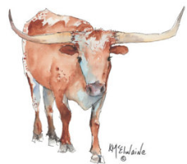

2. _____________ ________________

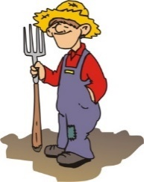

3. _____________________________



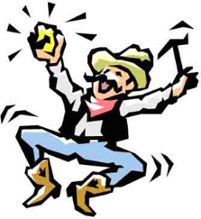**Discovery of Precious Metals: The Gold & Silver Rush Mining Boom**

The **Gold Rush** of 1848-1849 in **______________** brought thousands of people looking to get rich quick. They were called the **_________ers.**

Later gold and other precious metals would be discovered in the Rockies of Colorado, the Black Hills of South Dakota, and the Klondike in Alaska.

**Boom ___________** appeared as miners poured into an area, they just as quickly became ___________ **towns** as the gold ran out and the miners left.

**The Cattle Industry Begins**

*Texas Longhorn*

At the end of the Civil War, millions of wild ________________ cattle roamed the Great Plains in Texas.

Soon cowboys were rounding up the wild longhorns and trailing them __________to the railroads in ___________. It took 3 months to drive the cattle from __________ to __________. On this __________ drive, the cattle grazed on the short grasses of the ____________ range- public lands not belonging to any one and not fenced in.

From Kansas the longhorns were shipped by train to the slaughter houses in _____________. From there the cuts of beef were shipped in refrigerated cars to the Northeast.

Demand for cattle in the West was low, but in the East the growing population created a huge demand for beef, there was $ to be made.

A new industry was born! It lasted 20 years.

**The Cowboy**

Cowboys learned to rope and ride from the Mexican vaqueros, as well as the use of the saddle, spurs, boots, chaps, and the hat.

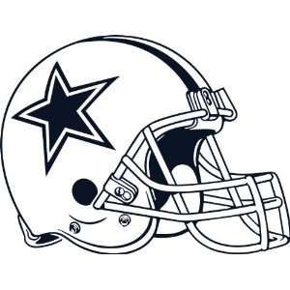The cowboy had the lonely and isolated job of gathering the wild cattle and driving them north.

The romantic image of the cowboy became a symbol of the individualism of the American spirit.

1 in 5 cowboys was **_____________.** Western music was born in celebration of the cowboy’s life.

**The Farming Frontier**

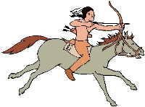The growth of the r__________________ and the **H________________ Act** had enabled farmers to settle the Great Plains. Farmer had read the railroad advertisements and they expected to find well-watered wooded lands, but they didn’t.

Instead farmers encountered many obstacles:

1. ____________________________________

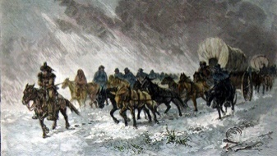2. ____________________________________

3. ____________________________________

4. ____________________________________

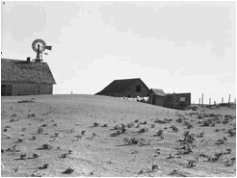5. _____________________________________

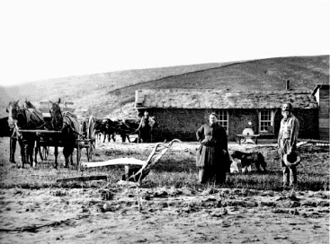6. _____________________________________

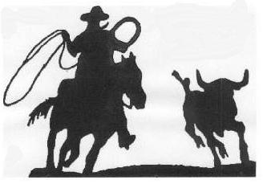

The expansion of the **railroads**, the **Homestead Act**, and the discovery of gold, made lands once occupied by the native peoples more desirable.

O_____________, once reserved for the Native Americans was sold to settlers, some got there ____________ than others.

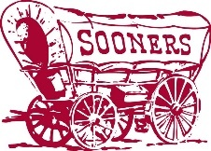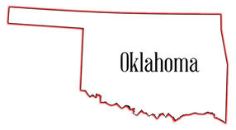

Indian attacks were common as Indians saw their hunting grounds become farms.

Cattlemen who felt threatened by farmers fencing their land led to violence- Range Wars. Farmers won as they fenced off their land with __________ ___________.

**What were the problems and solutions of farming on the Plains? Pg. 51 Gateway Book**

|  |  |  |  |
| --- | --- | --- | --- |
| **Obstacle:** | **Obstacle:** | **Obstacle:** | **Obstacle:** |
| **Solution:** | **Solution:** | **Solution:** | **Solution:** |

|  |  |  |
| --- | --- | --- |
| **Obstacle:** | **Obstacle:** | **Obstacle:** |
| **Solution:** | **Solution:** | **Solution:** |

**The Dawes Act (1887): A misguided Attempt at Reform**

Many in America wanted the Native Americans to undergo ________________– adopting to the mainstream culture of America.

The ___________ **Act** abolished the Native American tribal unit.

Each family was given 160 acres of land in hopes they would become farmers. This was an attempt to encourage private property and end Indian communal tribal lands and that the Indians would become prosperous _____________.

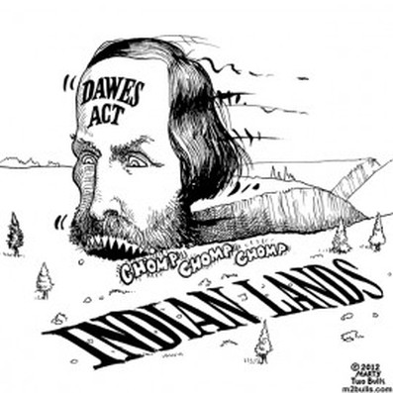Instead, the **Dawes Act** nearly *_____________*the Indian culture, because the Indians began selling most of their 160 acres to new homesteaders.

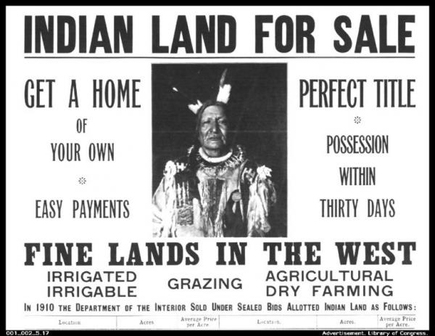Those who *_______________* (Americanized) were given citizenship and right to vote.

**The Closing of the Frontier**

The closing of the frontier (Manifest Destiny) and the growth of industry in the late 1800s are two factors often associated with the **rise of United States imperialism.**

The Growth of Industry

Closing of the Frontier

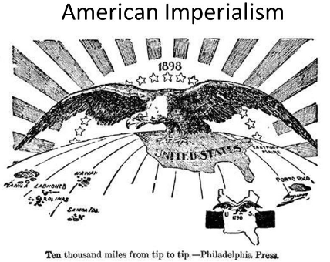

**EOC PRACTICE**

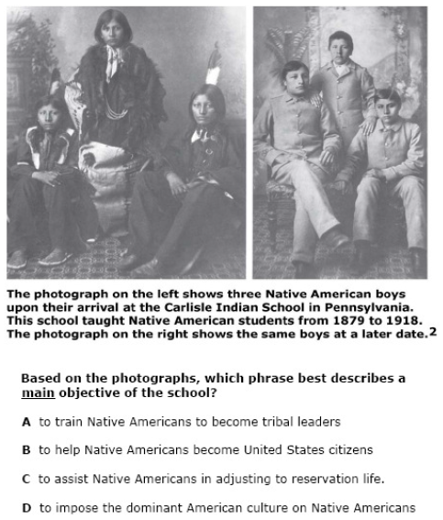**1.**

|  |
| --- |
| 2. How did railroads influence the growth of western territories? |
| |  |  | | --- | --- | | A. | The ability to bring in goods deterred industrial development. | | B. | Settlers moved away from Native American lands to follow the railroad routes. | | C. | Railroads spurred the foundation and expansion of towns along the western rail route. | | D. | Towns at the ends of railroad lines became ghost towns when the lines were extended. | |

|  |  |  |  |
| --- | --- | --- | --- |
|  | | The diagram below shows the various goals of the Dawes Act of 1877.    3. Which phrase best completes the diagram? | |
|  | | |  |  | | --- | --- | | A. | Lure Native Americans to migrate to the frontier | | B. | Entice Native Americans to move to urban areas | | C. | Give Native Americans jobs in the federal bureaucracy | | D. | Push Native Americans to adopt an agricultural lifestyle | | |
| 4. The Dawes General Allotment Act of 1887 | |
| |  |  | | --- | --- | | A. | recognized Native American tribes as independent nations. | | B. | presented land to individual tribes. | | C. | granted each Native American family a 160-acre farmstead. | | D. | improved the reservation system. | | |

5. The passage of the Homestead Act (1862) and the completion of the first transcontinental railroad (1869) encouraged settlement in which region?

(1) Great Plains

(2) Atlantic Coastal Plain

(3) Ohio River valley

(4) Gulf Coast

6. The Homestead Act (1862) encouraged the settlement of the West because it provided

(1) forty acres of land and a mule to formerly enslaved persons

(2) land to people who would live on it for at least five years

(3) mining claims for prospectors seeking gold and silver

(4) land to companies to build transcontinental railroads