**The Roaring Twenties (1920s) Chpt. 10**

**The Post War Recession**

* US began to **d**_____________ – the transition process during which a nation at war returns to a state of peace.
* After World War 1, America went into a period of **i**________________, refusing to be drawn into Europe’s drama.
* Government stopped spending money on the war effort.
* Factories shut down to **c**___________ from making war materials to making civilian products. From **Guns to Butter**
* Soldiers returned home from war and had a hard time finding **j**_________ because factories had shut down to change from military to civilian goods.
* Farmers ________ money since their European market was now gone and US govt was not buying more food for the military. The farmers entered a long, drawn **d**____________ that would linger throughout the 1920s and 30s
* US was hit by the Spanish Flu (Bird Flu) 500,000 to 650,000 Americans died from the flu

**The Red Scare- Russia became communist or B_______________ Oct. 1917.**

|  |  |  |
| --- | --- | --- |
| **[First] Red Scare** | **Sacco and Vanzetti Trial** | **Immigration Quota Acts** |
| **FEAR** of a **c**________________ takeover of the United States  **________________ Raids** *(4000 alleged communists arrested – hundreds deported)* | Two ___________ immigrants were found guilty of murder and executed based on questionable evidence of guilt  Many thought they were executed for being ***a________ and f___________ born*** | Placed quotas on immigration from _____________ and _____________ Europe  (New Immigrants) |

**Rise of Nativism**

**X___________________ - Fear of Foreigners**

American *nativism* reached a new peak in the 1920s due to the effects of   
  
WWI propaganda and the **R**__________________ Revolution in 1917.

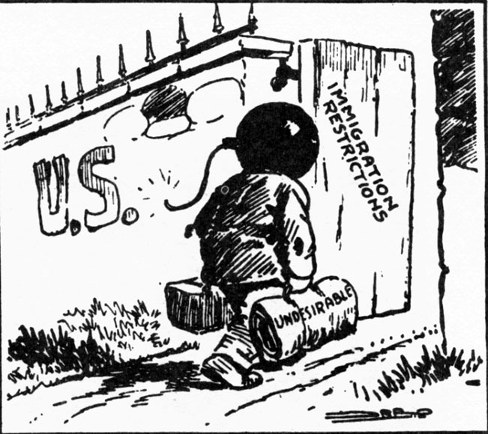The **Red Scare**, radical **a**_________ bombings, and the S______ & V________ trial led to a rise in **n____________** – the dislike of foreigners and **xenophobia**.

Nativists believed white Protestant (WASP- **W**____ **A**____ **S**______ **P**_________) Americans were superior to others. Like the nativistthese attitudes would bring restrictions on **i**___________________

Nativists believed white Protestant (WASP- **W**____ **A**____ **S**______ **P**_________) Americans were superior to others. Similar to the nativistthese attitudes would bring restrictions on **i**___________________

This political cartoon showcases American fears that many of the “New Immigrants” from Southern and Eastern Europe were __________________, __________________ , or __________________.

**Limits on Immigration**

Immigration A____ of 1921, 1924, and 1929

A **quota-** a **limited** or **fixed** number or amount of people or things, in particular.

* These were laws designed to keep immigrants from E__________ and S_________ E_________ out of America.
* Emergency Q______ Act (1921) Quotas were set allowing a certain number of immigrants from each nation to enter the USA.
* Great Britain, Ireland, & Germany were allowed the most, while the ‘New Immigrant’ was limited, and Asians were totally stopped. Latin America had no restrictions.

The new quota system was meant to restrict immigration from **SE E________- the n______ i_______________**

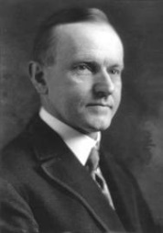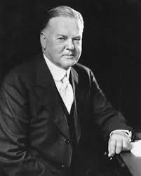**Three Republican Presidents: Harding, Coolidge, & Hoover (1921-1933)**

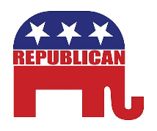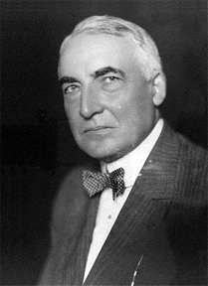

_____________ _______________ ______________

**All three Presidents favored l________ t_______, r_________ r_________ (laissez-faire) and r_________ t______ on overseas goods**

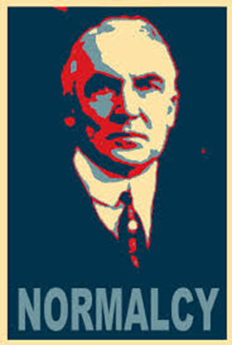In 1920, Americans elected **Warren G**. _______________, a Republican who promised America a “Return to **N**______________.” Harding had opposed America’s entry into the League of **N**______________, but supported America’s continued involvement in efforts to promote peace and understanding in Europe, including hosting the

Harding focused less on foreign policy and more on peace and prosperity at home. **Isolationism from E_____________.**

**Under Harding the USA refused to join the League of Nations, it lowered taxes, and restricted immigration.**

**1921-23**

-**A Higher Tariff-** a tariff (customs duties) is a tax on **i**___________making imports artificially more e___________.

A Tariff would keep out foreign products & protect US producers, farmers & their workers from cheap foreign competition.

-**Fordney-McCumber Act-** raised **t**___________ on import to an average of 38.5% of their value. Imports became VERY **E**___________________.

Other countries retaliated by raising tariffs on goods from USA, with a devastating impact on world trade.

Led to a t_______ war.

**Harding’s International Finance**: Allied War Debt and German **R_____________**

The D____________________ Plan was designed by the U.S. government to help Germany pay its war **r**_____________ while facilitating economic cooperation between the United States and Europe. Also, t**his was done to promote p____________ and e____________ stability in Europe.**

**International Finance: Allied War Debt and German R_____________**

**Dawes Plan**

Great Britain & France wanted

debt forgiveness. USA refused.

US demanded Allies pay back all loans. US taxpayers were paying interest to the **bond holders** who had raised large sums of cash for the war effort.

Allies were broke. England & France used the money they got from Germany **reparations** to pay back USA.

Germany broke. This created an unstable economy throughout Europe.

US came up with the **Dawes Plan-**

**This was done to promote p__________ and e__________ s___________in Europe**

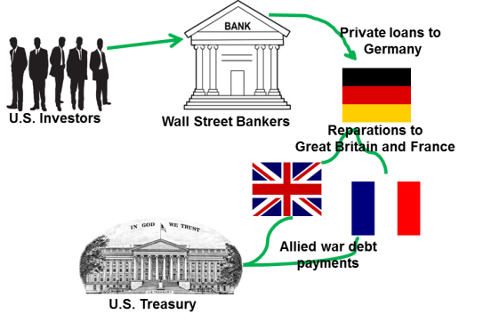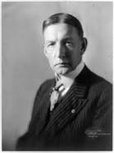

***Charles G. Dawes***

**US Foreign Policy 1920-1941**

United States did not join the League of N________but the US played an active role in promoting w________ peace through d____________ conferences through out the 1920s.



**1921 Washington N_______ Conference** limited the size of the great powers’ **n**_______________ forces by **t_________.**

**The Four- Power Treaty-** USA, Great Britain, France, and Japan agreed to respect each other’s territories

the Pacific and submit any disputes to a a joint conference of all four powers.

**Nine-Power Treaty (1922)** -affirming the sovereignty and territorial integrity of China as per the Open Door Policy.

What was the purpose of all these treaties? To prevent a future w_____________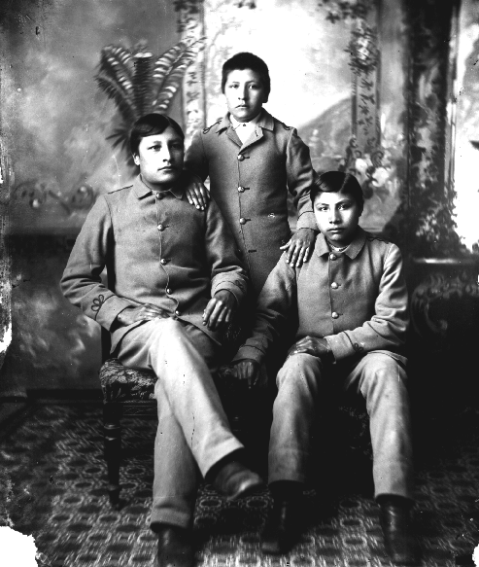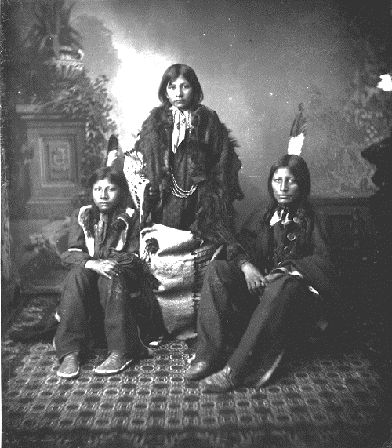.

Don’t confuse the **Dawes Plan** above with the **Dawes Act**

What is the main idea of the cartoon?

1. Travel on ocean-going ships was dangerous and should be banned.

(2) The United States should return to an isolationist foreign policy.

(3) The United States should take the lead in creating an international peacekeeping organization.

(4) The United States Navy should make efforts to improve its fleet.

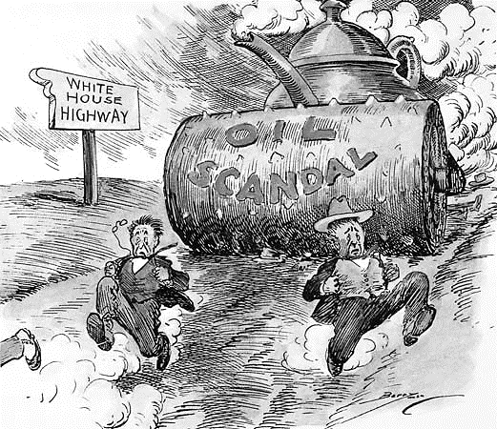**The T_____________ Dome Scandal** was one of the worst in history, as one of Harding’s Cabinet members leased government land to friends for bribes.

Additional scandals included Harding appointees stealing U.S.A.’s money from veteran hospitals.

These scandals u_____________ Harding’s Presidency

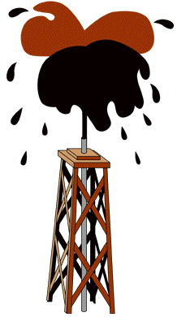

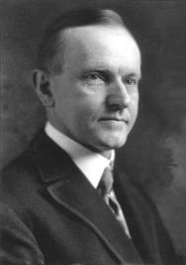**Pres. Calvin Coolidge 1923-1929**



Calvin Coolidge served as Pres. Harding’s Vice Pres., when Harding died, Coolidge became President.

Coolidge was re-elected again in 1924 on a **pro-business policy** and the slogan “**Keep Cool With Coolidge**”.

“Silent Cal’ had a motto of: **“the business of America is b_____________.”**

The U.S. economy boomed under Coolidge, in fact some say that his **laissez-______** **attitude** towards the economy led to over speculation that resulted in the stock market crash.

Immigration Act of 1924 or the National Origins Act – Lowered immigration per year to 150,000 and limited immigration based on national origin. It favored WASP-N__________ and W__________ Europeans.

**Coolidge’s Foreign Policy**

**The Geneva Disarmaments Conference 1927**

Led by the USA under Secretary of State Frank Kellogg and French Foreign Minister Aristide Briand to outlaw war.

**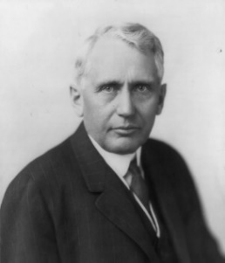****K______________- B____________ Pact** (1927)- was a treaty meant to outlaw war. 15 countries signed on to the Pact. It failed, World War II would start in 1939. Too few c__________ signed up and no means of e__________________.

*US Sect of State Frank Kellogg*

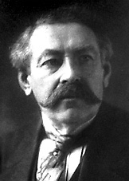

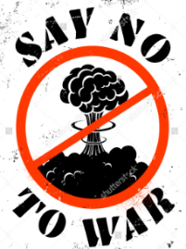

*French Foreign Minister Aristide Briand*

**Pres. Herbert Hoover 1929-32**



**Herbert Hoover** organized U.S. food production in WW 1 and predicted the end of poverty if elected president.

Hoover was impressed with the achievement of business in raising the standard of living in America.

Hoover said this ‘**rugged i____________________**’ had happened because:

* + Individuals were given equal opportunities
  + They had a free education,
  + They had a will to succeed

Hoover felt **too much g___________ i____________** in business **would ruin a good thing**.

*Putin’ on the Ritz:* a song about prosperity of the 1920s

Have you seen the well-to-do  
Up and down Park Avenue  
On that famous thoroughfare  
With their noses in the air

High hats and narrow collars  
White spats and lots of dollars  
Spending every dime  
For a wonderful time

Now, if you're blue  
And you don't know where to go to  
Why don't you go where fashion sits  
Puttin' on the Ritz

**By Irving Berlin**

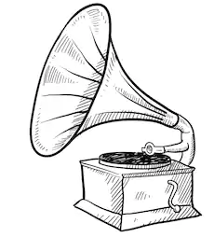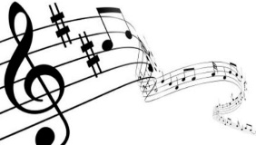

**A Booming Economy**



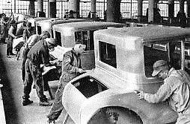**Mass Production**

Henry F______ didn’t invent the car, but he did perfect a way to make them *c_______* and *f______* so more people could afford a car.

Ford pioneered the use of the a__________ line to mass produce cars.

By 1924 Ford was producing one car every 10 seconds at a price of $300 per car.

He increased workers wages to $5.00 per day so they could afford to buy a car and other goods being mass produced.

**Henry Ford’s _________________ line** made production more efficient but cut out the need for skilled laborers. Automobiles became prevalent during the 1920s because of Ford’s assembly line.

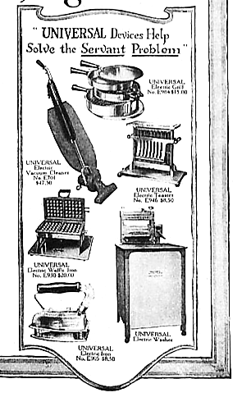

Many other products, such as _____________ and ______________, were mass produced on assembly lines.

**Household Appliances and Consumer Culture**

New household appliances, such as the vacuum cleaner, iron, and washing machine made it easier than ever for housewives to do household chores.

**THE AGE OF MASS CONSUMPTION/ CONSUMER CULTURE**

**ADVERTISING!!! Stimulates d_______________**

* Production techniques changed and so did patterns of consumption.
* Goods began to be mass marketed on a national level.
* Workers were receiving higher wages and they had more money (***d_________ income***) to spend and more leisure time.
* 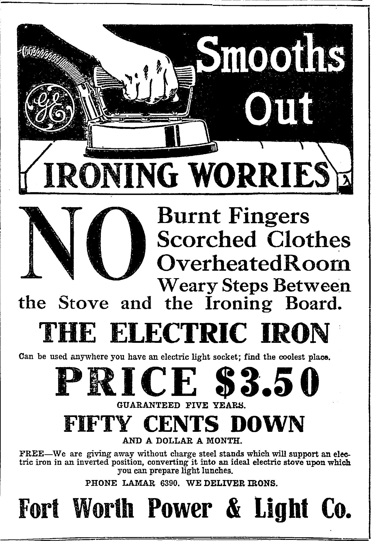New advertising industry sought to cultivate new markets-W_________ (i.e., f________ drivers, independent w________, flappers and young women).
* The more money a person made the more things they wanted to buy. M_________ class grew.
* Purpose of advertising is to create a new market to sell goods and service. W_______ became a mass market.

**B_____________ NOW, Pay _____________!**

Americans who couldn’t afford the new appliances purchased them on the **i**_________________ plan/buying.

**RESULT:** more consumer **d _________________**

* Consumers for the first time began buying on credit. *Buy* now *Pay* later!!!
* VISA, MasterCard, and other credit cards were not yet around, but i_________ plans were easy for a person to pay a small d______ payment and take the item home and then pay a little each month. The economy grew.

Buy Now Pay Later

* Suddenly American consumers were in debt!

**Speculation Boom**

1920s saw millions speculate in the stock market and in real estate (buying property). There was little to no govt regulations

The price of a share of a corporation skyrocketed as more and more people began to invest in the stock market.

|  |
| --- |
| **Stock Market  SPECULATION** |
| **SPECULATION:**  ***Buy*** *______,* ***sell*** *_______.*  **Buying on the ______________**  *(Borrowing $$$ to buy stocks)* |

* 1920s saw millions speculate in the s______ market and in real estate (buying p_________). There was little to no govt r____________ .
* The price of a share of a corporation s__________ as more and more people began to invest in the stock market.



The U.S. experienced unprecedented economic growth during the 1920s, but not everyone shared in the prosperity. There was a widening GAP between the “h_______” and the “have nots.”

|  |
| --- |
| ***The Losers:*** |
| 1. **C:\Users\Tom\AppData\Local\Microsoft\Windows\Temporary Internet Files\Content.IE5\VB3FIZXX\MC900433818[1].png__________________** (low crop prices) 2. **__________________** (anti-union sentiment) | |

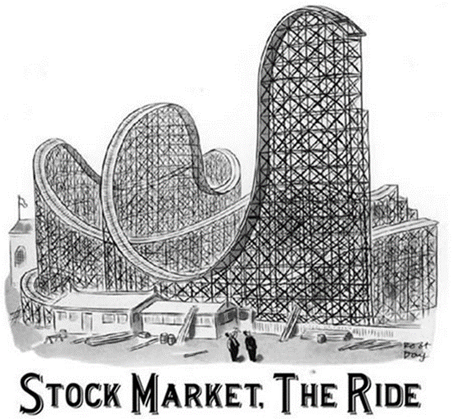A small percentage of Americans had the largest percent of the wealth.

With new farm equipment, electricity & fertilizers **f_________** faced lower i_________ due to **o_______________** of crops and **lower d____________ for U.S. farm products in Europe**

Workers in factories faced competition for jobs with immigrants. Unable to form unions due to ***r______ scare***

Minority Groups faced d_________________.

**Causes of the Great Depression:**

**Over production of consumer goods**

**Over production of farms (food products)**

**High consumer debt**

**Stock Market speculation**

**Uneven prosperity**

**Attempts to Preserve Traditional Values: The Bible vs. Science and Traditional Values vs. Modernism**

* During the Progressive Era the growth of **T_______________ Movement** (those against the drinking of alcohol) led to the passage of ____**th** **Amendment**.
* The Temperance Movement thought that drinking alcohol was s_________, led to c_______, and domestic violence.
* **Frances W___________** was an outspoken leader of Temperance Movement, women’s rights, women’s suffrage & better working conditions for labor.

**Attempts to Preserve Traditional Values**

**Temperance Movement and Prohibition**

**C:\Users\Tom\AppData\Local\Microsoft\Windows\Temporary Internet Files\Content.IE5\0XX5U2DA\MC900112496[1].wmf ORIGINS: T_______________ Movement** (Antebellum Period)

Prohibition gained traction during WWI due to anti-German sentiment and the wartime push to conserve grain (the primary ingredient in beer and liquor).

|  |  |  |  |
| --- | --- | --- | --- |
| **__th Amendment**  Banned the sale and consumption of “intoxicating liquors” | **ENFORCEMENT UNSUCCESSFUL** | | **__st Amendment**  REPEALED the 18th Amendment (1933) |
| **_____________________**  *Illegal alcohol sellers* (e.g., Al Capone) | **_____________________**  *Private clubs where alcohol was illegally consumed* |

**18th amendment and 21st amendment how not to confuse them: It is against the law to drink at 18 but it is legal at 21. Get it?**

**V**____________ Act-defined intoxicating liquors to include beer and wine.

The law provided penalties for the manufacture, sale and transportation of alcoholic beverages but not for their consumption. **It enforced the 18th Amendment-PROHIBITION.**

But instead of people obeying the law there was a growing **d**___________ for the law.

**S**______________ and **boot**_________ alcohol allowed the average consumer to obtain liquor without any problems.

Prohibition led to an increase in **o_____________ crime**, the gangsters which willingly supplied illegal booze to consumers became rich and famous.

Chicago crime boss Al “Scarface” Capone owned the city and all of its rackets. His gang was called the Outfit.

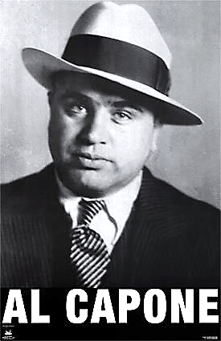By 1933, the American public saw that Prohibition was a ‘failed experiment’.

The **____s**t **Amendment** repealed or did away with Prohibition.

Prohibition proved that unpopular laws are often unenforceable.

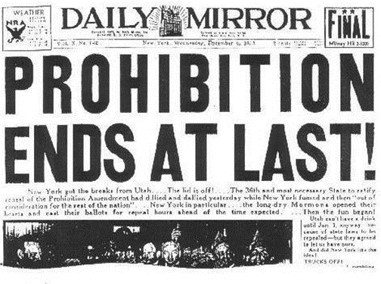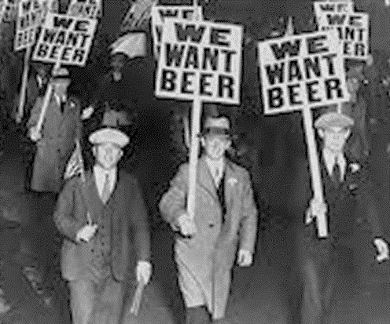

**The Bible vs. Science and Traditional Values vs. Modernism**

**FACT:** The phrase, “**Monkey Trial**,” was coined by **H.L. Mencken**, a reporter covering the trial for the *Baltimore Sun.*

**C:\Users\Tom\AppData\Local\Microsoft\Windows\Temporary Internet Files\Content.IE5\IU0RI2MS\MC900438131[1].wmfThe Scopes “M**___________**” Trial**

**QUESTION:** *How do we explain the origins of humanity?***ANSWER:** *Creation or Evolution*

|  |  |  |
| --- | --- | --- |
| **Religious F________________**  “Conservative” | **VS.** | **Modern Science**  “Liberal” |
| The ____________ contains a literal and true account of creation by God. | https://encrypted-tbn2.gstatic.com/images?q=tbn:ANd9GcRlgn8KsoNvjv1xKPIIOZn76c2lTkGJDhNBwAMDL17jxGcNJhy5 **Charles ______________**  **Theory of   E**__________________ |

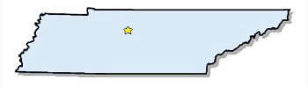In 1925, the Tennessee legislature passed a law forbidding the teaching of Charles Darwin’s theory of **e**________________ in public schools.

John Scopes, a substitute teacher and football coach, taught a lesson on evolution so that the town of Dayton, Tenn., could host a trial. The trial received national media coverage.

**Tennessee**

**It reflected disagreement over the c___________ v ___________of the American people**

**William Jennings Bryan,** a Fundamentalist, volunteered to prosecute the case against Scopes.

Scopes was defended by an attorney from the

|  |  |
| --- | --- |
|  | **A________________ C________________ L________________ U________________.** |

The ACLU created in January 19, 1920, to ensure individual ________ of citizens were _________from ____________abuse.

The Palmer Raids were considered abusive by many.

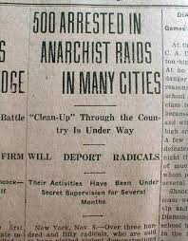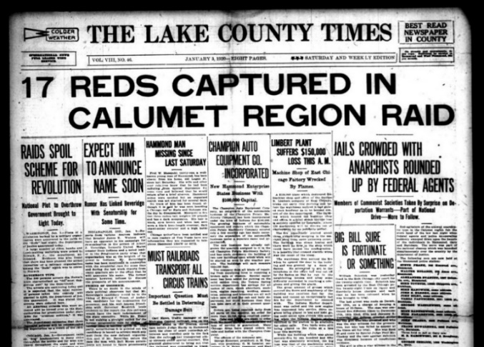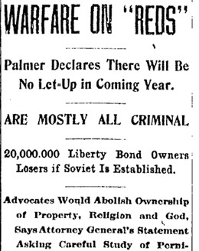

Which events do these newspapers describe?

1. Cold War c. Prohibition
2. Red Scare d. Great Migration

**The Role of Women**

Although women could vote in the 1920s thanks to the passage of the **___th** Amendment, women made little impact on politics, typically voting the same way as their husbands did.

Many young women, known as **f**_______________, challenged cultural norms of “ladylike” behavior. Flappers could be identified by their short hair, knee-length skirts, and their permissive lifestyles.

Flapper culture had very little impact on women as most women either stayed at home and made use of their new electrical appliance or worked menial jobs where they were paid less than men.

**Youth and the Lost Generation**

**A “Flapper”**

* A new group of writers, known as the “**Lost __________________**”, rejected the desire for material wealth.
* These writers believed they did not fit the patterns of everyday life after the horrors of World War I.
* 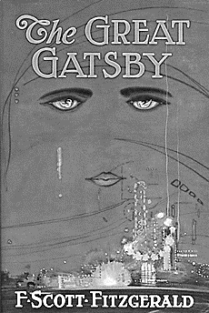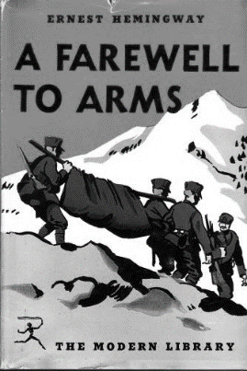The Lost Generation felt America had become overly m________________ and lacked spirituality. Many moved to **____________**, France



**African American Experience**

**Booker T. Washington**

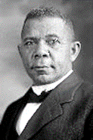He argued that African Americans should gain equality by focusing on **j______ t___________ (industrial training)**, not by demanding immediate social equality or political equality.

Believed that racism could be overcome by demonstrating that African Americans were h_______, s_______ and industrious.

**W. E. B. DuBois**

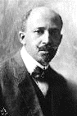

Help found the **N___________ A___________ A_____________ C_____________P_________(1909)**  to help African Americans gain **civil r___________** through l___________. Challenging Jim Crow in the courts.

First African American to earn a Ph.D. from Harvard.

**W.E.B. felt African Americans should achieve immediate racial equality and supported open protests. Political Rights- the vote was very important.**

W.E.B. DuBois insisted that intellectual training of the most "Talented Tenth” of the African American population would provide the leadership for African American advancement.

He often disagreed with another Civil Rights pioneer Booker T. Washington, but **both agreed that e_____________ was important.**

Black leaders, such as **W.E.B. DuBois** and **Booker T. Washington**, disagreed about the best way to help black citizens achieve political, economic, and social equality in America.

***In the space provided, note the accomplishments of these men and their philosophical differences: use notes and pg.208-09***

|  |  |
| --- | --- |
| https://upload.wikimedia.org/wikipedia/commons/thumb/1/1b/Booker_T_Washington_retouched_flattened-crop.jpg/724px-Booker_T_Washington_retouched_flattened-crop.jpg  **Booker T.** ___________ | https://upload.wikimedia.org/wikipedia/commons/thumb/1/12/WEB_DuBois_1918.jpg/786px-WEB_DuBois_1918.jpg  **W.E.B.** ___________ |

|  |
| --- |
| **Marcus**  ___________ |

**The Great Migration**

During the 1920s many African Americans began moving out of the South to the ‘Promised Land’ of the Northern cities.

They left in search of **j**_________ in the industrial cities of the North, and to ***escape*** (**poverty**) sharecropping, tenant farming, and the **deep r________ (segregation or caste)** of the South.

Jacob Lawrence was an American painter, and the most widely acclaimed African-American artist of the 20th century. He is best known for his Migration Series.

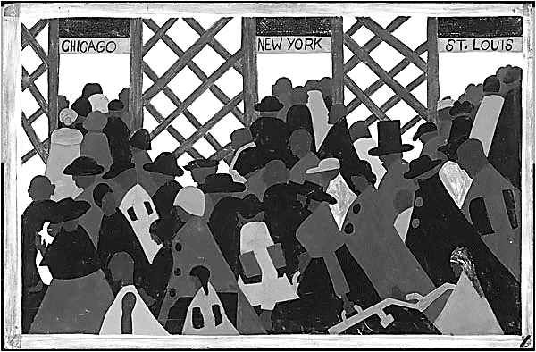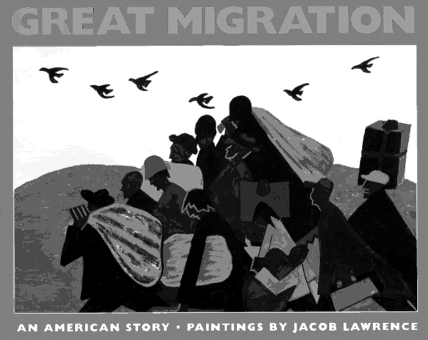

**The Harlem Renaissance (rebirth)**

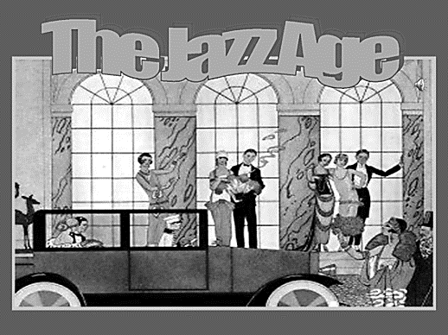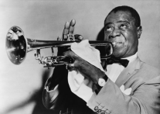

The 1920s is often called the **J________ Age**, because of the importance of the new form of African American music.

This ‘**rebirth**’ in the interest of the African American culture became known as the “**Harlem Renaissance**”.

The Renaissance was more than just about the music, it included dance, visual arts, literature, and poetry. **It included all the arts and cultural achievements of African Americans.**

**African Americans in the 1920s The Harlem Renaissance- re-birth of African American Culture**

|  |  |  |  |
| --- | --- | --- | --- |
| **The Great Migration** | **_________ Music** | **_________ Renaissance** | **Zora Neal __________** |
| http://pragmaticobotsunite.com/wp-content/uploads/2013/02/the_great_migration_f1834340cd6.jpg |  | LangstonHughes.jpgAn African American artistic and literary movement.  _____________ Hughes *(Famous Writer)* | a fixture of New York City's Harlem Renaissance, thanks to novels like Their Eyes Were Watching God |
| Black Americans leave the South to Search for _____  Escape ____________ | Black musicians played for white audiences, leading to some cultural exchange. |

**The [Second] Ku Klux Klan**

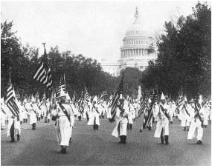Nativist sentiment and the success of the film, *Birth of a Nation*, laid the groundwork for a revival of the Ku Klux Klan. Members of the “Second” Ku Klux Klan cast themselves as the guardians   
  
of “One Hundred Percent __________________”

**Klan members march on Washington in the 1920s.**

|  |  |
| --- | --- |
| **“TRUE AMERICAN”** | **“UNAMERICAN”** |
| 1. _________________ 2. _______________ Born 3. _________________ | 1. _________________ 2. _______________ Born 3. ____________ or Jewish |

*The Klan considered anyone “Un-American” who did not fit the “WASP” [White Anglo-Saxon Protestant] profile. Note that while the Klan was a white supremacist organization, it also targeted immigrants and religious minorities.*

**MORAL WATCHDOG:** *The Klan also supported Prohibition, opposed bootlegging and gambling, and held its members of high moral standards. This function of the Klan was undermined by scandals involving its members in the late 1920s and early 1930s.*

The Klan’s membership exceeded four million in the 1920s, and the organization was stronger in the _________________ (Indiana, Ohio, etc.) than it was in the South.

**The Rise and Fall of the 1920s KKK**

In 1925, the Indiana KKK was the largest state branch in the Klan's ***"I_________ Empire."*** The conviction in November of that year of D. C. S___________, the powerful grand dragon of the Indiana Klan, for the murder of Madge O__________ led to a dramatic decline in the organization's membership and political influence.

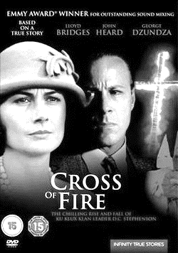What began as a vicious rape on a night train from Indianapolis to Chicago ended with arrests of Indiana's governor and other high state officials…..

[**http://www.famous-trials.com/stephenson/74-home**](http://www.famous-trials.com/stephenson/74-home)

**The KKK would rise again in the 1950’s.**

**EOC Practice**

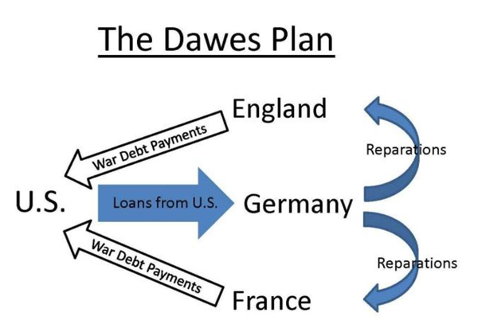

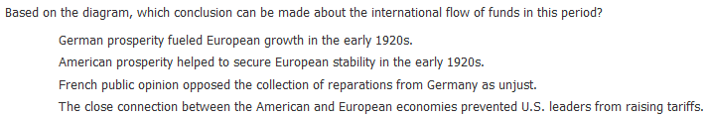**1**.

a.

b.

c.

d.

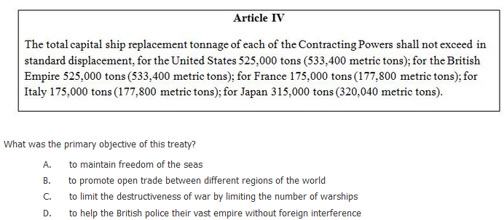

**2**.

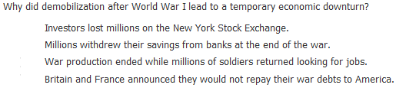**3**.

a.

b.

c.

d.

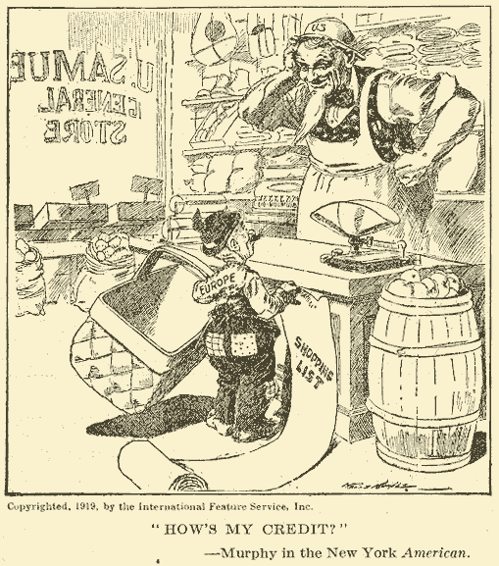

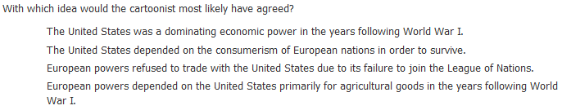**4**.

a.

b.

c.

d.

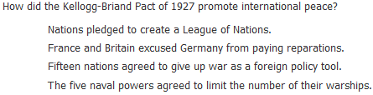**5.**

a.

b.

c.

d.

**Washington Naval Conference Nov. 1921-Feb 1922**

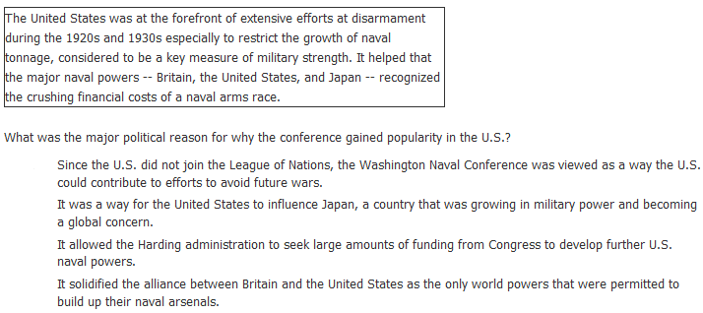

a.

b.

c.

d.

**6**.

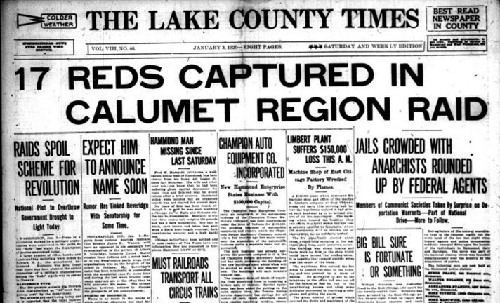

**7**. Which phrase ***best*** explains the above headlines.

a. Immigration raid by the border patrol.

b. Palmer raids against communists.

c. Prohibition agents raiding an illegal speakeasy.

d. The Red Scare.