Unit 2 Topic 2.1 Senate & House of Representatives Wapples pg. 106-121 AMSCO pg. 100-107
- The S________ is designed to represent s______ e______, while the H______ is designed to represent the p________
- Different chamber sizes and constituencies influence f_______ (rules) of d________
- C___________ in Congress are affected by term-length differences
- The enumerated and implied powers in the Constitution allow the creation of p______ p______ by Congress, which includes:
  - Passing a federal budget, raising revenue, and coining money
  - Declaring war and maintaining the armed forces
  - Enacting legislation that addresses a wide range of economic, environmental, and social issues based on the Necessary and Proper Clause
- P_______ b_______ legislation and l_______ affect the lawmaking in both chambers

INTENTIONS FO THE FOUNDERS

- Fear of e________ p________ c___________ in s_______ institution
- Fear of m______ rule by i____________ majority
- Concern about manner of representation in Congress
- Belief that C____________ would be the dominant branch of government and its power had to be limited. But how?
- Solution: b___________ legislature
  - Mob rule concern addressed by creation of "u_______ house" in which s__________ would be selected by s________ legislatures rather than the p_________, and which would check the p_________ of the people's representatives in the H_______.
  - Representation concerns settled by a Senate w/equal r__________ and a House with representation based upon p__________.

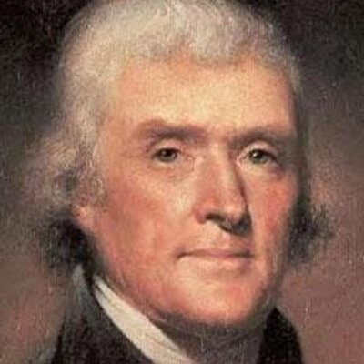
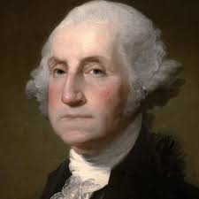

BICAMERALISM = TWO-HOUSE LEGISLATURE
- Purpose of Bicameralism
  - To p_______ against an overly p________ legislature
  - House of R_____ was expected to reflect p_______ will of average citizen
  - S________ was to provide more s________, c________, and in-depth deliberation
  - Acts as a m__________ effect on p__________, and p________ government from steamrolling ahead and i_________ on people’s rights
  - Part of the Connecticut (Great) Compromise at the Const. Convention
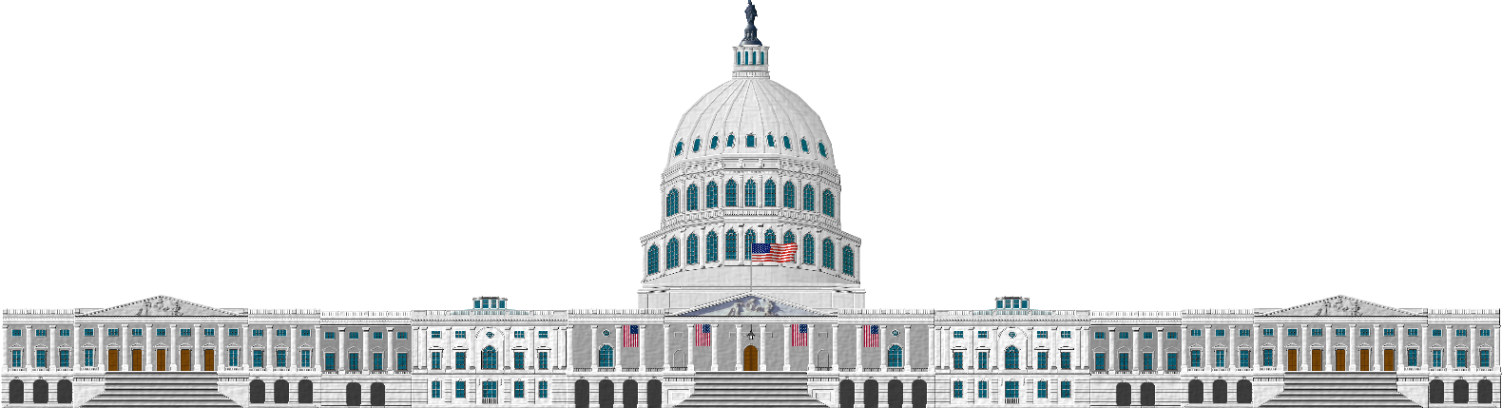
The Congress: Bi-Cameral

The Senate
The House of Representatives

H_________ of Rep’s was designed to be c______ to the p_________ / more responsive to the people:
Members elected d______ by the people (rather than indirectly elected, as were Senators until 1913)
Members are elected from s________ d________ rather than on an at l______ basis, like the Senate
Members elected for only a t___-year term
Entire b____ elected every t_____ years
R_______ bills (tax bills) must originate in the H___________

Senate was designed to be more r__________ from the people:
Members originally were i________ elected by s_______ l__________ (until the ___^{th} Amendment, 1913)
Members elected on an at-large basis by the e________ state
Members elected for a s_____year term
Only ___/____ of Senate is up for reelection every two years – more stability/continuity (s_________ terms)

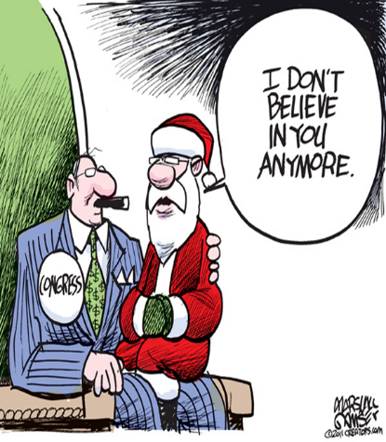
OVERVIEW OF CONGRESS: TERMS AND MEMBERSHIP
Terms
- Term of Congress lasts t____ years
- Terms begin on Jan. ___ of every o____-numbered year and it is divided into t____ o____ year sessions.
- Terms numbered consecutively (116th Congress from 2019-2021, 117th from 2021-2023)
- A____________: End of a term; date must be agreed upon by both houses. Two regular sessions per term. Periodic recesses (not to be confused w/adjournment).
Membership
- Over-representation of w_____, m_____, P________, u_____-middle class l_______ in their 50's ---> charges of conservative/status quo bias.
- Rebuttals:
  - Many more w______ and m_______ have been elected in recent years.
  - Perfectly possible for white, male, Protestant, upper-middle class lawyers in their 50's to represent the poor and afflicted.
  - In any case, the p_______ themselves are the ones who elected members
- Consequences of a bicameral legislature
  - G_________ – designed to be slowed down
  - C__________ between houses (especially if controlled by different parties- divided government) very difficult
  - Additional c_______and b________

The framers of the Constitution created the United States Senate to protect the rights of individual states and safeguard minority opinion in a system of government designed to give greater power to the national government. They modeled the Senate on governors' councils of the colonial era and on the state senates that had evolved since independence. The framers intended the Senate to be an independent body of responsible citizens who would share power with the president and the House of Representatives. James Madison, paraphrasing Edmund Randolph, explained in his notes that the Senate's role was "first to protect the people against their rulers [and] secondly to protect the people against the transient impressions into which they themselves might be led."

Constitutional /Formal Requirements for Membership

CONGRESSIONAL SIZE
HOUSE OF REPS
- Determined by C_______– ____ members since 1911. Can be changed by new congressional law.
- Members elected by d_________, not states.
- Number of r__________ per state is determined by p____________.
- Demographic trends show increase in Sun Belt state representation (e.g., 53 reps in CA, 36 in TX), decrease in Frost Belt representation.
SENATE
- ________ members, chosen in s_________ elections (“at l______”). With a s_________ size, the Senate has been a more i____________ body with less need than the House for as many s_________ procedures/r______.
- T_____ members from every state – established in Constitution. ALL states are E_________ in the Senate
- Only one-third of senators are elected every two years (two-thirds of the senators remain current members). Therefore, the Senate is a “_____________ body.”
CONGRESSIONAL RULES FOR DEBATE
House of Representatives
S________ of the H______ exerts great control. The S__________ is in charge of the c___________ (what bills are debated and when that occurs) and influences the House R_______ Committee in deciding the legislation to be considered.
- Because of the vast power wielded by the R______ Committee, its ratio has traditionally been weighted in favor of the m______ party
If each voting member spoke for 15 minutes, to be followed immediately by another speaker, nearly 109 hours of time would be required. That translates into eleven ten-hour days of non-stop speeches. Debate is important when considering contentious issues.
Nevertheless, given the reality of our large House, members often choose knowledgeable colleagues who represent a point of view supported by others to speak on their behalf.
Senate
- With a smaller size, the Senate has been a more informal body with less need than the House for as many strict procedures.
Why is the Senate seen as a more informal body when it comes to debate? In other words, why does the House have more rules and formality when it comes to debate?

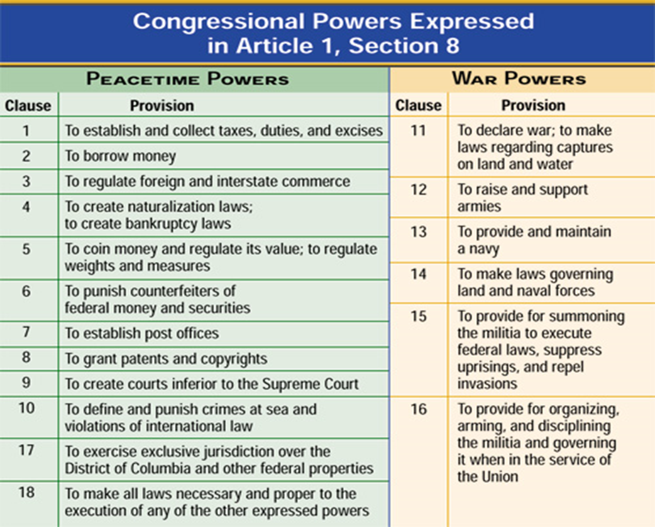
ENUMERATED or LISTED Powers of Congress. Sometimes referred to as the EXPRESSED POWERS

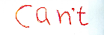
POWERS DENIED TO CONGRESS
- Passing ex p_____ f_____ laws-A law that makes an action a crime even though it was legal when it was committed or increases the penalty for a crime after it has been committed. Under the Constitution, neither the states nor Congress can pass such a law.
- Passing bills of a_________- A law that makes a person guilty of a crime without a trial. Neither Congress nor the states can enact such a law under the Constitution.
- Suspending h_______ c_________ except in cases of rebellion or invasion
H______ c_________- A court order directing authorities to show cause for why a person under detention should not be released.
NECESSARY AND PROPER CLAUSE
THE IMPLIED POWERS
Under Article I, Section 8 of the Constitution
–Congress has the power "to make all Laws which shall be necessary and proper for carrying into Execution the foregoing Powers, and all other Powers vested by this Constitution in the Government of the United States, or any Department or Officer thereof".

Congress has the power make any law necessary and proper to carry out the previous listed powers. For example. To raise and support an army. This implies Congress has the power to create a d________ law.

The Necessary and Proper Clause allows the national government to s_________ the meaning of the e_______ powers to create laws that are n___________ and p__________ for the good of America.

Explain how has the necessary and proper clause allowed the federal government to expand their powers?

