Topic 1.4-1.6 Challenges of the Articles of Confederation
1.4 Challenges of the Articles of Confederaton
WHY DID WE COME UP WITH THE ARTICLES OF CONFEDERATION (AND A CONFEDERATION)?
After the Declaration of Independence was signed, the 2nd Continental Congress created the Articles of Confederation on November 15, 1777 but didn’t go into effect until March 1, 1781. It lasted until 1787 when it was replaced by the Constitution.
LOOK AT THE NAME OF OUR COUNTRY
Declaration of Independence >> Revolutionary War >> Articles of Confederation (1781) and its weak central government. U.S. began as a confederation (a “firm league of friendship”)
“Each state retains its s____________, f___________, and i____________, and every Power, j___________, and right, which is not by this confederation expressly delegated to the United States, in Congress assembled.”
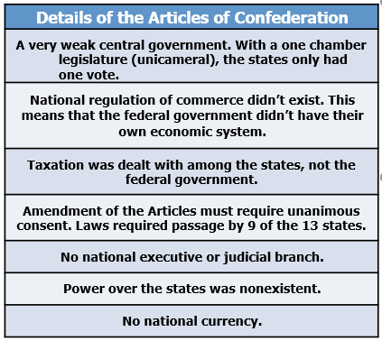
More power given to the s_________ than the n___________ (central) government and that was a problem

ECONOMIC PROBLEMS UNDER ARTICLES
One of the biggest problems was that the n__________ government had n___ p_______ to i________ t_______. To avoid any perception of “t___________ without r___________,” the Articles of Confederation allowed ONLY S_______ GOVERNMENTS TO LEVY T_______.
To pay for its expenses, the national government had to r__________ money from the states. The states, however, were often n_____________ in this duty, and so the national government was u________________.
Without money, the US government could not pay debts owed from the Revolution or easily secure new funds. Foreign governments were reluctant to loan money to a nation that might never repay it. The fiscal problems of the central government meant that the currency it issued, called the Continental, was largely worthless.
The country’s economic woes were made worse by the fact that the central government also lacked the p__________ to impose t___________ on foreign imports or r___________ i______________ c____________. Thus, it couldn’t protect American producers from foreign competitors. Compounding the problem, states often imposed t________ on items produced by other s____________ and otherwise i______________ with their neighbors’ trade.
SHAYS' REBELLION
- The national government under the Articles also lacked the power to raise an army or navy. Fears of a standing army in the employ of a tyrannical government had led the writers of the Articles of Confederation to leave defense largely to the states. Although the central government could declare war and agree to peace, it had to depend upon the states to provide soldiers. If state governors chose not to honor the national government’s request, the country would lack an adequate defense.
- The weaknesses of the Articles of Confederation became apparent as a result of Shays’ Rebellion. In 1786, farmers in western Massachusetts were heavily in debt, facing imprisonment and the loss of their lands. Many of them were veterans, who owed taxes that had gone unpaid while they were away fighting the British during the Revolution. The Continental Congress had promised to pay them for their service, but the national government did not have sufficient money. Moreover, the farmers were unable to meet the onerous new tax burden Massachusetts imposed in order to pay its own debts from the Revolution.
- Led by Daniel Shays, the indebted farmers marched to a local courthouse demanding relief. Faced with the refusal of many Massachusetts militiamen to arrest the rebels, with whom they sympathized, the governor of Massachusetts called upon the national government for aid, but none was forthcoming. The uprising was finally brought to an end the following year by a privately funded militia.
- Shays’ Rebellion brought home the weaknesses of the Articles of Confederation. The U.S. government had both failed to pay its veterans and failed to raise a militia in order to put down a rebellion. It had become clear the U.S. government’s inability to impose taxes, regulate commerce, or raise an army hindered its ability to defend the nation or pay its debts.
- To find a solution, members of Congress called for a revision of the Articles of Confederation. In 1787, delegates from 12 of the 13 states met in Philadelphia to craft a new Constitution.
GOLDILOCKS OF GOVERNMENT
TOO STRONG (KING)

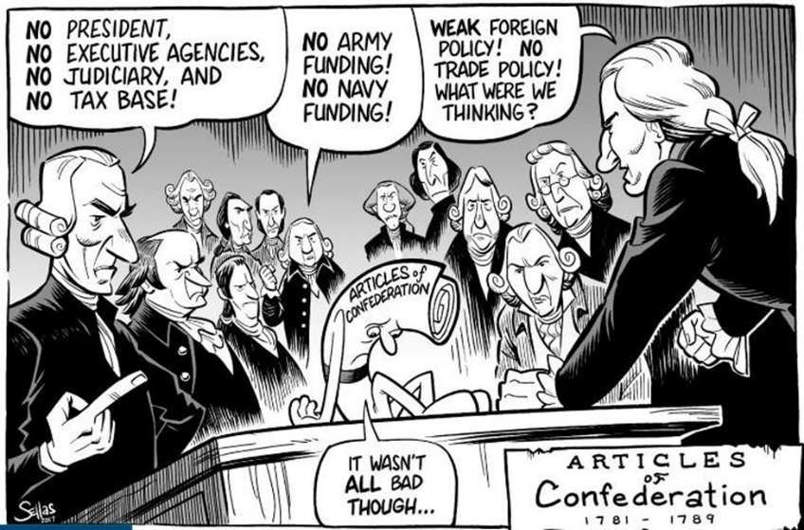
CONSENSUS – WHAT WERE THE THINGS THAT THEY AGREED UPON AT THE START?
- All delegates supported r___________ government (representative republic); scrap Articles
- Common philosophy was a general framework of government favoring the p_________ of p______
- States would determine voting q_____________; s____________ for property owners only because they feared that the majority who had no property could out vote property owners and take away all of their property.
- Provisions designed to increase the e____________ powers of the c___________ g___________
- Agreed on national government consisting of a supreme l__________, e_________, and j_________ branch
- Agreed on the need for a strong e__________ and an independent j______________
- S___________ national government (c___________), but not t____________
TOPIC 1.5 Ratification of the U.S. Constitution
Conflict And Compromise – On the Issue Of Representation
- The V__________ Plan (favored by more p_________ states) Representation in each house based on p_________ and/or monetary contributions to the national government by the state and national legislature (Congress) would have had the power to v_______ state laws, t________-branch system of government, national
executive to administer the business of state, a judiciary, and a b_________ or two--house legislature, The p_________ would elect a l__________ house that would then elect members of an u________ house. The national government supreme over the states and offered the ideas for a multitier court system and the separation of powers, defining the distinct responsibilities and limits of each branch to keep any one branch form becoming too powerful.
- The New Jersey Plan (favored by s_________ states)
  - Representation in-house would-be e__________ among the states
- The Connecticut Compromise (Great Compromise)
  - Created a b____________ congress – two legislative houses
    - One house in which representation would be based on p__________ – only form of direct democracy in original Constitution for elected officials (Virginia Plan = H_______ of R___________) and in which all b______ for r_______ or a__________ money (aka revenue bills) would originate
    - Second house in which each s_________ would have an equal vote (New Jersey Plan = S_______)
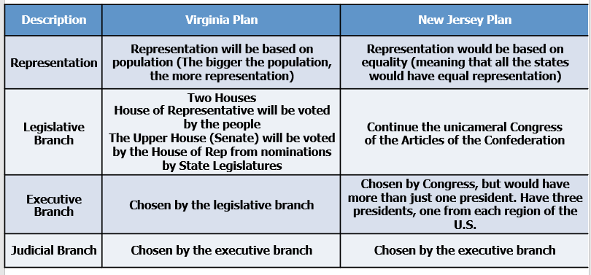
Would either of these plans work?

Virginia vs. New Jersey – Population in 1787
New Jersey
Virginia

THE GREAT COMPROMISE brought to you by Connecticut
Combing both plans together would create a two chamber (b___________) house.
- The H________ of R___________ would be based on the V________ P_______, meaning representation is based on s________ p___________.
- The S___________ would be based on the N________ J_________ P_______ and representation
would be e__________ divided among the s___________.

CONFLICT and COMPROMISE NORTH-SOUTH COMPROMISES
Ratification of treaties
    - Southern delegates insisted on a t_____-t_____ vote (s___________) in the S______ before presidents could ratify treaties

Three-fifths Compromise
  - Issue of counting slaves for representation in the House of Representatives
  - For every f_______ slaves, they would count as t_________ people for representation in the House
  - North happy because South has to pay more taxes
  - South happy because they get more reps

Slave Trade Compromise
  - Forbidding Congress the power to tax the e_________ of goods from any State, and, for 20 years, the power to act on the slave trade.
CONFLICT AND COMPROMISE – THE PRESIDENT
- Method of election:
  - Some wanted election by Congress
  - Some wanted election by state legislatures
  - Some wanted direct election

  - Compromise: E__________ C_________ system; created for two reasons
    - First - Buffer between the people and the selection of a President
      - The founding fathers were afraid of direct election of presidency
      - Feared a tyrant could manipulate public opinion & come to power
      - Vast majority of the people were uneducated, uninformed, etc
    - Second - Structure of the government that gave extra power to the smaller states
      - Small states had more p________ in selection of president
      - Under the system of the Electoral College each state had the same number of electoral votes as they have r____________ in Congress, thus no state could have less then 3 >> disproportionate power to the smaller states
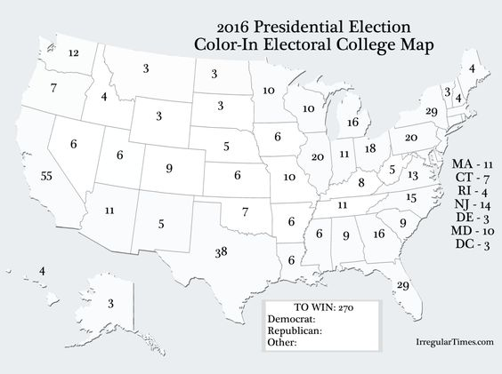
      - To avoid t_________ of the majority.
ELECTORAL COLLEGE
With Presidential Elections, the Founding Fathers believed that the average American was not well e__________ enough and couldn’t trust them to elect a p__________.
Founders created the Electoral College, which created electors in each state (# House Members + 2 Senators = Number Electoral vote) will cast votes.
Popular vote helps elect the electors, but many Americans believe that their vote doesn’t matter. Why?

What is a Typical Presidential Election Cycle?
The presidential election process follows a typical cycle:
- Spring of the year before an election – Candidates announce their intentions to run.
- Summer of the year before an election through spring of the election year primary and caucus debates take place.
- January to June of election year – States and parties hold primaries and caucuses.
- July to early September – Parties hold nominating conventions to choose their candidates.
- September and October – Candidates participate in presidential debates.
- Early November (8) – Election Day. Popular vote. The people are actually voting for electors.
- December (26-28?) – Electors cast their votes in the Electoral College.
- Early January (5, 6 or 7) of the next calendar year – Congress meets in joint session to count the electoral votes.
- January ____ – I_______________ Day

Explain how the following compromises were deemed necessary for adoption and ratification of the Constitution.
- Great (Connecticut) Compromise______________________________________________________
- Electoral College____________________________________________________________________
- Three-fifths Compromise_____________________________________________________________
- Compromise on the importation of slaves________________________________________________
TO ADOPT OR NOT TO ADOPT?
FEDERALISTS VS. ANTIFEDERALISTS
Main debate was primarily about the scope of power of the central government
  - The Federalists wanted a stronger national government and weaker state governments (balanced relationship between federal and state governments)
  - The Anti-federalists wanted a weaker national government and stronger state governments
Federalists:
  - Views
    - E_________ most fit to govern
    - Feared “excesses” of democracy; m____________
    - Favored strong central government
Antifederalists:
  - Views
    - Feared concentration of power in hands of elites; Believed that government should be closer to the people
    - Feared strong central government, favored stronger state governments
    - Feared the lack of B______ of R________ (which would be added later to protect individual liberty) – their strongest argument
The F___________ essays (written by Alexander Hamilton, James Madison, and John Jay) helped the ratification process
The A________-Federalist response was written in a series of essays by Brutus
RATIFICATION – THE GREAT DEBATE
BILL OF RIGHTS – THE FINAL COMPROMISE Federalist versus Anti-Federalists (4:44)
At stake – individual rights and the role of the national government in economic development
One of the many points of contention between F_________, who advocated a strong n_________ g_________, and A____-F_________, who wanted power to remain with s________ and l________ g_________, was the Constitution’s lack of a b_______ of r_________ that would place specific limits on g__________ p_______. Federalists argued that the Constitution did not need a bill of rights, because the people and the states kept any powers not given to the federal government. Anti-Federalists held that a bill of rights was necessary to s__________ individual liberty from the newly created F__________ government.
Madison, then a member of the U.S. House of Representatives, altered the Constitution’s text where he thought appropriate. However, several representatives, led by Roger Sherman, objected, saying that Congress had no authority to change the wording of the Constitution. Therefore, Madison’s changes were presented as a list of amendments that would follow Article VII.
The House approved 17 amendments. Of these, the Senate approved 12, which were sent to the states for approval in August 1789. T_________ amendments were approved (or r_________). Virginia’s legislature was the final state legislature to ratify the amendments, approving them on December 15, 1791.
FEDERALISTS VS. ANTI-FEDERALISTS
GOLDILOCKS
OF GOVERNMENT

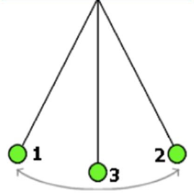
TOO STRONG (KING)
TOO WEAK (ART OF CONF)

JUST RIGHT (CONSTITUTION)

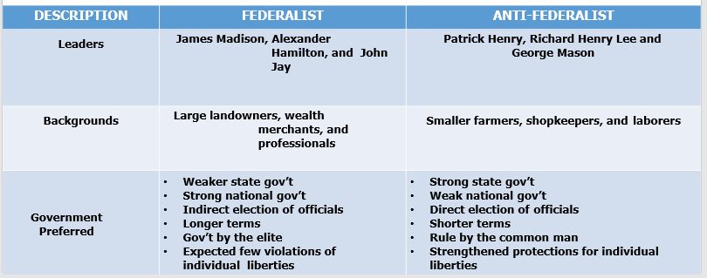

Types of Governments. Define each term in the box below.
Dictatorship Oligarchy
Despot(ism) Anarchy
Tyrant Theocracy
Totalitarian
Autocracy (Autocratic)
Authoritarianism
Krytocracy
Plutocracy
Kleptocracy
Monarchy
Republic (Representative Democracy)
Democracy

27

Constitutional Debates Today
The debate over the role of the central government, the powers of state governments, and the rights of individuals remains at the heart of present-day constitutional issues about democracy and governmental power, as represented by:
- Debates about government surveillance resulting from the federal government’s response to the 9/11 attacks
- The debate about the role of the federal government in public school education

Debate over the role of the central government, the powers of state governments, and the rights of individuals
Government Surveillance post 9/11 | Role of Fed Gov in Public Education
Patriot Act  Individual Rights  1st amendment  4th amendment | Education- NCLB Act  Healthy, Hunger-Free Kids Act of 2010 | State Power- Ed is a reserved power-10th amendment. States can make edu policy, ie curriculum, promote voucher programs- charter & private schools

TOPIC 1.6 Principles of American Government
Madison’s 3 Part Model in Preventing Tyranny
Federalist 51

Examples: President can veto laws; Congress can override presidential veto with 2/3 majority
SEPARATION OF POWERS |  | CHECKS AND BALANCES
Definition:  Legislative | Executive | Definition:  Judicial

Checks and Balances: Impeachment
Impeach- to be accused of a crime. The H______ of Representatives holds vote to determine if a crime has been committed- I_____________

If the House votes yes, the t_____ is held in the S________ with the C_______ Justice presiding. Senators are the j_____.
If the majority in the Senate votes yes, the President is removed from office.

You need to know the difference between checks and balances and separation of powers. Impeachment proceedings is a good example of separation of powers.

