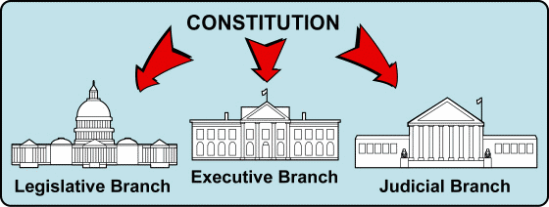**Chpt. 16 The Presidents Crisis and Resurgence 1969 – 1989**

**The Nixon Presidency 1968-1974**

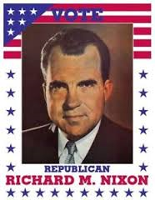The Constitution attempts to create a balance of power between the 3 separate __________ of government.

* Since FDR’s New Deal, Presidential powers have increased dramatically.
* The New Deal, World War II, and the following Cold War added powers.
* This increase in Presidential power is called an ***__________ Presidency***.
* This expansion of power reached its peak under **_________ Nixon**.

**John and Mary Tinker**

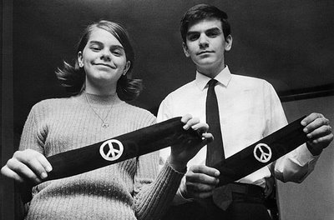

***Tinker v. Des Moines* (1969)** – John and Mary Tinker were _____________ from school for wearing black armbands to protest the V________________ War, the Supreme Court ruled this violated their _________ Amendment right, freedom of “symbolic” speech. Balancing the rights of students with the need of schools to maintain order.

**Chile, Détente, China, and USSR**

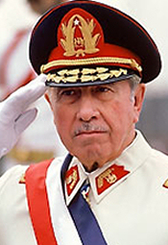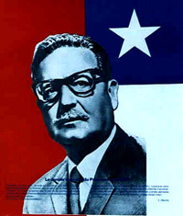**Nixon and Chile**

In 1970 ____________ Allende was elected president of Chile.

A devout communist, he began a policy of government take over of key industries known as **n_______________.**

Nixon and Kissinger instructed the C________ I____________ A_____________ (CIA) to cooperate with the Chilean military and remove Allende. General P_________ seized power and Allende was killed. He established a brutal dictatorship.

*Salvador Allende, President of Chile 1970-1973*

*Augusto Pinochet, President of Chile 1974-1990*

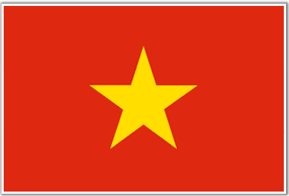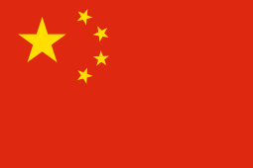To place additional pressure on North _________, to end the war in Indochina, Nixon took 2 steps- he visited the U_______ and Red C______

First step, in 1972, Nixon became the first American president to visit red ________________.

*People’s Republic of China*

Since China’s Communist Revolution, the USA had refused to establish diplomatic relations with China.

*Socialist Republic of Vietnam*

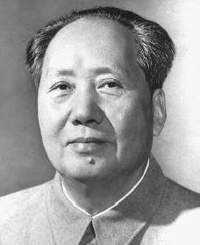China’s leader Mao _________________ agreed to meet with Nixon and to normalize relations with the US.

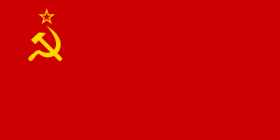Reopening China was one of Nixon’s greatest foreign policy achievements as it reduced tensions between the United States and China. This reduction of tensions is called __________________.

Second, Nixon visited the USSR. This was part of the ***d_________*** strategy or ___________________________.

USSR agreed to sign the S_____________ A__________ L___________ T____________ (SALT) Treaty. This treaty limited the further development of _____________ weapons.

*Mao Zedong*

*Union of Soviet Socialist Republics*

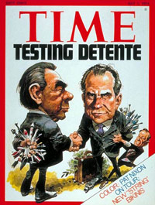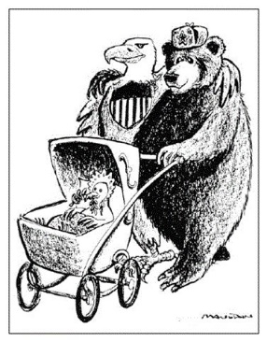Many historians agree that this was Nixon’s greatest _____________ as president.

As a result, N. Vietnam felt isolated & agreed to peace talks in Paris.

**Watergate**

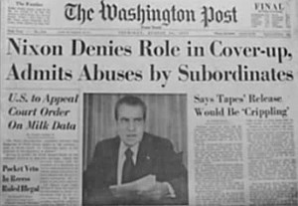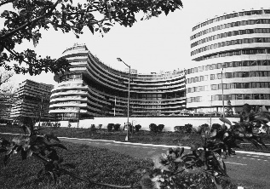In 1972, former _______ agents, working for Nixon’s re-election committee were caught breaking into the headquarters of the Democratic Party N__________ C_________ in the ______________ complex in Washington, D.C.

Two investigative reporters from the W____________ Post exposed the link between Nixon and the Watergate burglars.

*Watergate complex, Washington DC*

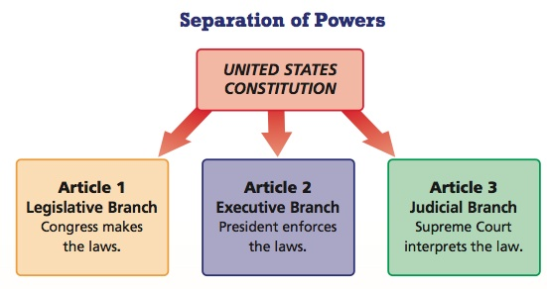Pres. Nixon attempted to cover up the investigation on the grounds that it involved national security.

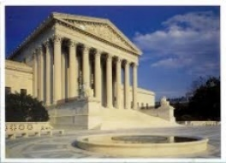

*Supreme Court, Washington DC*

**The Watergate Crisis**

A Special Prosecutor was appointed to look for wrongdoing.

Under oath, a Nixon aide stated Nixon was a part of the Watergate cover-up.

Nixon had recorded all of his White House conversations and the Senate wanted to listen to them, but Nixon refused claiming _______________ privilege.

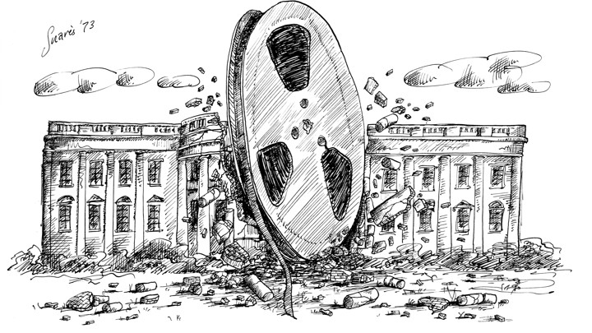Nixon claimed if he turned over the tapes it would lead to Judicial control over the Executive branch, violating the separation of ____________in the Constitution.

According to this cartoon, what brought an end to the Nixon Presidency?

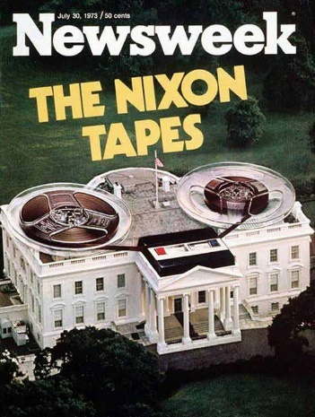***United States v. Nixon*** (1974) – the ____________Court ordered Nixon to turn over the tapes, proving that no one is above the C_______________ (the law).

When the ‘Nixon Tapes’ were released, they revealed Nixon had lied about his involvement in a cover-up and had even deleted portions of tapes.

The House of Representatives moved to **_____________** **(begin proceeding to remove him from office)** Nixon.

Fearing removal from office and trial in the Senate, Nixon became the 1st President to r______________.

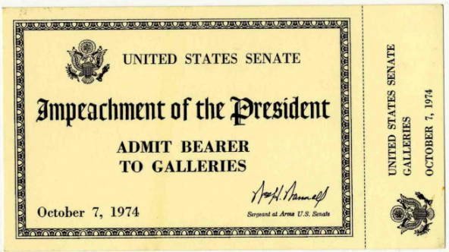

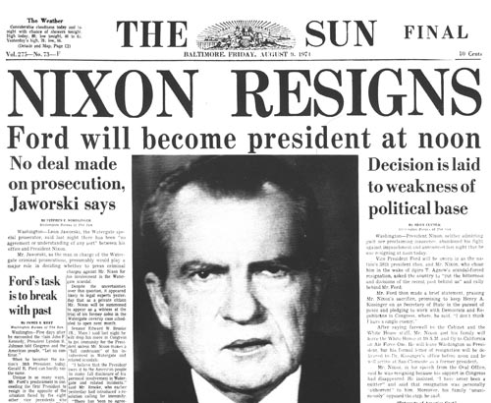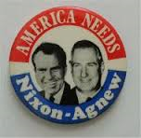

**The Ford Presidency 1974-1977**

Vice-President Spiro A________ resigned when it was found he took bribes while governor of Maryland.

Under the ______th Amendment, Nixon appointed Gerald Ford as his new VP.

Ford would later become the only man to be President that was not elected by the people of the USA. When Nixon resigned, **Gerald F_______** became the next President.

Ford had not even been elected as Vice-President, he had been appointed by Nixon after VP _______ had been forced to resign.

XXV Amendment US Constitution

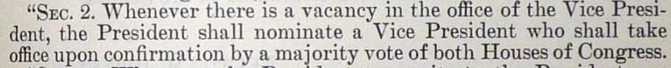

**The Impact of Watergate**

Lowered public confidence in the government, again…. (LBJ – Vietnam)

One of Ford’s first acts as President was to ___________ Nixon for any crimes he may have committed.

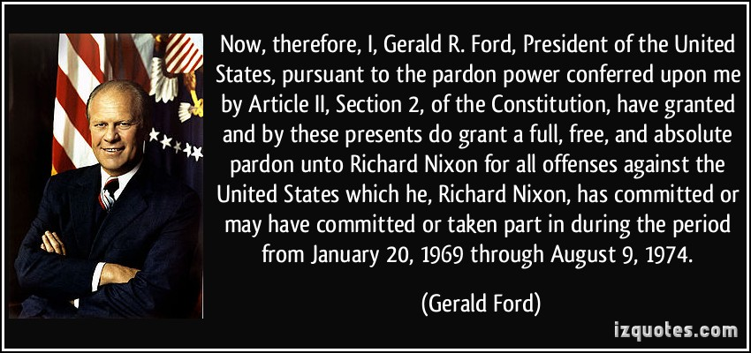This was not popular!

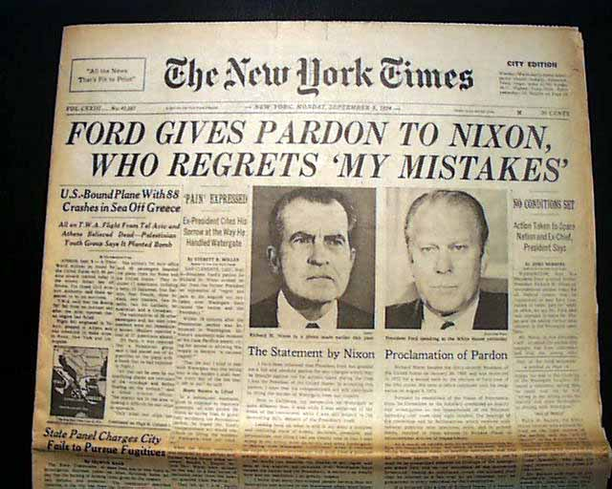Pres. Ford felt Nixon had suffered enough and he particularly wanted the nation to heal and move on.

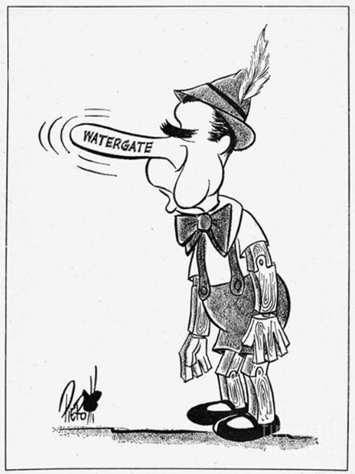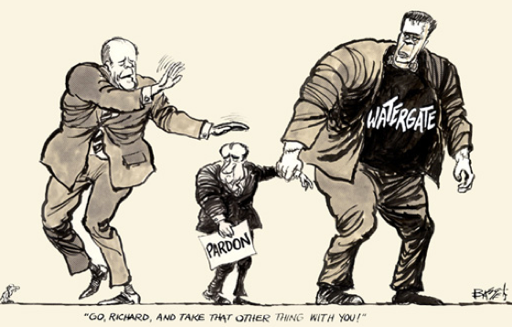

1974. "My fellow Americans, our long national nightmare is over. Our Constitution works; our great republic is a government of laws and not of men." Newly appointed President Gerald Ford spoke these words to the American public trying to put a close to the "Watergate" scandal which cost Richard Nixon his presidency.

A month after taking office, President Gerald Ford addressed the nation on television to announce that he had decided to pardon Richard Nixon. Ford was eager to get both Watergate and the controversial pardon out of the spotlight so national business could finally move ahead. (Probably published September 10, 1974)

**Ford and the US Economy**

Pres. Ford’s main worries were ______________ ones.

Inflation - means __________________ and is usually associated with economic growth and full employment.

Stagflation – is _________________ with high ________________.

During the Ford Presidency stagflation drove our economy.

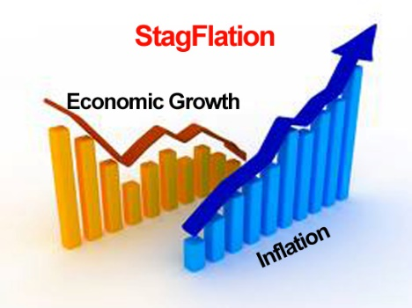Stagflation is caused by a negative s________ shock or a sudden loss of a commodity (oil) causing a rapid price increase.

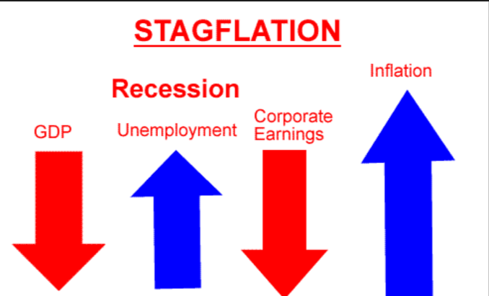

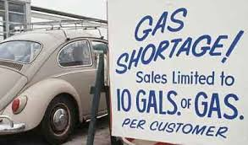

**Organization of Petroleum Exporting Countries (OPEC)**.

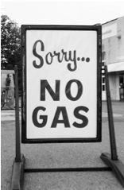In the 1960s, **OPEC** was formed by several oil producing nations located mostly in the Middle East to control the ____________ and ________of oil. OPEC is a _________________ an organization created to supply a product at a high price and limiting competition.

In 1973, OPEC used oil as a political weapon by placing an oil **___________** (or an official ban on trade with a particular country) on the USA & Western Europe for supporting Israel in a Middle East war.

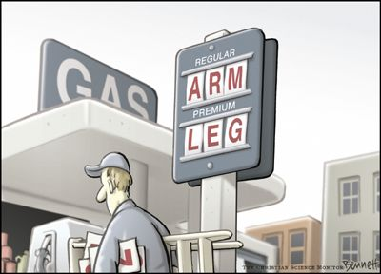Overnight the price of gas shot up!

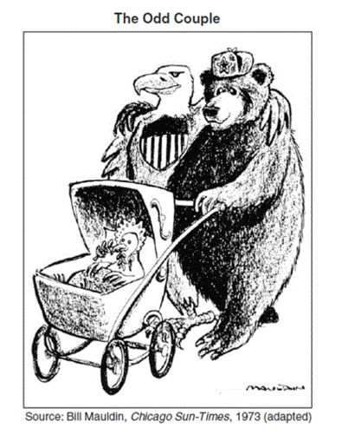Even after the war ended, OPEC continued with high oil prices, making them rich and costing us increased prices for fuel, electricity and food.

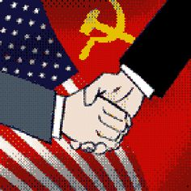

**Ford and Foreign Policy**

Helsinki Accords ultimately ___________________ tensions between the ________________ and the ___________.

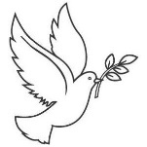The baby in the stroller is a ______________ and it represents ______________________.

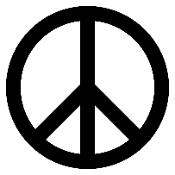

**=**

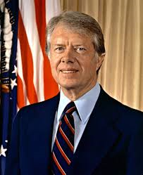

**President Jimmy Carter 1977-80**

Many Americans continued to blame __________ and the Republican party for the _________ scandal.

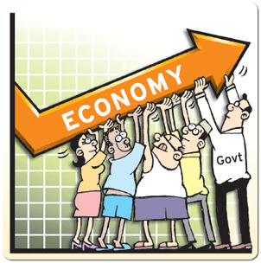**Jimmy Carter**, a Democrat from Georgia, ran against and defeated Pres. Ford in 1976.

Carter promised to ‘clean up’ Washington and end corruption.

Like Pres. Ford, Carter’s main problem was the U.S. _______________ .

Inflation was 10%, interests rates at 21% and price of oil continued rising.



**Pres. Jimmy Carter’s Foreign Policy- a course on Morality**

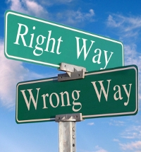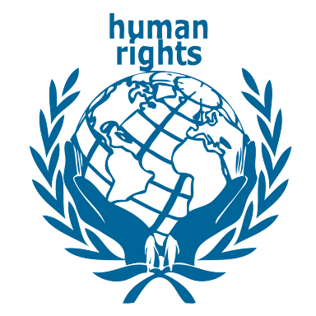 Pres. Carter wanted the U.S.A. to set a _________ example for the world and he made human ______a high priority.

Carter condemned __________(segregation) in South Africa, he pressured the USSR into allowing its Jews to ________ (leave), and stopped sending ___________ to dictators who violated human rights. For example dictator of Nicaragua, Anastasio Somoza.

Pres. Carter signed a deal with Panama returning control of the __________ Canal to Panama in the year 2000.

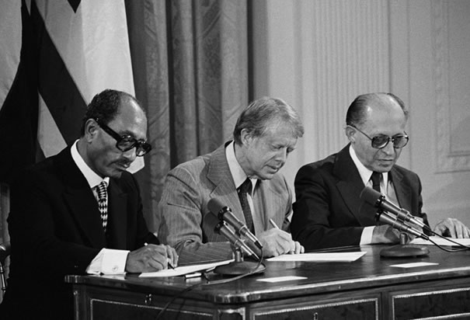 **Morality in the Middle East. Peace in the Middle East**

In 1977 Carter invited ___________________ of Israel and ____________________ of Egypt to Camp David in Maryland.

With Carter’s help they were able to reach an agreement under: the _______________________ Accords, Egypt recognized _________________. In exchange Israel returned the Sinai Peninsula, which it controlled since 1967 War with Egypt.

Egypt and Israel have fought several wars since Israel was created.

*From left to right: Sadat, Egypt; Carter, USA; Begin, Israel*

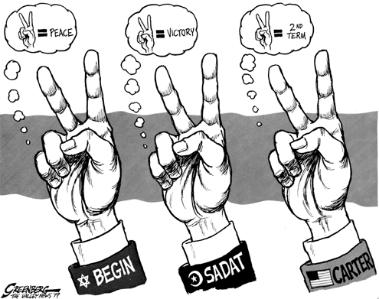The **Camp David Accords** ending 30 years of war between the two nations.

=2nd Term

=Victory

=Peace

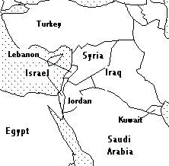

***Circle Egypt and Israel on the map.***

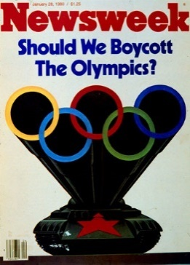Carter continued with Nixon’s policy of détente with the S_______ U______, until 1979 when the Soviet Union invaded Afghanistan.

But when the Soviet Union invaded Afghanistan in 1979, Pres. Carter stopped selling w________ to the Soviets and the U.S. b_________ the 1980 Olympic games held in Moscow.

**The Carter Doctrine-** fearing that the USSR may take the oil supplies in the Persian Gulf, Carter stated- any attempt by a foreign nation to gain power in the P_________ G______, was an attack on US vital interest and would be met by US _________ force.

Pres. Carter also postponed signing a new arms control agreement, known as **SALT II.**

**Iranian Revolution and the Hostage Crisis**

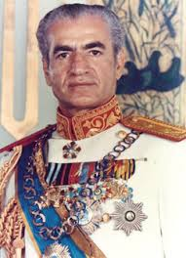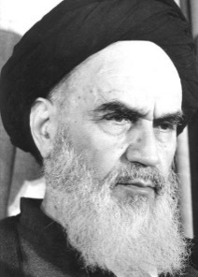The ________ or King of Iran was an ally of the USA, however he was also a brutal dictator.

In 1978, the he was overthrown by the **Ayatollah ______________** and radical religious leaders who were hostile to the USA.

In 1979, the Shah entered the USA for medical treatment, sparking riots in Iran that were anti- American.

The Shah of Iran

Two weeks later, Iranian students seized 52 staff members of American Embassy in Tehran, Iran. The Iranian government did nothing to secure their release.

Ayatollah Khomeini

**The Hostage Crisis-the undoing of an American President**

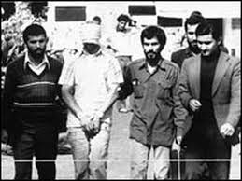These ___________ would be held for over a year (444 days).

Pres. Carter staged a rescue attempt, but it failed.

The U.S.A. imposed economic __________ on Iran and other countries around the world supported the United States.

America’s image suffered because of our inability to free the hostages.

American hostages in Iran, 1979

They remained captive until ________________ was inaugurated as President in 1980.

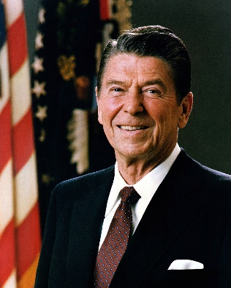**Ronald Reagan 1980-1989**

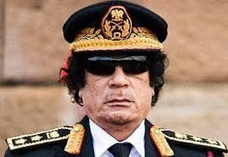­­________________ is the use of bombings, assassinations, kidnapping, or other acts of terror to make sure a political groups voice is heard and that governments will yield to their demands.

1983 – Reagan sends Marines to *Lebanon* as part of a multinational ______________ force, but a suicide bomber attacked the American Embassy in Beirut, killing 241 Marines.

*Muammar Gaddafi*

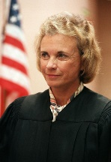1986 – Reagan bombed ________________ ‘s *Libya* in response to Libya’s involvement in terrorism.

**Ronald Reagan**

Fearing that the Republican party was losing touch with female voters, Reagan nominated the first woman to the Supreme Court, Sandra Day ___________

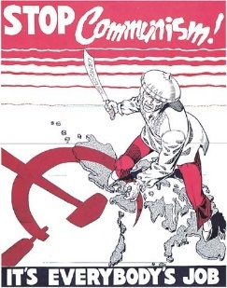**The Reagan Doctrine- not just to contain communism but to __________ it back and overwhelm it.**

The US had a moral obligation to support all forces fighting or opposed to _____________________ including military assistance. Communism had to be **_____________ed** back and not just contained.

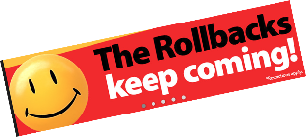Rolling back communism in:

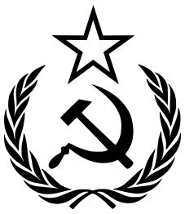**Afghanistan**:____________________________________________________________

**Grenada**:_______________________________________________________________

**Nicaragua**:______________________________________________________________

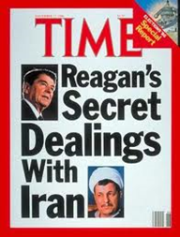**The Iran-Contra Affair** was a secret operation run by Reagan White House officials.

Reagan stated he would not negotiate with terrorists, but his administration sold weapons to Iran to gain the release of American hostages in _______________.

Profits from weapons sales were then given to Nicaraguan **______________,** anti-Communists who were fighting Communism in Nicaragua. This was a violation of a Congressional ban on aiding the Nicaraguan anti-communist rebels.

***Americans again wondered if they could trust their government.***

*The Evil Empire*

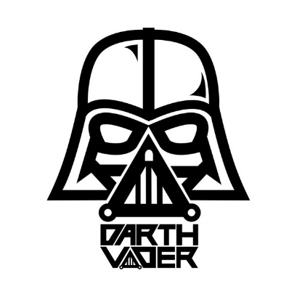**Changes in the Soviet Union**

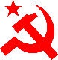Reagan often referred to the USSR as the ‘**E__________ Empire**’.

Soviet leader Mikhail _______________ introduced free-enterprise reforms to help the failing Russian economy.

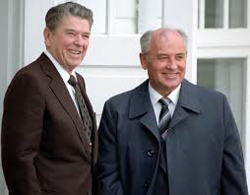**Glasnost** or ______________. For the first time, people in the USSR would be able to criticize and make suggestions without fear.

**Perestroika** or _______________. Introduced limited free enterprise into the Soviet economy. Now Russians could own their business free from government interference.

Ronald Reagan & Mikhail Gorbachev

Some say that Pres. ____________ deserves credit for the fall of Communism, because of his strong stand on defense and support of democracy.

Others believe Reagan benefitted from a **weak Russian e___________** and Gorbachev’s reform efforts which **eased c________ war t__________.**

**Reagan- Gorbachev Summit Talks**

**S________________ D________________ I_______________ or SDI (aka Star Wars)**

was a defense system that was proposed by Reagan that would include lasers and other futuristic weapons systems that would survive a nuclear attack.

Soviet leaders feared a US ____________ strike nuclear attack and USSR did not have the money to develop their own SDI. SDI pushed Gorbachev to seek discussions to reduce nuclear weapons.

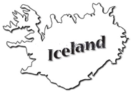An agreement was reached in Reykjavik, ________________and it was the most successful arms reduction treaty of the Cold War.

Are you really my father?

No, but I can be your friend

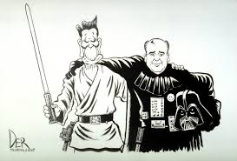

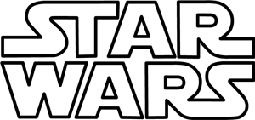

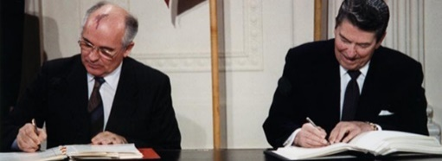

**EOC PRACTICE- for questions 1-3 use the cartoon below.**

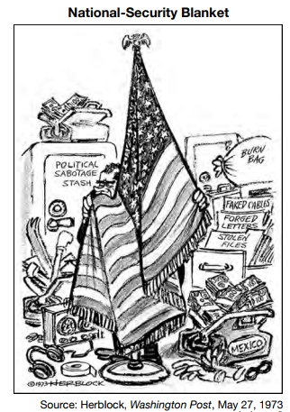

1. Which action by President Richard Nixon is the focus of this cartoon?

(1) recalling diplomats from Mexico

(2) supporting tax decreases and budget cuts

(3) attempting to hide evidence from investigators

(4) making concessions to the Soviet Union

2.

3. The outcome of the events illustrated in the cartoon resulted in the

(1) expansion of the Vietnam War into Cambodia

(2) resignation of President Richard Nixon

(3) growing support for environmental protection legislation

(4) visit to Communist China by President Richard Nixon

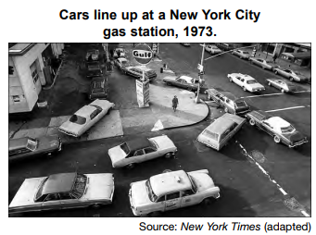

4. This 1973 photograph shows a situation most directly related to

(1) the development of nuclear power sources

(2) the end of oil production in the Gulf of Mexico

(3) terrorist attacks on United States petroleum reserves

(4) an oil embargo imposed by nations in the Middle East

5. President John F. Kennedy and President Ronald Reagan both visited the Berlin Wall in order to

(1) assess the military strength of the Soviet Union

(2) prepare for an invasion of the Soviet Union

(3) demonstrate the commitment of the United States to maintain freedom in Western Europe

(4) challenge the North Atlantic Treaty Organization (NATO) nations that were supported by the Soviet Union

6. Which document is the result of President Jimmy Carter’s efforts to increase stability in the Middle East?

(1) Camp David Accords

(2) Nuclear Test Ban Treaty

(3) Panama Canal Treaty

(4) Paris Peace Accords